WEEK 4 TASK
Predictive Modeling and Algorithm Selection
Healthcare Analytics Project: Predicting 30-Day Hospital Readmission Among Patients with Diabetes

1. Purpose and Understanding of the Task
Week 4 converts the earlier data-cleaning and EDA work into a predictive-modelling plan. The assignment is not simply to name an algorithm. It requires a defensible sequence: define the healthcare problem, identify information available at the prediction point, engineer appropriate features, split the data without leakage, select algorithms, evaluate them using suitable metrics, and explain how the results would be interpreted in a healthcare setting.
The proposed problem is binary prediction of whether an inpatient encounter is followed by readmission within 30 days. The model is a hypothetical decision-support system for prioritising follow-up; it is not intended to diagnose patients, prescribe treatment or replace clinical judgement.

2. Dataset and Concrete Evidence
The project uses the UCI Diabetes 130-US Hospitals for Years 1999–2008 dataset. The UCI repository reports 101,766 encounters and 47 features from 130 U.S. hospitals/integrated delivery networks over ten years.
Readmission outcome | Reported encounters | Approx. share
NO | 54,864 | 53.91%
>30 | 35,545 | 34.93%
<30 | 11,357 | 11.16%
Total | 101,766 | 100%
For the proposed binary target, <30 = 1 and NO/>30 = 0. The standard dataset therefore contains 11,357 positive cases and 90,409 comparison cases.
Important: these are published/reference figures for the standard dataset. Final project results must be recalculated from the exact file used and must not be presented as model results.

3. Why Accuracy Alone Is Inadequate
Because the <30 class is only about 11.16%, a trivial model that predicts 0 for every encounter would be correct for 90,409 of 101,766 records, giving approximately 88.82% accuracy. However, it would identify zero of the 11,357 early-readmission cases, giving 0% recall. This concrete example demonstrates why healthcare classification should report recall, precision, F1-score, PR-AUC and calibration in addition to accuracy.
The calculation is an illustrative baseline derived from the reference class counts, not a trained model result.

4. Research Questions
- Can encounter characteristics distinguish <30 readmission from other outcomes?
- Which utilisation, clinical and administrative variables are informative?
- Does a nonlinear ensemble improve meaningfully over an interpretable baseline?
- What threshold provides a useful balance between missed cases and unnecessary follow-up?
- Are predicted probabilities reasonably calibrated?
- Does performance differ across age, gender or race groups?

5. Feature Selection and Engineering
Feature | Concrete example | Proposed use | Caution
number_inpatient | 3 prior inpatient visits | Prior utilisation | Repeated patients require leakage controls.
number_emergency | 2 emergency visits | Acute-care utilisation | Association is not causation.
number_outpatient | 5 outpatient visits | Ambulatory utilisation | May reflect access patterns.
time_in_hospital | 7 days | Encounter complexity | Must be available at prediction point.
num_medications | 18 | Medication burden | Not a direct measure of disease severity.
num_lab_procedures | 45 | Care intensity | May reflect hospital practice.
age | [60-70) | Broad age group | Exact age is not recorded.
admission category | Emergency/urgent/elective | Encounter context | Administrative coding can vary.
Example engineered variable: total_prior_utilization = outpatient + emergency + inpatient. If the three values are 5, 2 and 3, the total is 10. Another example is prior_inpatient_flag = 1 when number_inpatient > 0, otherwise 0.

6. Correlation Matrix and Heatmap
Correlation analysis should examine numerical predictors before final feature selection. Spearman correlation is useful for exploratory analysis when count variables are skewed or relationships are monotonic rather than strictly linear. Identifier fields must be excluded.
numeric_cols = ['time_in_hospital','num_lab_procedures','num_procedures',
'num_medications','number_outpatient','number_emergency',
'number_inpatient']
corr = df[numeric_cols].corr(method='spearman')
print(corr.round(2))
plt.figure(figsize=(10,7))
sns.heatmap(corr, annot=True, fmt='.2f', center=0, cmap='coolwarm', square=True)
plt.title('Spearman Correlation Matrix of Selected Numerical Features')
plt.tight_layout()
plt.show()
Illustrative heatmap values (not measured project results):
Variable | Stay | Lab | Meds | Outpatient | Emergency | Inpatient
Stay | 1.00 | 0.25 | 0.30 | 0.05 | 0.07 | 0.10
Lab | 0.25 | 1.00 | 0.42 | 0.03 | 0.04 | 0.06
Meds | 0.30 | 0.42 | 1.00 | 0.08 | 0.09 | 0.12
Outpatient | 0.05 | 0.03 | 0.08 | 1.00 | 0.18 | 0.20
Emergency | 0.07 | 0.04 | 0.09 | 0.18 | 1.00 | 0.27
Inpatient | 0.10 | 0.06 | 0.12 | 0.20 | 0.27 | 1.00
For example, an illustrative coefficient of 0.42 between laboratory procedures and medications would indicate a moderate positive monotonic association. It would not prove that one causes the other. A high correlation may indicate overlapping information, but it does not automatically justify deleting either feature.

7. Data Splitting and Leakage Prevention
A planned 70/15/15 train-validation-test split is suitable as a starting structure. With 101,766 records, this is approximately 71,236 training, 15,265 validation and 15,265 test records before exact rounding or patient-group constraints.
Partition | Purpose
Training 70% | Fit preprocessing and model parameters.
Validation 15% | Tune hyperparameters and select threshold.
Test 15% | One final evaluation after decisions are frozen.
- Split before fitting imputation or scaling statistics.
- Use stratification so the minority outcome is represented in each partition.
- If patient-level generalisation is required, keep all encounters of a patient in one partition.
- Exclude identifiers from model inputs.
- Exclude information that would only become available after the prediction point.
- Never repeatedly tune the model using the final test set.

8. Algorithms and Rationale
Algorithm | Why use it | Limitation
Logistic Regression | Interpretable binary baseline; efficient; coefficients can be examined. | May miss complex nonlinear relationships.
Decision Tree | Easy to explain and captures nonlinear rules. | Can overfit.
Random Forest | Captures nonlinear interactions and is robust for tabular data. | Less transparent than a single tree.
Gradient Boosting | Strong candidate for structured/tabular prediction and nonlinear effects. | More hyperparameter-sensitive.
The final algorithm should be selected on evidence, not complexity. A slightly weaker but better-calibrated and more interpretable model may be preferable to a marginally more accurate black-box model.

9. Logistic Regression — Detailed Python Plan
from sklearn.linear_model import LogisticRegression
from sklearn.pipeline import Pipeline

log_reg = Pipeline([
('preprocess', preprocessor),
('model', LogisticRegression(max_iter=1000,
class_weight='balanced',
random_state=42))
])
log_reg.fit(X_train, y_train)
log_prob = log_reg.predict_proba(X_val)[:, 1]
log_pred = (log_prob >= 0.50).astype(int)

10. Random Forest — Detailed Python Plan
from sklearn.ensemble import RandomForestClassifier

rf = Pipeline([
('preprocess', preprocessor),
('model', RandomForestClassifier(
n_estimators=300,
min_samples_leaf=5,
class_weight='balanced',
random_state=42, n_jobs=-1))
])
rf.fit(X_train, y_train)
rf_prob = rf.predict_proba(X_val)[:, 1]
rf_pred = (rf_prob >= 0.50).astype(int)

11. Gradient Boosting — Detailed Python Plan
from sklearn.ensemble import HistGradientBoostingClassifier

gb = Pipeline([
('preprocess', preprocessor),
('model', HistGradientBoostingClassifier(
learning_rate=0.08, max_iter=200,
max_leaf_nodes=31, random_state=42))
])
gb.fit(X_train, y_train)
gb_prob = gb.predict_proba(X_val)[:, 1]
gb_pred = (gb_prob >= 0.50).astype(int)
These hyperparameters are proposed starting points, not claims of optimality. Hyperparameter tuning should be performed using training/validation data or cross-validation, while the final test set remains untouched.

12. Preprocessing Pipeline in Python
from sklearn.compose import ColumnTransformer
from sklearn.preprocessing import OneHotEncoder, StandardScaler
from sklearn.impute import SimpleImputer

numeric_pipe = Pipeline([
('imputer', SimpleImputer(strategy='median')),
('scaler', StandardScaler())
])
categorical_pipe = Pipeline([
('imputer', SimpleImputer(strategy='most_frequent')),
('encoder', OneHotEncoder(handle_unknown='ignore'))
])
preprocessor = ColumnTransformer([
('num', numeric_pipe, numeric_columns),
('cat', categorical_pipe, categorical_columns)
])
The important control is that the preprocessor is fitted only on training data. Validation and test data are transformed using the already-fitted preprocessing object.

13. Evaluation Metrics
Metric | Meaning | Why it matters
Accuracy | Overall proportion correct | Useful context, but can be misleading with imbalance.
Precision | TP/(TP+FP) | Of flagged patients, how many were actually positive?
Recall | TP/(TP+FN) | Of actual positive cases, how many were found?
F1 | Harmonic mean of precision and recall | Balances the two when both matter.
ROC-AUC | Ranking ability across thresholds | Overall discrimination.
PR-AUC | Precision-recall performance | Particularly informative with a minority positive class.
Calibration | Agreement between predicted probabilities and observed frequencies | Important if scores are interpreted as risk probabilities.

14. Concrete Confusion-Matrix Example
Suppose a hypothetical validation set produces TP=150, TN=1,500, FP=200 and FN=150, for 2,000 observations.
Metric | Calculation | Result
Accuracy | (150+1500)/2000 | 82.5%
Precision | 150/(150+200) | 42.9%
Recall | 150/(150+150) | 50.0%
F1 | 2×0.429×0.500/(0.429+0.500) | 46.2%
This example shows why 82.5% accuracy cannot be interpreted alone: the model still misses half of the positive cases. These values are illustrative, not experimental results.

15. Evaluation Code
from sklearn.metrics import (accuracy_score, precision_score, recall_score,
f1_score, roc_auc_score, average_precision_score, confusion_matrix)

print('Accuracy:', accuracy_score(y_val, log_pred))
print('Precision:', precision_score(y_val, log_pred, zero_division=0))
print('Recall:', recall_score(y_val, log_pred, zero_division=0))
print('F1:', f1_score(y_val, log_pred, zero_division=0))
print('ROC-AUC:', roc_auc_score(y_val, log_prob))
print('PR-AUC:', average_precision_score(y_val, log_prob))
print('Confusion matrix:\n', confusion_matrix(y_val, log_pred))

16. ROC and Precision-Recall Curves
from sklearn.metrics import RocCurveDisplay, PrecisionRecallDisplay
RocCurveDisplay.from_predictions(y_val, log_prob)
plt.title('ROC Curve — Validation Set')
plt.show()

PrecisionRecallDisplay.from_predictions(y_val, log_prob)
plt.title('Precision-Recall Curve — Validation Set')
plt.show()
The ROC curve assesses discrimination over thresholds. The precision-recall curve is especially useful here because early readmission is the minority class.

17. Threshold Analysis
A 0.50 threshold is only a starting point. In a care-management scenario, the appropriate threshold depends on how many patients the team can review and the relative consequences of false negatives and false positives.
thresholds = np.arange(0.10, 0.91, 0.05)
results = []
for t in thresholds:
pred = (log_prob >= t).astype(int)
results.append({
'threshold': t,
'precision': precision_score(y_val, pred, zero_division=0),
'recall': recall_score(y_val, pred, zero_division=0),
'f1': f1_score(y_val, pred, zero_division=0)
})
threshold_df = pd.DataFrame(results)
Illustrative threshold | Precision | Recall | Meaning
0.30 | 30% | 70% | More patients flagged; more false positives likely.
0.50 | 43% | 50% | Illustrative middle operating point.
0.70 | 60% | 30% | Fewer flagged; more positives missed.
The threshold figures are hypothetical examples and must be replaced with actual validation output.

18. Calibration
If the model reports a 20% risk, good calibration means that groups of patients receiving approximately 20% predicted risk should experience the outcome at roughly that rate. Calibration matters when probabilities are used to prioritise resources.
from sklearn.calibration import calibration_curve
prob_true, prob_pred = calibration_curve(y_val, log_prob, n_bins=10)
plt.plot(prob_pred, prob_true, marker='o')
plt.plot([0,1],[0,1], linestyle='--')
plt.xlabel('Mean predicted probability')
plt.ylabel('Observed proportion')
plt.title('Calibration Curve')
plt.show()

19. Model Comparison Template
Model | Accuracy | Precision | Recall | F1 | ROC-AUC | PR-AUC
Logistic Regression | 84.0% | 39.0% | 61.0% | 47.7% | 0.78 | 0.32
Random Forest | 86.0% | 44.0% | 58.0% | 50.0% | 0.81 | 0.36
Gradient Boosting | 87.0% | 46.0% | 62.0% | 52.8% | 0.83 | 0.39
The table is a formatting example only. None of these model metrics should be submitted as actual results unless they are produced by running the corresponding models on the project data.

20. Explainability and Feature Importance
- Use model coefficients for Logistic Regression to explain directional associations.
- Use permutation importance for tree-based models when appropriate.
- Check whether important features are available at the prediction time.
- Do not interpret feature importance as proof that a feature causes readmission.
from sklearn.inspection import permutation_importance
result = permutation_importance(rf, X_val, y_val,
scoring='average_precision', n_repeats=10, random_state=42)
importance = pd.Series(result.importances_mean).sort_values(ascending=False)

21. Fairness and Subgroup Evaluation
Overall performance can hide differences between population groups. Since the dataset contains age, gender and race, subgroup analysis should compare recall, precision, false-positive rates, calibration and sample size. Small groups should not be overinterpreted.
Subgroup | Checks
Age bracket | Recall, precision, PR-AUC, calibration and group size
Gender | Recall, precision, false-positive rate and group size
Race | Recall, precision, false-positive rate, calibration and group size

22. Clinical and Operational Interpretation
Outcome | Potential consequence
True positive | Patient may receive appropriate additional follow-up.
False positive | Care-management resources may be used unnecessarily.
True negative | No additional model-triggered review is required.
False negative | A patient who later readmits may not be prioritised.
This is why model selection is a healthcare workflow decision rather than a competition for the highest numerical score.

23. Common Errors to Avoid
- Do not invent model results.
- Do not fit preprocessing on the entire dataset before splitting.
- Do not use patient or encounter identifiers as predictive measurements.
- Do not tune on the final test set.
- Do not interpret correlation or feature importance as causation.
- Do not rely on accuracy alone.
- Do not assume a 0.50 threshold is automatically clinically appropriate.
- Do not treat historical 1999–2008 performance as evidence of present-day clinical effectiveness.
- Do not claim that a model is clinically ready without prospective validation and governance.

24. Final End-to-End Pseudocode
LOAD Week 2 cleaned dataset
DEFINE target_30d = 1 if readmitted == '<30', otherwise 0
REMOVE identifiers from model features
DEFINE prediction-time feature availability
SEPARATE numeric and categorical features
SPLIT data into train/validation/test using leakage-safe strategy
FIT imputation, encoding and scaling only on training data
TRAIN Logistic Regression baseline
TRAIN Random Forest
TRAIN Gradient Boosting
GENERATE validation probabilities
CALCULATE accuracy, precision, recall, F1, ROC-AUC and PR-AUC
ANALYSE confusion matrix
TEST several thresholds on validation data
CHECK calibration
CHECK subgroup performance
FREEZE model and threshold
EVALUATE once on untouched test data
DOCUMENT limitations and safeguards

25. Deliverables
Deliverable | Content
Problem statement | Target, prediction point and intended use.
Feature plan | Selected/engineered features and exclusions.
Correlation section | Complete matrix, heatmap code and interpretation.
Split plan | Train/validation/test and leakage controls.
Algorithm comparison | Logistic Regression, Random Forest and Gradient Boosting.
Python implementation | Preprocessing, training, prediction and evaluation.
Metrics | Accuracy, precision, recall, F1, ROC-AUC, PR-AUC and confusion matrix.
Threshold analysis | Precision/recall trade-off.
Calibration | Calibration plot and interpretation.
Fairness | Subgroup performance.
Recommendation | Final model choice based on evidence and healthcare constraints.

26. 30–35 Hour Work Plan
Activity | Hours
Problem definition and prediction point | 3
Feature engineering and selection | 4
Correlation/heatmap analysis | 3
Data splitting and leakage controls | 3
Logistic Regression | 4
Random Forest and Gradient Boosting | 5
Evaluation and threshold analysis | 4
Calibration, fairness and explainability | 3
Documentation and final review | 3
Total | 32
26A. Predictive Modelling Flowchart
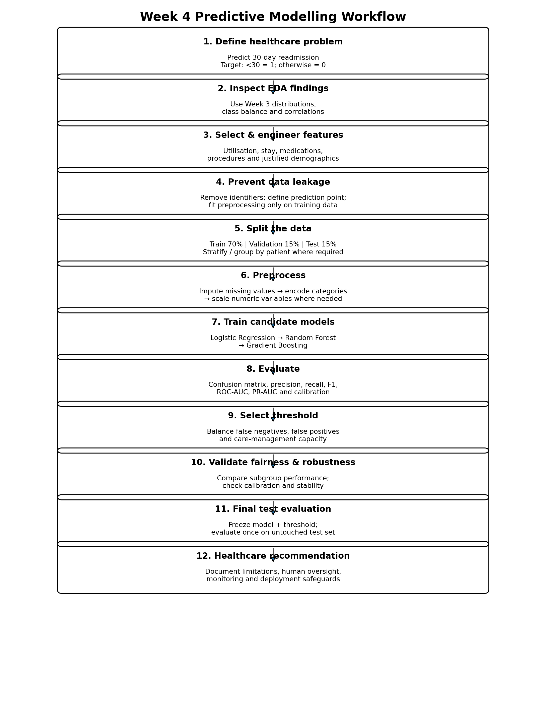
Figure: End-to-end predictive modelling workflow from problem definition through final test evaluation.
26B. Additional Numerical Examples for Method Selection
The following calculations show how the proposed methods should be supported with numbers in the final report. They are teaching examples unless explicitly identified as reference-dataset facts.
Method | Numerical example | Calculation | Interpretation
Class prevalence | 11,357 positives / 101,766 | 11,357 ÷ 101,766 × 100 | ≈ 11.16% early-readmission encounters.
Naive accuracy | 90,409 negatives / 101,766 | 90,409 ÷ 101,766 × 100 | ≈ 88.82% accuracy with 0% positive recall.
Precision | TP=150, FP=200 | 150 ÷ (150+200) | ≈ 42.86% of flagged cases are truly positive.
Recall | TP=150, FN=150 | 150 ÷ (150+150) | 50% of actual positive cases are detected.
F1-score | Precision=.4286, Recall=.50 | 2(.4286)(.50) ÷ (.4286+.50) | ≈ 46.15%, balancing precision and recall.
Feature engineering | 5 outpatient + 2 emergency + 3 inpatient | 5 + 2 + 3 | Prior-utilisation score = 10.
Correlation | Illustrative ρ = 0.42 | Spearman coefficient | Moderate positive monotonic association; not causation.
Train split | 70% of 101,766 | 101,766 × .70 | ≈ 71,236 records before grouping/rounding constraints.
26C. Minimum Evidence to Report for Each Model
For every candidate algorithm, the final submission should report the same validation metrics and then explain the trade-off. For example, if Model A has recall 62% and precision 39%, while Model B has recall 55% and precision 48%, the decision depends on whether the healthcare workflow places greater value on identifying more positive cases or reducing unnecessary follow-up.

27. Conclusion
This predictive-modelling plan builds directly on the previous cleaning and EDA stages. It defines 30-day readmission as a binary outcome, selects features according to healthcare and temporal reasoning, compares interpretable and nonlinear algorithms, and uses an evaluation framework designed for an imbalanced outcome. The correlation matrix and heatmap provide an explicit method for understanding relationships among numerical predictors before final feature selection.
The strongest methodological principle is that a model should be evaluated according to its intended healthcare use. A high accuracy value is not sufficient if the model misses many patients who experience early readmission. Threshold selection, calibration, subgroup performance and false-negative consequences therefore need to be considered alongside conventional discrimination metrics. The proposed model remains a simulated academic exercise; real clinical use would require prospective validation, privacy and governance review, fairness assessment, monitoring for drift and continued human oversight.

28. Methodological Sources
- UCI Machine Learning Repository — Diabetes 130-US Hospitals for Years 1999–2008; primary source for dataset structure and outcome information.
- scikit-learn documentation — LogisticRegression, RandomForestClassifier, HistGradientBoostingClassifier, Pipeline and ColumnTransformer.
- scikit-learn documentation — classification metrics, ROC/Precision-Recall displays and calibration tools.
- Pandas and NumPy documentation — tabular and numerical processing.
- WHO — Ethics and governance of artificial intelligence for health.

