

ALAGA Program
User Manual
Barangay Sta. Rita Digital ID System
Comprehensive Guide for Administrators, Staff, and Beneficiaries
Capstone / Research Documentation | Updated October 2026

Table of Contents
Contents and page numbers for this edition. Section titles match the headings in the manual.
Introduction to the ALAGA Program 4
1.1 About the System 4
1.2 System Purpose and Objectives 4
1.3 Target Users 4
Getting Started 5
2.1 Home Page / Landing Page 5
2.2 Navigation and Notifications 6
2.3 User Roles and Access Levels 6
Beneficiary Portal 7
3.1 Beneficiary Sign Up 7
3.2 Beneficiary Login 10
3.3 Beneficiary Dashboard 11
3.4 Requesting Assistance 11
3.5 Request History 12
3.6 Profile and QR ID 13
3.7 Renewing Your Beneficiary ID 14
3.8 Correcting an Account Application 14
3.9 Beneficiary Activity Logs 15
Admin Portal 15
4.1 Admin Login 15
4.2 Admin Dashboard 16
4.3 Account Requests 17
4.4 Walk-In Registration 18
4.5 Beneficiary Management 19
4.6 QR Verification 20
4.7 Assistance Requests 21
4.8 Assistance Records 22
4.9 Assistance Guidelines 23
4.10 Reports Generation 23
4.11 User Management 24
4.12 Renewal Requests 25
4.13 Activity Logs and Audit Reports 26
Workflows and Processes 27
5.1 Beneficiary Workflow 27
5.2 Admin Workflow 27
5.3 Guardian/Representative Workflow 28
Security and Privacy 28
6.1 Authentication and Sessions 28
6.2 Data Privacy Features 29
Troubleshooting 29
7.1 Common Errors and Solutions 29

Introduction to the ALAGA Program

About the System
The Barangay Sta. Rita ALAGA Program (Ako, Lolo at Lola, may Alaga Program) Digital ID System is a comprehensive web-based platform designed to modernize and streamline the delivery of social services to vulnerable sectors within the barangay. The system serves as a centralized digital hub for beneficiary registration, assistance request processing, QR-based ID verification, and assistance tracking and reporting.
Built with Next.js, React, and Supabase PostgreSQL, the system provides a responsive interface for barangay personnel and beneficiaries. It supports installation through compatible browsers as a Progressive Web App (PWA). An internet connection is required for login, current records, uploads, verification, and submissions; application data is not cached for offline transactions.

System Purpose and Objectives
The ALAGA Program Digital ID System was developed to address the growing need for efficient, transparent, and accountable delivery of barangay social services. The primary objectives include:
- Register and maintain accurate records of PWD (Persons with Disability), Senior Citizen, and Solo Parent beneficiaries
- Process both online and walk-in assistance requests through a standardized digital workflow
- Track request statuses from initial submission through approval to final release
- Issue and verify QR-based Beneficiary IDs for quick identification and service access
- Generate comprehensive sector-based reports on released assistance for transparency and auditing

Target Users
The system serves administrators, sector coordinators, beneficiaries, and guardians or representatives. Existing Staff accounts remain supported, with access limited by their assigned sectors.
User Role | Primary Functions | Access Level
Administrator | Full system management, user creation, budget control, report generation | All modules and settings
Coordinator / Staff | Assigned-sector registration, request processing, QR verification, reports | Primary Sector scope; no Administration modules
Beneficiary | Submit assistance requests, view profile and QR ID, track request status | Own records only
Guardian | Submit requests on behalf of beneficiary | Through beneficiary forms

Getting Started

Home Page / Landing Page
The public landing page serves as the entry point for all users. It provides a comprehensive overview of the ALAGA Program, including its mission, available services, and the process flow for beneficiaries. The page features a clean, accessible design with navigation to both the Beneficiary Portal and Admin Portal.
Key elements on the landing page include: a hero section explaining the program, service cards highlighting the three main beneficiary sectors (PWD, Senior Citizen, Solo Parent), a step-by-step process guide, and contact information for the Barangay Sta. Rita office. Action buttons for Sign In, Sign Up, and Register Account are prominently displayed.
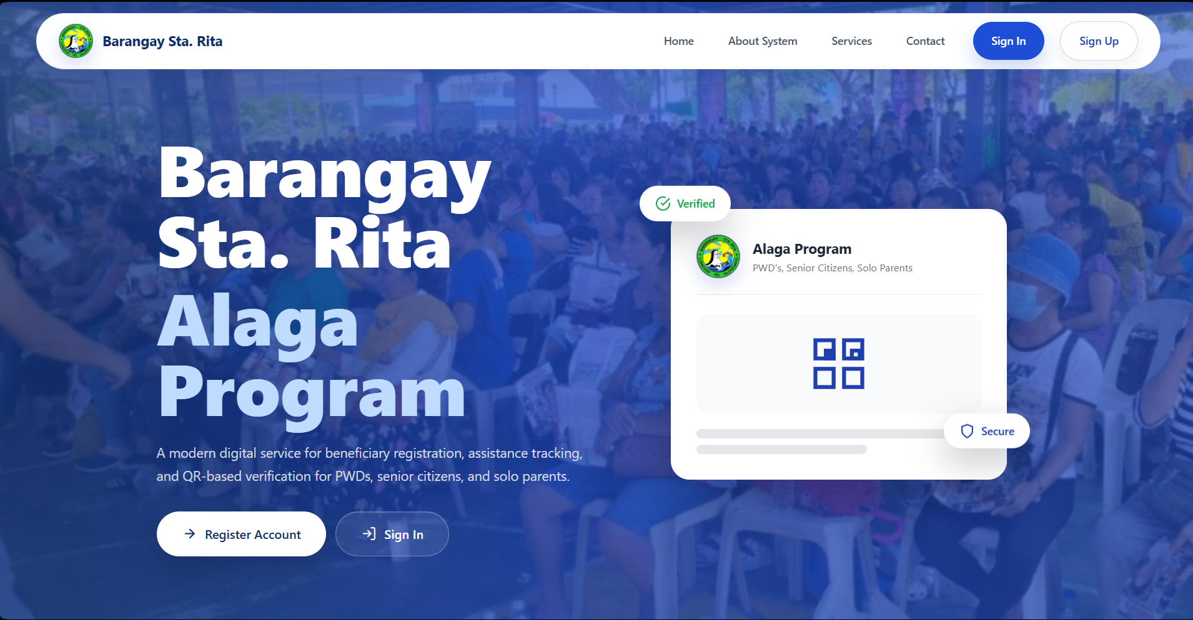
Figure 1: ALAGA Program Landing Page

Navigation and Notifications
On desktop, use the sidebar to open modules. On a phone or touch device, use the bottom navigation and More for additional pages, theme controls, notifications, and logout. The light/dark theme control changes the portal display preference.
Open the notification bell to review All or Unread notifications. Select an item to open its related page and mark it read, or select Mark all read. Notification delivery by SMS or email depends on the configured service; check the portal status if a message does not arrive.

User Roles and Access Levels
The system implements role-based access control to ensure data security and appropriate functionality for each user type. The following table summarizes the access permissions for each role:
Coordinators are PWD Coordinator, Senior Citizen Coordinator, or Solo Parent Coordinator. Access to beneficiaries, assistance records, verification, and reports follows the beneficiary's Primary Sector. Secondary-sector membership does not add access. Administration modules, beneficiary profile editing, password resets, and ID renewal decisions remain Admin-only.
Module | Admin | Staff /  Coordinator | Beneficiary | Description
Dashboard | Yes | Yes | Yes | Analytics and overview
Account Requests | Yes | No | N/A | Approve/archive signups
Beneficiaries | Yes | View assigned | Own only | Admin edits; coordinator views by Primary Sector
QR Verification | Yes | Yes | View own | Scan and verify QR IDs
Assistance Requests | Yes | Yes | Own only | Process assistance applications
Guidelines | Edit | View | N/A | Budgets and requirements
Reports | Yes | Scoped | No | PDF/XLSX; All Sectors is Admin-only
User Management | Yes | No | No | Manage admin/staff accounts
Renewal Requests | Yes | No | Submit own | Admin reviews updated ID
Activity Logs | All | Own  actions | Own  account | Read-only; Admin PDF export

Beneficiary Portal
The Beneficiary Portal is the primary interface for registered beneficiaries and their guardians. It provides self-service capabilities for managing assistance requests, viewing personal information, and accessing the digital QR ID card.

Beneficiary Sign Up
New beneficiaries must complete a multi-step registration process to create an account. The sign-up process is designed to collect all necessary information while guiding users through each step with clear instructions and validation.
The current sign-up order is Beneficiary Type, Personal Details, Address, Identity Verification, Account Setup, and Review & Submit. Earlier screenshots below illustrate the original screens; follow the updated step descriptions and current on-screen labels.
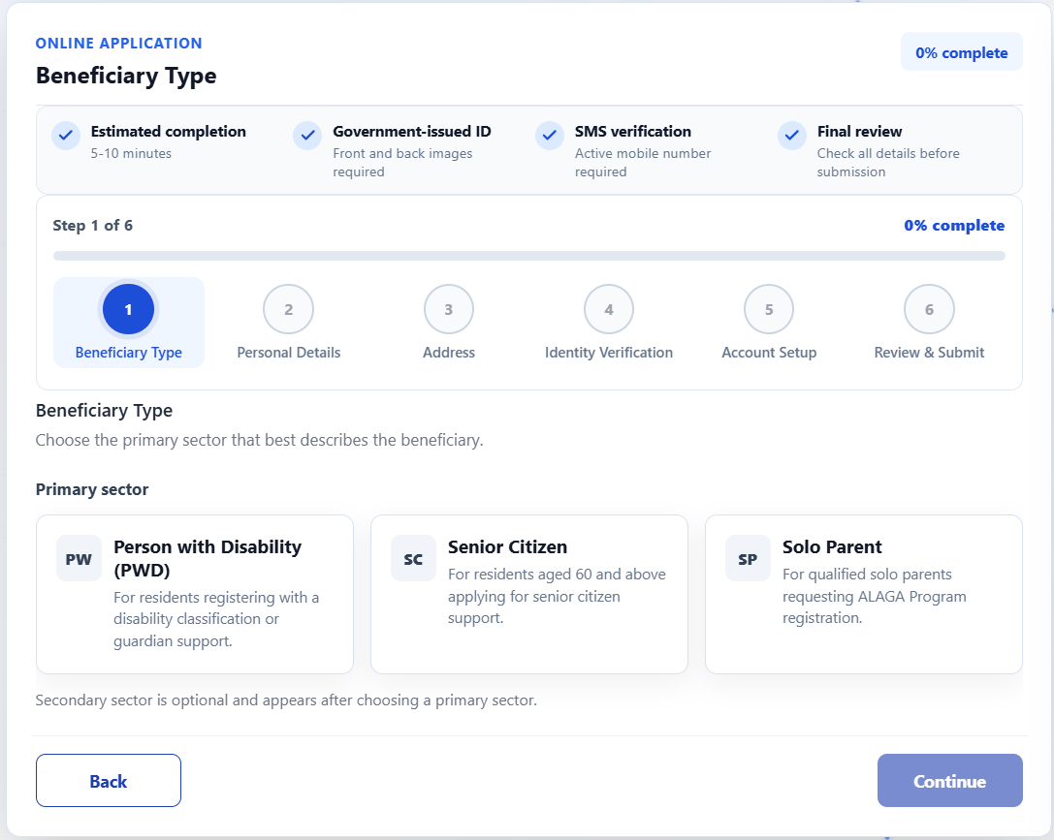
Step 1: Beneficiary Type - Choose one Primary Sector: PWD, Senior Citizen, or Solo Parent. If applicable, choose one different Secondary Sector from the available options. A beneficiary may have up to two sectors. The Primary Sector determines which coordinator can handle the record.
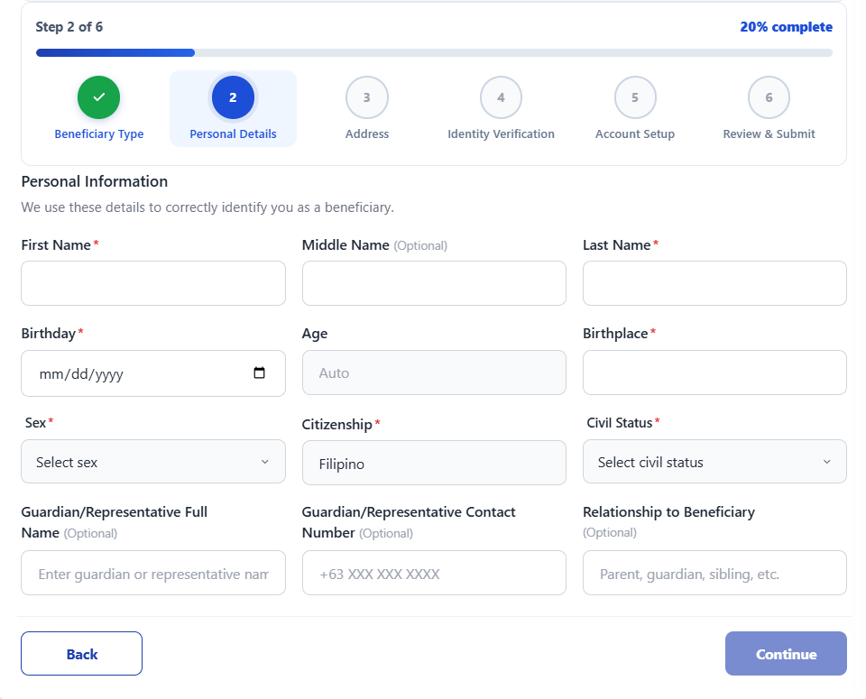

Figure 2: Sign Up - Personal Details
Step 2: Personal Details - Enter the beneficiary's full name, birthdate, birthplace, sex, civil status, and required personal details. Use the name and birthdate shown on the valid ID so the identity check can match them. Complete guardian or representative details when required.
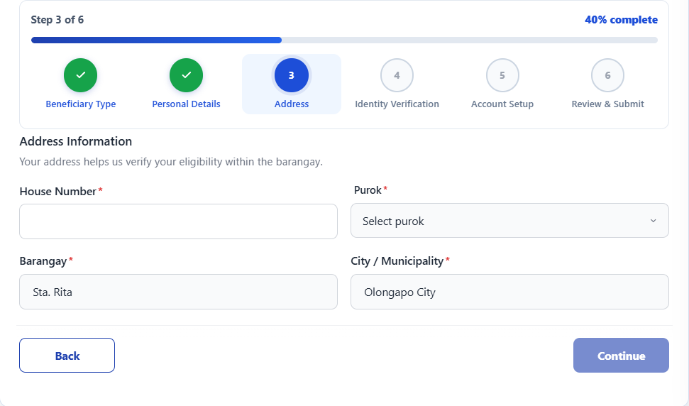
Figure 3: Sign Up - Address Information
Step 3: Address - Provide the house number and purok in Barangay Sta. Rita, Olongapo City. Enter the street when applicable and review the fixed barangay and city fields.
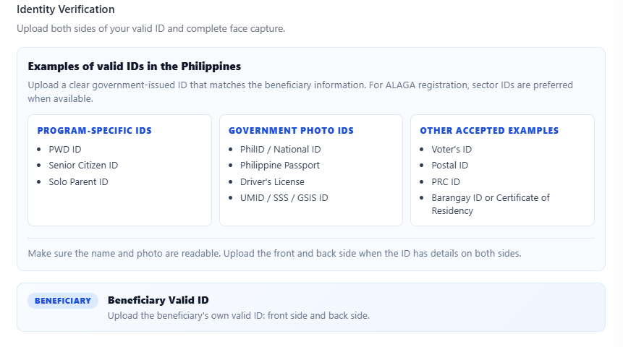
Figure 4: Sign Up - Identity Verification
Step 4: Identity Verification - Upload or photograph clear front and back images of a supported beneficiary ID. Wait for the system to read the ID and compare its type, name, and birthdate with Personal Details. After identity verification, allow camera access and complete the live selfie check.

Identity verification guidance: Keep all ID edges visible, avoid glare and blur, and ensure the text and portrait are readable. Correct mismatched personal details or replace the images when prompted. The live selfie must show the beneficiary. A face result marked for manual review will be reviewed by an administrator.
Step 5: Account Setup - Enter the beneficiary contact number and create and confirm a password of at least eight characters. Choose Contact number (SMS) or Gmail / Email code for account verification. Request a code, enter it, and complete verification before continuing. Email verification enables Google sign-in with the same linked account after approval.
Supported ID examples include PWD ID, Senior Citizen ID, Solo Parent ID, PhilID / National ID, Philippine Passport, Driver's License, UMID / SSS / GSIS ID, Voter's ID, and PRC ID. Follow the supported-ID guidance displayed on the form. Upload a separate guardian or representative valid ID when that field is required.
Step 6: Review & Submit - Review the sector pair, personal and address details, verification method, uploaded IDs, and selfie result. Read the privacy notice and terms, provide the required consent, and submit once. Wait for administrator approval before logging in.
Eligibility checks: Senior Citizen classification requires age 60 or above. Online applicants below 18 must be classified as PWD and use Single civil status. The form does not allow Married for Solo Parent classification. For a minor PWD, complete the guardian or representative name, contact, relationship, and ID. If representative details are optional, either leave them blank or complete the required set.

Beneficiary Login
Approved beneficiaries log in using their registered contact number and password. Use the password visibility toggle to check typing. Google sign-in is also available when the selected Google email is linked to an approved beneficiary account; it does not create or approve an account automatically.
After successful authentication, beneficiaries are redirected to their dashboard. If the account is still pending or needs correction, follow the displayed notice. If the linked email is not recognized, use the registered contact number or ask the barangay office for help. Sign in again when the session expires.

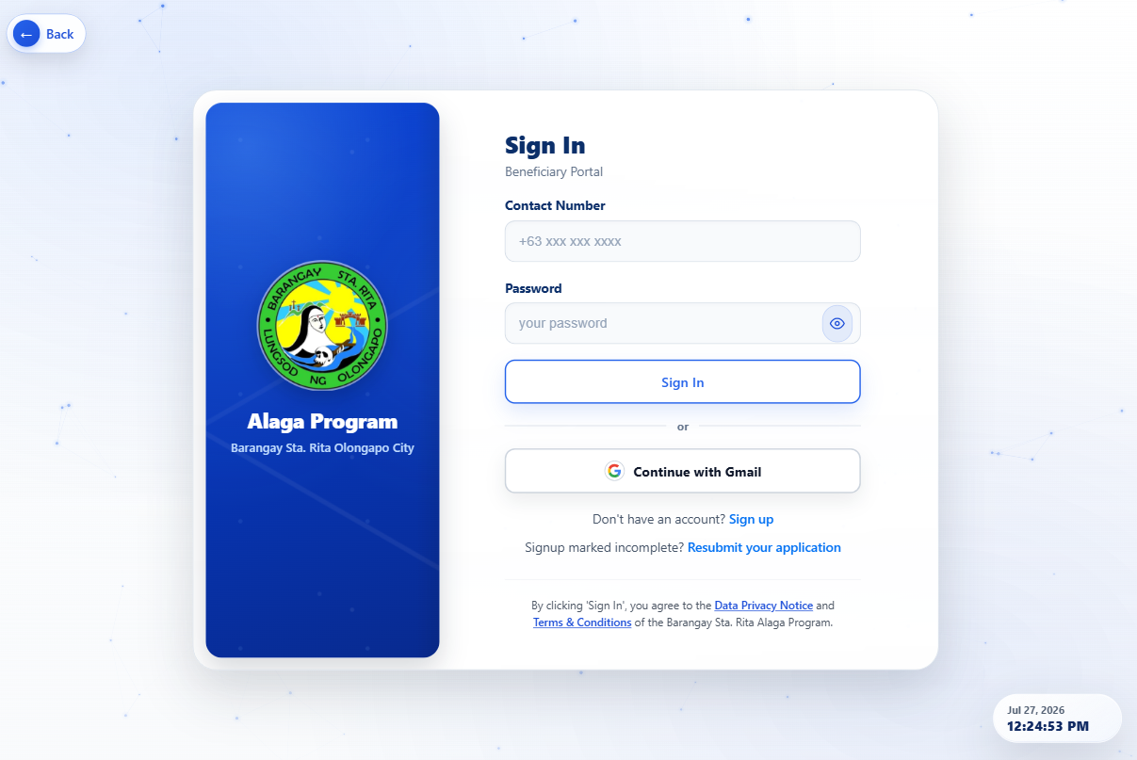
Figure 5: Beneficiary Sign In Page

Beneficiary Dashboard
The beneficiary dashboard provides an at-a-glance overview of the beneficiary's assistance request activity. KPI cards display total requests, active requests, completed requests, and incomplete requests.
The main dashboard area shows the current active request (if any) with its control number, type, status badge, and request date. Recent requests are listed below with quick access to details. Guidance cards provide helpful information about the process and next steps.
Action buttons enable quick navigation to create a new request, view request history, access profile information, or view the QR ID card.
The main action changes with your account state: New Request when eligible, Edit Incomplete Request when correction is needed, or Renew ID when ID renewal is required. Review the next eligible date and any active-request message before proceeding.
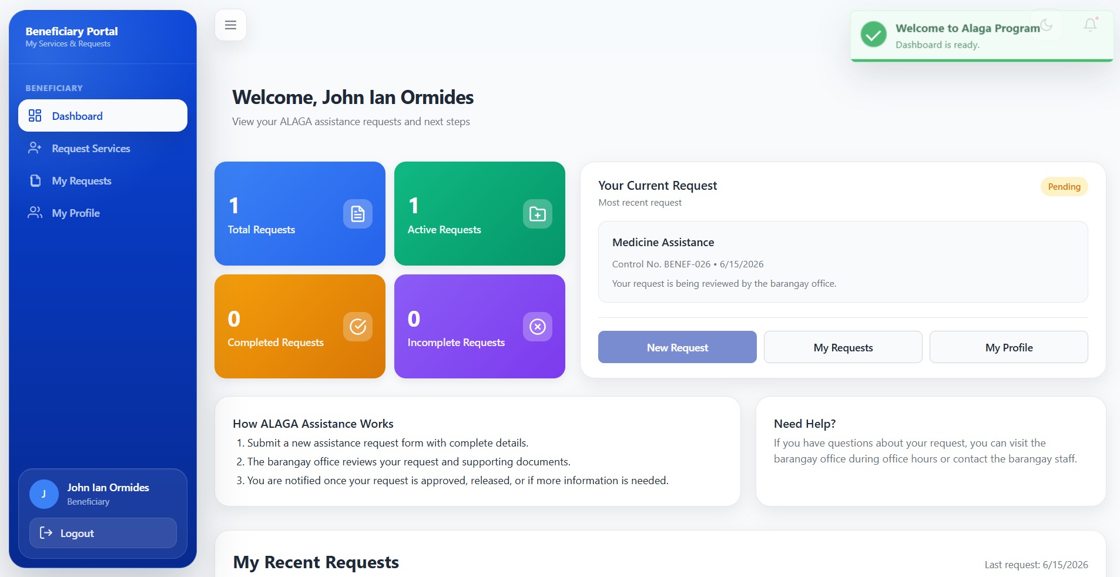
Figure 6: Beneficiary Dashboard Overview

Requesting Assistance
Beneficiaries can submit assistance through Request Services. Eligibility is checked for the beneficiary across all assistance types and both online and walk-in channels. Only one Pending, Resubmitted, or Approved request may be active at a time. After assistance is released, a three-month waiting period applies before another request can be created.
The five steps are Review Information, Assistance Type, Upload Documents, Requirements Checklist, and Review & Submit. Choose Medicine Assistance, Confinement Assistance, or Burial Assistance. The Budget Ceiling is filled automatically from the selected type and is read-only. Review the displayed requirements, upload the documents, check the completed requirements, and confirm the summary before submitting.
If the latest request is Incomplete or Rejected, edit and resubmit that existing request instead of creating another. Changing the assistance type or visiting the office does not bypass the active-request rule or the three-month waiting period. An Expired or Renewal Pending ID must complete renewal before assistance services are available.
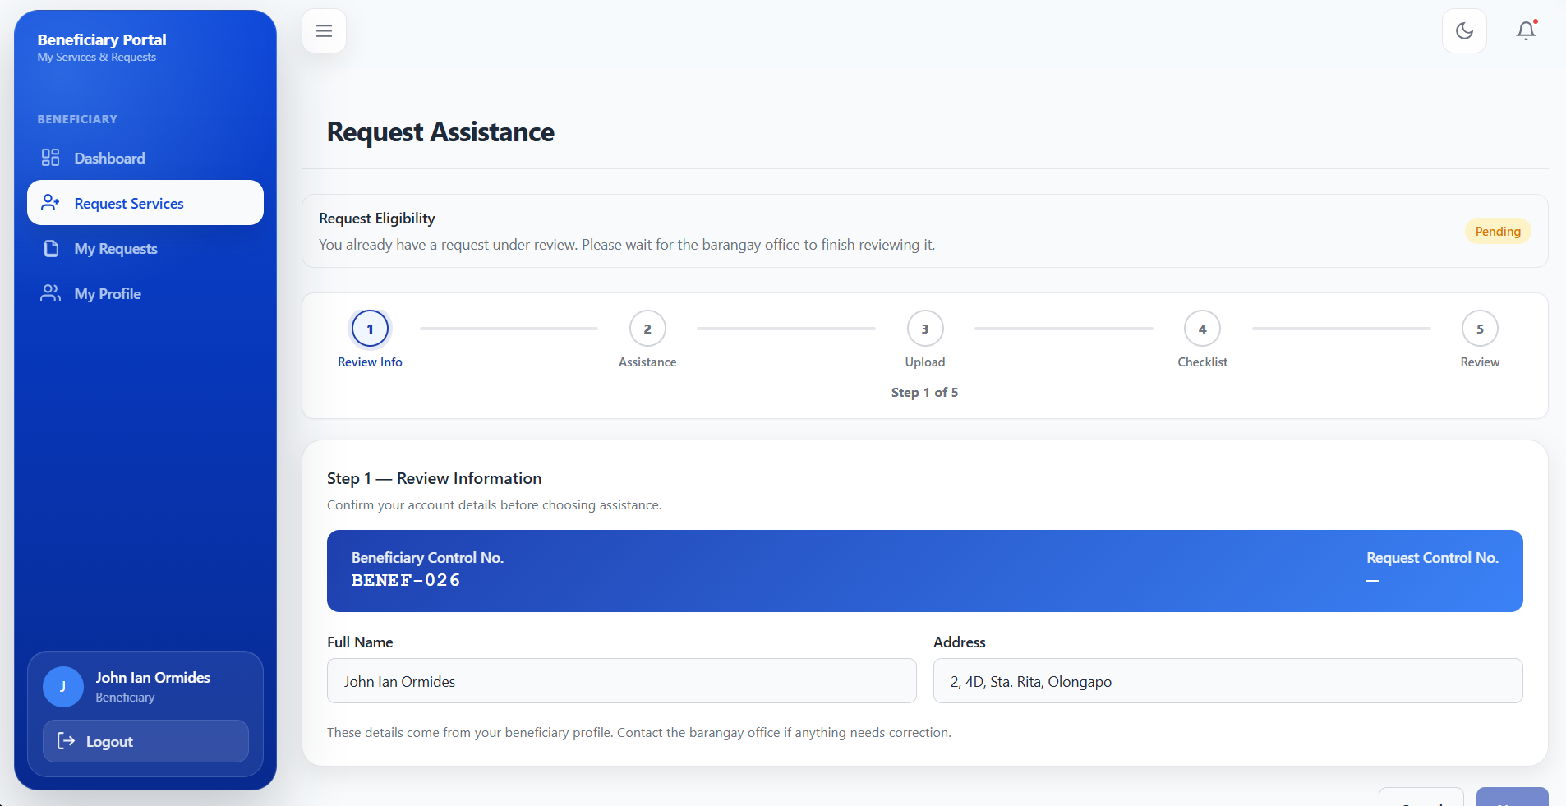
Figure 7: Assistance Request Form

Request History
The request history page displays all past and current assistance requests submitted by the beneficiary. Each entry shows the control number, assistance type, request date, requested amount, and current status.
Requests are shown as Pending, Resubmitted, Approved, Released, or Incomplete. Older Rejected records are treated as incomplete in the workflow. Open the request details to read decision remarks and review uploaded documents. Use Edit for a Pending, Resubmitted, or Incomplete request when available; approved and released requests cannot be edited by the beneficiary.
A cooldown notification banner appears when the beneficiary is not yet eligible to submit a new request, displaying the next eligible request date.
To correct a request, open My Requests, choose its details and Edit, read the remarks, replace missing or unsuitable requirement files, review the checklist, and submit again. Keep the existing control number for follow-up.
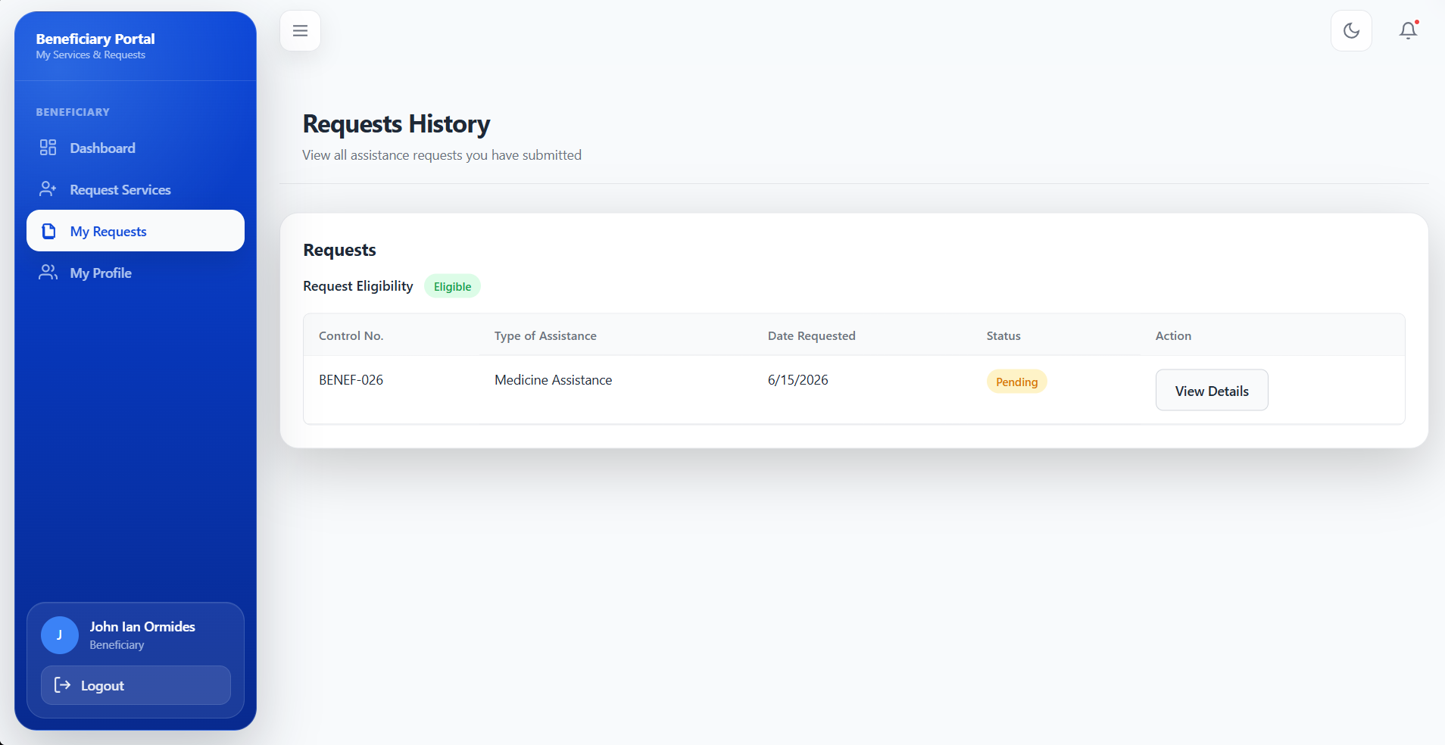
Figure 8: My Request History Page

Profile and QR ID
My Profile displays personal information, address, primary and secondary sectors, representative details when applicable, and the digital Beneficiary ID. Select View Actual ID to reveal the card and Hide Actual ID when finished. For a printed card, ask an administrator to use Print ID Card in Beneficiaries.
The QR ID card contains the beneficiary's name, control number, sector badges, QR code, issue date, and expiry date. This card serves as official identification when availing of barangay services and can be verified by admin staff using the QR Verification module.
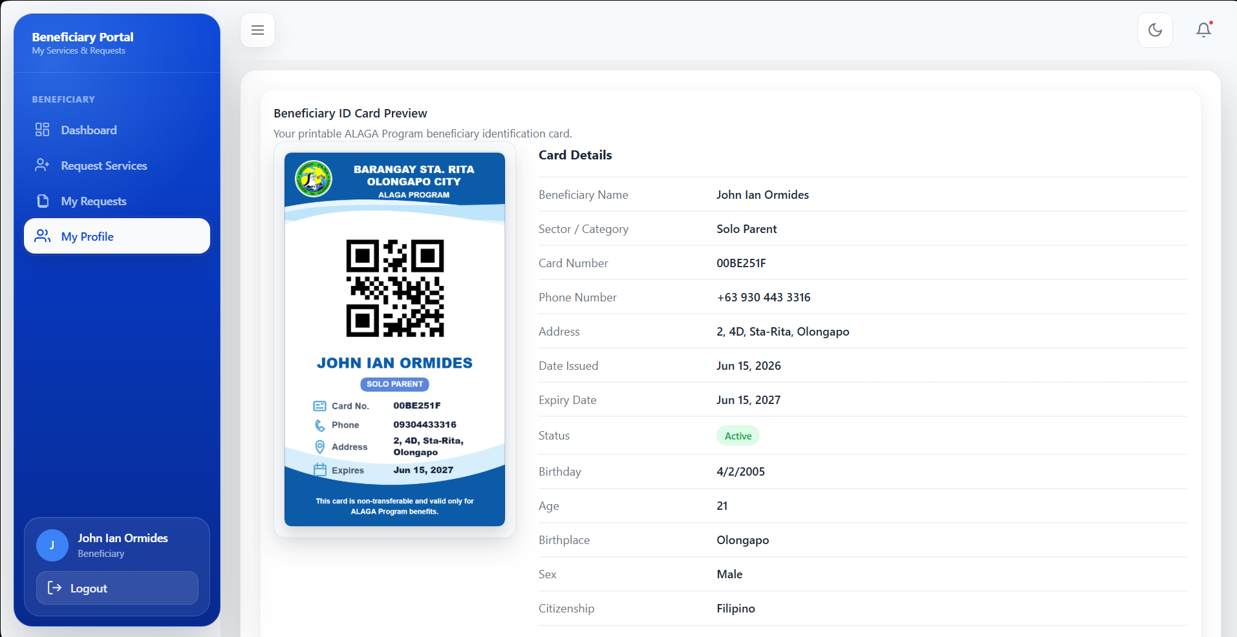
Figure 9: Beneficiary Profile and QR ID Card

Renewing Your Beneficiary ID
The ID status can be Active, Expiring Soon, Expired, or Renewal Pending. Expiring Soon begins within 30 days of expiry. Renew ID normally becomes available during the final seven days or after expiry. It is disabled while a renewal is Pending.
Step 1: Open My Profile and check the expiry date and latest renewal status. Select Renew ID when enabled.
Step 2: In Renew Beneficiary ID, upload the updated valid ID, add remarks if needed, and select Submit Renewal Request. Wait for the confirmation before leaving the page.
Step 3: Check Latest renewal and the administrator remarks. If Incomplete, select Renew ID again, provide the corrected document, and resubmit. If Approved, review the updated expiry date on the card.
While the ID is Expired or Renewal Pending, the portal keeps Dashboard, My Profile, and Activity Logs available, but restricts Request Services and My Requests. QR verification also treats Renewal Pending as invalid until the renewal is approved.

Correcting an Account Application
An Incomplete sign-up application must be corrected through Resubmit Account Request, rather than by creating a duplicate registration. Use the resubmission link or open /account-requests/resubmit and enter the eight-character code provided for your application.
Read the correction remarks, update the permitted personal, address, or sector fields, and provide the required front and back ID images and face capture. The original contact number remains fixed on this form. Complete the required consent and submit; the application becomes Resubmitted for administrator review.
If the code is invalid, already used, or was not delivered, ask the barangay office to check the application and send a new code. Successful resubmission still requires approval before login.

Beneficiary Activity Logs
Open Activity Logs to view recorded actions connected to your own beneficiary account, including relevant request decisions and ID renewal events. Search by action, description, or reference; optionally set Action, Date from, and Date to, then choose Apply Filters. Use Clear to remove filters and the page controls to browse results.
The audit trail is read-only. It displays the actor, role, action, description, reference, and date/time. Beneficiaries cannot see other beneficiaries' logs or download the administrator activity report.

Admin Portal
The Admin Portal provides comprehensive tools for barangay administrators and staff to manage beneficiaries, process assistance requests, verify IDs, and generate reports. The portal is accessible through a separate login with role-based permissions.

Admin Login
Administrators and staff members log in using their registered email/username and password. The admin login uses Supabase Auth for authentication with additional HMAC-signed session cookies for security.
Administrators and coordinators are redirected to the Analytics Dashboard after login. Account Requests, Renewal Requests, and User Management are Admin-only. Coordinators work with records whose Primary Sector matches their assigned role; a Secondary Sector does not grant another coordinator access.
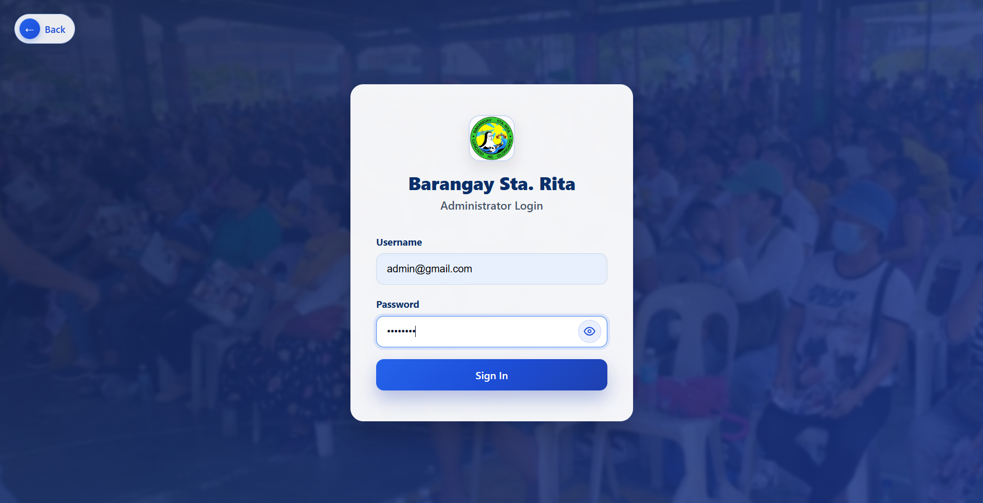
Figure 10: Administrator Login Page

Admin Dashboard
The Analytics Dashboard provides an overview through KPI cards, charts, and summary tables. The KPI cards show Total Beneficiaries, New Registrations, Active Request, and Released Assistance. Select a card to open its related module.
The dashboard features interactive charts including: registration trends over time (line chart), sector distribution (pie chart), and purok/demographic distribution (bar chart). Recent account requests and staff activity are also displayed for quick monitoring.
Filters allow customization by time period and trend month/year for more focused analysis.
Sector counts can overlap because a beneficiary may belong to two sectors. The dashboard also presents gender and age demographics. Coordinator totals and records follow assigned Primary Sector access.
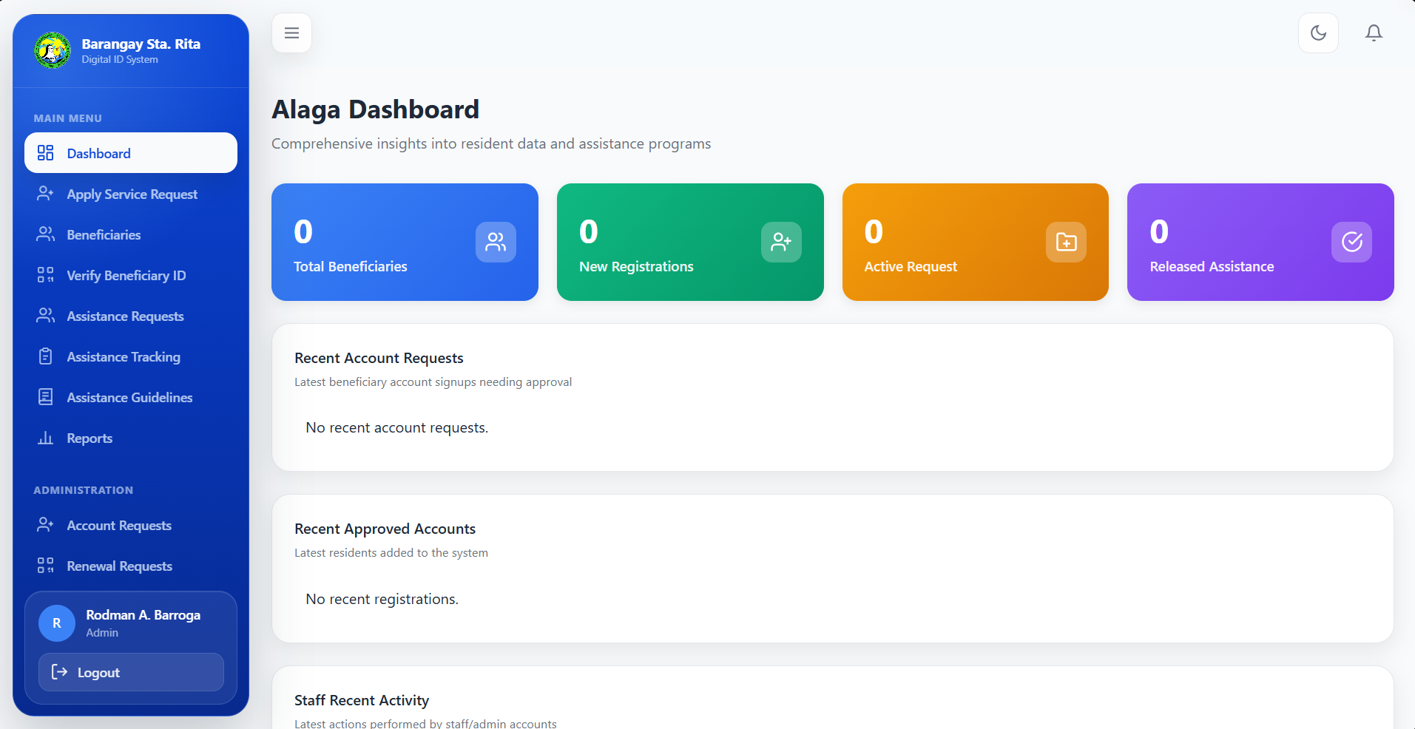
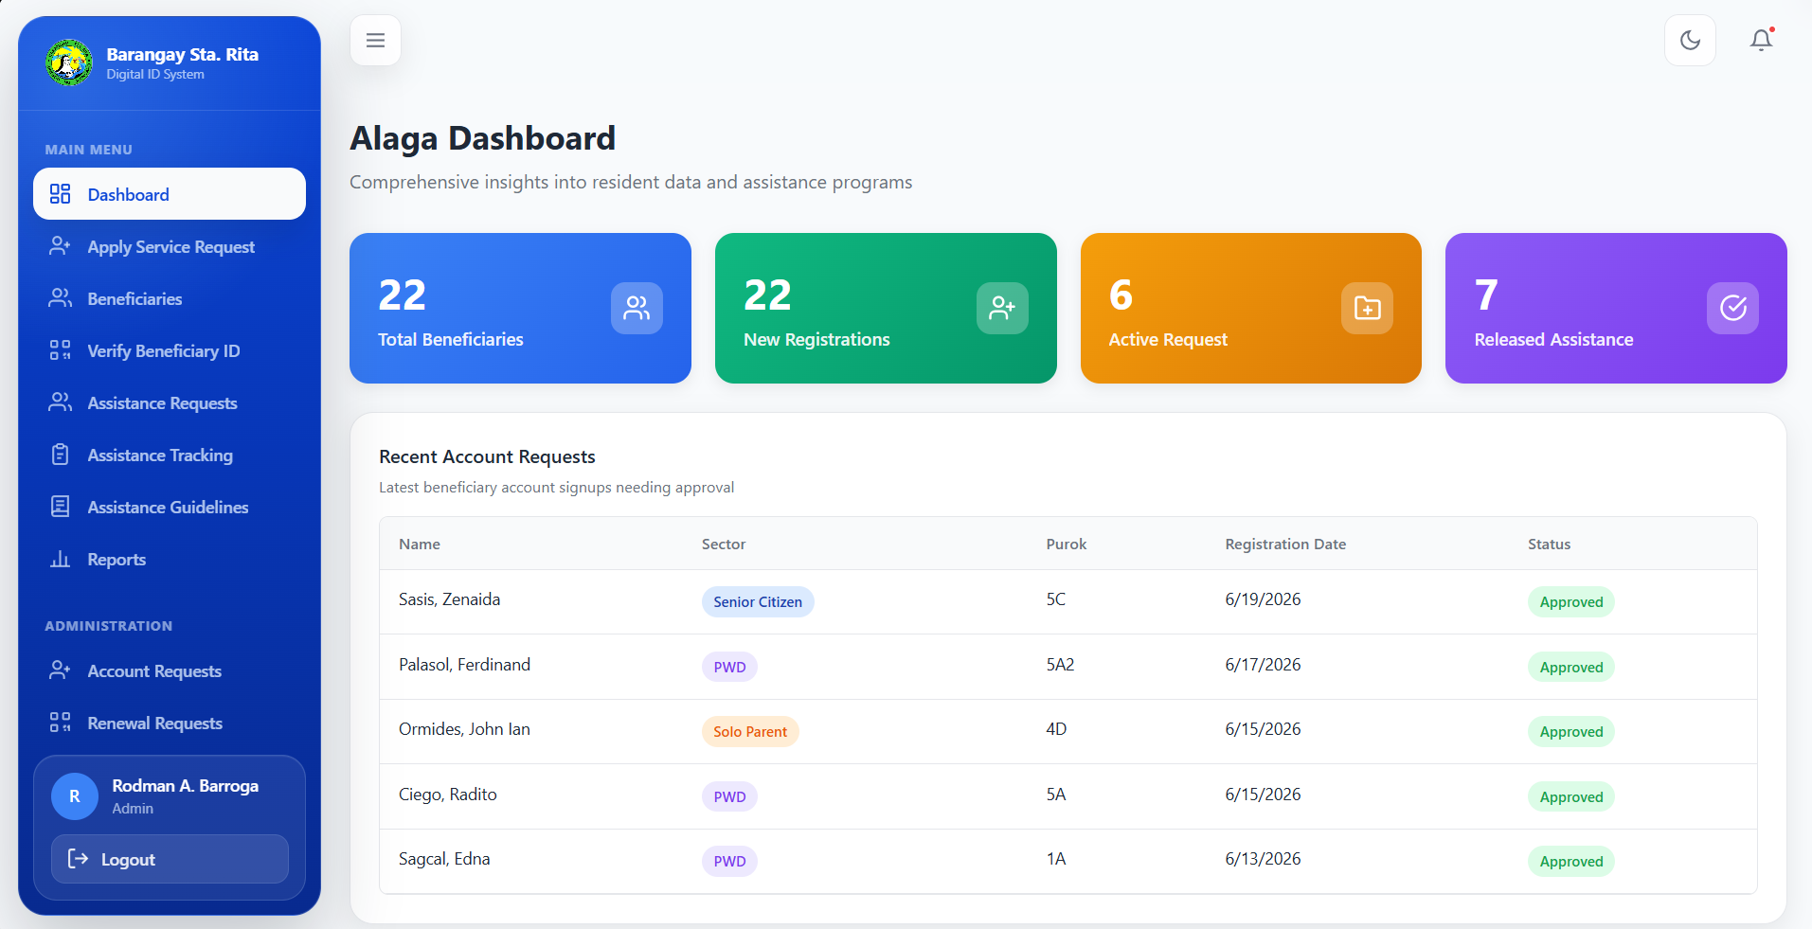
Figure 11: Admin Analytics Dashboard

Account Requests
The Account Requests module (Admin-only) displays online sign-up submissions. The status filter includes All Status, Pending, Resubmitted, Approved, and Incomplete. Older Archived or Rejected submissions are displayed as Incomplete.
Open the request details and review the personal information, primary and secondary sectors, front and back ID images, OCR identity result, selfie and face result, and representative ID when supplied. Approve a complete application or mark it Incomplete with clear correction remarks. Review any notification-delivery message after saving the decision.
Approval creates or links the beneficiary record with a unique control number and issues the Beneficiary ID. Marking an application Incomplete generates a resubmission code for correcting that same application. The applicant receives the code through the configured notification channel; administrators can resend it when needed.
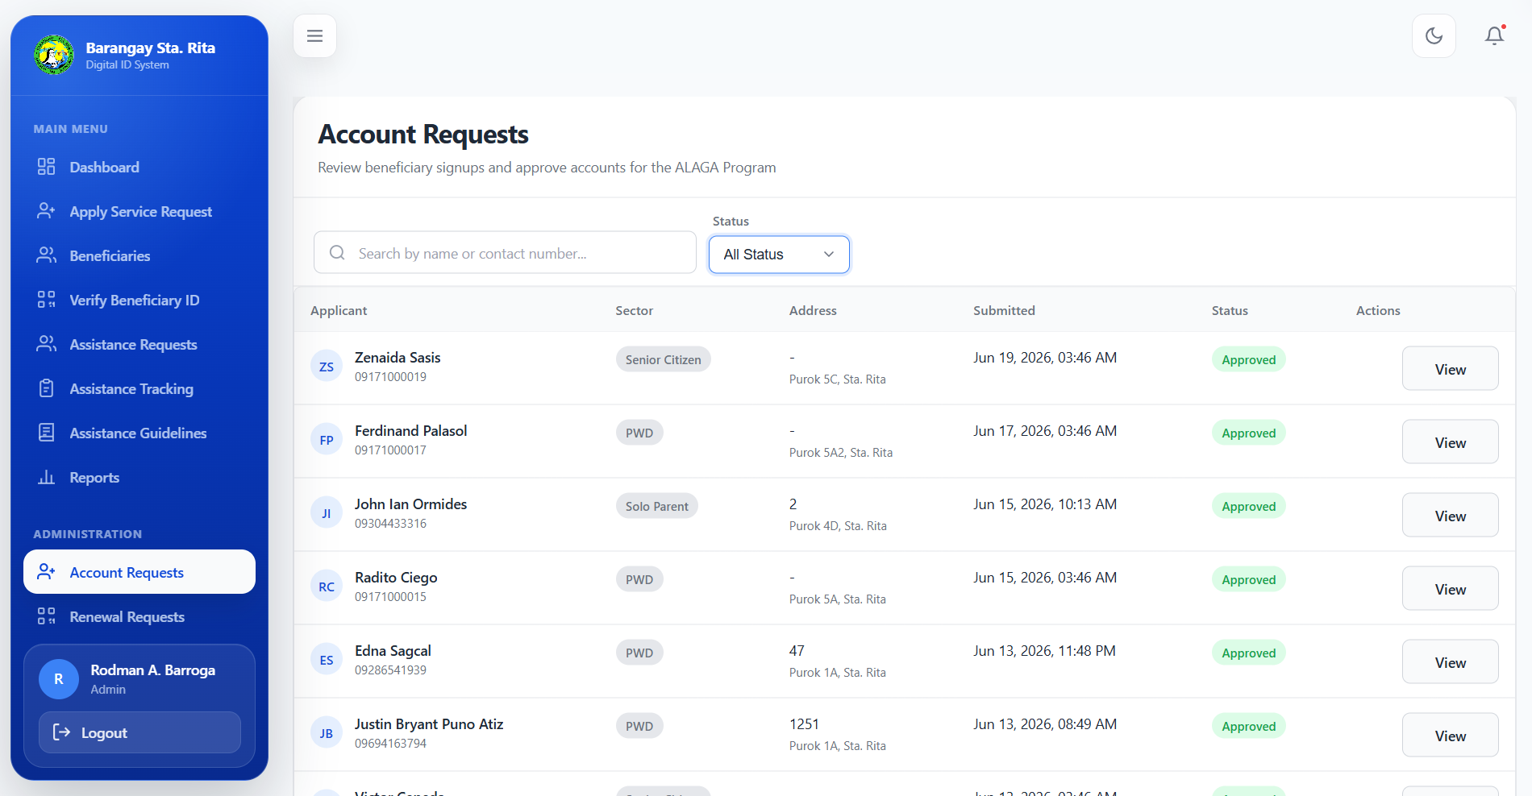
Figure 12: Account Requests Management Page

Walk-In Registration
The Walk-In Registration module allows admin staff to register beneficiaries in person at the barangay office. This module combines resident registration with an optional initial assistance request in a single streamlined form.
The Apply Service Request form collects personal information, contact details, a Primary Sector and optional Secondary Sector, beneficiary photo, registration requirements, and optional initial assistance details. For a new beneficiary, capture or upload the official photo and set a beneficiary account password of at least eight characters. Review all information before saving.
This feature is particularly useful for assisting elderly beneficiaries or those who may have difficulty with online registration.
For an existing beneficiary, search Beneficiaries first and open the available service-request action. The form loads that record for a new walk-in request, avoiding duplicate registration. Select the assistance type, check the auto-filled ceiling and requirements, provide representative details where needed, and review eligibility before saving. A coordinator can select only an allowed Primary Sector.
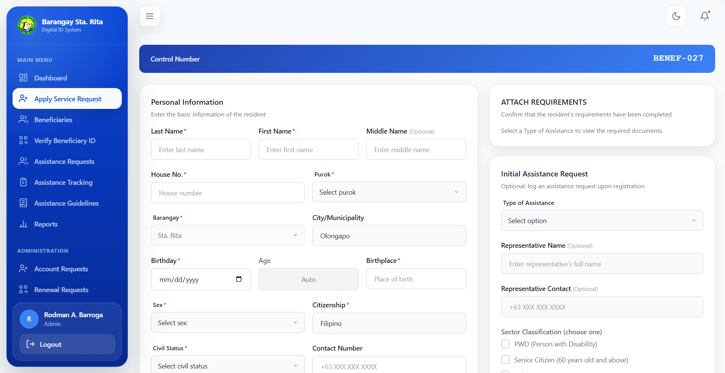
Figure 13: Walk-In Registration / Apply Service Page

Beneficiary Management
The Beneficiaries module provides a complete directory of all registered beneficiaries with powerful search and filtering capabilities. Filters include: status, registration type, sector, QR status, sort options, and keyword search.
Open a beneficiary to view details and assistance History within your access scope. Administrators can use Edit Profile and Reset Password after password verification, inspect online sign-up evidence, and print the existing ID. Renew ID Card opens the renewal workflow. Coordinators cannot edit beneficiary profiles, reset beneficiary passwords, or process ID renewals.
The table view is optimized for desktop, while a card view is available for mobile devices. Each beneficiary row displays their control number, name, sector, QR status, and eligibility indicators.
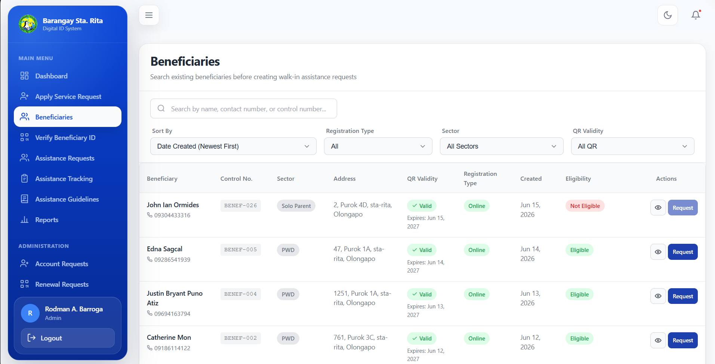
Figure 14: Beneficiary Management Page

QR Verification
The QR Verification module enables staff to quickly verify beneficiary identity using their QR ID card. Verification can be done either by manually entering the QR token or by scanning the QR code using a device camera.
Upon successful verification, the system displays: card validity status, complete beneficiary profile, sector classifications, representative information (if applicable), and the full history of released assistance for that beneficiary.
Camera controls include: scan activation, camera flipping (front/rear), and scanner close functionality. This module is essential for fast and accurate beneficiary identification during service delivery.
Read the displayed validity result before providing service: Active and Expiring Soon are valid states; Expired and Renewal Pending require renewal action. If camera access is denied, allow camera permission in the browser or use the manual QR-token field. Coordinators may verify only records within their permitted Primary Sector.
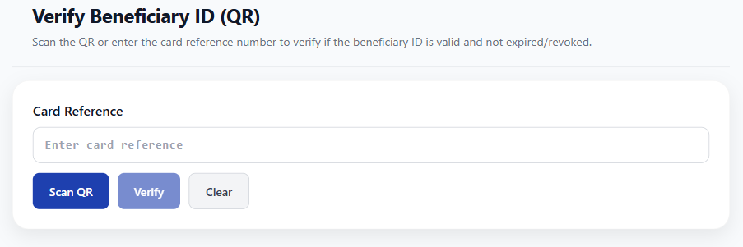
Figure 15: Verify Beneficiary ID Page

Assistance Requests
The Assistance Requests module processes online and walk-in applications. Summary cards and filters distinguish Pending/Resubmitted, Approved, Released, and Incomplete requests. Use the source, sector, and search controls available on the page to locate the application.
Open View Details, review the uploaded documents and requirements, then Approve or Mark incomplete. Add useful decision remarks so the beneficiary knows what to correct. Use Reopen for an incomplete application when appropriate. Use Mark as Released only after an approved request has been disbursed; approval alone is not release.
The normal status path is Pending (or Resubmitted) -> Approved -> Released. An application needing correction becomes Incomplete, then returns for review after editing and resubmission or reopening. An incomplete application is retained, not deleted. Notifications may be delivered through the configured services.
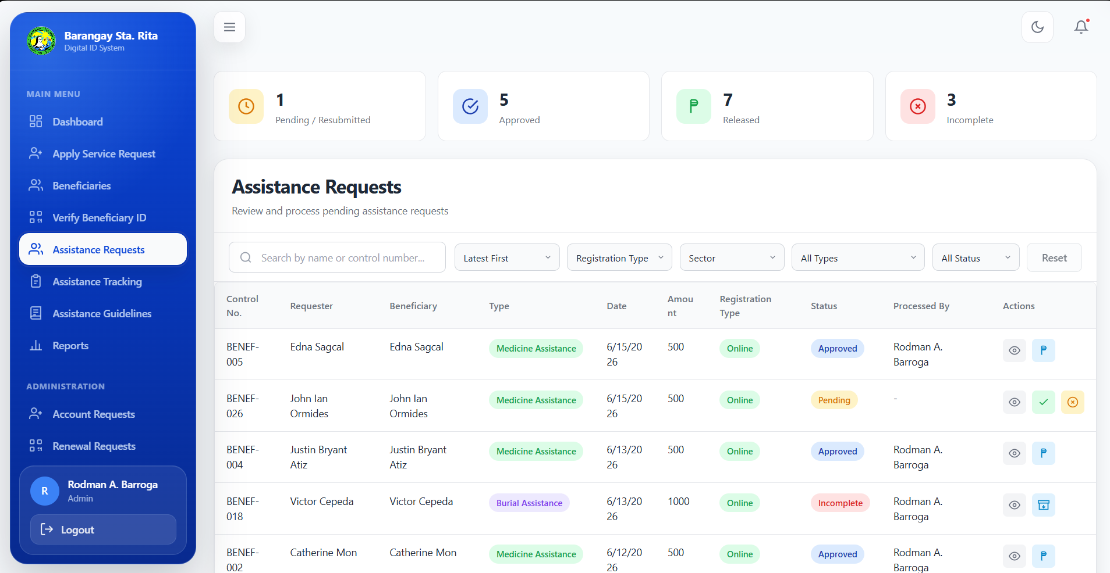
Figure 16: Assistance Requests Processing Page

Assistance Records
The Assistance Records module is labeled Assistance Tracking in the sidebar. It provides a read-only view of released assistance transactions for monitoring and reporting.
Records are filtered to show only released assistance, with eligibility badges, type/sector filters, and search functionality. A link to the Assistance Guidelines is provided for reference.
This page focuses on transparency and accountability, providing a complete historical record of all assistance provided through the ALAGA Program.
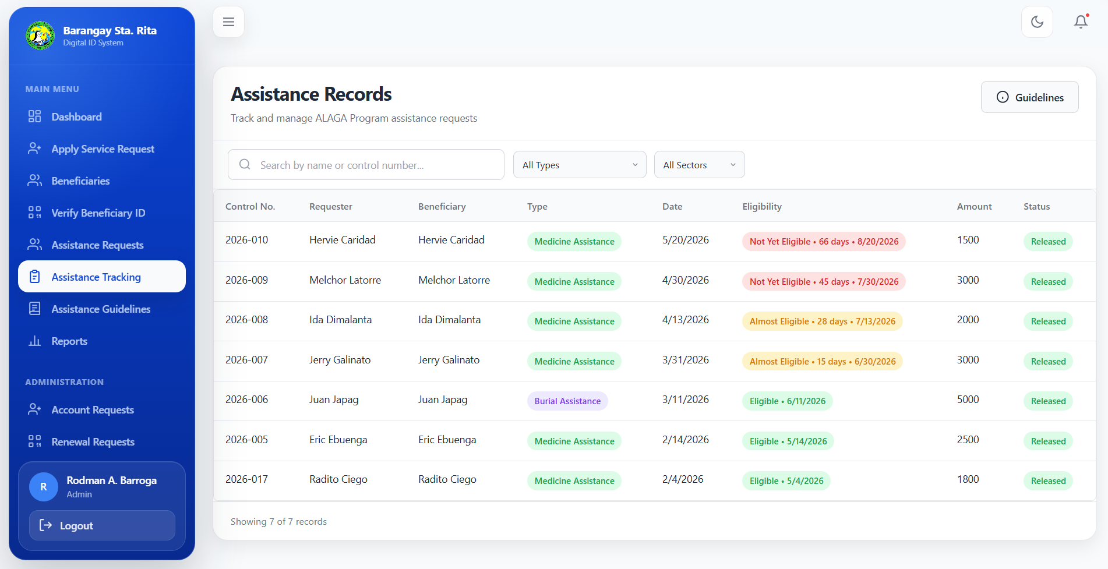
Figure 17: Released Assistance Records Page

Assistance Guidelines
The Assistance Guidelines module documents the requirements, budget ceilings, and process flow for each type of assistance offered through the ALAGA Program.
Admin users can edit budget ceilings and add, remove, or revise requirement items for Medicine Assistance, Confinement Assistance, and Burial Assistance. Coordinators have read-only access. Open the relevant edit control, enter the changes, and confirm the save.
Budget ceilings are validated to ensure non-negative amounts. The system rejects unchanged amounts to prevent unnecessary updates. Requirements are maintained per assistance type to ensure beneficiaries submit the correct documentation.
Use the requirements and budget currently displayed by the system. An administrator should review dated requirement wording before a new program period. After saving changes, verify the updated ceiling and checklist in the relevant assistance form.
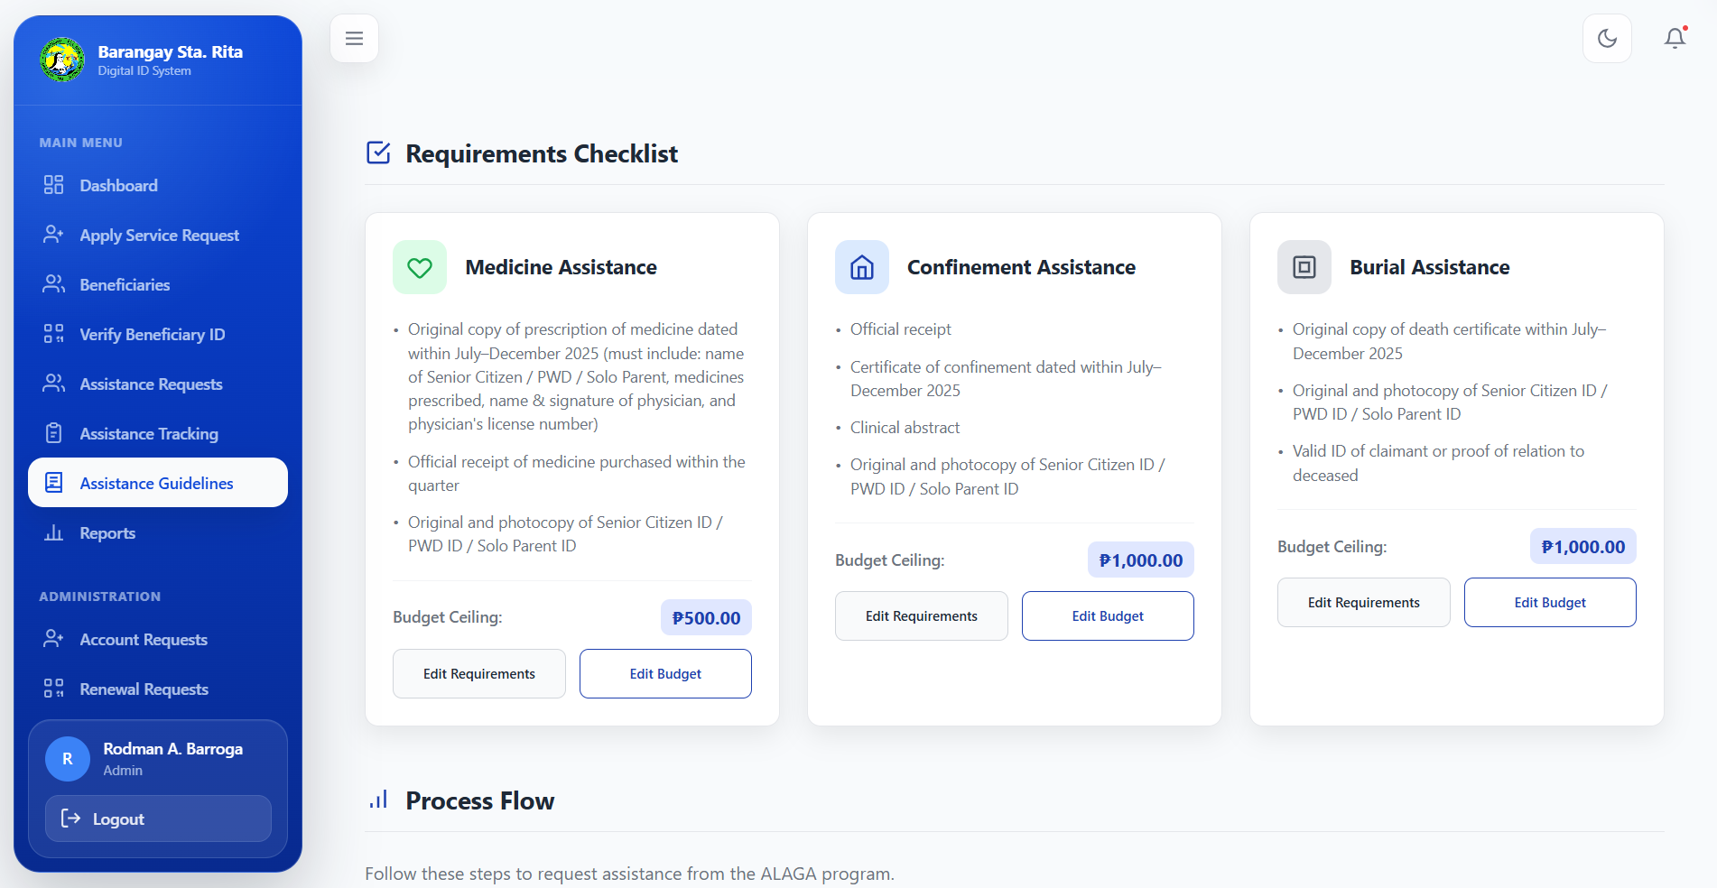
Figure 18: Assistance Guidelines and Budget Management

Reports Generation
The Reports module offers eight report types: PWD, Senior Citizens, Solo Parents, All Sectors, Eligible Beneficiaries, Not Yet Eligible Beneficiaries, Online Registration, and Walk-In Registration. The first four summarize released assistance; the others support eligibility monitoring and registration tracking.
Select a report card, set the Report Year (2000-2100), choose PDF or Excel/XLSX, and select Generate Report. All Sectors is Admin-only. Coordinators may generate their assigned-sector report and permitted eligibility or registration reports within their access scope. CSV is not an available export format in the updated system.
These reports are essential for barangay transparency, municipal reporting requirements, and program evaluation.
Eligible Beneficiaries lists active beneficiaries who can request assistance now. Not Yet Eligible Beneficiaries identifies records blocked by active or incomplete requests or the waiting period, with the applicable status and next eligible date. These are current eligibility views; registration and released-assistance reports use the selected report year.
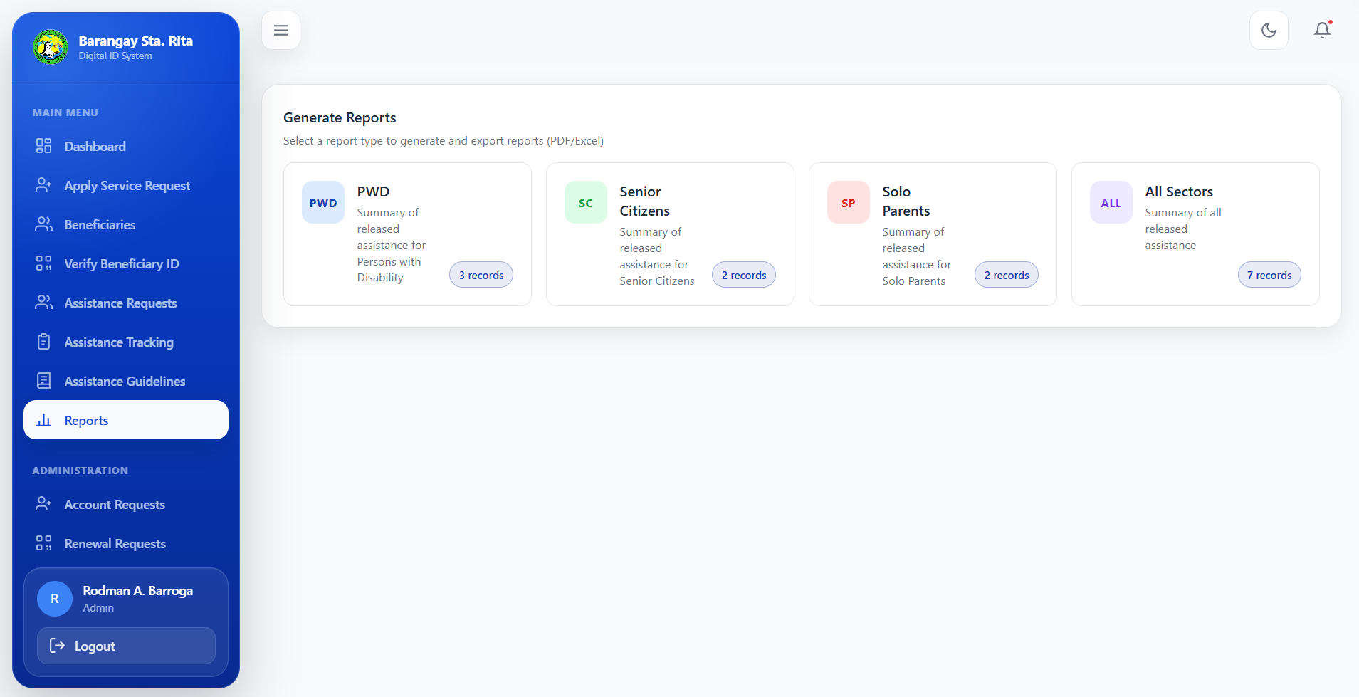
Figure 19: Generate Reports Page

User Management
The User Management module (Admin-only) provides tools for managing administrator and staff accounts. Admins can add new users, view account details, edit user information, activate/deactivate accounts, and reset passwords.
User creation requires a username, valid email, contact number, role, and initial password. Choose Admin, PWD Coordinator, Solo Parent Coordinator, or Senior Citizen Coordinator. Sector access is assigned automatically from the selected role. Existing generic Staff accounts remain supported; new accounts use the named roles. Password resets require password verification.
This module ensures proper governance of system access, allowing the barangay to maintain an appropriate number of active staff members with appropriate permissions.
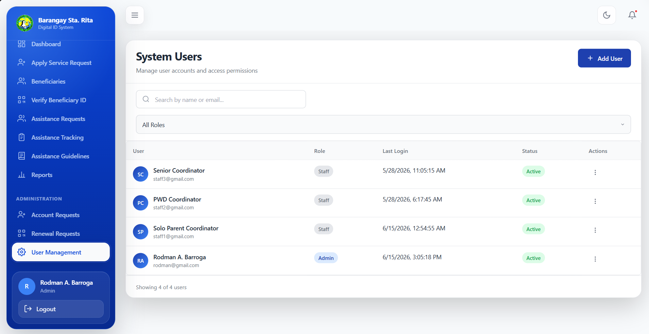
Figure 20: User Management Page (Admin Only)

Renewal Requests
The Renewal Requests module is Admin-only. It lists beneficiary requests to renew their Digital Beneficiary ID using an updated valid ID. Beneficiaries can normally apply during the final seven days before expiry or after expiry; an incomplete renewal can be corrected and resubmitted.
The page displays all submitted renewal applications organized by status tabs:
- All Status – Displays all renewal requests regardless of status.
- Pending – Renewal requests awaiting review.
- Incomplete – Requests requiring additional documents or corrections.
- Approved – Successfully approved renewal requests.
For each renewal request, the following information is displayed:
- Beneficiary Name and Control Number
- Current ID Expiration Date
- Renewal Request Status
- Uploaded Renewal Document
- Submission Date and Time
Administrators may perform the following actions:
- View Document – Review the uploaded identification or supporting document submitted by the beneficiary.
- Approve Renewal - Validate the uploaded ID and confirm approval. The system extends validity by one year from the later of the current expiry date or the approval date, updates the record, and returns the beneficiary to Active status.
- Mark as Incomplete - Return the renewal when the document is missing, unclear, expired, or invalid. Provide clear remarks describing the required correction. The beneficiary must replace or correct the submission and send it for review again.
Once approved, the beneficiary's Digital ID remains active with an updated expiration date, ensuring continued access to assistance services and QR-based verification.
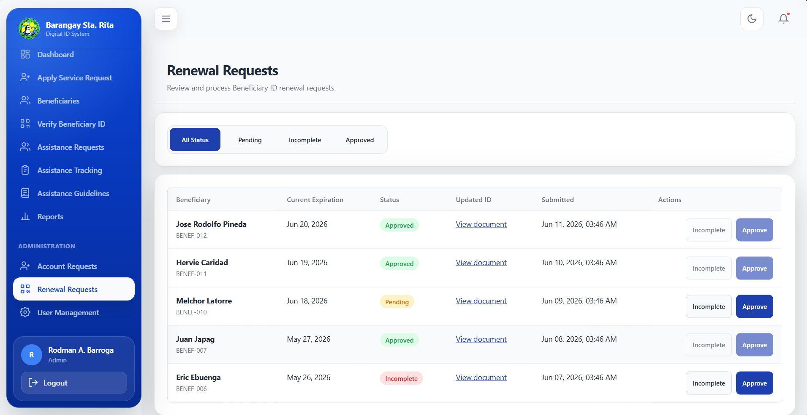
Figure 21: Renewal Requests Page

Activity Logs and Audit Reports
Open Activity Logs in the Admin Portal. Administrators can inspect system-wide recorded activities; coordinators can inspect only actions performed using their own staff account, even when they can access other beneficiary records in their sector.
Enter Search logs or Action and set Date from and Date to. Administrators can also filter by User and Role. Choose Apply Filters, then review the actor, action, description, reference, and date/time. Choose Clear to reset the search. Logs are read-only.
Administrators can choose Download PDF to save the filtered audit report or Print PDF to open it for printing. For a large result set, narrow the date range and filters; exports are limited to 5,000 matching entries. These audit reports are separate from assistance and registration reports.

Workflows and Processes

Beneficiary Workflow
The typical workflow for beneficiaries involves the following steps:
1. Online Registration: Select the primary and optional secondary sector, enter personal details and address, complete ID reading and live selfie verification, verify SMS or email, set a password, and submit with consent.
2. Account Approval: Wait for admin review and approval of your account request. You will receive notification upon approval.
3. Login: Use the registered contact number and password, or the linked Google account after approval.
4. Submit Assistance Request: Complete the request form with assistance type, required documents, and checklist confirmation.
5. Track Status: Monitor your request status through the dashboard and request history pages.
6. Edit/Resubmit if Needed: If your request is marked incomplete, make the necessary corrections and resubmit.
7. Receive Assistance: Once approved and released, receive your assistance at the barangay office.
8. Use QR ID: Present your QR ID card for quick verification during future barangay transactions.

Admin Workflow
The typical workflow for administrators involves:
1. Login: Access the Admin Portal using your credentials.
2. Review Dashboard: Check analytics, recent requests, and system activity.
3. Process Account Requests: Review identity evidence and approve or mark incomplete; provide correction remarks and a resubmission code when needed.
4. Manage Beneficiaries: Review records, update details when authorized, print existing IDs, and process ID renewal requests.
5. Process Assistance Requests: Review submitted documents, approve complete requests, or mark incomplete applications for correction.
6. Release Assistance: Mark approved requests as released after disbursement.
7. Maintain Guidelines: Update budget ceilings and requirements as needed.
8. Generate Reports: Create periodic reports for transparency and compliance.

Guardian/Representative Workflow
Guardians or representatives assisting beneficiaries can:
- Complete the beneficiary registration with the beneficiary's information and your separate guardian or representative fields. This does not create a separate guardian login.
- When representative fields are required or used, provide the full name, contact number, relationship, and required representative ID. A PWD beneficiary below 18 requires a guardian or representative.
- Enter representative contact information in its designated field and keep beneficiary account details accurate. Identity verification must use the beneficiary's ID and face; the representative ID is a separate upload.
- Help the beneficiary review decision remarks, provide corrections, track requests, and coordinate with the barangay office. Follow the assistance form's requester and beneficiary fields when acting for another person.

Security and Privacy

Authentication and Sessions
The system implements multiple layers of authentication security:
- Admin/Staff authentication uses Supabase Auth with email/password credentials plus HMAC-signed admin_session cookies.
- Beneficiary authentication uses the registered contact number and password, or a linked Google account, with a signed beneficiary session cookie. Passwords are stored as hashes, not readable passwords.
- Passwords are hashed using Node.js crypto scrypt algorithm with optional pepper for additional security.
- Session cookies are cryptographically signed to prevent tampering.
- Portal session cookies have a configured eight-hour lifetime. Sign in again when prompted after expiry, and use Logout on shared devices.

Data Privacy Features
The ALAGA Program system prioritizes beneficiary data privacy through the following measures:
- Privacy notice and terms of service are prominently displayed during login and sign-up processes.
- Document uploads are stored exclusively through Cloudinary with URL validation to prevent untrusted storage access.
- OTP codes are hashed, have expiration times, and attempt limits to prevent brute force attacks.
- QR card tokens are HMAC-signed and validated for expiry and revocation status.
- Row-Level Security (RLS) policies exist in the database schema, with server-side authorization as the primary enforcement layer.
- Beneficiaries can access only their own account information and permitted request actions. Profile corrections are handled by an administrator. Coordinators are restricted by Primary Sector; activity logs have a separate account-specific visibility rule.

Troubleshooting

Common Errors and Solutions
The following table lists common errors users may encounter and their recommended solutions:
Error Message | Solution
Invalid contact number or password | Verify your contact number is correct (11 digits starting with 09) and check your password. Use the show/hide toggle to verify.
Contact number must be 11 digits | Ensure your Philippine mobile number follows the format 09XXXXXXXXX.
OTP expired | Request a new OTP code. Codes are valid for a limited time period.
Session expired | Your session has expired. Sign in again and retry the action.
Account inactive | Ask the barangay office to check your account status. Pending sign-ups need approval; incomplete applications need correction before login.
Please upload at least one file | Ensure you have uploaded all required documents for your selected assistance type.
Only one active request allowed | Check My Requests. Wait for the active request to finish, or edit and resubmit an incomplete request. The same rule applies to walk-in requests.
3-month cooldown period | Wait until the next eligible date shown after the latest released assistance. Changing assistance type or submission channel does not reset the waiting period.
Valid ID is required | Upload clear front and back images of a supported beneficiary ID. Complete ID verification and live selfie capture; provide the separate representative ID when required.
ID details could not be verified | Check the name and birthdate against the ID. Retake both sides in clear light with all edges visible, then retry the identity check.
Camera or selfie check failed | Allow browser camera permission, use adequate light, and retake the beneficiary selfie. Follow manual-review guidance when shown.
Verification code not received | Check the contact number or email and the email spam folder. Wait for the resend control, request a new code, and enter the newest code.
Gmail not linked | Use the contact-number login or the Google email linked to the approved application. Pending or incomplete applications cannot log in yet.
Incomplete application or invalid resubmit code | Read the correction remarks and use the application resubmission page. Ask the office to resend a code if the existing code is invalid or already used.
Renew ID is disabled | Check whether renewal is Pending or whether the ID is outside the seven-day renewal window. Incomplete renewals can be corrected and resubmitted.
Services hidden after ID expiry | Open My Profile and complete renewal. Request Services and My Requests are restricted while the ID is Expired or Renewal Pending.
Record or report outside assigned sector | Check the beneficiary Primary Sector and your coordinator role. Ask an administrator to handle records outside your access; All Sectors reports are Admin-only.
Print window or PDF does not open | Allow pop-ups for the system and retry. Use Download PDF where available, or ask the administrator to print the ID.

ALAGA Program
Ako, Lolo at Lola, may Alaga
Barangay Sta. Rita, Olongapo City, Zambales
For support, contact the Barangay Sta. Rita ALAGA Program Office
Barangay Sta. Rita ALAGA Program Office, Olongapo City

