|  |
| --- |
| StatLine, A Division of MTF |
| 6400 S Fiddler’s Green Circle |
| Suite 300 |
| Greenwood Village, CO 80111 |
| Telephone 303 691-3363 |
| Toll Free 888 881-7828 |
| Fax 303 504-3161 |

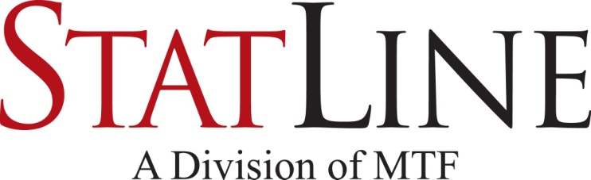

|  |
| --- |
| Facsimile Transmittal |

To: Fax:

From: Statline – Triage Date: October 26, 2016

Attn: Pages: 2

 Urgent  For Review 🞎 Please Comment 🞎 Please Reply 🞎 Please Recycle

**Donate Life California Organ & Tissue Donor Registry**

**Donor Registry Verification**

## DonateLifeCalifornia_bw**Document of Gift**

(Pursuant to SB 112, Chapter 405, 2003 Statutes and SB 689, Chapter 665, 2005 Statutes)

The deceased named below has completed a California Document of Gift authorized by state law. This is an authorization from the deceased for anatomical gifts to be made upon their death, if 18 years of age or older. This person documented their legally binding consent to donate organs, eyes, and tissues, unless otherwise indicated in the limitations section. A document of gift, not revoked by the donor before death, is irreversible and does not require the consent of any other person. It also authorizes any examination necessary to ensure the medical acceptability of the anatomical gift.

|  |  |  |  |
| --- | --- | --- | --- |
| Registration Information | | | |
|  |  |  |  |
| Date of birth: |  | Referral #: |  |
|  |  | Date of Registry activity: |  |
| Full Name: |  | Area: |  |
|  |  | Driver license #: |  |
|  |  | I.D. #: |  |
| Address: |  | Email address: |  |
|  |  |  |  |
| ***Signature section*** | | Limitations | |
|  | | I do NOT give consent for the following: | |
|  | |  | |
| I affirm that I am the applicant on this application and the information is true. | | Other Limitations: | |
|  | |  | |

I hereby give consent to release any information and reports pertaining to the evaluation, use, and follow-up of my donated organs and/or tissues to authorized personnel in order to determine the medical suitability and safety of these gifts. This information includes hospital records and post mortem examination reports.

Under the California Uniform Anatomical Gift Act, an anatomical gift not revoked by the donor before death is irrevocable and does not require consent or concurrence of any person after the donor's death. The law also authorizes any examination necessary to assure the medical acceptability of the anatomical gift.

In order to comply with my wishes, representatives from all organ and tissue procurement entities serving California are authorized to examine or remove copies of medical records, obtain blood and tissue samples to test for hepatitis, HIV, syphilis, and conduct any other examination to determine the medical suitability of the anatomical gift.

A different location may be needed to carry out the recovery of donated organs and tissues. In that case, my body may be transferred to an alternative surgical facility for the recovery of organs and tissues.