|  |
| --- |
| StatLine, A Division of MTF |
| 6400 S Fiddler’s Green Circle |
| Suite 300 |
| Greenwood Village, CO 80111 |
| Telephone 303 691-3363 |
| Toll Free 888 881-7828 |
| Fax 303 504-3161 |

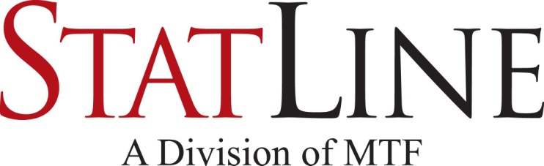

|  |
| --- |
| Facsimile Transmittal |

To: Fax:

From: Statline – Triage Date: February 19, 2019

Attn: Pages: 2

 Urgent  For Review 🞎 Please Comment 🞎 Please Reply 🞎 Please Recycle

Confidential

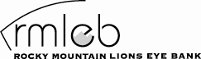

1675 Aurora Court

Mail Stop F751

Aurora, CO 80045

1-800-444-7479

Donor Registry Verification

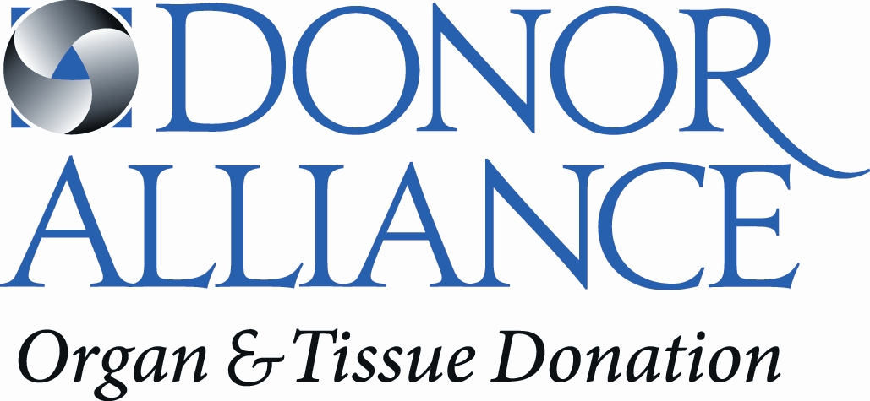200 Spruce Street

Suite 200

Denver, CO 80230

1-888-868-4747

Colorado: C.R.S. 15-19-204, 15-19-220

Wyoming: W.S. 35-5-204, 35-5-219

The person named below has listed himself/herself in the Donor Registry. This is a legal authorization to donate all eligible organs and tissues upon his/or her death for transplantation. **No other authorization or signature is necessary.**

|  |  |  |  |
| --- | --- | --- | --- |
| Driver’s License/ID number: |  | Renewal Date: |  |
| Full Name: |  |  |  |
| Date of Birth: |  | Source: |  |
| Residential Address: |  | Referral # |  |
| Exceptions: |  |  |  |

DISCLOSURES

* The gift of organs, heart for valves, skin, bone, soft tissue and vertebral segments is made to Donor Alliance*, a non-profit organization, or to the appropriate organ procurement organization or tissue bank, for the purpose of transplantation, therapy, research or education. The recovery, distribution, and determination of use of these donated gifts will be coordinated by Donor Alliance and/or its affiliated non-profit or for-profit agencies in accordance with current medical and ethical standards.
* The gift of eye tissue for the purpose of transplantation is made to the Rocky Mountain Lions Eye Bank*, a non-profit organization. The recovery, evaluation and distribution of these donated gifts will be coordinated by the Rocky Mountain Lions Eye Bank in accordance with current medical and ethical standards.
* Organs and tissues may be transplanted locally, regionally, nationally, or internationally.
* All costs associated with the recovery of donated tissues are the responsibility of Donor Alliance and/or the Rocky Mountain Lions Eye Bank. In making this gift the donor’s estate will not receive monetary compensation or valuable consideration for the gift.
* Donor Alliance and/or the Rocky Mountain Lions Eye Bank will make every effort to minimize any visual changes to the body and to minimize any delays in the funeral arrangements.
* A different location may be needed to carry out the recovery of donated organs and/or tissues. In that case, the body may be transferred to an alternative surgical facility at no cost to the family.
* Examinations or procedures will be necessary to ensure the medical suitability of donated organs and/or tissues, including, but not limited to testing for infectious diseases utilizing blood and/or appropriate tissues. Such samples may be archived for future testing. Medical information and other relevant records which may include photographic or other imaging records will be used to determine the medical suitability of donated organs and/or tissues. This information may be copied, released and/or reviewed by other appropriate parties to assist in making these determinations and as required by law or regulation.
* For more information or assistance regarding authorization for donation, please call (800) 448-4644 or (303) 321-0060.

*In the Wyoming counties of Sweetwater, Lincoln and Uinta, the recovery agencies are Intermountain Donor Services and the Utah Lions Eye Bank of Salt Lake City.

RMLEB PR-CONS-004-4

DA Form #: SD100.03.xx1

Revised February 28, 2019