|  |
| --- |
| StatLine, A Division of MTF |
| 6400 S Fiddler’s Green Circle |
| Suite 300 |
| Greenwood Village, CO 80111 |
| Telephone 303 691-3363 |
| Toll Free 888 881-7828 |
| Fax 303 504-3161 |

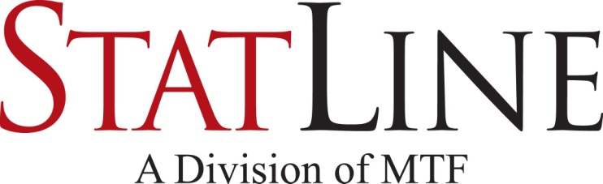

|  |
| --- |
| Facsimile Transmittal |

To: Fax:

From: Statline – Triage Date: February 25, 2014

Attn: Pages: 2

 Urgent  For Review 🞎 Please Comment 🞎 Please Reply 🞎 Please Recycle

Confidential Donor Registry Verification

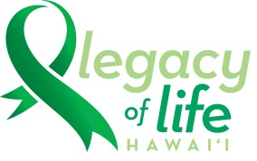 Donate Life Hawai’i Organ and Tissue Donor Registry 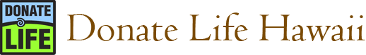

405 North Kuakini Street

Suite 810

Honolulu, HI 96817

# Document of Gift

Pursuant to Hawaii Revised Uniform Anatomical Gift Act [Hawaii Revised Statutes § 327]

The person below has listed himself/herself in the Donor Registry. This is a legal authorization to donate all eligible organs and tissues upon his/her death for transplantation. A document of gift, not revoked by the donor before death, is irreversible and does not require the authorization of any other person.

|  |  |  |  |
| --- | --- | --- | --- |
| Driver’s License/ID number  OR Registry ID number: |  | Date of Registry activity: |  |
| Full Name: |  | Referral # |  |
| Date of Birth: |  |  |  |
| Last known address: |  |  |  |
| Donor Comments: |  |  |  |

* The gift of organs, heart for valves, skin, bone, soft tissue, eyes/cornea, and saphenous veins is made to Legacy of Life Hawai’i, a non-profit organization. Legacy of Life Hawai’i in and/or its affiliated non-profit or for-profit agencies in accordance with current medical and ethical standards will coordinate the recovery, distribution, and determination of the use of these gifts.
* Local transplant recipients are the first priority for donated organs and/or tissues. If a suitable recipient cannot be found locally, organs and/or tissues may be transplanted elsewhere in the United States or internationally.
* All costs associated with recovery of donated organs and/or tissues are the responsibility of Legacy of Life Hawai’i.
* Legacy of Life Hawai’i will make every effort to minimize any visual changes to the donor’s body and to minimize any delays in the funeral arrangements.
* A different location may be needed to carry out the recovery of donated tissues. In that case, the body may be transferred to an alternative surgical facility at no cost to the family.
* Examinations or procedures will be necessary to ensure the medical suitability of donated organs and tissues, including but not limited to testing for transmissible diseases such as HIV, hepatitis, and cancer. In addition, medical information from hospital records, physician records, and autopsy results may be reviewed and copied to assist in determining suitability of donated tissues.