|  |
| --- |
| StatLine, A Division of MTF |
| 6400 S Fiddler’s Green Circle |
| Suite 300 |
| Greenwood Village, CO 80111 |
| Telephone 303 691-3363 |
| Toll Free 888 881-7828 |
| Fax 303 504-3161 |

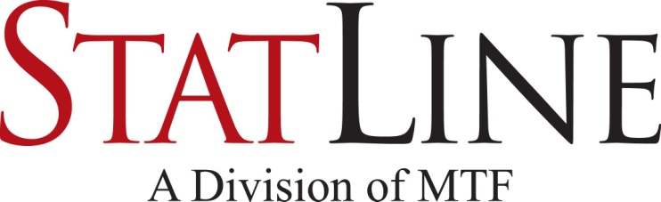

|  |
| --- |
| Facsimile Transmittal |

To: Fax:

From: Statline – Triage Date: February 21, 2017

Attn: Pages: 2

 Urgent  For Review 🞎 Please Comment 🞎 Please Reply 🞎 Please Recycle

**Donor Registry of Nebraska Verification**

The individual named below has registered to be included in the Donor Registry of Nebraska established by the Revised Uniform Anatomical Gift Act, Neb.Rev.Stat. §71-4824 et seq. This is an authorization for anatomical gifts to be used for transplant and therapy upon the donor's death.

**Driver’s License / ID Number:** **Renewal Date:**

**Full Name:** **Source:**

**Date of Birth:**

**Residential Address:**

**Restrictions:**

Anatomical gifts authorized by a donor before death do not require authorization by any other person. Upon joining Nebraska’s Donor Registry the donor acknowledged the following:

* Recovery of my donated organs and tissues may be conducted at surgical facilities designated by the organ and/or tissue recovery agency.
* The organ and/or tissue recovery agency will obtain and share with necessary entities that are involved in the donation and transplantation process copies of their complete medical record, emergency response records, coroner and autopsy reports, photographs and other imaging, and samples of my tissue, including but not limited to, spleen, lymph nodes and blood, as necessary for screening, archiving, and infectious disease testing to ensure medical suitability and compatibility for transplant. These results may be the basis for not using my organs and tissues for transplantation and/or therapy. Recovery agencies will access and release my medical information only as necessary or required by law or regulation.
* The organ and/or tissue recovery agency will make reasonable efforts to minimize any changes to my appearance or delay funeral arrangements. Recovery agencies will return my remains to my family or other authorized representative(s).
* Neither my next of kin nor my estate will receive monetary compensation or other valuable consideration for my gift.
* The organ and/or tissue recovery agency shall be responsible for those expenses directly related to the recovery and donation process. Recovery agencies will not reimburse medical or other expenses not directly related to recovery or donation.
* To achieve and maintain medical suitability for organ recovery, medications and procedures including but not limited to, heparin, vasodilators, blood products, central line placement and bronchoscopy may be necessary.
* Tissues may be used in reconstructive and/or cosmetic procedures.
* Not for profit and/or for profit organizations may be involved with facilitating my gift, including the possibility of organs and/or tissues being distributed and used internationally in accordance with accepted medical, legal and ethical standards.

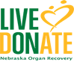 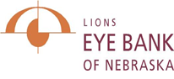

**Nebraska Organ Recovery System Lions Eye Bank of Nebraska   
 (800) 925-0215 (800) 225-7244**

NORS #__________ UNOS ID__________