|  |
| --- |
| StatLine, A Division of MTF |
| 6400 S Fiddler’s Green Circle |
| Suite 300 |
| Greenwood Village, CO 80111 |
| Telephone 303 691-3363 |
| Toll Free 888 881-7828 |
| Fax 303 504-3161 |

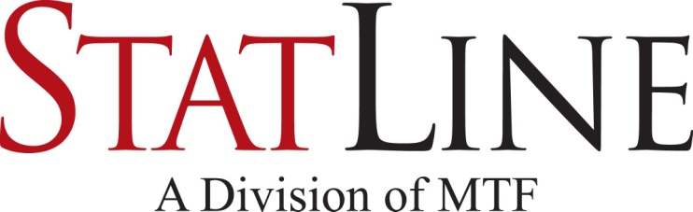

|  |
| --- |
| Facsimile Transmittal |

To: Fax:

From: Statline – Triage Date: October 19, 2016

Attn: Pages: 2

 Urgent  For Review 🞎 Please Comment 🞎 Please Reply 🞎 Please Recycle

Confidential Donor Registry Verification

Nevada: Pursuant to NRS 451.500et seq.

The deceased named below is listed in the Donor Registry. This is an authorization from the deceased for anatomical gifts to be made upon their death. A signature is not required.

|  |  |  |  |
| --- | --- | --- | --- |
| Driver’s License/ID number  OR Registry ID number: |  | Date of Registry activity: |  |
| Full Name: |  | Referral # |  |
| Date of Birth: |  |  |  |
| Last known address: |  |  |  |
| Donor Comments: |  |  |  |

Under the Nevada Revised Statutes, an anatomical gift not revoked by the donor before death is irrevocable and does not require consent or concurrence of any person after the donor’s death. The law also authorizes any examination necessary to assure the medical acceptability of the anatomical gift.

In order to comply with the wishes of this deceased, organ, tissue, and eye recovery agency representatives are authorized to examine or remove copies of medical records, obtain blood and tissue samples to test for hepatitis, HIV, syphilis, and conduct any other examination to determine the medical suitability of the anatomical gift.

A different location may be needed to carry out the recovery of donated tissues. In that case, the body may be transferred to an alternative surgical facility for the recovery of tissues.

The Registry will only accommodate restrictions or exclusions related to individual organs or tissues that can be removed for purposes of transplantation, medical education or research. Organs are distributed according to national regulations.

Donate Life Nevada is a collaboration of agencies committed to saving lives through organ, eye and tissue donation in Nevada. Member organizations include Nevada Donor Network, Donor Network West, Sierra Donor Services and Intermountain Donor Services. We are a proud affiliate of Donate Life America, a not-for-profit alliance committed to motivating the American public to register now as organ, eye, and tissue donors.

For further information, visit our website, www.DonateLifeNevada.org

# 

**Original (File in Medical Record)**