10..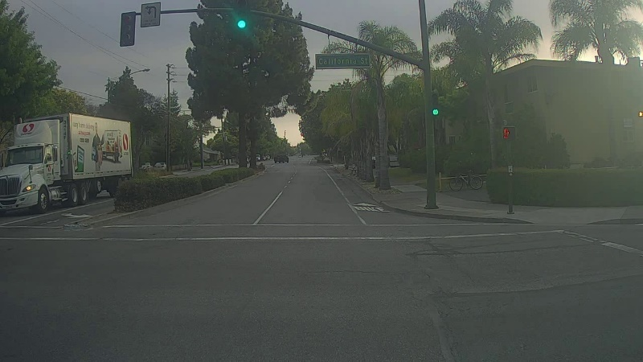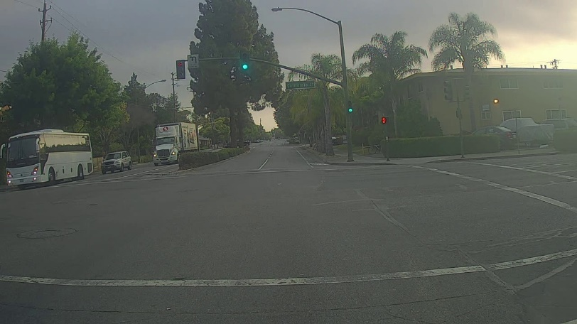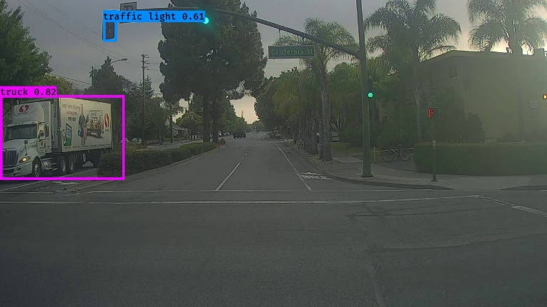

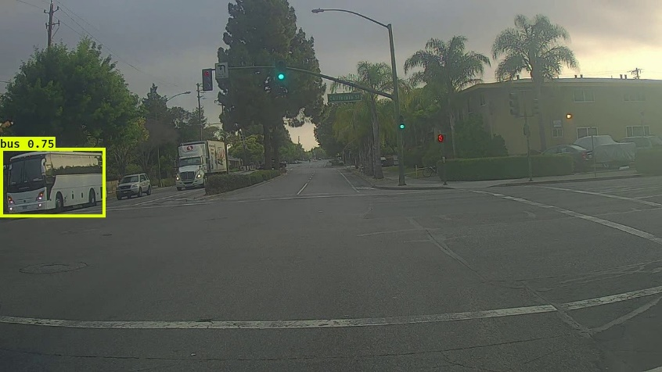

Correctly detected objects -2   
Incorrectly detected objects-0  
Undetected objects-2  
Incorrect bounding boxes-0

Correctly detected objects -1   
Incorrectly detected objects-0  
Undetected objects.-9  
Incorrect bounding boxes-0

# maxbox-01

11.

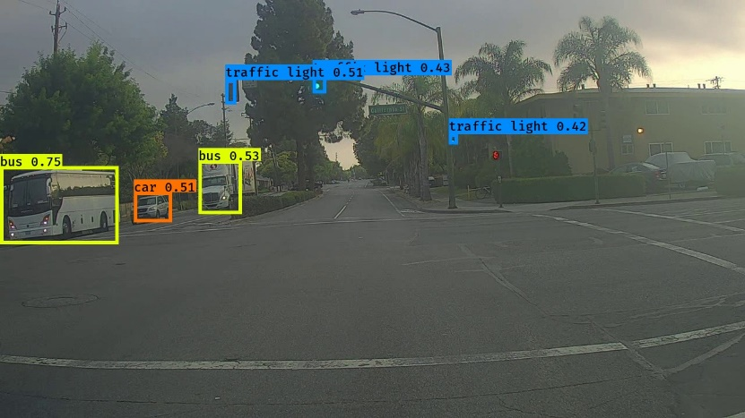

# score_threshold=.3

Correctly detected objects -1   
Incorrectly detected objects-0  
Undetected objects.-3  
Incorrect bounding boxes-0

Correctly detected objects -1   
Incorrectly detected objects-0  
Undetected objects.-9  
Incorrect bounding boxes-0

Correctly detected objects -5  
Incorrectly detected objects-1  
Undetected objects.-3  
Incorrect bounding boxes-0

Correctly detected objects -5   
Incorrectly detected objects-1  
Undetected objects.-3  
Incorrect bounding boxes-0

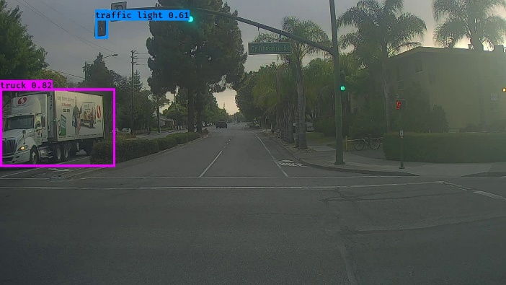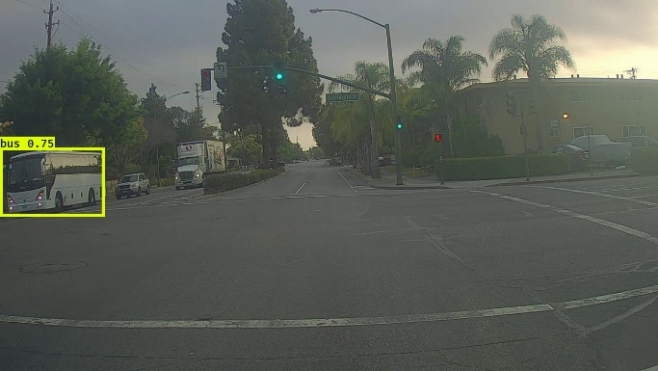

# iou_threshold=.3

Correctly detected objects -2  
Incorrectly detected objects-0  
Undetected objects.-8  
Incorrect bounding boxes-0

Correctly detected objects -1  
Incorrectly detected objects-0  
Undetected objects.-9  
Incorrect bounding boxes-0

7.

Max value-1805  
minimum value -7