{
"email":"test1@google.com",
"password":"Abc123"
}
http://localhost:3000/api/auth/login
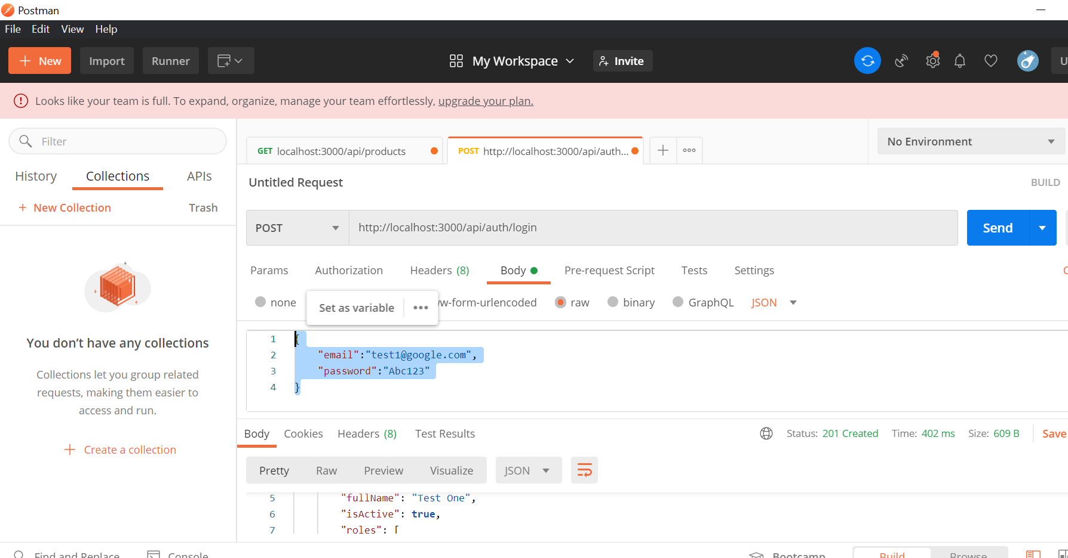
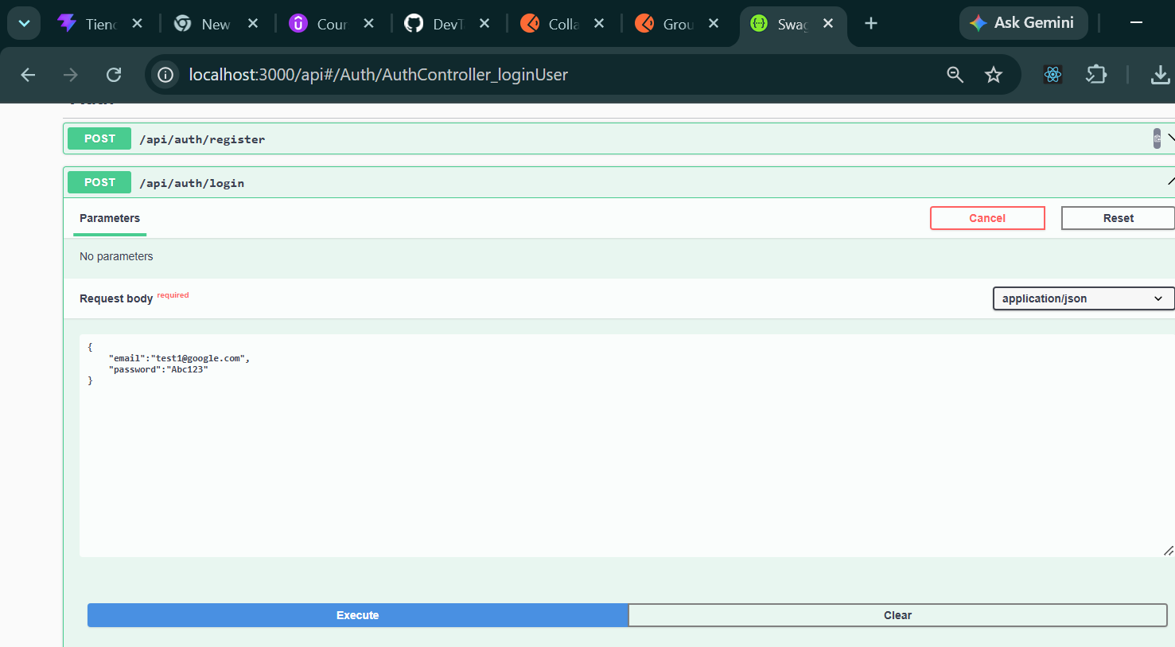

Registrar
{
"email":"jomr10@hotmail.com",
"password":"Abc123",
"fullName": "janier machado"
}
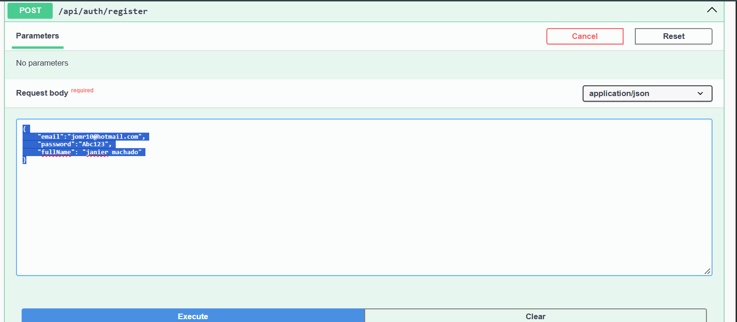
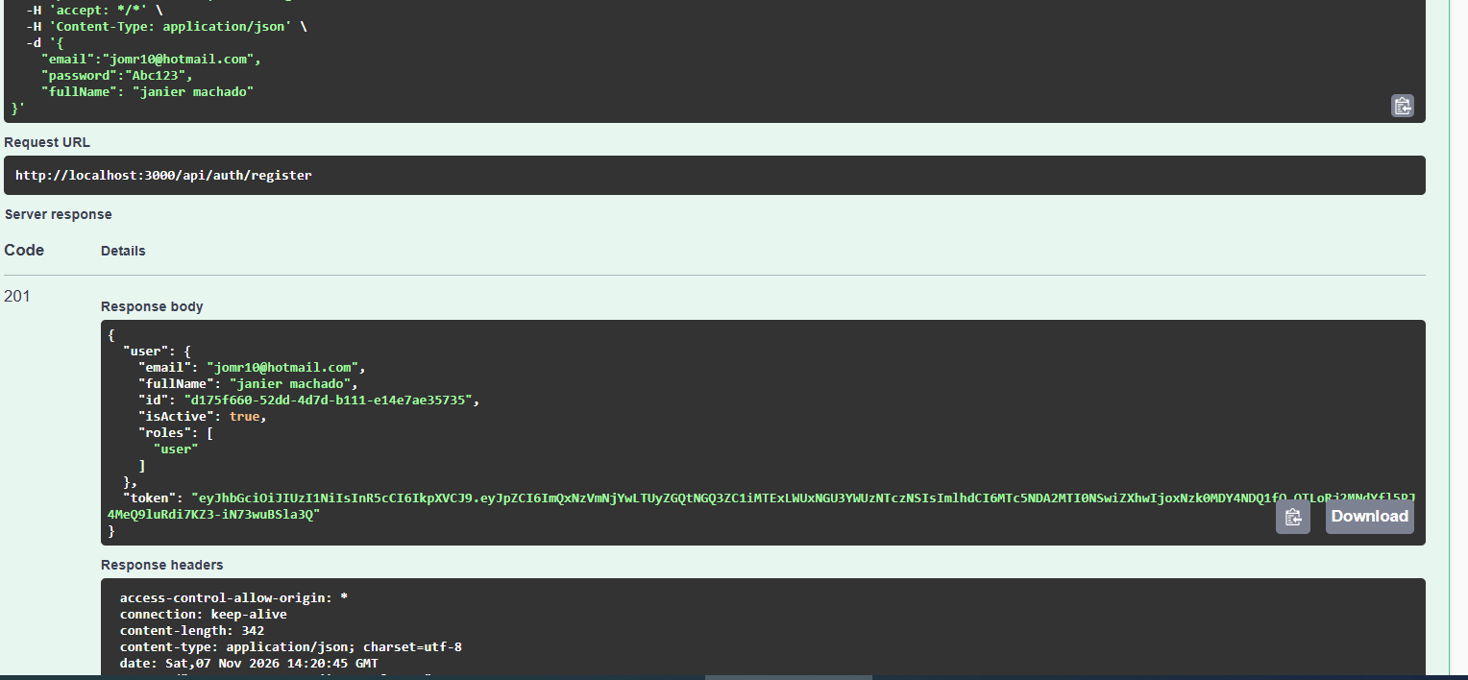

http://localhost:3000/api/auth/check-status


