Task 2: Basic Wireshark Traffic Capture & Analysis Report

(JANIE.V – AIML B , 2nd Year)

1. Overview of Protocols Identified
- ARP (Address Resolution Protocol): Resolves Layer 3 IP addresses to Layer 2 physical MAC addresses on the local network. In the capture, request packets ask "Who has 10.235.137.222? Tell 10.235.137.58" followed by ARP responses stating "10.235.137.222 is at 66:a8:91:48:d0:27".
- DNS (Domain Name System): Resolves human-readable domain names into IP addresses over UDP Port 53. Standard queries (A and AAAA records) were sent from host 10.235.137.222 to gateway 10.235.137.58 for domains such as play.google.com and acrobat.adobe.com.
- HTTP (Hypertext Transfer Protocol): Unencrypted application-layer web protocol operating over Port 80. The capture shows cleartext GET requests sent to download system update files without encryption.
- TCP / TLS (Transmission Control Protocol / Transport Layer Security): TCP manages reliable, connection-oriented data delivery via handshakes (SYN, SYN-ACK, ACK). TLS operates over TCP Port 443 to encrypt application traffic following Client Hello and Server Hello certificate exchanges.

2. Screenshot Proofs

Screenshot 1: DNS Traffic Capture

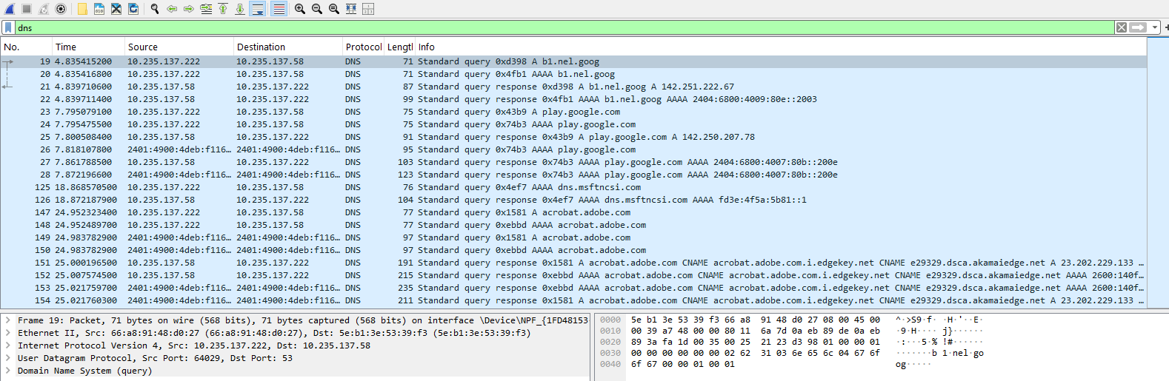

Screenshot 2: HTTP Plain-Text Capture

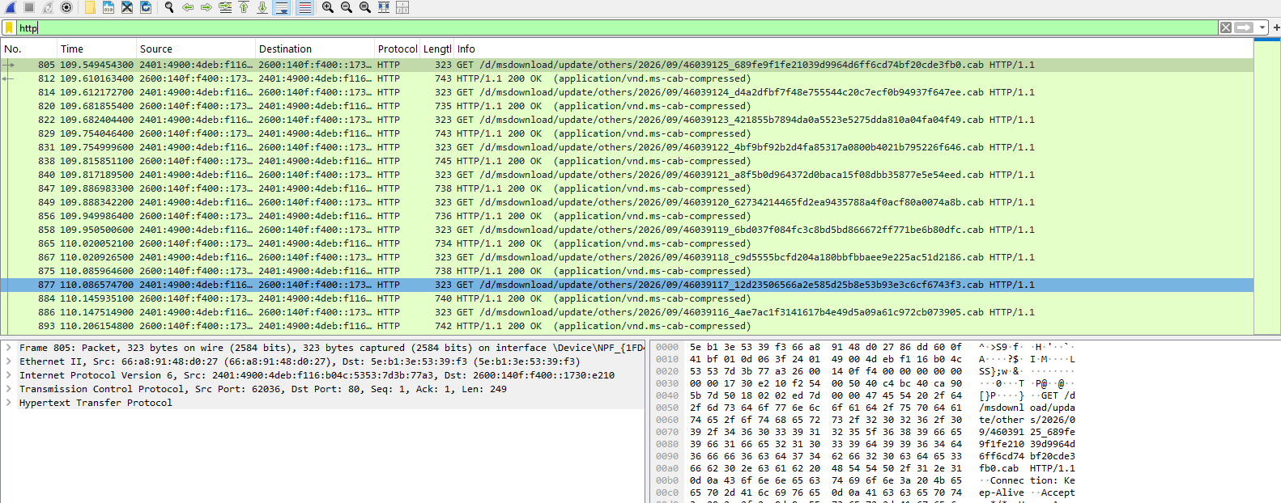

Screenshot 3: TCP & TLS Session Traffic

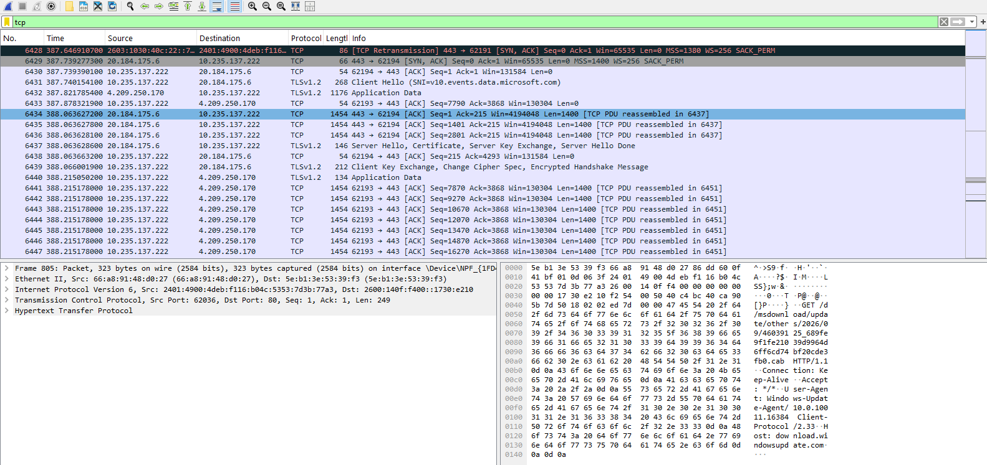

Screenshot 4: ARP Protocol Overview

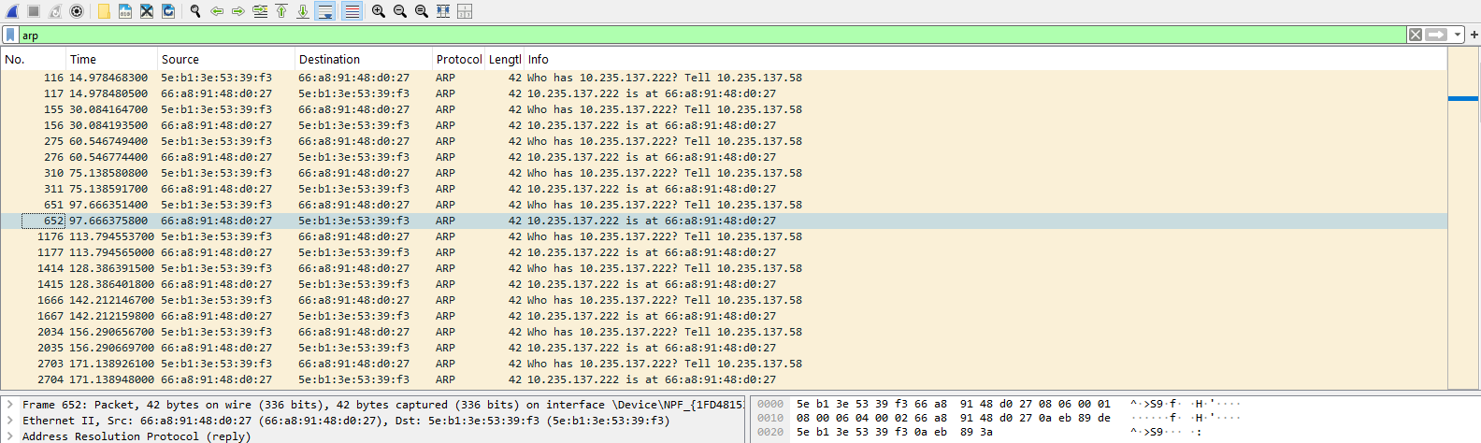

3. Packet Walkthrough: DNS Lookup Exchange (play.google.com)
Below is the packet-by-packet breakdown of a DNS resolution exchange from Frame 23 to Frame 25:
- Packet 1 — Standard Query (Client $\rightarrow$ DNS Server):
  - Frame Number: Frame 23
  - Source IP: 10.235.137.222 | Destination IP: 10.235.137.58
  - Protocol / Port: UDP / Port 53
  - Info: Standard query 0x43b9 A play.google.com
  - Explanation: The client host issues an unencrypted DNS query with Transaction ID 0x43b9 requesting the IPv4 address ('A' record) for play.google.com.
  - Verification: The query is logged in the packet list with transaction ID 0x43b9 awaiting a response from server 10.235.137.58.
- Packet 2 — Standard Query Response (DNS Server $\rightarrow$ Client):
  - Frame Number: Frame 25
  - Source IP: 10.235.137.58 | Destination IP: 10.235.137.222
  - Protocol / Port: UDP / Port 53
  - Info: Standard query response 0x43b9 A play.google.com A 142.250.207.78
  - Explanation: The DNS server replies with matching Transaction ID 0x43b9, successfully resolving play.google.com to target IPv4 address 142.250.207.78.
  - Verification: The client accepts the response payload and proceeds to establish a connection with the resolved IP address.

4. Traffic Summary & Unencrypted Security Observations
- Unencrypted Traffic Risks (HTTP & DNS):
  - HTTP: Frame 805 shows an unencrypted HTTP GET request for files hosted under msdownload/update/.... Inspecting the packet bytes reveals plain-text headers, including full URL paths, User-Agent strings (WindowsUpdateAgent/10.0.10011.16384), and hostnames (download.windowsupdate.com). Anyone sniffing the network can read or alter these unencrypted HTTP payloads.
  - DNS: Standard DNS queries run over unencrypted UDP Port 53. Visited hostnames (acrobat.adobe.com, play.google.com) are broadcast in plain text across the local network.
- Encrypted Security (TLS/HTTPS):
  - Secure traffic on Port 443 undergoes a TLS handshake (Frames 6431–6439). Following the exchange of Client Hello and Server Hello keys, application payloads are scrambled into encrypted Application Data blocks, preventing local interception.

