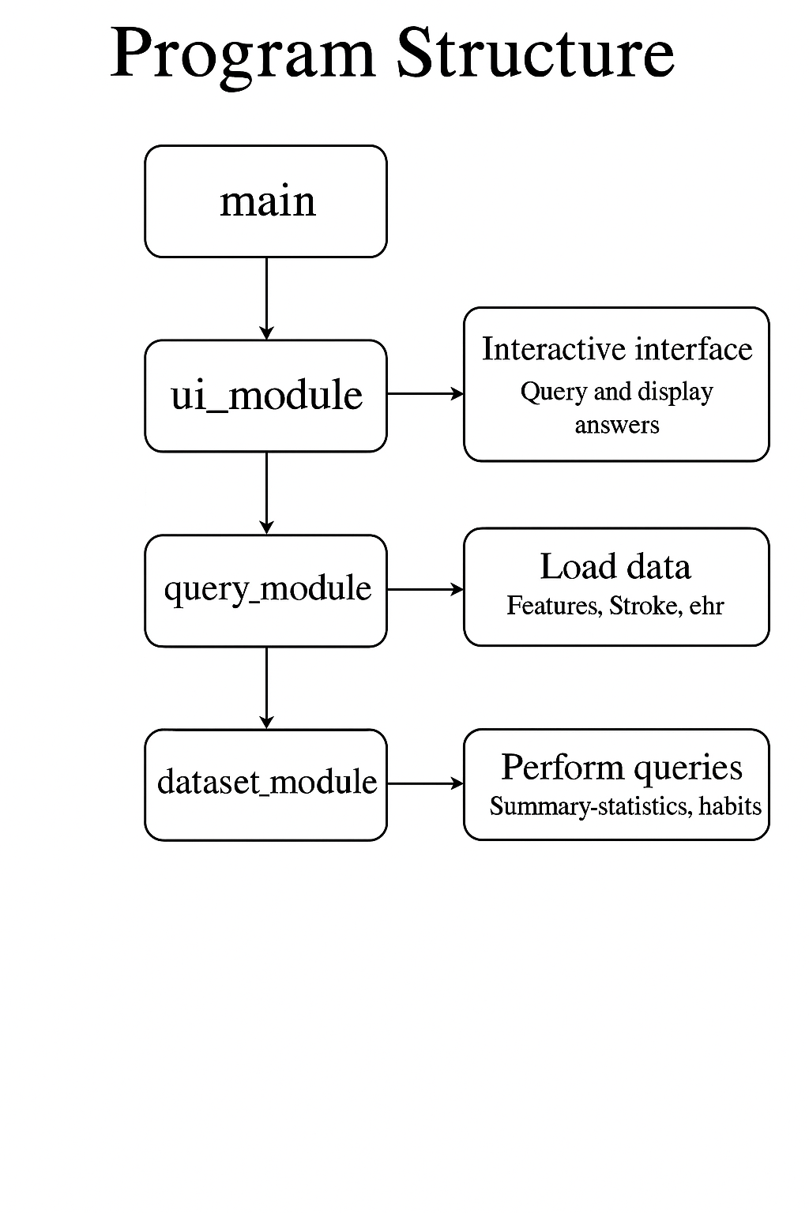

Figure 1: Program Structure and Module Interactions