**28th February, 2019**

**PROGRAMMING WITH ASSEMBLY LANGUAGE**

**Assignment 2**

**Projector**

**GROUP MEMBERS**

**Jesse Anim 1644417**

**Yinbil Nayinzor Nicholas 1659717**

**Frank Sarpong 1658117**

**Paddy Gabriel 1657017**

**Manu Leonard Amankwah 1652917**

**Bamfo Emmanuel Oppong 1647417**

**Yeboah Enoch 1661117**

**Ayomide Olomi 1655117**

**Ebenezer Anane Wiredu 1659217**

**SCREENSHOTS**

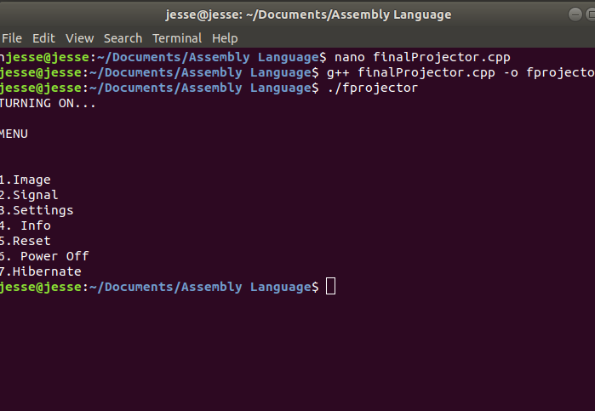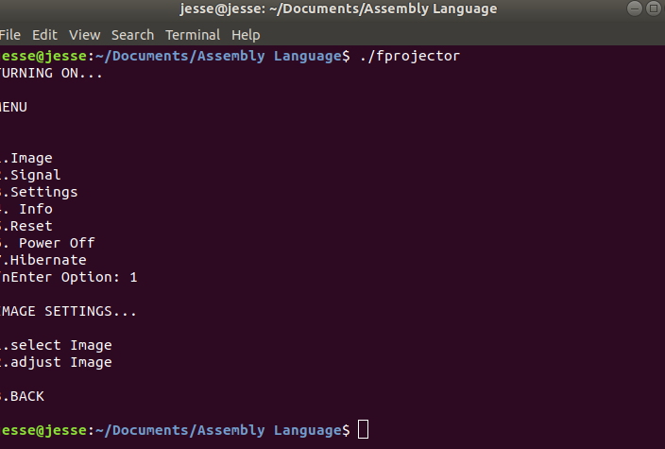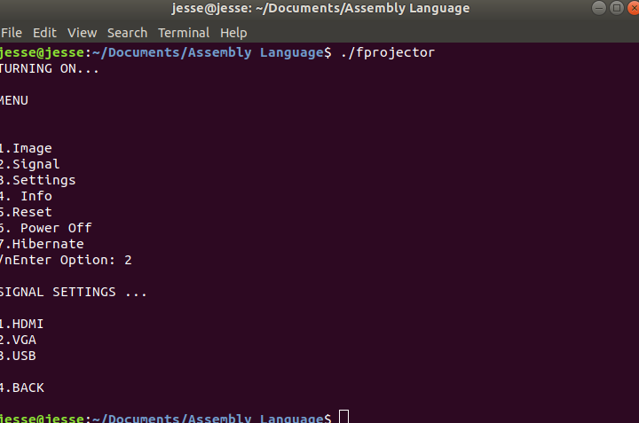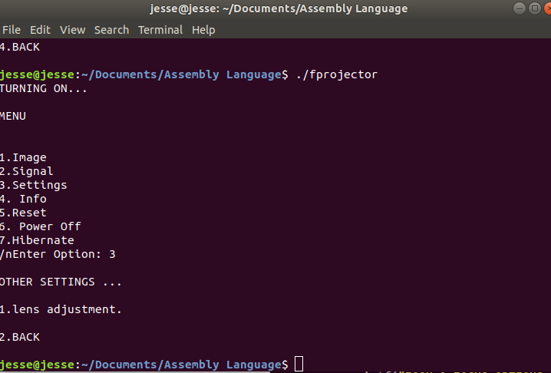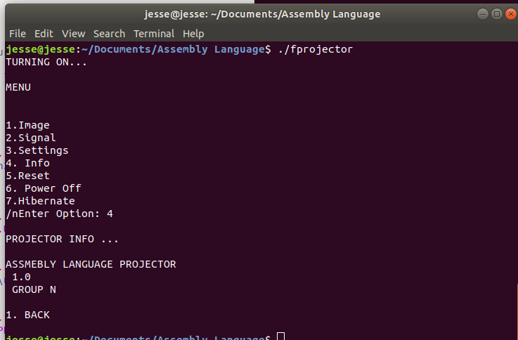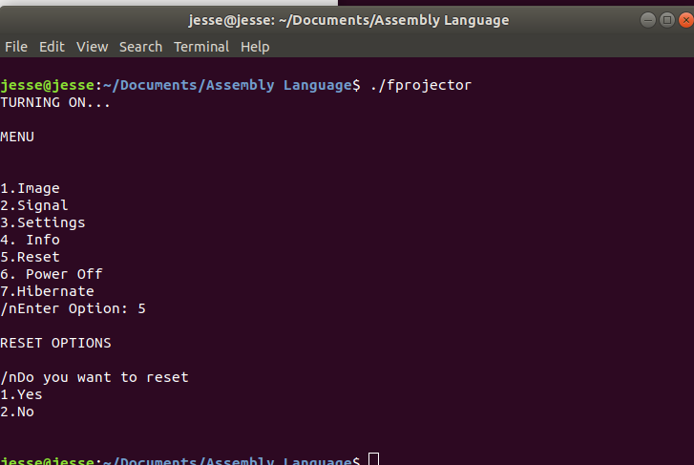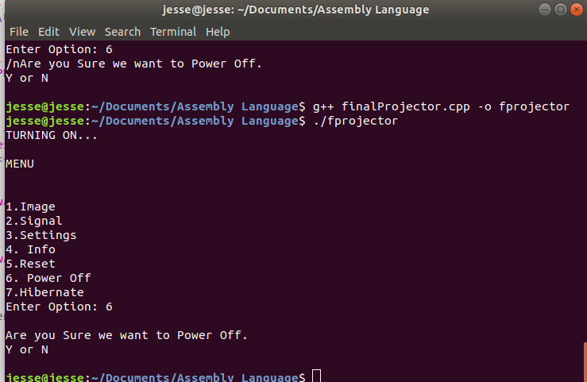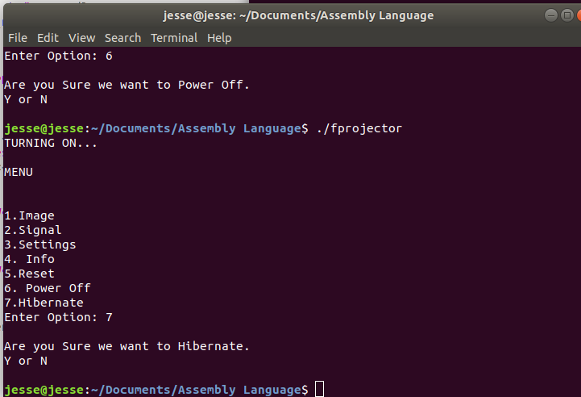

**CODE**

section .data

proj_name db "Hp Project Series A3d"

lenproj_name equ $-proj_name

turn_on db "1. Turn_on"

lenTurnOn equ $-turn_on

userMsg db "Enter Option: "

lenUserMsg equ $-userMsg

dispMsg db 'You have entered: '

lenDispMsg equ $-dispMsg

oning db 'Turning On...'

lenOning equ $-oning

onMsg db 'Welcome, User...'

lenOnMsg equ $-onMsg

view_mode db "Welcome -- MENU"

lenview_mode equ $-view_mode

cabel_source db "1. Source"

len_cable_source equ $-cabel_source

;source values

Hdmi_mode db "---SOURCE SETTINGS---"

lenHdmi equ $-Hdmi_mode

;source value ends here

hdmi_thesource db "1. HDMI"

lenhdmi_thesource equ $-hdmi_thesource

vga_thesource db "2. VGA"

lenvga_thesource equ $-vga_thesource

usb_thesource db "3. USB"

lenusb_thesource equ $-usb_thesource

settings db "2. Settings"

lensettings equ $-settings

;settings values starts here

setting_menu db "---SETTINGS MENU---"

lensetting_menu equ $-setting_menu

;settings values ends here

adjust_image db "1. Adjust Image"

lenadjust_image equ $-adjust_image

change_resolution db "2. Change Resolution"

lenchange_resolution equ $-change_resolution

info db "3. Info"

leninfo equ $-info

;info values starts here

info_menu db "---PROJRCTOR INFORMATION---"

leninfo_menu equ $-info_menu

;info values ends here

reset db "4. Reset"

lenReset equ $-reset

;reset values starts here

reset_menu db "---RESET MENU---"

lenreset_menu equ $-reset_menu

;reset values ends here

powerOff db "5. Power Off"

lenpowerOff equ $-powerOff

;poweroff mennu starts here

poweroff_menu db "---POWER OFF MENU---"

lenpoweroff_menu equ $-poweroff_menu

;poweroff menu ends here

hibernate db "6. Hibernate"

lenhibernate equ $-hibernate

;hibernate menu starts here

hibernate_menu db "---HIBERNATE MENU---"

lenhibernate_menu equ $-hibernate_menu

;hibernate menu ends here

projector_about db "Assembly language Project 1"

lenprojector_about equ $-projector_about

groupname db "Group M"

lengroupname equ $-groupname

sure_poweroff db "Are you sure you want to Power Off(yes or no)?"

lensure_poweroff equ $-sure_poweroff

sure_reset db "Are you sure you want to Reset(yes or no)?"

lensure_reset equ $-sure_reset

sure_hibernate db "Are you sure you want to hibernate(yes or no)?"

lensure_hibernate equ $-sure_hibernate

section .bss

num resb 5

section .text

global _start

_start:

; projector name text declaration

mov eax,4

mov ebx,1

mov ecx, proj_name

mov edx,lenproj_name

int 80h

mov eax,3

mov ebx,2

mov ecx, num

mov edx, 5

int 80h

;Turn on text

mov eax,4

mov ebx,1

mov ecx,turn_on

mov edx, lenTurnOn

int 80h

mov eax,4

mov ebx,1

mov ecx, num

mov edx,5

int 0x80

;Enter Number Text declaration

mov eax,4

mov ebx,1

mov ecx, userMsg

mov edx, lenUserMsg

int 80h

mov eax,3

mov ebx, 2

mov ecx,num

mov edx,5

int 0x80

; dislay message text declaration

mov eax,4

mov ebx, 1

mov ecx,dispMsg

mov edx, lenDispMsg

int 80h

mov eax,4

mov ebx, 1

mov ecx, num

mov edx, 5

;checking if user input is 1

mov bl, [ecx]

cmp bl,'1'

JE L7

int 80h

;end declarations

mov eax,1

mov ebx,0

int 80h

L7:

;Turning on progress message

mov eax,4

mov ebx,1

mov ecx, oning

mov edx, lenOning

int 80h

mov eax,3

mov ebx, 2

mov ecx,num

mov edx,5

int 0x80

;welcome user message

mov eax,3

mov ebx,2

mov ecx, num

mov edx, 5

int 80h

mov eax,4

mov ebx, 1

mov ecx,onMsg

mov edx, lenOnMsg

int 80h

mov eax,3

mov ebx,2

mov ecx, num

mov edx, 5

int 80h

;choose view mode

mov eax,4

mov ebx,1

mov ecx, view_mode

mov edx,lenview_mode

int 80h

mov eax,3

mov ebx,2

mov ecx, num

mov edx, 5

int 80h

;other HP projector options

mov eax,4

mov ebx,1

mov ecx,cabel_source

mov edx,len_cable_source

int 80h

mov eax,4

mov ebx,1

mov ecx, num

mov edx,5

int 0x80

mov eax,4

mov ebx,1

mov ecx,settings

mov edx, lensettings

int 80h

mov eax,4

mov ebx,1

mov ecx, num

mov edx,5

int 0x80

mov eax,4

mov ebx,1

mov ecx,info

mov edx, leninfo

int 80h

mov eax,4

mov ebx,1

mov ecx, num

mov edx,5

int 0x80

mov eax,4

mov ebx,1

mov ecx,reset

mov edx, lenReset

int 80h

mov eax,4

mov ebx,1

mov ecx, num

mov edx,5

int 0x80

mov eax,4

mov ebx,1

mov ecx,powerOff

mov edx, lenpowerOff

int 80h

mov eax,4

mov ebx,1

mov ecx, num

mov edx,5

int 0x80

mov eax,4

mov ebx,1

mov ecx,hibernate

mov edx, lenhibernate

int 80h

mov eax,4

mov ebx,1

mov ecx, num

mov edx,5

int 0x80

;Enter Menu Option declaration

mov eax,4

mov ebx,1

mov ecx, userMsg

mov edx, lenUserMsg

int 80h

mov eax,3

mov ebx, 2

mov ecx,num

mov edx,5

int 0x80

;check if user input is 1 then open source

mov bl, [ecx]

cmp bl,'1'

JE source

int 80h

;chek if user is 2 then open setting

mov bl, [ecx]

cmp bl,'2'

JE settings_label

int 80h

;check if user is 3 then open info

mov bl, [ecx]

cmp bl,'3'

JE info_label

int 80h

;check if user is 4 then open reset

mov bl, [ecx]

cmp bl,'4'

JE reset_label

int 80h

;check if user is 5 then open Power Off

mov bl, [ecx]

cmp bl,'5'

JE powerOff_label

int 80h

;check if user is 6 then open hibernate

mov bl, [ecx]

cmp bl,'6'

JE hibernate_label

int 80h

;LE ends here

;source starts here

source:

mov eax,4

mov ebx,1

mov ecx, Hdmi_mode

mov edx,lenHdmi

int 80h

mov eax,3

mov ebx,2

mov ecx, num

mov edx, 5

int 80h

mov eax,4

mov ebx,1

mov ecx, hdmi_thesource

mov edx,lenhdmi_thesource

int 80h

mov eax,3

mov ebx,2

mov ecx, num

mov edx, 5

int 80h

mov eax,4

mov ebx,1

mov ecx, vga_thesource

mov edx,lenvga_thesource

int 80h

mov eax,3

mov ebx,2

mov ecx, num

mov edx, 5

int 80h

mov eax,4

mov ebx,1

mov ecx, usb_thesource

mov edx,lenusb_thesource

int 80h

mov eax,3

mov ebx,2

mov ecx, num

mov edx, 5

int 80h

;end declarations

mov eax,1

mov ebx,0

int 80h

;source ends here

;settins starts here

settings_label:

mov eax,4

mov ebx,1

mov ecx, setting_menu

mov edx,lensetting_menu

int 80h

mov eax,3

mov ebx,2

mov ecx, num

mov edx, 5

int 80h

mov eax,4

mov ebx,1

mov ecx, adjust_image

mov edx,lenadjust_image

int 80h

mov eax,3

mov ebx,2

mov ecx, num

mov edx, 5

int 80h

mov eax,4

mov ebx,1

mov ecx, change_resolution

mov edx,lenchange_resolution

int 80h

mov eax,3

mov ebx,2

mov ecx, num

mov edx, 5

int 80h

;end declarations

mov eax,1

mov ebx,0

int 80h

;settings ends here

;info starts here

info_label:

mov eax,4

mov ebx,1

mov ecx, info_menu

mov edx,leninfo_menu

int 80h

mov eax,3

mov ebx,2

mov ecx, num

mov edx, 5

int 80h

mov eax,4

mov ebx,1

mov ecx, projector_about

mov edx,lenprojector_about

int 80h

mov eax,3

mov ebx,2

mov ecx, num

mov edx, 5

int 80h

mov eax,4

mov ebx,1

mov ecx, groupname

mov edx,lengroupname

int 80h

mov eax,3

mov ebx,2

mov ecx, num

mov edx, 5

int 80h

;end declarations

mov eax,1

mov ebx,0

int 80h

;info ends here

;reset starts here

reset_label:

mov eax,4

mov ebx,1

mov ecx, reset_menu

mov edx,lenreset_menu

int 80h

mov eax,3

mov ebx,2

mov ecx, num

mov edx, 5

int 80h

mov eax,4

mov ebx,1

mov ecx, sure_reset

mov edx,lensure_reset

int 80h

mov eax,3

mov ebx,2

mov ecx, num

mov edx, 5

int 80h

;Enter reset option

mov eax,4

mov ebx,1

mov ecx, userMsg

mov edx, lenUserMsg

int 80h

mov eax,3

mov ebx, 2

mov ecx,num

mov edx,5

int 0x80

;end declarations

mov eax,1

mov ebx,0

int 80h

;reset ends here

;power off starts here

powerOff_label:

mov eax,4

mov ebx,1

mov ecx, poweroff_menu

mov edx,lenpoweroff_menu

int 80h

mov eax,3

mov ebx,2

mov ecx, num

mov edx, 5

int 80h

mov eax,4

mov ebx,1

mov ecx, sure_poweroff

mov edx,lensure_poweroff

int 80h

mov eax,3

mov ebx,2

mov ecx, num

mov edx, 5

int 80h

;Enter poweroff option

mov eax,4

mov ebx,1

mov ecx, userMsg

mov edx, lenUserMsg

int 80h

mov eax,3

mov ebx, 2

mov ecx,num

mov edx,5

int 0x80

;end declarations

mov eax,1

mov ebx,0

int 80h

;power off ends here

;hibernate starts here

hibernate_label:

mov eax,4

mov ebx,1

mov ecx, hibernate_menu

mov edx,lenhibernate_menu

int 80h

mov eax,3

mov ebx,2

mov ecx, num

mov edx, 5

int 80h

mov eax,4

mov ebx,1

mov ecx, sure_hibernate

mov edx,lensure_hibernate

int 80h

mov eax,3

mov ebx,2

mov ecx, num

mov edx, 5

int 80h

;Enter hibernate option

mov eax,4

mov ebx,1

mov ecx, userMsg

mov edx, lenUserMsg

int 80h

mov eax,3

mov ebx, 2

mov ecx,num

mov edx,5

int 0x80

;end declarations

mov eax,1

mov ebx,0

int 80h

;hibernate ends here