E-Sports Bomb Arena Tournament System

1. Introduction
The Operational Challenge Managing grassroots e-sports events, university gaming tournaments, and local LAN cafe competitions is often an administrative bottleneck. Organizers typically rely on a messy combination of spreadsheets, manual bracket drawing, and human scorekeeping. This leads to scheduling delays, scoring disputes, and a disjointed experience for both players and spectators.

2. Short Project Report
Core Features & Mechanics
- Gameplay Simulation: Matches take place on a dynamic 15x15 grid where hidden bombs are randomly dispersed for every game. Players take turns selecting coordinates; safe cells yield points, while uncovering a bomb results in immediate elimination or match forfeiture.
- Tournament Administration: The system autonomously handles the administrative lifecycle of the event, including team registration, roster management, and match scheduling.
- Dynamic Leaderboard: Incorporates automated score calculation and real-time leaderboard sorting, providing up-to-date team rankings after every match until a final champion is crowned.

Group Members and Individual Contributions
- Member 1 (Team Management): Developed the logic for registering new teams, validating unique Team IDs and names to prevent duplicates, and tracking the number of players per team.

- Member 2 (Player Management): Implemented player registration, linking individual players to existing teams using structures, and creating the display system for all registered participants.

- Member 3 (Bomb Arena Gameplay): Engineered the core 15x15 2D grid generation, randomized bomb placement logic, and the turn-based interactive gameplay loop (including hit detection and safe-zone point allocation).

- Member 4 (Match Scheduling): Built the scheduling system to pair distinct teams for matches, track pending vs. completed games, and handle manual match overrides and result inputs.

- Member 5 (Leaderboard & Scoring): Programmed the dynamic tournament leaderboard to calculate total points, track match wins, and automatically update team standings based on live gameplay results.

System Overview
The E-Sports Bomb Arena Tournament System is a console-based C application that simulates a competitive gaming tournament. The implemented system utilizes a 15x15 bomb grid arena for expanded gameplay. Teams compete in scheduled matches where players take turns navigating a randomly generated grid filled with hidden bombs. Selecting a safe coordinate awards the team points (10 points per safe cell), while hitting a bomb results in immediate elimination and the end of the match. The system serves as a comprehensive tournament manager, handling everything from team and player registration to match scheduling, live gameplay simulation, and dynamic leaderboard updates.
- Programming Concepts Used
- This project was specifically engineered to demonstrate mastery over the following core C programming concepts:
- Pointers: Utilized to pass variables by reference (e.g., in the addscore and findteam functions) allowing the program to directly manipulate memory addresses and optimize data handling.
- Arrays & 2D Arrays: Employed 1D arrays to store lists of registered entities (teams, players, matches) and 2D arrays to map the game grid and bomb locations accurately.
- String Functions: Integrated standard library functions like strcpy() to securely assign names and strcmp() to compare strings and prevent duplicate team names.
- Nested Structures: Implemented a 'struct team' inside the 'struct player' definition to strictly associate and link an individual player to their parent team's data.
- Passing Structures to Functions: Demonstrated clean modularity by passing a 'team' structure by value into the print_team_info() function for formatted output.
- Passing Arrays of Structures to Functions: Passed the global arrays of structures into functions like showteams() to cleanly iterate through and display registered entities without relying purely on global scope within the print logic.
- Sorting and Searching: Employed Linear Search algorithms to look up specific Team IDs and prevent duplicate registrations. Engineered a Bubble Sort algorithm in the sortboard() function to dynamically rank the leaderboard based on team points.
- Validation of User Input: Integrated robust buffer-clearing techniques (while (getchar() != '\n');) paired with scanf value checking to cleanly handle non-integer inputs and prevent infinite loops/crashes.
.

Screenshots of Outputs
Main Menu
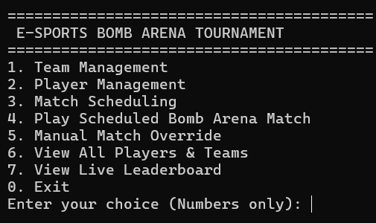
Team/Player Registration
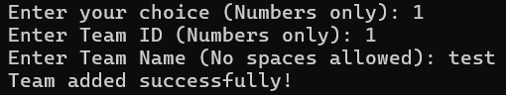
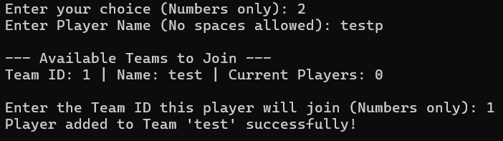
Match scheduling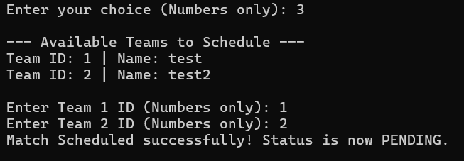
View registered players
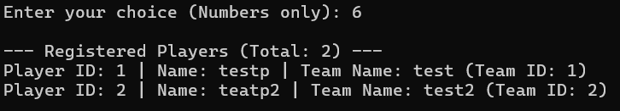

Insert Gameplay Grid
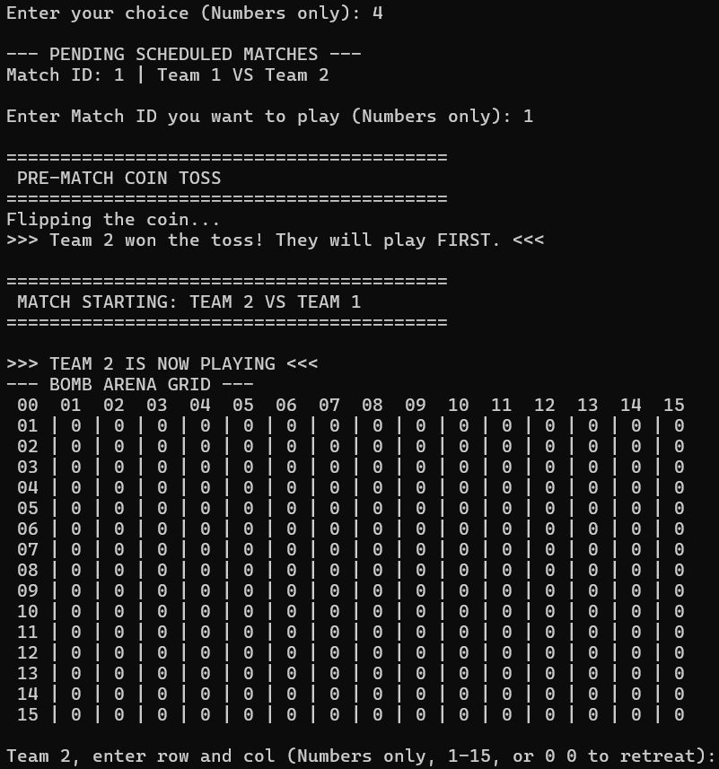
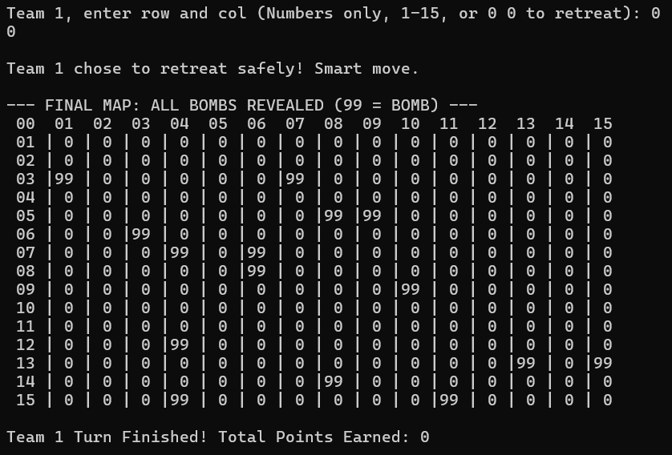

Leaderboard
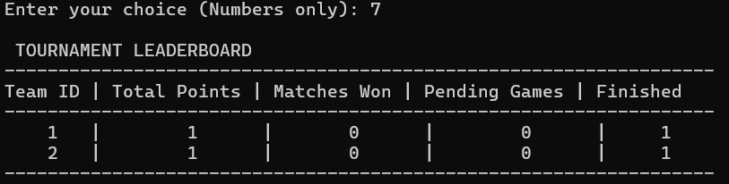

Challenges Faced and Solutions
- Challenge 1: Handling Non-Integer Inputs. If a user entered a letter when asked for a numeric Team ID, the scanf function would fail, leaving the letter in the input buffer and causing an infinite loop that crashed the program.
Solution: We implemented input validation using if (scanf("%d", &var) != 1) paired with a buffer-clearing loop to safely discard invalid characters and prompt the user again.
- Challenge 2: Out-of-Bounds Grid Selection. Players could enter coordinates outside the 15x15 grid size, which would cause the program to access restricted memory arrays and crash.
Solution: Added strict range checking to reject invalid coordinates before checking the 2D array.
- Challenge 3: Empty Team Matchmaking. The tournament organizer could accidentally start a scheduled match for a team that had no registered players.
Solution: Integrated a pre-game logical check that verifies both teams have at least one active roster member before allowing the match to initialize.
- Challenge 4: Providing a Tactical Retreat Option. Players needed a way to manually exit or end their turn if they felt the risk of hitting a bomb was too high.
Solution: We mapped the coordinates 0 0 as a hidden escape command. If typed, the game recognizes it as a safe retreat, ends the turn, reveals the remaining bombs, and banks their current points.
- Challenge 5: Random Bomb Placement and Overlap Prevention. When placing bombs randomly on the grid, the rand() function could select the same coordinates multiple times, resulting in fewer than the required bombs on the board.
Solution: We implemented a validation check before placing a bomb. If the spot is already occupied, the loop counter is decremented, forcing the system to generate new coordinates until an empty spot is found.
- Challenge 6: Preventing Duplicate Team IDs and Names. Users could accidentally register multiple teams with the same ID or identical names, which would break the match scheduling and leaderboard tracking.
Solution: During team registration, we built a linear search loop that iterates through all existing teams to check for matching IDs or string values. If a duplicate is detected, the system rejects the input and prompts for a unique value.
- Challenge 7: The Fairness Problem: Static Match Turns The Problem: Originally, when a match started, teamone always got to play first, this creates a massive unfair advantage and makes the matches feel predictable and boring. The Solution: We added a Pre-Match Coin Toss using a random number generator (rand() % 2). Now, the game acts like a real e-sports broadcast, flipping a virtual coin to decide which team gets to go first.
- Challenge 8: showboard() function was just printing the teams in the exact order they were registered. If Team 4 had the most points, they would still be stuck at the bottom of the screen. The Solution: We built a Bubble Sort Algorithm inside the sortboard() function. Now, right before the leaderboard is printed, the system automatically checks every team's score and re-arranges them so the team with the highest points is always at the top (Rank #1).
- Challenge 9: Duplicate Names The Problem: The system allowed a user to add two teams with the exact same ID, or register three different players all named "Shadow". This breaks the logic of a management game. The Solution: We implemented Duplicate Name/ID Checks using strcmp() (String Compare). Now, if a user tries to enter a team name, team ID, or player name that already exists, the system blocks it, throws an error, and forces them to pick a unique name.

Conclusion
The E-Sports Bomb Arena Tournament System successfully consolidates core C programming mechanics into a fully functional game management application. By utilizing structures, 2D arrays, and strict input validation, the system provides a robust, crash-resistant user experience. The project effectively demonstrates how individual modular components can be merged to solve a larger, complex problem.

