Activity: UML Final Project – Title & Design Proposal

Project Title
Kakanin Corner: A Web-Based Ordering and Reservation System

Problem Statement
The local Kakanin stall currently manages customer records, orders, sales, and inventory manually using paper and notebooks. This manual process is time-consuming and often leads to errors such as lost order slips, incorrect billing for bulk orders, and poor tracking of daily kakanin supply and deliveries. Because of this, daily operations become inefficient and difficult to monitor during peak hours. The absence of a computerized system makes it hard for the owner to manage transactions, monitor real-time sales of different delicacies (like Bibingka or Puto Bumbong), and generate accurate financial reports.

Project Objectives
- To automate record-keeping: Replace manual logbooks with a centralized digital database for customers, kakanin inventory, and sales.
- To streamline order and payment processing: Provide a platform for customers to place walk-in or online orders and pay via cash or digital methods like GCash/Maya.
- To monitor inventory in real-time: Enable the admin to track available stocks of various native delicacies to prevent shortages during the day.
- To improve service transparency: Allow customers to track their kakanin order status and view their past transaction history.
- To generate accurate business reports: Provide tools for the admin and staff to generate daily or monthly sales and operational reports automatically.

Target Users
- Admin (Owner): Has full access to manage the digital menu, monitor delicacy inventory, and view high-level financial reports.
- Staff: Responsible for processing incoming orders (walk-in and online), updating order preparation statuses, and confirming payments.
- Customers: Can register, place orders for kakanin refills or gift sets, and track their pickup or delivery status.

System Scope
What is included and excluded?

Included
- User Authentication: Secure login and registration for Admin, Staff, and Customers.
- Online/Offline Payments: Integration for recording cash payments and digital wallet transactions for online orders.
- Order Tracking: Real-time updates on status (e.g., Preparing, Ready for Pickup, Completed).
- Inventory Management: Digital tracking of different kakanin types and ingredient stocks.
- Reporting: Automated generation of sales summaries and popular delicacy trends.

Excluded
- Automatic GPS Routing: The system tracks delivery status but does not provide live GPS navigation.
- Native Mobile Application: The system is a web-based platform accessible via browsers, not a downloadable app.
- Hardware Sensors: No physical integration with cooking equipment or automated vending machinery.

UML Diagram (Use Case Diagram)
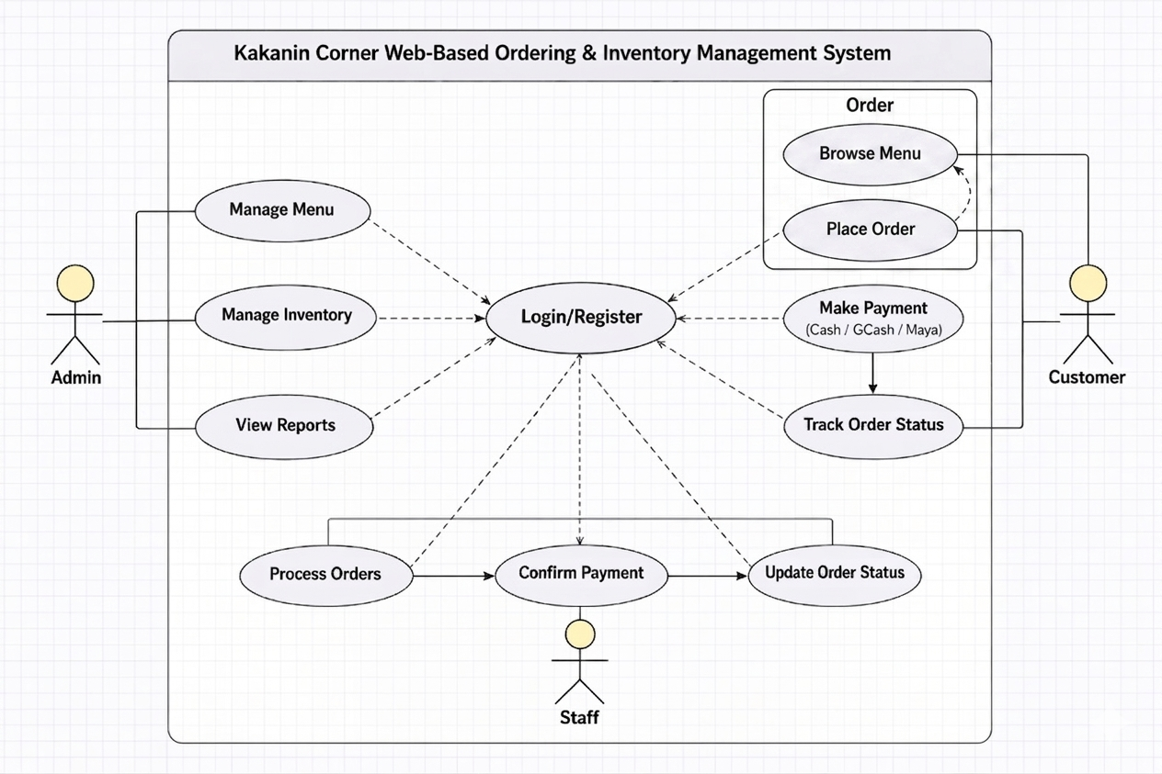

Short Explanation (For Your Output)
The Use Case Diagram for Kakanin Corner accurately maps the interactions between the three primary actors and the web-based system. It utilizes standard UML elements—such as the system boundary to define scope and include relationships to show functional dependencies, like mandatory payment selection during ordering. This design ensures that manual record-keeping is replaced by automated digital processes, specifically addressing the need for real-time inventory and streamlined payment tracking for both walk-in and online customers.

