**INITIAL DESIGNS**

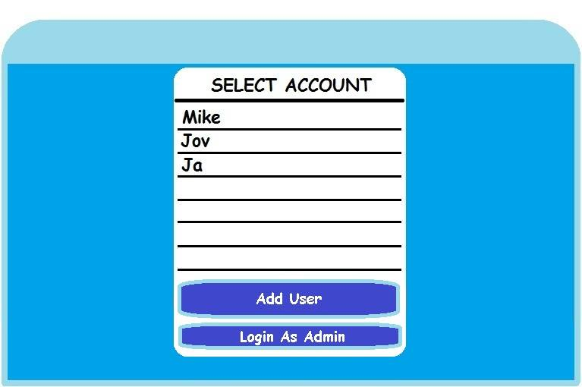

**Figure 1**

**Proposed User Log-in**

This is where the user will choose an existing account; if the user doesn’t have an account, the user needs to add a new account. Or Log in as Admin.

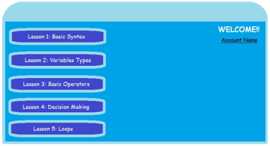

**Figure 2**

**Proposed Main Menu**

Interface for the lesson list of the application. It will be indicated if the lesson is unlocked or still locked.

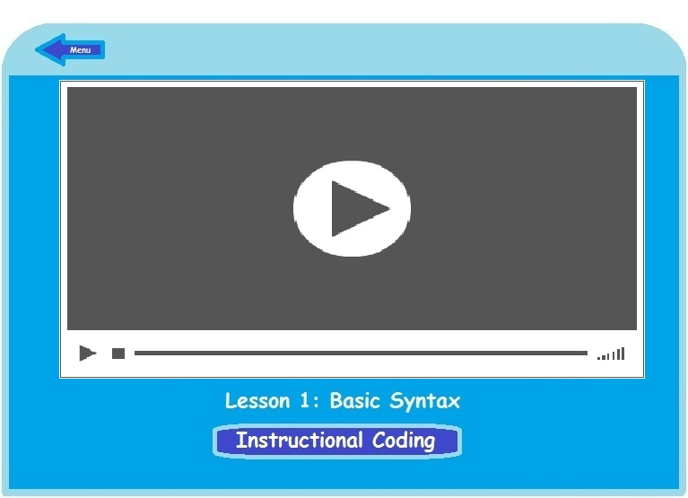

**Figure 3**

**Proposed Tutorial**

Preliminary design for the discussion of the lesson is through a variety of lesson presentations such as animations, recorded slideshows, etc

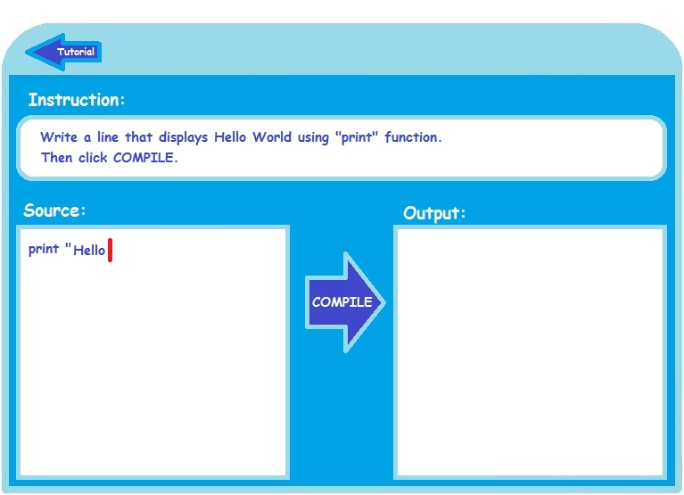

**Figure 4**

**Proposed Coding Activity**

Design for the coding activity in the tutorial. Where the user needs to follow the instructions and write the code on the left side of the window and the output will be shown on the right side of the window.

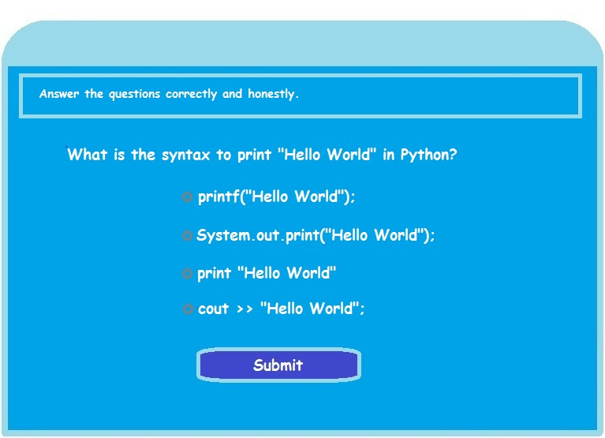

**Figure 5**

**Proposed Evaluation**

This assessment aims to test the user’s knowledge about Python programming language to identify if the user learned after the tutorial or if the user needs to take more tutorials

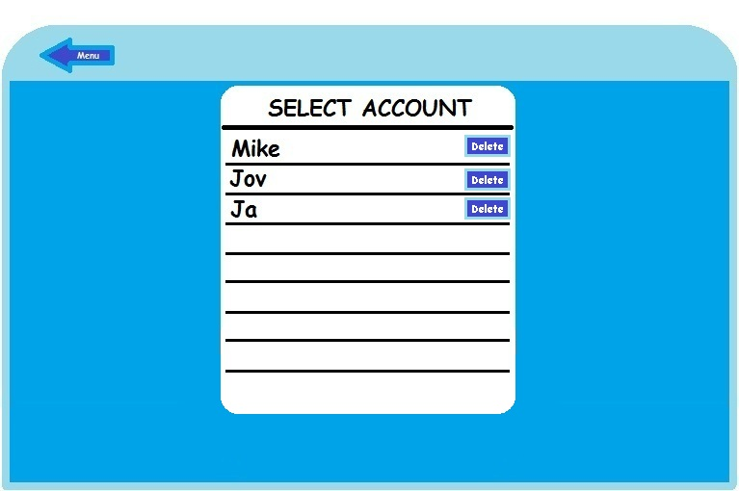

**Figure 6**

**Proposed Admin access to User accounts**

This is where the admin can delete an account in the system.

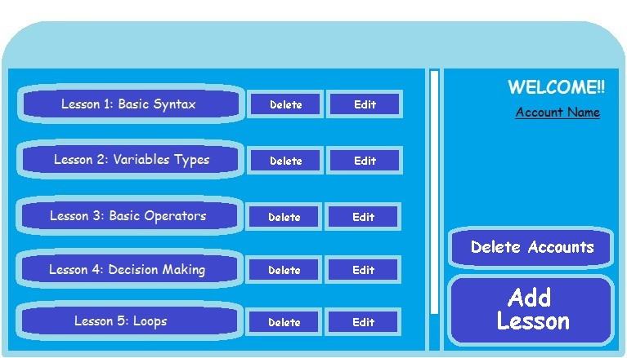

**Figure 7**

**Proposed Admin access to Lessons’ contents**

This is where the admin can add, edit and delete a lesson in the system.