


SHRAMDAAN: MOBILE APP CONNECTING VOLUNTEERS WITH COMMUNITY PROJECTS

By
Janis Adhikari
LUC Registration No:
LC00021000826
A Final Year Project Report
Submitted in partial fulfillment of the requirement for the degree of
Bachelor of Information Technology (Hons)

At the
National College of Management & Technical Science
Lincoln University College, Malaysia
Faculty of Computer Science and Multimedia

Kathmandu, Nepal
May 2026

CERTIFICATION
We, the undersigned, certify that we have read and hereby recommend for acceptance by the NCMT College, Lincoln University College, Final Year Project (FYP) report submitted by Janis Adhikari entitled “Shramdaan: Mobile app connecting volunteers with community projects”, in partial fulfillment of the requirements for the award of the degree of Bachelor of Information Technology (Hons) of Lincoln University College, Malaysia.

____________________
Chandramohan Bhatt
GRP Supervisor

______________________
External Examiner

________________________
Dr. Arun Kumar Thakur
Research Committee Chairman

________________________
Mr. Bikash Bidari
Vice-Principal, NCMT College

Date: May 2026

Declaration of authenticity
I, Janis Adhikari, declare that this FYP entitled “Shramdaan: Mobile app connecting volunteers with community projects” is my own original work and that it has fully and specifically acknowledged wherever adapted from other sources. I also understand that if at any time it is shown that I have significantly misrepresented material presented to the Faculty of Computer Science and Multimedia, Lincoln University College, any credits awarded to me on the basis of that material may be revoked.

_____________________
Janis Adhikari
April 2026

Acknowledgement
I would like to express my heartfelt gratitude to my supervisor for their constant guidance, valuable feedback, and encouragement throughout the course of this project. Their insights greatly contributed to shaping the direction and quality of this proposal.
I am also thankful to the Department of Information Technology at National College of Management and Technical Science for providing a supportive academic environment and essential resources that made this work possible.
My sincere appreciation goes to my mentors and peers whose suggestions and technical input played a vital role in refining my ideas and strengthening the project framework. Lastly, I am deeply grateful to my family and friends for their unwavering support, motivation, and patience during this journey.

Janis Adhikari
LC00021000826

Preface
The idea for Shramdaan mobile application is derived from the traditional notion of free, voluntary labor done by an individual or group towards a community to improve the well-being of people in the nation. However, this practice has come down in recent years especially at urban citizens with no structured coordination and less access to organizing such an activity. In an extension to the growing field of mobile technology, this project was aimed to fill this gap by providing an effective and transparent system at grassroots level for volunteering using mobile applications. This report details the design and implementation of a mobile-first platform we named Shramdaan, where volunteers (~actors), organizers, and administrators come together under one single workflow for event creation/moderation/discovery/participation & attendance verification. Project scope involves the development of features like event discovery in your vicinity, attendance-based participation, QR code based attendance system in different events, communication tools and ways to track contributions. This report is aimed toward those involved in academic analysis, mobile application development, civic tech. It provides both technical and non-technical details about the system. As an author, the project has also provided a service learning experience for him in both practical and analytical terms; it reflects training active citizenship through diasporic digital innovation.

Abstract
Shramdaan a mobile-first community volunteering platform aimed at streamlining & verifying local service events. The gap identified by this project is the absence of a centralized, stable method to discover and track grassroots-level volunteering events; often coordinating happens off-line and with mere verbal acknowledgment. This application allows volunteers, organizers, and administrators to interact with each other in a well-defined workflow that facilitates event creation, moderation, discovery, and participation. Cross-platform mobile development is done using Flutter while Firebase services are leveraged for handling authentication, real-time data management and notification delivery. It includes essential features like event discovery, RSVP-based attendance, communication with other attendees via chat concerning the specific event and QR code-based validation. The platform has a unique characteristic of verified participation, recording actual attendance and contributing to user contribution records for credibility and accountability. This solution is scalable, efficient, and can handle the full spectrum of community events from start to finish while streamlining coordination between groups, maximizing individual interest, and promoting continued community engagement.
Keywords: community, mobile application, event management, attendance using QR code, firebase, flutter, real time system, civic engagement.

Table of Contents
CERTIFICATION II
Declaration of authenticity III
Acknowledgement IV
Preface V
Abstract VI
Table of Contents VII
List of Figures X
List of Tables XI
List of Abbreviations XII
CHAPTER 1: INTRODUCTION 1
1.1. Introduction 1
1.2. Background 1
1.3. Problem Statement 1
1.4. Objective 2
1.5. Scope of the Project 3
1.6. Significance of the project 4
1.6.1. Social Impact 4
1.6.2. Beneficiaries 4
CHAPTER 2: Literature Review 5
2.1. Cultural Significance of ShramDaan 5
2.2. Digital Volunteering Platforms: Evolution and Relevance 6
2.3. Scalability and Inclusivity in Technology-Enabled Volunteering 6
2.4. Real-Time Coordination and Community Empowerment 6
2.5. Impact of Urbanization and Migration on Manual Volunteering 7
2.6. Theoretical and Practical Implications 7
2.7. Technical Review of ShramDaan 8
2.8. Research Gaps 9
CHAPTER 3: System Analysis And Design 11
3.1. Feasibility Study 11
3.1.1. Technical Feasibility 11
3.1.2. Operational Feasibility 11
3.1.3. Economic Feasibility 11
3.1.4. Legal & Ethical Feasibility 12
3.1.5. Schedule Feasibility 12
3.2. Requirements Specification 13
3.2.1. Functional Requirements 13
3.2.2. Non-Functional Requirements 16
3.3. System design 16
3.3.1. System Architecture 16
3.3.2. Use Case Diagram 16
3.3.3. Dataflow Diagram 17
3.3.4. ER Diagram 20
3.3.5. Sequence Diagram 22
3.3.6. Database schema 23
3.3.7. Wireframe 28
CHAPTER 4: Implementations and results 30
4.1. Development Methodology 30
4.2. Module Breakdown 30
4.2.1. Authentication Module 30
4.2.2. Event discovery module 31
4.2.3. Event Management Module 31
4.2.4. RSVP and Participation module 31
4.2.5. Attendance Verification Module 32
4.2.6. Chat and communication module 32
4.2.7. Notification Module 32
4.2.8. Profile Module 32
4.2.9. Leaderboard and Achievement Module 33
4.2.10. Admin Module 33
4.2.11. Shared Services and System Logic 33
4.3. Tech Stacks 34
4.4. Project Timeline (Gantt Chart) 36
4.5. Risk Analysis 36
4.6. Results and Outcomes 38
CHAPTER 5: limitation & future scope 40
CHAPTER 6: Conclusion 41
References 42
Appendix A: Application Screenshots 44
Appendix B: Code Snippets 46

List of Figures
Figure 3.1: System Architecture 16
Figure 3.2: UseCase Diagram 17
Figure 3.3: DFD Level 0 18
Figure 3.4: DFD level 1 19
Figure 3.5: DFD Level 2 Process Attendance Verification 20
Figure 3.6: ER Diagram 21
Figure 3.7: Sequence Diagram 22
Figure 3.8: Post Event Screen Wireframe 28
Figure 3.9: Event List screen Wireframe 28
Figure 3.10: Chat Screen Wireframe 29
Figure 3.11: Profile Screen Wireframe 29
Figure 3.12: Leaderboard Screen Wireframe 29
Figure 3.13: Event Detail Screen Wireframe 29
Figure 4.1: Project Gantt Chart 36

List of Tables
Table 3.1: Functional Requirements 13
Table 3.2: Non Functional Requirements 16
Table 3.3: User Table 23
Table 3.4: Events Table 24
Table 3.5: Chat Message Table 25
Table 3.6: RSVP Table 25
Table 3.7: Notification Table 26
Table 3.8: Broadcast Table 27
Table 3.9: Attendance Table 27
Table 4.1: Risk Analysis 37

List of Abbreviations
LUC Lincoln University College
BIT Bachelor of Information Technology
API Application Programming Interface
FCM Firebase Cloud Messaging
ER Entity-Relationship
OSM OpenStreetMap
GPS Global Positioning System
UI User Interface
UX User Experience
MVP Minimum Viable Product
NGO Non-Governmental Organization
GDPR General Data Protection Regulation
JWT JSON Web Tokens
REST Representational State Transfer
SQL Structured Query Language
PK Primary Key
FK Foreign Key
RSVP Répondez S'il Vous Plaît (Please Respond)
UNV United Nations Volunteers
GPS Global Positioning System
UI/UX User Interface/User Experience
TLS Transport Layer Security
AI Artificial Intelligence

INTRODUCTION

Introduction
Shramdaan is a community volunteering platform that organizes and manages local service activities on a structured, integrated mobile digital system. That is where this application comes in to help out the volunteers, organizers and administrators connected in a single workflow for creating, moderating, discovering, participatory events and verifying attendance. This app also allows users to find community events, RSVP and join the event, chat on an event-oriented chat group, check-in/check-out by QR code to validate their participation. Features like real-time notification, contribution tracking and leaderboard-based engagement have also been integrated into the system to engage users & hold them accountable. Built on Flutter for cross platform mobile development and powered by Firebase services for backend, Shramdaan offers a scalable and efficient solution to manage the entire lifecycle of community volunteering events.

Background
ShramDaan literally, donation of labor is a customary practice in South Asia, especially in Nepal and India, in which communities used to volunteer their time and resources to create public infrastructure or repair temples and surrounding areas while contributing towards the environment. This nurtured strong social ties and community responsibility. In cities, things have slowly changed over the years with busy life styles and migration contributing to the decline of this culture (along with breakdown of traditional community structures). While many people still want to volunteer, there aren’t as many ways or channels for them to work physically in their community. But the landscape of mobile technology and social media presents an opportunity to fill in the gaps. According to research, mobile platforms aid in bridging volunteers with community initiatives and help better organize physical volunteering (Navina Shri, 2023).

Problem Statement
In many communities, and particularly in Nepal, there is a large rift between those who want to volunteer and people organizing local development projects. Unfortunately, there is no dedicated and reliable connection between these groups yet. Most volunteering platforms either informally relay opportunities through word-of-mouth or advertise them on social media at the eleventh hour, which makes it impossible for interested volunteers to sign up in time. Current event platforms are packed with unrelated activities and making it hard for volunteers to find the right community service opportunity matching their interest or availability. The absence of a specific platform leads to poor coordination, confusion over logistics for each event, details on available volunteers and necessary material resources which inevitably end in low volunteering turnout and ineffective project execution. Additionally, the lack of a methodical approach to this hinders a culture of volunteering, where many people expect local authorities to initiate social projects instead of responding with community initiative.
Not having integrated approaches that integrate funding and volunteer cost raises financial barriers were due to lack of mobilization initiatives like these. Unfortunately, many altruistic ideas never take flight or go unfinished without funding for basic materials to build or tools & refreshments needed. The above needs highlight the strong efficacious requirement for a systematic platform connecting potential volunteers with authenticated beneficiaries, people who can summarize their projects required and those who are ready to volunteer working as one (Saravana Kumar N, 2025).

Objective
The main goal of the Shramdaan project is to create a structured platform that allows community members to collaborate, engage with others, and manage volunteer activities on mobile devices. The system seeks to overcome existing limitations in traditional volunteering practices of discoverability, communication and relationship building, accountability through tracking activities and long-term engagement by offering a unified digital solution.
Project specific objectives are as follows:
- To enable efficient event management including creation, moderation, discovery, and participation within a single mobile platform.
- To implement a secure and structured attendance verification mechanism using QR-based check-in and check-out.
- To provide real-time features such as chat, notifications, and contribution tracking for seamless user interaction and system responsiveness.

Scope of the Project
Shramdaan is an initiative to create a mobile application that will help people sign up for community service by doing some sort of activity involving their physical efforts towards local development. It is built around the idea of connecting volunteers with community organizers by giving them access to key tools they need for discovering events, coordinating efforts, communicating and supporting each other at every step of the volunteering process. This enables individuals to contribute and be involved with community programming while assisting organizers in streamlining their projects and volunteers.
It has features like volunteer signup and profile management, which allows for a personalized profile where you can tell us about yourself and what you're interested in with your participation history. Organizers can post community service projects, and volunteers may search for locations near them to join events. To provide a check for safety and legitimacy, there is a project verification process by an admin. In-app chat and real-time notifications enable communication between organizers and volunteers. With features like event scheduling with calendar integration, gamification elements such as leaderboards and badges, and comprehensive project information available alongside each initiative; all of these drive user engagement and participation even more.
The Shramdaan mobile application is aimed at a broad spectrum of users, especially social workers, interested in community or local development. We use these to tokenise sentences and accumulate words Key users would be youth & students, local volunteers, NGOs & social groups and local government bodies who wish to promote civic participation in community initiatives.
The application is primarily designed for Android mobile devices with an aim to be accessible in different regions and accommodate both urban as well as rural setups. The system is designed to work efficiently on basic level internet and cover a wide range of digital infrastructure from the most basic to intermediate, ensuring everyone has access.

Significance of the project
By introducing a new model of technology-driven community volunteering, the Shramdaan project aims to overcome issues with issues such as fragmented coordination, limited event visibility and lack of participation verification. The initiative facilitates trust, accountability, and overall efficiency in volunteering activities by providing a centralized platform equipped with event management tools to verify attendance and communication. By empowering individuals with an Easy to Use Platform, it allows citizens to get involved in developing their communities while helping organizers and institutions run projects. This project on the whole helps to make community work together and also makes a more systemized, sustainable ecosystem of volunteering.

Social Impact
The platform will directly help communities by allowing more volunteers to join local initiatives: clean-up campaigns, volunteering to repair things in the community or contribute to environmental conservation. This solution not only helps community organizers bring their volunteers together in a more coordinated effort, but it can also help strengthen community ties and foster an ethos of civic engagement while revitalizing the age-old tradition of collective labour for the public good. It also gives local organizers and municipalities to better mobilize the citizens, making it less reliant on government solutions to improve the community.

Beneficiaries
The beneficiaries of the application include volunteers, organizers, local communities, and institutions such as NGOs and local authorities. Volunteers benefit by gaining easy access to verified service opportunities that match their interests and availability, along with a system to track their contributions and achievements. Organizers and NGOs are supported through tools that help them efficiently plan, manage, and coordinate events while ensuring participant reliability through verified attendance. Local governments and institutions can use the platform to promote civic engagement and mobilize citizens for community development activities. Overall, communities benefit from improved participation, better coordination of initiatives, and stronger social connections, leading to more effective and sustainable local development.

Literature Review
ShramDaan, or “donation of labor,” is an age-old tradition in South Asia, particularly in Nepal and India, where communities get together to lend physical assistance in the construction of public goods like roads and water supply projects or even for cleaning up their neighborhoods. Historically, it has signified values associated with civic duty, solidarity and social capital (Tacchi, 2005) . Nonetheless, as modernization, urbanization and migration have taken their toll on North African societies, many such traditions are slowly disappearing particularly in urban areas (Thewes, Sept, & Richter, 2024). As a result, digital platforms are being investigated increasingly as potential media to save and adapt this tradition for modern times. One such initiative is the proposed ShramDaan mobile application which aims at connecting volunteers with community based organizers through means of digital coordination platforms.
This review brings together interdisciplinary literature on the cultural origins of ShramDaan, evolution of digital volunteering platforms, issues brought by modernization and implications for grassroots empowerment through technology.

Cultural Significance of ShramDaan
Anthropological studies have shown ShramDaan to be a practice enmeshed in communal existence and collective identity within South Asia. It developed deep networks of trust and reciprocity, providing the opportunity for resource-poor communities to be active in co-producing infrastructure, keeping their environment clean, and promoting social cohesion (Afandi, Anomsari, Setiyono, Novira, & Sutiyono, 2024). ShramDaan embodied a sense of civic duty that was relational, not transactional; it stressed the importance of communal well-being as an activity above individual gain.
However, in many parts of the world, it have become less visible and their participation, as urbanization and migration have fragmented traditional social structures. This begs the question of how digital tools may maintain the essence of collective labor while enabling its manifestation for 21st century, mobile populations (Stein, Pentzold, Peter, & Sterly, 2022).

Digital Volunteering Platforms: Evolution and Relevance
Digital platforms like VolunteerMatch, UNV and Do-it. org that can significantly improve on this by (1) scaling the volunteer coordination via technology, (2) providing real-time event discovery and (3) integrating further enhancements like management of donations or administrative verification. These innovations are in line with what the ShramDaan app aims to achieve inclusive, scalable and trust-based volunteer ecosystems.
Yet difficulties remain when it comes to translating conventional practices into digital frameworks. But scholars warn that platforms can undermine volunteerism altogether by transforming deep community engagement into one-off, transactional minutiae (Mos, 2021) And this tension between technological efficiency on the one hand, and cultural authenticity on the other, is at the heart of the debate over ShramDaan’s future in a digital age.

Scalability and Inclusivity in Technology-Enabled Volunteering
The analyzed studies stressed that scalability within the scope of digital volunteering is enabled only through multi-actor partnerships, flexible architectures and hybrid online-offline models (Vakali, Dematis, & Tolikas, 2017). Inclusivity, though, is an ongoing barrier. Some examples of barriers that hinder participation from marginalized groups include structural inequalities, digital illiteracy and rural infrastructure gaps (Nyagaya & Mwau, 2024). Involving the community in shaping platform features through co-design approaches has also led to increased inclusivity and use of different platforms (Seguin, Varghese, Anwar, Bartindale, & Olivier, 2022).
To ensure ShramDaan is inclusive, we need to develop culturally sensitive interfaces, provide local language support etc. and supplement the digital components with off-line features because not everyone has the access or know-how.

Real-Time Coordination and Community Empowerment
Real-Time Communication, Event Discovery and Feedback mechanism. These are one of the strongest affordances created by mobile applications. Features like live monitoring, verification processes and donation integration have notable effects on trust, transparency and responsiveness (Mehta, et al., 2022) according to empirical studies. Furthermore, gamification and recognition mechanisms enhance motivation and retention of volunteers (Vakali, Dematis, & Tolikas, 2017).
However, if such risks are not managed carefully, they can subvert these benefits through misinformation, a breakdown in coordination (pre-coronavirus and certainly post, see Blog Street level health responses) and security vulnerabilities that cannot be addressed when direct contacts for work create information silos. Largely, this means that the design of ShramDaan’s app must reconcile technical innovations with safeguards that help ensure reliability and accountability.

Impact of Urbanization and Migration on Manual Volunteering
ShramDaan was traditionally encouraged through community networks, these are gradually breaking down as urbanization forces migration to megacities, pulling people away from their hometowns. Research shows decreasing engagement in collective manual volunteering, and particularly in urban areas characterized by individualistic lifestyles and time shortages (Thewes, Sept, & Richter, 2024).However, we see resilience and adaptability in new models created by self-organizing volunteer groups that stem from the ground up (Afandi, Anomsari, Setiyono, Novira, & Sutiyono, 2024).
Digital platforms can potentially play a mediating role in these changes by providing flexible, time-bound volunteering options and connecting geographically dispersed communities. However, the evidence behind how effective these interventions are is limited.

Theoretical and Practical Implications
The literature contains both heartening and cautionary reports. By the same token, digital platforms are able to overcome many of the deficiencies inherent in collective labor traditions; they provide scalability, inclusivity, and real-time coordination. On one hand, they threaten to commoditize ShramDaan and if so, being reduced to yet another transactional exchange thereby undermining its communal ethos. In practice, culturally sensitive design, participatory co-production and hybrid engagement models rise as the dominant strategies for maintaining genuine community empowerment (Cardullo & Kitchin, 2024).
While the admin verification, toggle for donation amounts and grassroots empowerment functions built into the ShramDaan app align with best practices indicated by the literature search above, whether or not these evidence-based strategies can be effective will depend on their context-aware implementation.

Technical Review of ShramDaan
The Shramdaan System is built on a mobile-first architecture which is meant to handle ephemeral scale, real-time engagement and to manage data efficiently with respect to community planning and volunteering functions. The application frontend is built using Flutter and Dart to provide cross-platform mobile development with one codebase while retaining high performance and a consistent user interface on different devices. It simplifies development and facilitates fast iteration in the development lifecycle.
For backend, to access authentication and real-time database management services, we created a Backend-as-a-Service (BaaS) application using Firebase, which also integrates cloud storage and serverless function capabilities. The backend uses cloud firestore as the main database where we can have a fast, scalable NoSQL document solution with real-time data sync and offline persistence capabilities with changing applications having dynamic updates (Google, 2020). Firebase Authentication is used to securely manage user identity and access control, allowing for email-based authentication and role-based system behavior.
Firebase Cloud Messaging (FCM) is utilized to provide real-time communication and engage users through push notifications, allowing for timely updates like event reminders and alerts from the system (Celik & Sevim, 2019). Event-based group chat feature is another implementation, where participants can interact asynchronously with each other through Firestore’s built-in real-time streaming capabilities, without needing a separate messaging server.
Location Based Features: For the location services, the system uses OpenStreetMap combined with Flutter-compatible mapping libraries to achieve features like interactive Map Rendering and event place visualization without tying up to proprietary capabilities. Also, attendance verification is performed with QR based scanning mechanisms to ensure that the user participates in an event. Firebase Cloud Functions which is server-side logic that runs in the background such as for notification scheduling and system automation.
In summary, the Shramdaan approach is a modern, cloud-native stack that leverages cross-platform mobile development with scalable backend services and capabilities for real-time communication and secure authentication. This unified and comprehensive technology stack offers a solid and effective framework for backdrop community volunteering efforts while upholding performance, dependability, and maintainability.

Research Gaps
There exists an extensive literature on the subject of traditional volunteering and performing community service as well as on the role of digital platforms in connecting volunteers with opportunities but there are still considerable lacunae that justify the design and development of ShramDaan mobile application. Digitally, however despite some attempts in South Asia to create platforms that mirror community and social values (Tacchi, 2005), none are successful or widespread in integrating the cultural implications of ShramDaan. Existing volunteering apps are mostly transactional, and thus in danger of commodifying the relational/project-based/well rooted aspect of its classical definition. Clearly, solutions that maintain social cohesion while utilizing technology are needed.
In the second scenario, global volunteering platforms like VolunteerMatch and UNV showcase scalability and efficiency. However, more often than not they disregard local context of South Asian communities. Factors like language diversity, rural infrastructure limitations and localized socioeconomic norms shape participation greatly (Stein, Pentzold, Peter, & Sterly, 2022). With only little knowledge gained so far about how to build platforms that achieve both technical efficacy and cultural relevance in these parts of the world.
Third, local contexts are underexplored for real-time coordination and verification mechanisms that are critical to trust and accountability in volunteering. While research notes the advantages of live communication, event oversight and feedback systems (Mehta, et al., 2022), few platforms utilize strong mechanisms to substantiate events for immunity against misinformation. The growing over fragmentation of traditional community networks caused by urbanization and migration needs to be supported through hybrid models that integrate both online volunteering with offline, hands-on activities (Thewes, Sept, & Richter, 2024),but little is written about these either.
Finally, grassroots volunteering platforms do not yet include secure donation management and financial tools. Indeed, while some apps still offer poor solutions for small-scale, community-based financial contributions, literature highlights severe issues related to transaction security, data privacy and transparency on those already available. Additionally, these developments can pose hurdles to trust and sustained engagement between volunteers and organizers that must be addressed from both a technical and ethical perspective.
Together, these gaps make a case for a context awareness, culturally sensitive and technically sound platform such as ShramDaan which helps us bridge the gap between archaic volunteering practices with modern day digital solutions.

System Analysis And Design

Feasibility Study

Technical Feasibility
The Shramdaan system is technically feasible as it is built on modern and widely supported technologies such as Flutter for frontend and Firebase for backend services. Flutter allows cross-platform mobile development with native performance, and Firebase offers integrated solutions for authentication, real-time data storage, notifications, and serverless processing. This tech stack is very well for implementing features like real time chat, QR based attendance verification & location based event discovery. The fact that these technologies are scalable, well-documented and supported by active developer communities also means they will be easier to develop, maintain, and scale in the future.

Operational Feasibility
The further operational desirability is robust since the platform targets a clear gap in community solutions for organizing physical volunteer programs. ShramDaan will help build communities, social groups and local organizers: The direct way to mobilize volunteers for your local cause will likely lead communities, social groups and local organizers to adopt ShramDaan. I think the simplicity of using Facebook, real-time updates and ease of access will go a long way in maximizing the app’s use specifically around parts of the world where volunteering by physically showing up is already common but does not have adequate infrastructure to coordinate members.

Economic Feasibility
Economically, the initial buildout is minimized using open-source and free-tier technologies. Initial development has minimal expenses (for example, you can use free versions of cloud services or databases) but may generate additional costs as it scales. On the other hand, social welfare and community effects may be ecosystem reasons to raise funding by joining forces with NGOs, local authorities or social responsibility schemes. From the numbers, it seems that platforms make a lot of sense economically Since in USD it has become fairly inexpensive and while I can understand how this can become really useful to communities in long term.

Legal & Ethical Feasibility
There are no significant legal restrictions in building and operating this type of application. However, the platform must comply with data privacy regulations such as GDPR or local data protection laws, ensuring user data is secure and consent is obtained for data usage. Ethical considerations include ensuring fair access to all community members, preventing misuse of the platform, and promoting safety through clear guidelines for volunteers.

Schedule Feasibility
The Shramdaan project is schedule viable, as the completion of the project can happen within a fixed period using iterative development. Using an Agile methodology, the implementer works in phases (planning, design, develop, test & refine). While modern frameworks like Flutter and Firebase help in speeding up the development because offers ready-to-use components and backend services, which decrease implementation time. Constant communication with users allows for the identification of potential issues before they become bigger problems. As such, the project road map is reasonable and doable given the assigned development stage.

Requirements Specification

Functional Requirements
Table 3.1: Functional Requirements
Functional Requirement | Severity
A. Home Page
a1. The system shall display a list of approved events to users. | must
a2. The system shall allow users to search events by title and location. | must
a3. The system shall provide filters for category, time, and distance. | should
a4. The system shall display featured events separately. | could
a5. The system shall show event details preview with basic information. | must
B. Chat Screen
b1. The system shall allow users to send and receive messages in event-based chats. | must
b2. The system shall display messages in real-time. | must
b3. The system shall show unread message count. | should
b4. The system shall allow users to view participant list. | could
b5. The system shall restrict chat access to event participants only. | must
C. Event Detail Screen
c1. The system shall display full event information including date, time, and location. | must
c2. The system shall allow users to RSVP to events. | must
c3. The system shall allow users to leave events. | must
c4. The system shall display organizer details. | should
c5. The system shall allow users to add events to calendar. | could
D. Attendance Screen
d1. The system shall allow users to scan QR codes for check-in. | must
d2. The system shall allow users to scan QR codes for check-out. | must
d3. The system shall validate QR code expiry. | must
d4. The system shall display attendance status feedback. | must
E. Profile Screen
e1. The system shall display user profile information. | must
e2. The system shall allow users to edit profile details. | must
e3. The system shall display user achievements and points. | should
e4. The system shall display joined and organized events. | must
F. Add/Edit Post Screen
f1. The system shall allow organizers to create new events. | must
f2. The system shall allow organizers to edit existing events. | must
f3. The system shall allow users to upload event images. | must
f4. The system shall allow users to select event location using map or search. | must
f5. The system shall validate required fields before submission. | must
f6. The system shall allow resubmission of rejected events. | should
G. Leaderboard Screen
g1. The system shall display ranked users based on points. | must
g2. The system shall provide leaderboard filters (daily, monthly, all-time). | must
g3. The system shall highlight the current user ranking. | should
g4. The system shall display user points and participation stats. | must
g5. The system shall update rankings based on verified attendance. | must
H. Admin Dashboard
h1. The system shall allow admins to approve or reject events. | must
h2. The system shall allow admins to manage users (ban/unban). | must
h3. The system shall display analytics of events and users. | should
h4. The system shall allow admins to send broadcast notifications. | could

Non-Functional Requirements
Table 3.2: Non Functional Requirements
Non-Functional Requirement | Severity
NFR1. The system shall provide a user-friendly interface. | must
NFR2. The system shall handle errors without crashing. | must
NFR3. The system shall work properly on Android devices. | must

System design

System Architecture
Shramdaan consists of a mobile-first stack system architecture in which Firebase services are interfaced through the Flutter application with server as client. This app interacts with Cloud Firestore for data storage, Firebase Authentication for user management, and Firebase Cloud Messaging for notifications. Cloud Functions and other things run in the background, mapping and location services help users discover events. 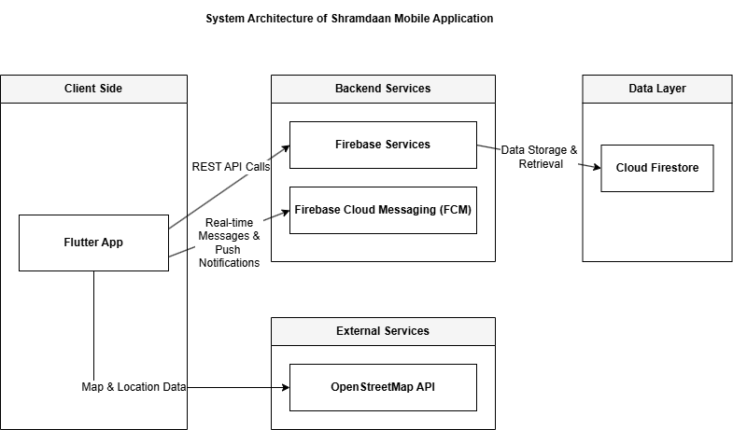
Figure 3.1: System Architecture

Use Case Diagram
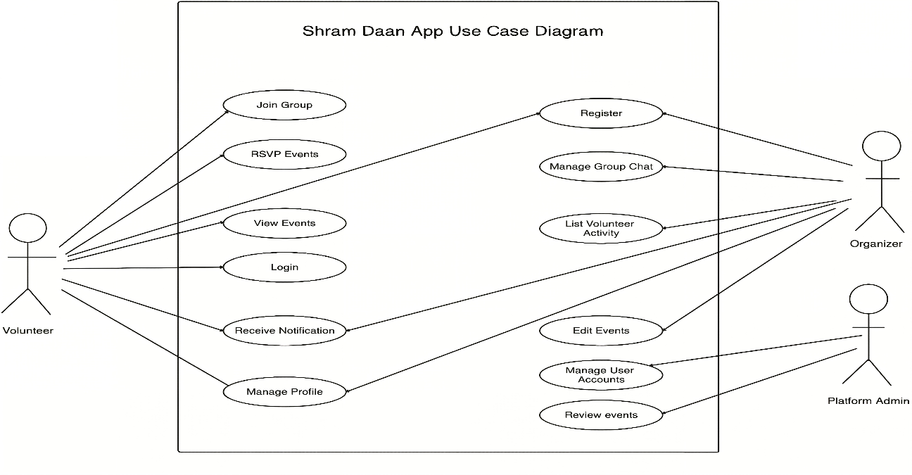
The use case diagram show how different users are using the Shramdaan system. It also indicates the primary users including volunteers, organizers, and administrators, as well as the principal operations (i.e., creating and managing profiles, creating/joining events, verifying attendance, chatting with other users on the platform or moderating it). This diagram summarizes the system’s functional interactions from the user perspective
Figure 3.2: UseCase Diagram

Dataflow Diagram
The Data Flow Diagram (DFD) illustrates how data moves through the Shramdaan system by showing the interactions between external entities, internal processes, and data stores. It represents how key information such as user details, event data, RSVPs, attendance records, chat messages, and notifications are collected, processed, stored, and retrieved within the system.
At the highest level, the context diagram provides an overview of the entire platform, highlighting the interaction between users such as volunteers, organizers, and administrators with the system. The Level 1 DFD further decomposes the system into major functional processes including authentication, event management, discovery and RSVP handling, attendance verification, communication, contribution tracking, and administration. These processes interact with centralized data stores to maintain system consistency.
The Level 2 DFD focuses on a specific process, providing a more detailed view of internal operations. In this case, the attendance verification process is broken down into sub-processes such as QR code generation, scan validation, check-in and check-out recording, and contribution calculation. This layered representation helps in understanding both the overall system workflow and the detailed processing logic within critical components.
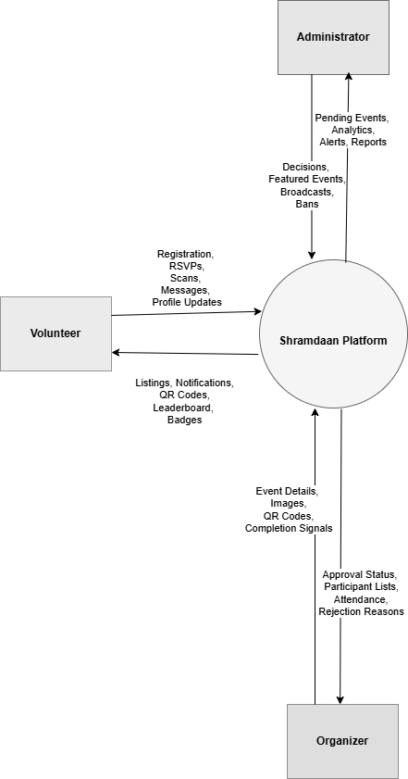
Figure 3.3: DFD Level 0

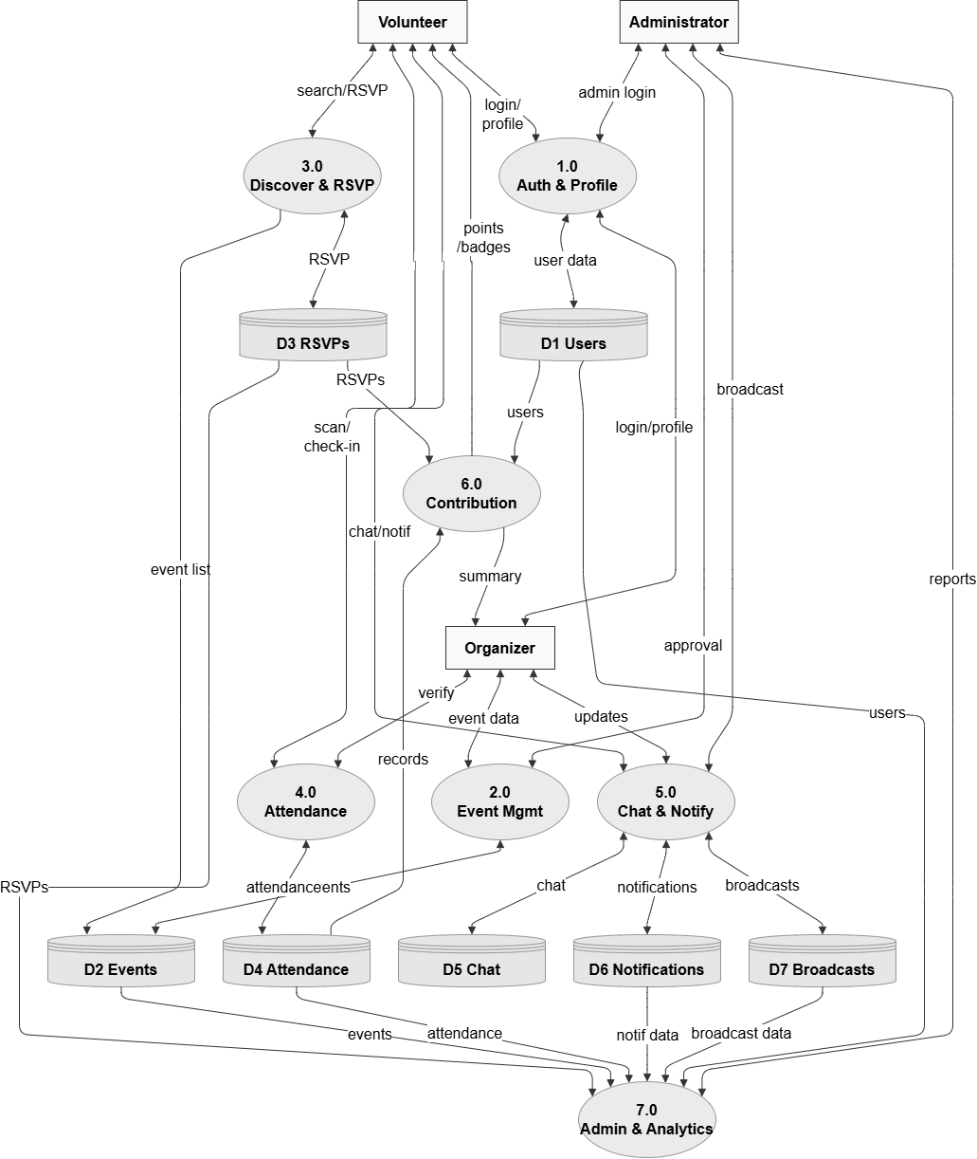
Figure 3.4: DFD level 1
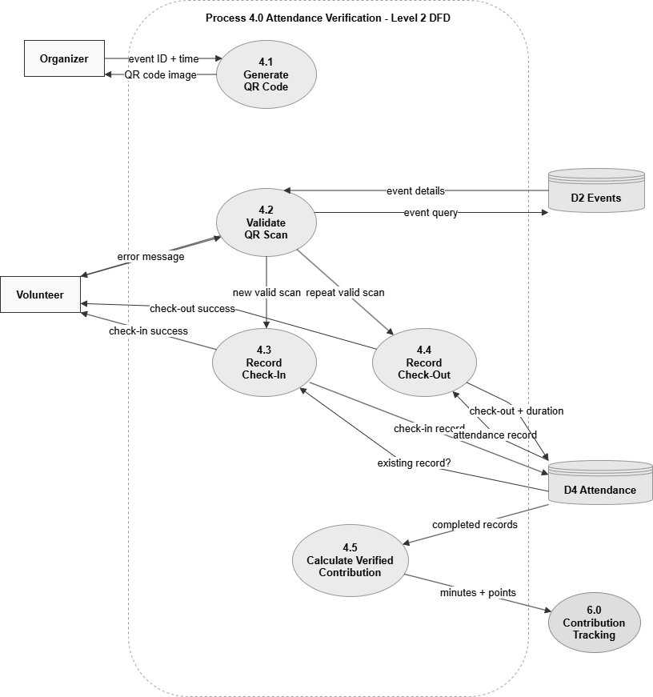
Figure 3.5: DFD Level 2 Process Attendance Verification

ER Diagram
Shramdaan System ER Diagram The diagram given below explains the basic entities of the Shramdaan system and their relationships with each other Illustrates events creation and participation, rsvps and attendance tracking, messaging and notification handling. This diagram illustrates the supporting entities like chat summaries and broadcasts.
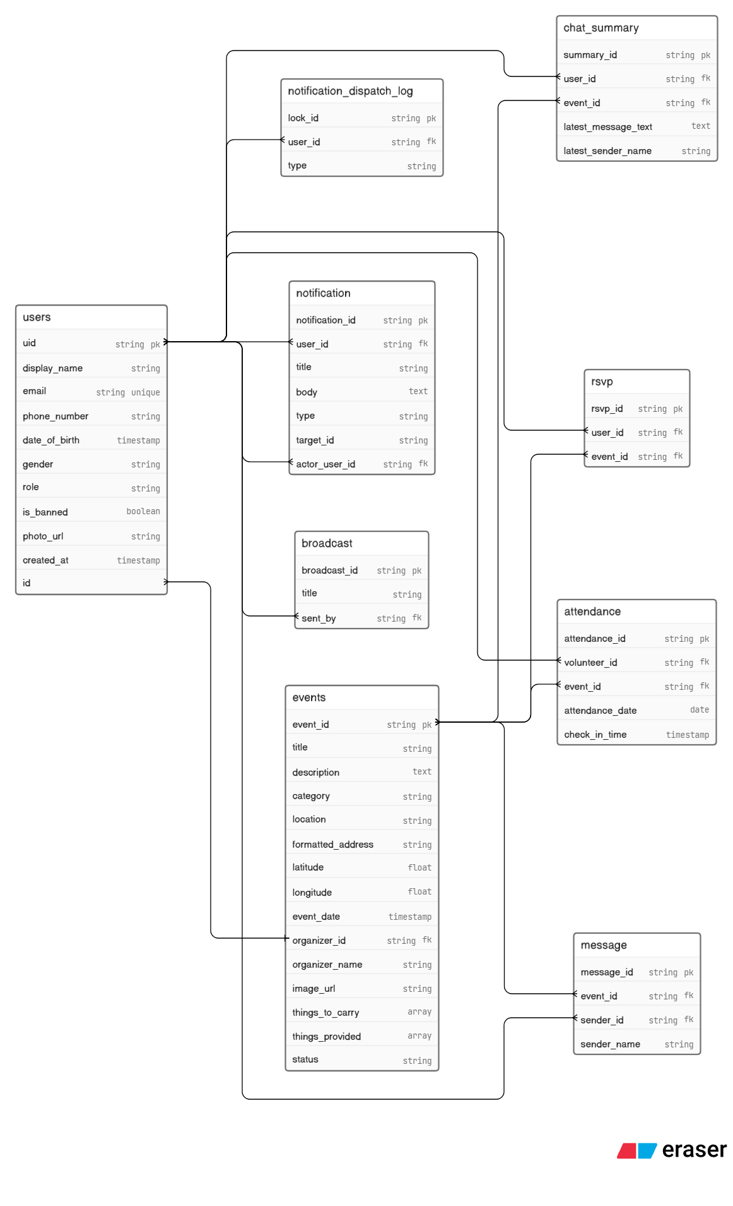
Figure 3.6: ER Diagram

Sequence Diagram
This diagram is the sequence of steps to be followed by the user, application and backend during a particular flow in Shramdaan system. It is one of the component types by representing how a request between components in the system is sent, in what manner actions are called and responses returned. It aids in comprehending the dynamic behavior of the system during operations like event creation, participation, and attendance verification.
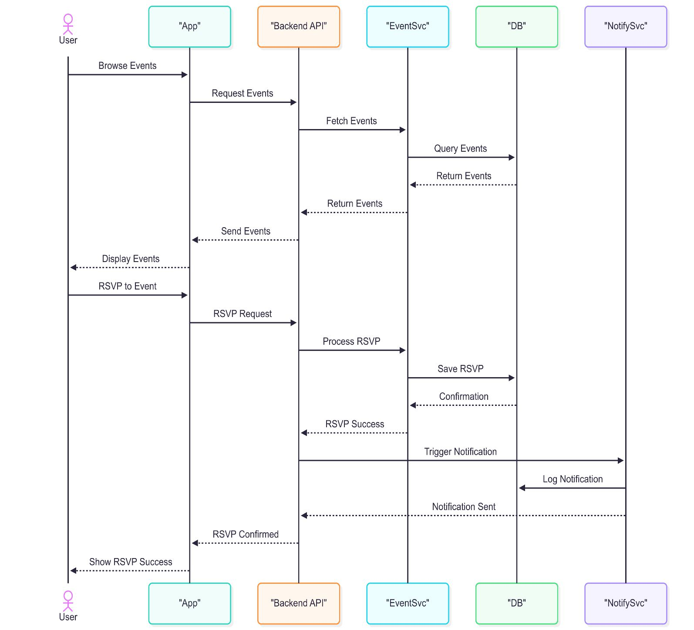
Figure 3.7: Sequence Diagram

Database schema
Users Table: The users table stores all information related to application users, including their identity, profile details, and role within the system. It also maintains account status such as whether a user is banned and stores metadata like account creation time and profile image. This table is central to authentication, authorization, and personalization features across the platform.
Table 3.3: User Table
Field | Type | Description
user_id | String | Unique identifier of the user
display_name | String | Name displayed in the application
email | String | User email address
phone_number | String | User contact number
date_of_birth | Timestamp | User date of birth
gender | String | User gender
role | String | User role such as volunteer, organizer, or admin
is_banned | Boolean | Indicates whether the user account is banned
photo_url | String | URL of the user profile image
created_at | Timestamp | Date and time when the user account was created
Events Table: The events table contains all data related to community events created by organizers. It includes event details such as title, description, category, location, date, and associated media. Additionally, it manages the lifecycle of events through status fields like pending, approved, or rejected, and supports features such as featured events and moderation tracking.

Table 3.4: Events Table
Field | Type | Description
event_id | String | Unique identifier of the event
title | String | Title of the event
title_lowercase | String | Lowercase version of title used for searching
description | Text | Detailed description of the event
category | String | Category of the event
location | String | Event location name
formatted_address | String | Clean formatted address of the event
latitude | Float | Latitude coordinate of the event location
longitude | Float | Longitude coordinate of the event location
event_date | Timestamp | Date and time of the event
organizer_id | String | User ID of the event organizer
organizer_name | String | Name of the event organizer
image_url | String | URL of the event cover image
things_to_carry | Array | List of items participants should bring
things_provided | Array | List of items provided by the organizer
status | String | pending, approved, rejected, or archived
rejection_reason | Text | Reason for rejection if the event is rejected
is_featured | Boolean | Indicates whether the event is featured
review_requested_at | Timestamp | Date and time when the event was submitted for review
Chat Messages Table: The chat_messages table stores messages exchanged within event-specific group chats. It maintains communication between participants and organizers by storing sender details, message content, and timestamps. This table supports real-time interaction and coordination during events.
Table 3.5: Chat Message Table
Field | Type | Description
message_id | String | Unique identifier of the message
event_id | String | Event ID of the related chat
sender_id | String | User ID of the message sender
sender_name | String | Display name of the sender
text | Text | Message content
timestamp | Timestamp | Date and time when the message was sent
RSVP Table: The rsvps table records user participation intent for events. Each entry represents a user’s decision to join an event, allowing the system to track expected participants. This table plays an important role in managing event engagement, enabling features like participant lists, RSVP limits, and access to event-specific functionalities such as chat.
Table 3.6: RSVP Table
Field | Type | Description
rsvp_id | String | Unique RSVP document identifier
user_id | String | User ID of the participant
event_id | String | Event ID of the joined event
timestamp | Timestamp | Date and time when the RSVP was made

Notifications Table: The notifications table manages all system-generated notifications for users. It stores details such as message content, type, related actions, and read status. This enables the system to provide timely updates, reminders, and alerts while also maintaining a history of notifications for user reference.
Table 3.7: Notification Table
Field | Type | Description
notification_id | String | Unique notification identifier
user_id | String | User ID of the notification receiver
title | String | Notification title
body | Text | Main notification message
type | String | Type of notification
target_id | String | Related event, chat, or target reference
actor_user_id | String | User ID of the user who triggered the notification
created_at | Timestamp | Date and time when notification was created
is_read | Boolean | Indicates whether the notification has been read
Broadcast Table: The broadcasts table stores messages sent by administrators to all users or specific groups. These broadcasts are used for important announcements, updates, or system-wide communication.

Table 3.8: Broadcast Table
Field | Type | Description
broadcast_id | String | Unique identifier of the broadcast
title | String | Broadcast title
body | Text | Broadcast message content
sent_by | String | User ID of the admin who sent the broadcast
sent_at | Timestamp | Date and time when the broadcast was sent
Attendance Table: The attendance table stores verified participation data using check-in and check-out timestamps. It ensures that actual attendance is recorded rather than just RSVP intent. This data is used to calculate verified contribution metrics such as participation duration, points, and achievements, making it critical for maintaining system credibility.
Table 3.9: Attendance Table
Field | Type | Description
attendance_id | String | Unique attendance record identifier
volunteer_id | String | User ID of the volunteer
event_id | String | Event ID related to the attendance
attendance_date | Date | Date of attendance
check_in_time | Timestamp | Time when the volunteer checked in
check_out_time | Timestamp | Time when the volunteer checked out
updated_at | Timestamp | Last update time of the attendance record

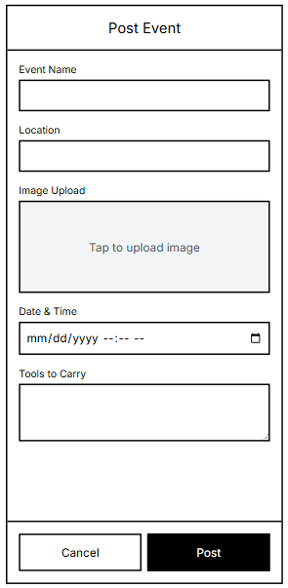
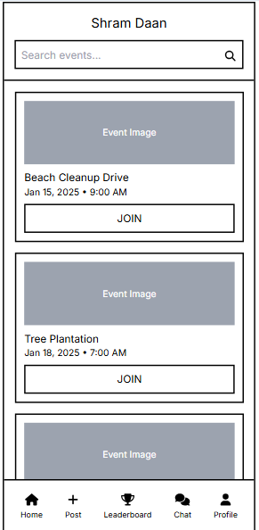
Wireframe
Figure 3.8: Post Event Screen Wireframe
Figure 3.9: Event List screen Wireframe
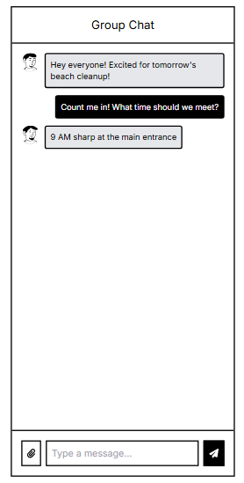
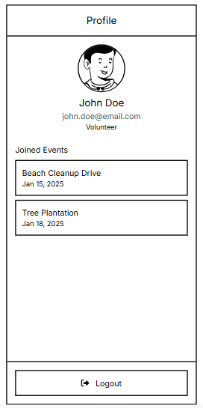
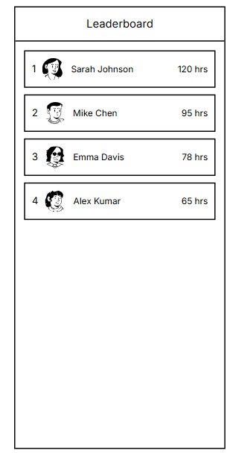
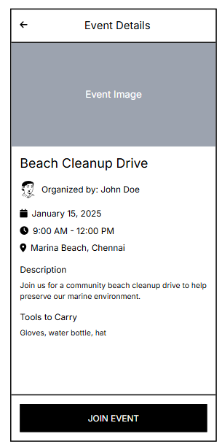
Figure 3.10: Chat Screen Wireframe
Figure 3.11: Profile Screen Wireframe
Figure 3.12: Leaderboard Screen Wireframe
Figure 3.13: Event Detail Screen Wireframe

Implementations and results

Development Methodology
In the Shramdaan system which was inspired primarily by the Agile Software Development methodology, building was performed in incremental iterations. The whole thing was developed in pieces, each piece small and manageable, which kept them tweaking and improving all the way through to the end. And each iteration involved planning, designing, implementing, testing and reviewing so as to make sure we stayed on track with the project goals.
The agile methodology allowed iteration as requirements and design created updates throughout development. New features and improvements were merged in future sprint iterations while minimising friction with the existing workflow. This method was particularly useful in honing various critical components including event administration, attendee validation, and interactivity.
At the conclusion of each development cycle, we conducted regular testing and verification. This made it possible to spot problems early and fix them in an effective manner. This helped in iteratively testing that the system would become more stable and less prone to major defects later in the process. This modular development approach also enabled components to be developed and integrated in stages.
Agile methodology improved time management, enhanced system quality using structured development process. All of this led to a working and stable application that does what it was meant to do.

Module Breakdown
The ShramDaan app is built using a modular approach to ensure each part of the system performs specific functions effectively. The following are the major modules of the system, along with their responsibilities:

Authentication Module
This module manages user sign up and sign in. It leverages Firebase Authentication to verify the credentials and Firestore to keep user's data. At login, it not only checks credentials but also looks into the isBanned status to decide if the user should be allowed. Auth state listeners keep track of the sessions and decides where to navigate. Password requirements like length and very specific must be met before making the new account. The authentication state is preserved with token-based secure sessions even if the app is restarted.

Event discovery module
The module is designed for searching and browsing events by users. It is based on matching keywords in the fields of events and filtering the results by category, time, and distance from the user. The calculation of distance is done by obtaining the geographical coordinates of the user and the event location and then applying a geographic distance formula such as the Haversine formula that finds the shortest distance between two points on the surface of the Earth. Events are sorted by a priority algorithm: first, approved events, then newly announced events, and finally by closest distance. Debouncing is used to prevent sending too many search queries when the user is typing. Stored location data is reused in order to cut down on the number of times GPS is called and to speed up the performance.

Event Management Module
The module that is described here gives the ability to creating and managing events by organizers. It not only checks for the required inputs but also converts addresses to latitude and longitude by geocoding. The images are first uploaded to Firebase Storage and then, their URLs are saved in Firestore and linked to the events. States like pending, approved, and rejected are used for defining the event status. To keep the data integrity, logical constraints are implemented so that the user cannot even change an event once it is marked as completed. The timestamps are used both for keeping a record of the event life cycle and for sorting/filtering purposes.

RSVP and Participation module
This module handles participation in events. It implements time-based rules by checking the present timestamp against the event starting time; thus, it makes sure RSVP is closed prior to the event. Participation information is recorded using composite keys to avoid double entries. The module checks the event status to permit user actions like joining or leaving only after validation. That way, users won't be able to engage with old or completed events. Multi-user interactions with the same event scenario are handled by atomic database transactions to ensure data consistency.

Attendance Verification Module
This module confirms real attendance through the scanning of QR codes. Each QR code is embedded with details like event ID and expiry time. The system checks if a QR is valid by comparing current time to expiry timestamp. Attendance data is logged using a deterministic key, while the check-in and check-out events are registered in a single record. Time span between check-in and check-out is utilized for measuring how long the participant was physically present. Apart from that, the system handles errors that arise from scanning expired/invalid QR codes so as to prevent fraudulent cases of using those.

Chat and communication module
The module facilitates instant communication through messaging. Messages are ordered through timestamps for storing and retrieval. Chat summaries keep the info on unread counts which are changed and reset based on the user's interaction. The sorting mainly focuses on chats with the biggest number of unread counts and latest activities. Firestore listeners help to constantly keep track of the changes without the need of a manual refresh. Data normalization guarantees that both chat summaries and messages are consistent among the different users.

Notification Module
This module handles notifications. It employs Firebase Cloud Messaging for push delivery and Firestore for persistent storage. Scheduled functions send notifications after certain time conditions like event reminders. A locking system checks the dispatch log to avoid sending duplicate notifications. Notification routing works in such a way that users see the relevant screens according to the type of notification they receive. Token management helps keep the delivery effective by removing invalid or expired device tokens.

Profile Module
The module is responsible for handling user information and activity logs. It fetches and modifies user data with Firestore queries, plus it uses Firebase Storage for image storing. To avoid repeated database calls and to speed up the system, the data is cached. Loading asynchronously helps the UI to render smoothly without interfering with the main thread. Participation and achievements from the user's profile are statistical information that are figured out from the records kept. Good state management stops the UI from being rebuilt unnecessarily.

Leaderboard and Achievement Module
This module ranks and calculates users' contributions numerically. Points are determined as follows: Points = 10 + floor(verified minutes / 15) This way, only full-time intervals are counted for the score. Ranking is based on a compound sorting method of points, time spent, and number of events attended. Badges are assigned by evaluating through several conditions. Attendance data is accumulated to calculate the overall user contributions in an effective manner.

Admin Module
This module is in charge of system control and moderation. It implements database queries to control and filter events and users according to their status and activity. Aggregation functions help compute statistics including the number of users total, number of events, and completion rates. Completion rate is the fraction of completed events to approved events. With role-based access control, actions requiring admin privileges can only be done by authorized users. Broadcast messages are sent via notification pipelines to reach all users who are eligible.

Shared Services and System Logic
This module is the backbone for all system functions. It brings together database functionalities, API interactions, as well as core business logic spread over different modules. Performance boosting methods are caching, minimizing database queries, and smart usage of component states. Besides, there is a data stream to provide instant changes to all the parts of the system. In addition to being time-tested and feature-complete, error handling and validation are regularly maintained as for the essential criteria of the system reliability.

Tech Stacks
I. Frontend (Mobile): Flutter is an open-source UI framework developed by Google, while Dart serves as its primary programming language. It enables the development of natively compiled applications for mobile platforms using a single codebase. Flutter is selected due to its capability to deliver high-performance applications with a consistent and responsive user interface, along with rapid development through its rich set of pre-built widgets.
II. Backend (BaaS): Firebase is a cloud-based Backend-as-a-Service platform that provides a suite of integrated backend services, including authentication, database, and messaging. It is utilized to eliminate the complexity of managing dedicated backend infrastructure, thereby enabling faster development and seamless scalability.
III. Database: Cloud Firestore is a NoSQL, document-oriented database that supports real-time data synchronization. It is employed because of its ability to handle dynamic and structured data efficiently while ensuring low-latency access and real-time updates across multiple clients.
IV. Authentication: Firebase Authentication is a secure authentication service that manages user identity and access control. It supports various authentication mechanisms and ensures secure session handling. It is chosen for its reliability, ease of integration, and strong security features.
V. Notifications: Firebase Cloud Messaging (FCM) is a cross-platform messaging service that facilitates the delivery of push notifications. It is used to ensure real-time communication with users by sending event updates, reminders, and alerts directly to their devices.
VI. Cloud Functions: Firebase Cloud Functions provide a serverless environment for executing backend logic in response to events. These functions are triggered automatically based on predefined conditions. They are used to implement background operations such as scheduled notifications and automated workflows without requiring server management.
VI. Storage: Firebase Storage is a scalable cloud storage solution designed for storing user-generated content such as images and files. It is utilized due to its secure access control mechanisms and ability to efficiently handle large volumes of media data.
VII. Maps & Location: OpenStreetMap is an open-source mapping platform, and flutter_map is a Flutter library used to render maps within the application. This stack is employed to provide interactive map-based visualization of event locations while avoiding dependency on proprietary services.
VIII. Location Services: Geolocator is a Flutter plugin that enables access to device location services using GPS. It provides accurate geographical coordinates. It is used to support location-aware functionalities such as proximity-based event discovery and filtering.
IX. QR Scanning: mobile_scanner is a library that facilitates real-time QR code scanning using the device camera. It is selected for its efficiency and ease of integration in implementing attendance verification mechanisms.
X. QR Generation: qr_flutter is a package used to generate QR codes dynamically within the application. It is employed to create event-specific QR codes that are used for validating user attendance.
XI. Local Notifications: flutter_local_notifications is a plugin that enables the display of notifications within the application when it is active. It supports both immediate and scheduled alerts. It is used to enhance user engagement by providing timely in-app notifications.
XII. Calendar Integration: add_2_calendar is a library that allows integration with the device’s native calendar system. It is utilized to enable users to save event details directly to their personal calendars, improving event tracking and participation.
XIII. Networking: The http package is a lightweight networking library used to perform API requests. It enables communication between the application and external services. It is used for functionalities such as location search and geocoding, ensuring smooth data exchange.

Project Timeline (Gantt Chart)
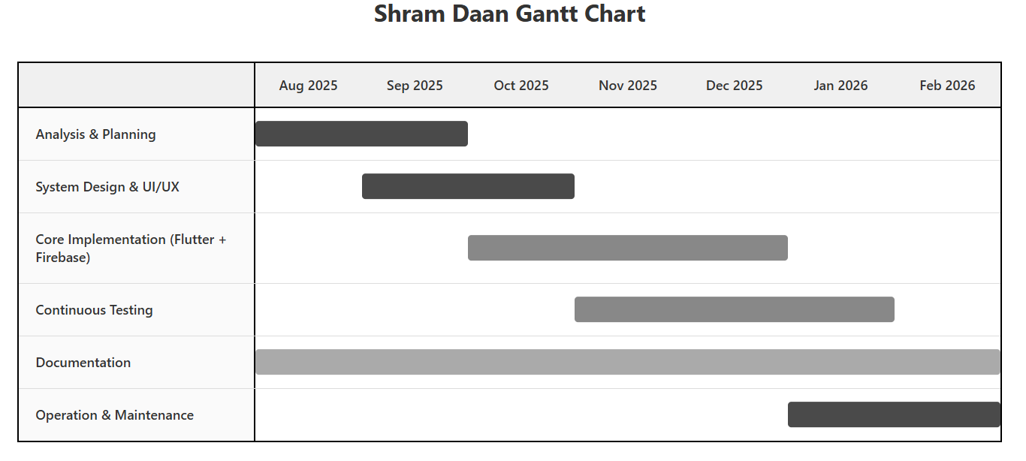
Figure 4.1: Project Gantt Chart

Risk Analysis
During the development of Shramdaan, several risks were identified that could potentially impact progress, system quality, and the timely completion of the project. These risks were continuously monitored and managed throughout the development lifecycle using appropriate mitigation strategies. The following table presents the key risks encountered during the development phase along with the corresponding measures taken to address them.

Table 4.1: Risk Analysis
Risk Description | Likelihood | Severity | Impact | Mitigation Strategy
Delay in development due to underestimation of task complexity or feature scope | High | Medium | Medium | Break tasks into smaller units, set realistic timelines, and follow an iterative development approach.
Technical challenges while implementing new technologies (e.g., Flutter, Firebase services) | Medium | Medium | Medium | Allocate time for learning, use official documentation, and seek support from developer communities.
Integration issues between frontend and Firebase services | Medium | High | High | Develop and test features incrementally and validate data flow during early stages.
Insufficient time allocated for testing and debugging | Medium | Medium | Medium | Plan dedicated testing periods and prioritized critical functionalities for testing.
Dependency on a single developer for the entire system | Medium | High | High | Maintain proper documentation and follow a structured development schedule with buffer time.
Data loss or inconsistencies during development | Low | High | High | Use version control systems (e.g., Git) and rely on Firebase’s data reliability features.
Security vulnerabilities in user authentication or data handling | Medium | High | High | Implement secure authentication practices and follow Firebase security rules for data access control.

Testing and Validation
Testing was carried out to verify that the Shramdaan application behaves correctly across its main functional modules and that important business rules are protected before the system is used by volunteers, organizers, and administrators. The testing strategy focused on unit and service-level testing because most core logic is implemented in Dart services that interact with Firebase Authentication, Cloud Firestore, Firebase Storage, Firebase Cloud Messaging, QR attendance payloads, and shared model classes.
The test suite was written using flutter_test, mocktail, fake_cloud_firestore, and firebase_auth_mocks. These tools made it possible to test the application without making real Firebase network calls. Firestore operations were executed against an in-memory fake database, authentication behavior was simulated through mocked Firebase users and credentials, and storage upload behavior was isolated through injectable upload handlers. This approach improved test reliability, reduced dependency on internet connectivity, and made the tests suitable for repeated execution during development.

Testing Tools and Setup
? flutter_test was used as the main testing framework for arranging, executing, and asserting Dart and Flutter behavior.
? mocktail was used to create mock Firebase Authentication, Firebase Storage, user, and credential objects where external services needed to be isolated.
? fake_cloud_firestore was used to create an in-memory Firestore database for testing event discovery, RSVP records, attendance records, notifications, admin actions, chat summaries, and leaderboard calculations.
? firebase_auth_mocks was used to simulate signed-in user sessions and authentication-state persistence without connecting to the real Firebase backend.
? Each test follows the Arrange, Act, Assert pattern so that test data setup, action execution, and expected outcomes are clearly separated.

Test Coverage Summary
The following table summarizes the major modules tested in the Shramdaan application and the key validation points covered by the unit test suite.
Module | Main Test Focus | Validation Outcome
Authentication | Email/password signup, login, invalid email, weak password, banned user restriction, default volunteer role, and session persistence. | Valid users can register and login, banned users are blocked, and authentication exceptions are handled safely.
Event Discovery | Approved-event filtering, category filtering, title search, location search, Haversine distance calculation, sorting behavior, and empty result handling. | Users only see approved and relevant events, and distance-based calculations work correctly.
Event Management | Event creation, editing, completed-event validation, image upload success/failure, geocoding data, and default pending status. | Submitted events enter pending review, and completed events are protected from editing.
RSVP | Join event, leave event, duplicate RSVP prevention, deterministic RSVP document IDs, and event expiry validation. | Participation intent is recorded once per user-event pair, and expired events cannot be joined.
Attendance Verification | QR parsing, QR expiry, check-in, check-out, duration calculation, wrong-event QR rejection, and checkout-before-checkin prevention. | Verified attendance is recorded only under valid event and time conditions.
Chat | Message ordering, unread count updates, participant access restriction, and empty message rejection. | Event chat remains participant-only and message summaries update correctly.
Notifications | Notification routing data, unread counts, filtered notification types, duplicate read handling, and invalid FCM token cleanup policy. | Notification data routes users correctly and unread counters behave as expected.
Leaderboard | Points formula, descending ranking, verified minutes, attended event counts, and achievement badge thresholds. | Contribution ranking follows Points = 10 + floor(verifiedMinutes / 15).
Admin | Event approval, rejection, user ban/unban, event visibility after approval, and role-based access expectations. | Moderation actions update Firestore correctly; final permission enforcement belongs in Firebase Security Rules or backend functions.

Test Execution Result
After implementing the test suite, the command flutter test was executed from the project root. The final test run completed successfully with 48 passing tests and no failed tests. Some console messages appeared during the run because the suite intentionally includes failure-path cases such as invalid signup, weak password, expired RSVP, rejected chat access, and failed image upload. These messages are expected outputs of negative test cases and do not represent test failures.

Sample Test Command
flutter pub get
flutter test

Validation Conclusion
The completed testing process shows that the major business rules of Shramdaan are testable and behave as expected under both normal and edge-case conditions. The tests improve confidence in authentication, event discovery, RSVP, QR attendance, chat, notifications, leaderboard scoring, and admin moderation. They also support future maintenance because new changes can be checked against the existing automated suite before deployment.

Results and Outcomes
The implementation of the Shramdaan system demonstrates a successful integration of multiple functional modules into a single, cohesive mobile application. The system effectively supports the complete lifecycle of community volunteering activities, including event creation, discovery, participation, and verification. All core functionalities such as authentication, event management, communication, and administrative control operate together seamlessly, resulting in a stable and user-friendly platform.
From a functional perspective, the application enables users to create and manage profiles while maintaining a record of their participation history. Organizers are provided with structured tools to create, update, and manage events, while administrators ensure platform reliability through moderation and control mechanisms. The event discovery module enhances accessibility by allowing users to search and filter events based on relevant criteria, making it easier to find suitable opportunities.
The RSVP-based participation model, combined with QR-based attendance verification, ensures that user involvement is both structured and credible. This approach helps distinguish between user intent and actual participation, improving the reliability of contribution tracking. The integration of real-time chat and notifications further enhances coordination among participants and organizers, ensuring smooth communication throughout the event lifecycle.
The system also incorporates gamification features such as points, achievements, and leaderboards, which encourage user engagement and sustained participation. These features provide measurable indicators of user contribution, promoting a sense of accountability and recognition within the platform.
From a technical standpoint, the use of Firebase services enables real-time data synchronization and efficient data management. Updates related to events, chat messages, and notifications are reflected instantly across all users, contributing to a responsive and consistent user experience. The system performs reliably under normal operating conditions and supports scalable usage as the number of users and events increases.

In terms of outcomes, the project successfully addresses key challenges associated with traditional volunteering systems, including lack of coordination, limited visibility of events, and absence of participation verification. By providing a centralized and structured platform, the application improves overall efficiency in managing community service activities.
Overall, the Shramdaan system achieves its intended objectives by delivering a functional, scalable, and user-centric solution. The results indicate that the system is capable of supporting real-world community engagement scenarios while maintaining reliability, usability, and performance.

limitation & future scope
While Shramdaan system achieves its aim to the core, it is not without limitations. As of now, the app only supports standard authentication through email; there is no option for social login with Google or Facebook. The chat feature only supports text messages with character limit and cannot send images/logos/attachments. Also, it should be noted that you need to have an active internet connection because the system does not work offline yet. The event management system does not enable recurring or long-term events, and organizers can only take advantage of advanced analytics features to a limited extent.
These limitations can open avenues for future enhancements. Additionally, implementing features like crowdfunding and sponsorship management will help to better fund community projects. Integrating automation through AI for listing and verifying events can ease admin strain and optimize timing. Improved analytics and reporting tools can also improve the platform. Supporting multiple languages would make it more accessible in different parts of the world and for more users. Offline capabilities may allow event information for low-connectivity environments. Expanding from here, making the platform a web application would allow for more extensive reach and access. Collaborating with local governments and NGOs can also help to expand the platform's reach and enhance its effectiveness in promoting community development.

Conclusion
The Shramdaan project succeeds as a proof of concept of how to design and implement a mobile-first platform that effectively enhances the organization and management of on-the-ground community-scale volunteering events. The system combines six core functionalities, namely event-creating and moderation location targeting RSVP real-time interaction QR-based participant identification to provide a trustworthy solution for both the volunteers and organizers.
It solves the major problems in traditional volunteering practices such as fragmented coordination, limited visibility of events and no participation credibility. With a new system to ensure attendance and track user contributions, the platform enhances trust, accountability, as well as user engagement. Modern technologies like Flutter and Firebase guarantee that this service retains a real-time, scalable platform with easy and low maintenance.
All in all, the project achieves its intended goals delivering a working and ergonomic application, tracking the complete lifecycle of community service events. Hear this, it is also a true reinvention of Louisiana democracy that empowers people and improves society through the use of digital tools. This can be built upon in later iterations and will allow for greater scope of volunteering activities and users.

References
Afandi, M., Anomsari, E., Setiyono, B., Novira, A., & Sutiyono, W. (2024). Self-organizing volunteers as a grassroot social innovation: The contribution and barrier to empowerment and collaborative governance in stunting intervention. Development studies research, 11(1). doi:10.1080/21665095.2024.2357102
Aragón, P., Garcia, A., Dantec, C., Flores-Saviaga, C., & Saldivar, J. (2020). Civic technologies: Research, practice and open challenges. arXiv: Computers and Society. doi:10.1145/3406865.3430888
Cardullo, P., & Kitchin, R. (2024). Provincialising platform citizenship: Citizen participation in and through civic platforms. doi:10.31235/osf.io/jdpu3
Carida, A., Colurcio, M., & Melia, M. (2022). Digital platform for social innovation: Insights from volunteering. Creativity and Innovation Management, 31(4), 755-771. doi:10.1111/caim.12499
McCord, C., & Becker, C. (2023). Beyond transactional democracy: A study of civic tech in Canada. Proceedings of the ACM on Human-Computer Interaction, 7(CSCW1), 1-37. doi:10.1145/3579462
Mehta, D., Prasad, V., Chitta, T., Naik, N., Prakash, A., & Vashistha, A. (2022). Mobilizing digital volunteers to support underserved communities in India during COVID-19 lockdowns. doi:10.1145/3530190.3534827
Mos, E. (2021). Platformization in the third sector: Reframing volunteering and civil society relations as a platform transaction. City, 25, 315-331. doi:10.1080/13604813.2021.1935773
Muqorobin, M., Yasnita, Y., & Abdillah, F. (2024). Civic engagement komunitas pemuda dalam upaya penguatan civil society. De Cive, 4(11), 393-398. doi:10.56393/decive.v4i11.2574
Navina Shri, D. S. (2023). Reimagining Altruism in the Technological Era: Nurturing Societal Welfare and Contributions Through Collaborative Digital Platforms.
Novak, J., Becker, M., Grey, F., & Mondardini, R. (2018). Citizen engagement and collective intelligence for participatory digital social innovation. doi:10.2307/J.CTV550CF2.16
Nyagaya, S., & Mwau, D. (2024). Digital public spaces for youth engagement in informal settlements. The Journal of Public Space, 9(2), 245-258. doi:10.32891/jps.v9i2.1781
Pröll, B., Schwinger, W., Kapsammer, E., Retschitzegger, W., Schönböck, J., Lechner, M., & Linz, K. (2023). Towards a digital platform for goal-oriented and competence-based bundling of volunteering. doi:10.23919/cisti58278.2023.10211528
Saravana Kumar N, e. a. (2025). Volunteer Connect: A Volunteer Coordination Platform with Chatbot Assistance via Retrieval-Augmented Generation. International Journal of Scientific Research in Science and Technology.
Seguin, J., Varghese, D., Anwar, M., Bartindale, T., & Olivier, P. (2022). Co-designing digital platforms for volunteer-led migrant community welfare support. doi:10.1145/3532106.3533544
Shri, N., Nanditha, D., & Sheela, M. (2023). Reimagining altruism in the technological era: Nurturing societal welfare and contributions through collaborative digital platforms. doi:10.1109/iccebs58601.2023.10448624
Stein, V., Pentzold, C., Peter, S., & Sterly, S. (2022). Digitalization and civic participation in rural areas. A systematic review of scientific journals, 2010-2020. Raumforschung Und Raumordnung, 80(3), 251-265. doi:10.14512/rur.112
Tacchi, J. (2005). Supporting the democratic voice through community media centres in South Asia.
Thewes, C., Sept, A., & Richter, R. (2024). A voluntary divide? Exploring the role of digitalisation in German rural volunteering. European Countryside. doi:10.2478/euco-2024-0004
Vakali, A., Dematis, I., & Tolikas, A. (2017). Vol4all: A volunteering platform to drive innovation and citizens empowerment. doi:10.1145/3041021.3054712
Viano, C. (2024). Context-based civic blockchain: Localising blockchain for local civic participation. Digital Geography and Society, 100090. doi:10.1016/j.diggeo.2024.100090

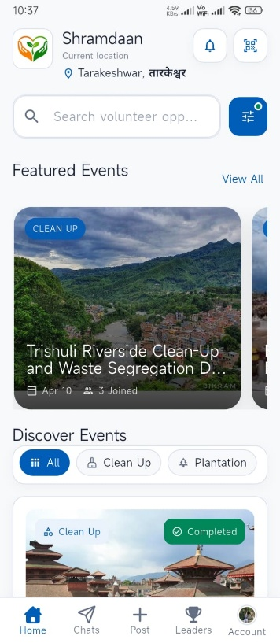
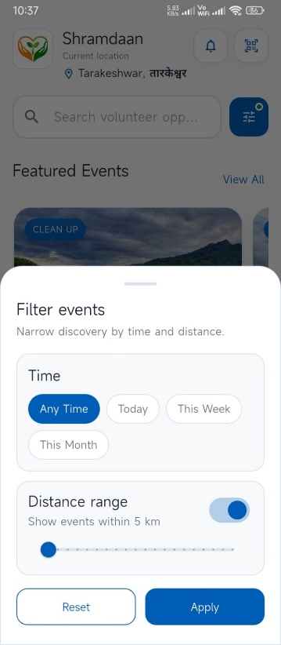
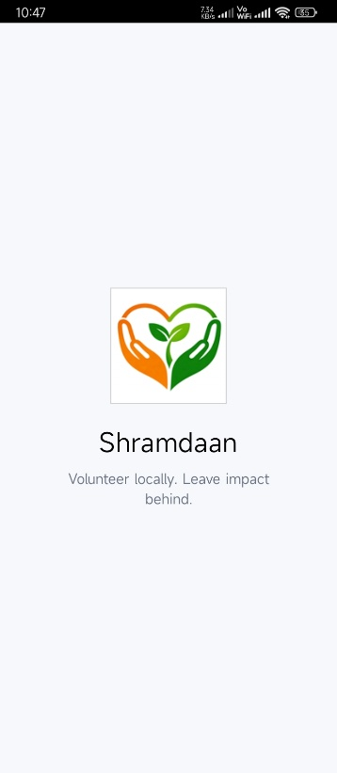
Appendix A: Application Screenshots
Appendix A 6.2 Home screen
Appendix A 6.3: search filter
Appendix A 6.1: Launch Screen
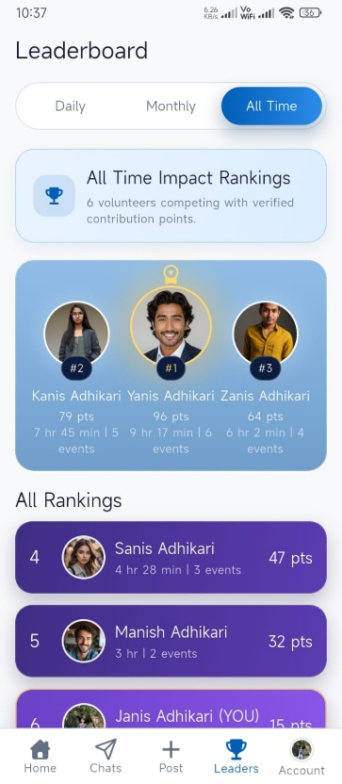
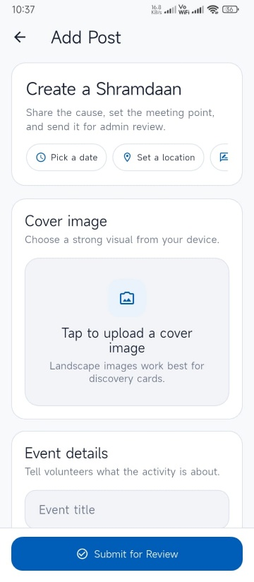
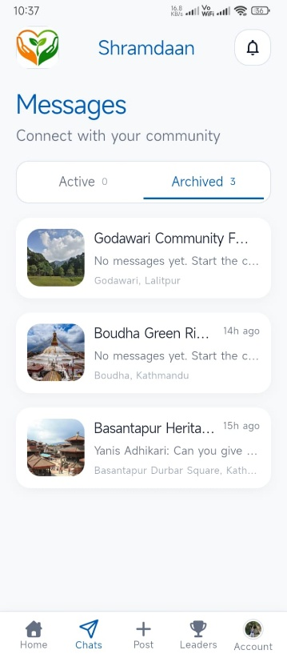
Appendix A 6.6: Leaderboard Screen
Appendix A 6.5: Add post screen
Appendix A 6.4: Chat list screen

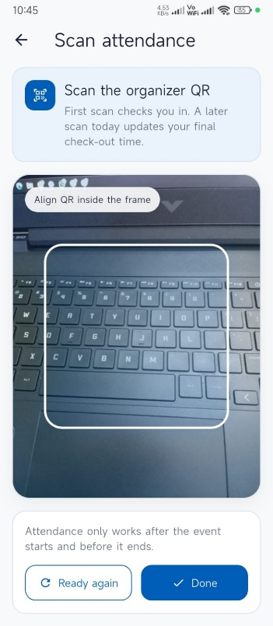
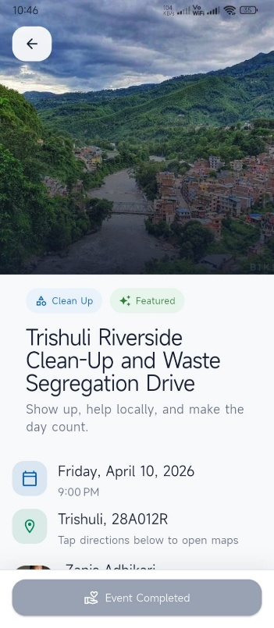
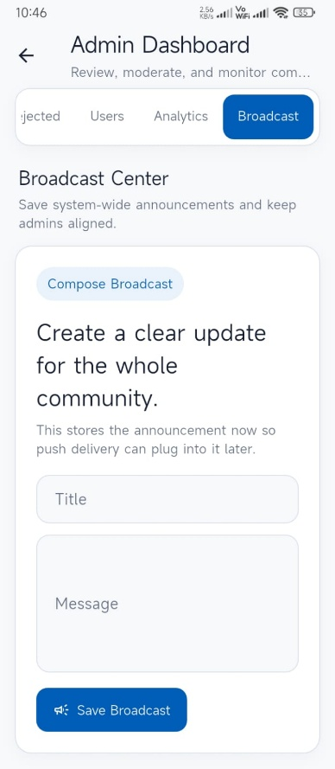
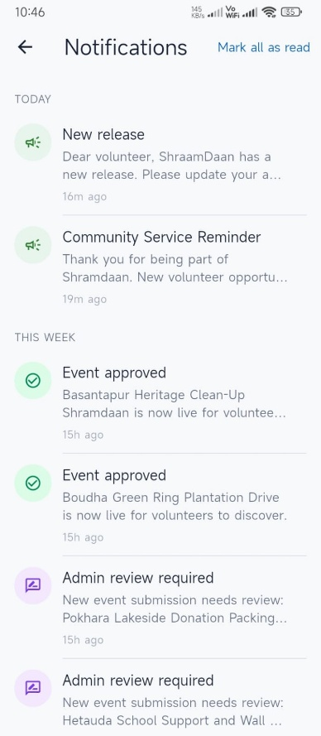
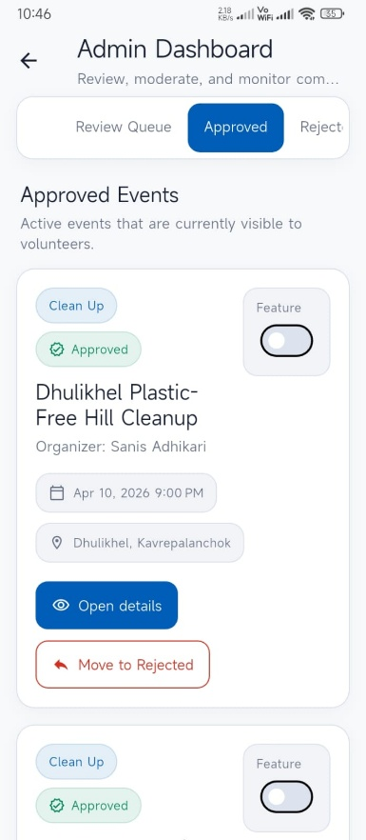
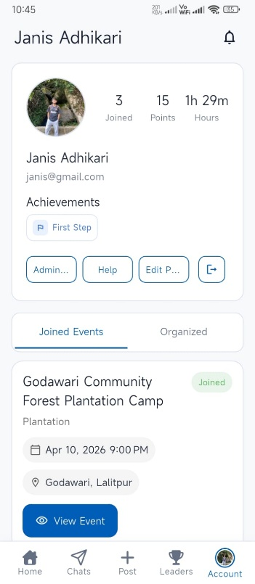
Appendix A 6.8: Scan QR
Appendix A 6.9: Event Detail screen
Appendix A 6.11: Broadcast Notification
Appendix A 6.12: Notification screen
Appendix A 6.10: Admin dashboard
Appendix A 6.7: Private profile

Appendix B: Code Snippets
B.1 Firebase Initialization and App Bootstrap
This snippet shows the application's startup flow, Firebase initialization, Firestore offline caching, and Firebase Messaging background registration.
Source: lib/main.dart
Future<void> _firebaseMessagingBackgroundHandler(RemoteMessage message) async {
await Firebase.initializeApp(options: DefaultFirebaseOptions.currentPlatform);
}

Future<void> main() async {
WidgetsFlutterBinding.ensureInitialized();
await Firebase.initializeApp(options: DefaultFirebaseOptions.currentPlatform);
FirebaseFirestore.instance.settings = const Settings(
persistenceEnabled: true,
cacheSizeBytes: Settings.CACHE_SIZE_UNLIMITED,
);
FirebaseMessaging.onBackgroundMessage(_firebaseMessagingBackgroundHandler);
await NotificationService.instance.initializePlatformNotifications();

runApp(const ShramDaanApp());
}

B.2 Event Submission to Firestore
This snippet shows the event document structure used when users submit new posts for admin review.
Source: lib/shared/services/firestore_service.dart
Future<void> addEvent({
required String title,
required String description,
required String location,
required String formattedAddress,
required double latitude,
required double longitude,
required DateTime eventDate,
required String category,
required String organizerId,
required String organizerName,
required String imageUrl,
required List<String> thingsToCarry,
required List<String> thingsProvided,
}) async {
await _db.collection('events').add({
'title': title,
'title_lowercase': title.toLowerCase(),
'description': description,
'location': location,
'formattedAddress': formattedAddress,
'latitude': latitude,
'longitude': longitude,
'eventDate': Timestamp.fromDate(eventDate),
'category': category,
'organizerId': organizerId,
'organizerName': organizerName,
'imageUrl': imageUrl,
'thingsToCarry': thingsToCarry,
'thingsProvided': thingsProvided,
'status': 'pending',
'reviewRequestedAt': FieldValue.serverTimestamp(),
'rejectionReason': null,
'isFeatured': false,
});
}

B.3 User Registration with Firebase Authentication and Firestore
This excerpt demonstrates how the app creates a Firebase Auth account and then stores structured user information in Firestore.
Source: lib/features/auth/services/auth_service.dart
Future<User?> signUpWithEmailAndPassword(
String email,
String password,
String fullName,
String? phoneNumber,
DateTime? dob,
String? gender,
) async {
try {
UserCredential userCredential = await _auth.createUserWithEmailAndPassword(
email: email,
password: password,
);

await userCredential.user?.updateDisplayName(fullName);
await userCredential.user?.reload();

if (userCredential.user != null) {
await _firestore.collection('users').doc(userCredential.user!.uid).set({
'uid': userCredential.user!.uid,
'displayName': fullName,
'email': email,
'phoneNumber': phoneNumber ?? '',
'dob': dob != null ? Timestamp.fromDate(dob) : null,
'gender': gender ?? '',
'role': 'volunteer',
'isBanned': false,
'createdAt': FieldValue.serverTimestamp(),
});
}

return _auth.currentUser;
} on FirebaseAuthException {
return null;
}
}
B.4 Event Search and Filtering Logic
This code shows how approved events are fetched from Firestore and then filtered by category, title keywords, and location text.
Source: lib/shared/services/firestore_service.dart
Stream<List<Event>> getEventsStream({String? category, String? searchQuery}) {
Query query = _db.collection('events').where('status', isEqualTo: 'approved');

if (category != null && category != 'All') {
query = query.where('category', isEqualTo: category);
}

return query.snapshots().map((snapshot) {
final events = snapshot.docs
.map((doc) => Event.fromMap(doc.id, doc.data() as Map<String, dynamic>))
.toList();

final normalizedQuery = searchQuery?.trim().toLowerCase() ?? '';
final filteredEvents = normalizedQuery.isEmpty
? events
: events.where((event) {
final title = event.title.toLowerCase();
final location = event.location.toLowerCase();
final address = event.formattedAddress.toLowerCase();
final titleWords = title
.split(RegExp(r'[^a-z0-9]+'))
.where((word) => word.isNotEmpty)
.toList();

final queryWords = normalizedQuery
.split(RegExp(r'\s+'))
.where((word) => word.isNotEmpty)
.toList();

final locationMatches =
location.contains(normalizedQuery) || address.contains(normalizedQuery);

final titleMatches = title.contains(normalizedQuery) ||
queryWords.any(
(queryWord) => titleWords.any(
(titleWord) =>
titleWord.contains(queryWord) ||
queryWord.contains(titleWord),
),
);

return titleMatches || locationMatches;
}).toList();

filteredEvents.sort((a, b) => a.eventDate.compareTo(b.eventDate));
return filteredEvents;
});
}

B.5 Attendance Check-In and Check-Out Logic
This is one of the most important snippets in the project because it proves how a QR scan becomes either a check-in or a check-out record.
Source: lib/shared/services/firestore_service.dart
Future<AttendanceRecord> recordAttendanceScan({
required String volunteerId,
required String eventId,
DateTime? now,
}) async {
final currentTime = now ?? DateTime.now();
final event = await getEventById(eventId);
if (event == null || !event.isAttendanceOpen) {
throw Exception('Attendance scanning is unavailable for this event.');
}

final dayStart = DateTime(currentTime.year, currentTime.month, currentTime.day);
final recordId = _attendanceRecordId(
volunteerId: volunteerId,
eventId: eventId,
date: currentTime,
);

final recordRef = _db.collection('attendance').doc(recordId);
final existingSnapshot = await recordRef.get();
final existingData = existingSnapshot.data();

if (!existingSnapshot.exists || existingData == null) {
final createdData = {
'volunteer_id': volunteerId,
'event_id': eventId,
'attendance_date': Timestamp.fromDate(dayStart),
'check_in_time': Timestamp.fromDate(currentTime),
'check_out_time': null,
'updated_at': FieldValue.serverTimestamp(),
};
await recordRef.set(createdData);
return AttendanceRecord.fromMap(recordId, createdData);
}

await recordRef.update({
'check_out_time': Timestamp.fromDate(currentTime),
'updated_at': FieldValue.serverTimestamp(),
});

return AttendanceRecord.fromMap(recordId, {
...existingData,
'check_out_time': Timestamp.fromDate(currentTime),
});
}

B.6 Event Chat Message and Notification Flow
This excerpt shows the relationship between real-time chat, per-user chat summaries, and notification creation.
Source: lib/shared/services/firestore_service.dart
Future<void> sendMessage(String eventId, ChatMessage message) async {
await _db.collection('events').doc(eventId).collection('messages').add(message.toMap());

final participants = await _db
.collection('rsvps')
.where('eventId', isEqualTo: eventId)
.get();

final recipientIds = participants.docs
.map((doc) => doc.data()['userId'] as String)
.where((userId) => userId != message.senderId)
.toSet();

final eventDoc = await _db.collection('events').doc(eventId).get();
final eventTitle = eventDoc.data()?['title'] ?? 'an event';

await _db.collection('users').doc(message.senderId).collection('chatSummaries').doc(eventId).set({
'eventId': eventId,
'latestMessageText': message.text,
'latestSenderName': message.senderName,
'latestMessageAt': message.timestamp,
'unreadCount': 0,
}, SetOptions(merge: true));

for (final userId in recipientIds) {
await createNotification(
userId: userId,
title: 'New chat message',
body: '${message.senderName} sent a message in $eventTitle.',
type: 'chat_message',
targetId: eventId,
actorUserId: message.senderId,
);
}
}

B.7 Firestore Composite Index Manifest
This shows the backend indexing support required for important Firestore queries used by the application.
Source: firestore.indexes.json
{
"indexes": [
{
"collectionGroup": "events",
"queryScope": "COLLECTION",
"fields": [
{ "fieldPath": "status", "order": "ASCENDING" },
{ "fieldPath": "category", "order": "ASCENDING" },
{ "fieldPath": "eventDate", "order": "ASCENDING" }
]
},
{
"collectionGroup": "events",
"queryScope": "COLLECTION",
"fields": [
{ "fieldPath": "status", "order": "ASCENDING" },
{ "fieldPath": "isFeatured", "order": "ASCENDING" }
]
}
],
"fieldOverrides": []
}

