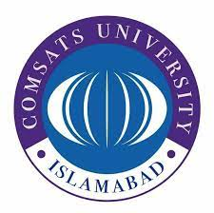
COMSATS UNIVERSITY ISLAMABAD
[Vehari Campus]

ASSIGNMENT 3
Profiles of Famous Volunteers
& Activists in Social Welfare
One National & Two International

Submitted To | Dr. Zoobia
Subject | Civics Engagement
Submitted By | Ghazala Ismail
Reg. Number | FA25-BEN-008
Semester | 2nd Semester
Date | April 2026

National Volunteer — Pakistan
Malala Yousafzai
Nobel Peace Prize Laureate | Champion of Girls’ Education | UN Messenger of Peace

 | QUICK FACTS
  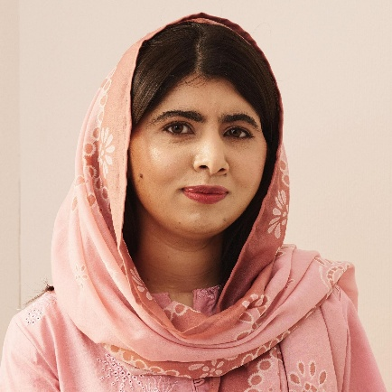
  Born | July 12, 1997
  Birthplace | Mingora, Swat, Pakistan
  Nationality | Pakistani
  Education | PPE, University of Oxford
  Nobel Prize | 2014 (Youngest Ever)
  UN Role | Messenger of Peace

“One child, one teacher, one book, one pen can change the world.”
— Malala Yousafzai, United Nations Youth Assembly, 2013
Ⅰ | WHO IS MALALA?

Malala Yousafzai is a Pakistani education activist and the youngest-ever Nobel Peace Prize laureate. She rose to global prominence after surviving a Taliban assassination attempt in October 2012, when she was shot at the age of 15 for advocating girls’ right to education in Pakistan’s Swat Valley. Her courage transformed her into a worldwide symbol of resilience. She co-founded the Malala Fund with her father and serves as its Executive Chair and Board Chair, working across eight priority countries to dismantle barriers keeping girls out of school. The United Nations designated her a Messenger of Peace in 2017. She graduated from the University of Oxford in 2020 with a degree in Philosophy, Politics and Economics. As of 2026, she continues to address world leaders at international forums, most recently speaking at the UN International Women’s Day commemoration in March 2026, advocating for Afghan girls and speaking against gender apartheid.

Ⅱ | ORGANIZATION

Organization | Malala Fund
Founded | 2013 — Co-founded with father Ziauddin Yousafzai
Mission | Ensure 12 years of free, safe, and quality education for every girl worldwide through advocacy, funding, and amplifying girls’ voices.
Website | https://malala.org

Ⅲ | KEY RESPONSIBILITIES

► | Executive Chair and Board Chair of Malala Fund, overseeing global strategy, fundraising, and advocacy for girls’ education across eight priority countries.
► | Leads the Education Champion Network, investing directly in local activists and educators in Pakistan, Afghanistan, Nigeria, India, Brazil, Ethiopia, Lebanon, and Turkey.
► | United Nations Messenger of Peace (since 2017), raising worldwide awareness about girls’ education and gender equality.
► | Campaigns at international forums — UN General Assembly, G7 Summits, the Commission on the Status of Women, and the Transforming Education Summit — for increased government funding and legislative action.
► | Advocates against gender apartheid, demanding rights for Afghan girls and women banned from secondary and higher education by the Taliban.
► | Collaborates with partners such as Apple Inc., Bill & Melinda Gates Foundation, World Bank, and Brookings Institution on research and policy initiatives.

Ⅳ | MAJOR WORK & ACHIEVEMENTS

► | Survived a Taliban assassination attempt on October 9, 2012, sparking an international movement. In Pakistan, over 2 million people signed a Right to Education petition and the National Assembly ratified the first Right to Free and Compulsory Education Bill.
► | Helped secure a $2.9 billion commitment for girls’ education from G7 countries and the World Bank in June 2018 — one of the largest financial pledges for girls’ education in history.
► | Partnered with Apple Inc. (2018) to expand Malala Fund into India and Latin America, providing technology and curriculum development with the goal of reaching over 100,000 girls.
► | Authored the international bestseller “I Am Malala” (2013), translated into dozens of languages, and was featured in the Oscar-shortlisted documentary “He Named Me Malala” (2015).
► | Addressed the UN International Women’s Day commemoration in March 2026, calling on leaders to recognize gender apartheid and stand with Afghan girls.
► | Launched Assembly, a digital publication by and for girls, amplifying young women’s voices and stories worldwide.

Ⅴ | AWARDS & HONORS

► | Nobel Peace Prize (2014) — Youngest-ever laureate, jointly with Kailash Satyarthi.
► | Pakistan’s National Youth Peace Prize (2011) — First recipient; later renamed National Malala Peace Prize.
► | Sakharov Prize for Freedom of Thought (2013) — European Parliament.
► | Honorary Canadian Citizenship (2017) — Youngest person to address the Canadian Parliament.
► | WHYY Lifelong Learning Award (2026) — For lifelong commitment to education advocacy.
International Volunteer — Sweden
Greta Thunberg
Climate Activist | Founder of Fridays for Future | Environmental Justice Advocate

 | QUICK FACTS
  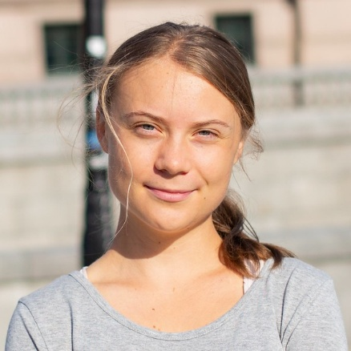
  Born | January 3, 2003
  Birthplace | Stockholm, Sweden
  Nationality | Swedish
  Education | Secondary School, Stockholm
  TIME POTY | 2019 (Youngest Ever)
  Movement | Fridays for Future

“I want you to act as if the house is on fire, because it is.”
— Greta Thunberg, World Economic Forum, Davos 2019
Ⅰ | WHO IS GRETA?

Greta Thunberg is a Swedish environmental activist who became the face of the global youth climate movement. In August 2018, at just 15 years old, she began a solo protest outside the Swedish Parliament with a sign reading “Skolstrejk för Klimatet” (School Strike for Climate). What started as one teenager sitting alone quickly grew into Fridays for Future, a worldwide movement inspiring millions of students across more than 150 countries to join climate strikes. Thunberg has spoken at the UN Climate Action Summit, the World Economic Forum in Davos, the European Parliament, and numerous COP conferences, delivering blunt, science-based calls for systemic change. She established The Greta Thunberg Foundation in 2019 to channel prize money and donations toward sustainability and justice causes. Her influence on public discourse has been termed “the Greta Effect.” She has also increasingly engaged with broader social justice issues including indigenous rights and humanitarian causes.

Ⅱ | ORGANIZATION

Organization | Fridays for Future / The Greta Thunberg Foundation
Founded | Fridays for Future: August 2018 | Foundation: 2019
Mission | Fridays for Future mobilizes youth worldwide to demand climate action aligned with the Paris Agreement. The Foundation promotes ecological, climatic, and social sustainability by funding grassroots organizations.
Website | https://fridaysforfuture.org | https://thegretathunbergfoundation.org

Ⅲ | KEY RESPONSIBILITIES

► | Founded and inspires Fridays for Future, a youth-led global climate strike network active in 150+ countries with millions of participants demanding science-based climate policies.
► | Manages The Greta Thunberg Foundation, distributing funds to organizations working for ecological sustainability, indigenous rights, climate justice, and mental health awareness.
► | Delivers high-profile speeches at the UN Climate Action Summit, World Economic Forum, European Parliament, and COP conferences to hold leaders accountable.
► | Raises public awareness about the climate crisis through books, social media, and media appearances, making complex science accessible to all ages.
► | Funds grassroots organizations including indigenous Sámi communities, youth climate activists from Most Affected People and Areas (MAPA), and environmental justice movements.
► | Advocates for broader human rights and social justice causes alongside environmental activism.

Ⅳ | MAJOR WORK & ACHIEVEMENTS

► | Launched the global Fridays for Future movement (August 2018) with a solo school strike, growing it into the largest youth-led climate movement in history — an estimated 14 million participants across 7,500+ cities by 2019.
► | Named TIME Magazine’s Person of the Year (2019), becoming the youngest individual ever honoured, for sparking a global climate awakening.
► | Fridays for Future received UNEP’s Champion of the Earth recognition, the UN’s highest environmental honour.
► | Through the Foundation, donated hundreds of thousands of euros to IOM for climate migration relief, indigenous Sámi legal battles, COVAX vaccine equity, and youth activists from the Global South.
► | Authored “The Climate Book” (2022), a comprehensive collection featuring over 100 scientists and experts presenting the full scope of the climate crisis and solutions.
► | Her influence, termed “the Greta Effect,” is credited with shifting government policies, corporate behavior, and public attitudes on climate change globally.

Ⅴ | AWARDS & HONORS

► | TIME Person of the Year (2019) — Youngest individual ever to receive the distinction.
► | Right Livelihood Award (2019) — The “Alternative Nobel Prize.”
► | UNEP Champion of the Earth (Fridays for Future).
► | Ambassador of Conscience Award (2019) — Amnesty International’s most prestigious human rights award.
► | International Children’s Peace Prize (2019) — KidsRights Foundation.

International Volunteer — India
Kailash Satyarthi
Nobel Peace Prize Laureate | Crusader Against Child Labour | Champion of Children’s Rights

 | QUICK FACTS
  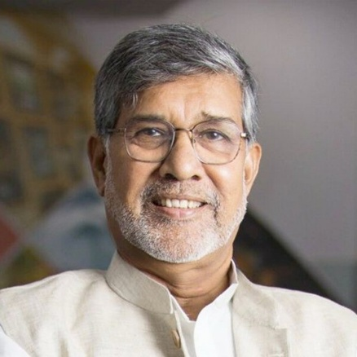
  Born | January 11, 1954
  Birthplace | Vidisha, Madhya Pradesh, India
  Nationality | Indian
  Education | B.E. Electrical Engineering
  Nobel Prize | 2014 (with Malala)
  Children Rescued | 130,000+

“The single biggest thing that can be done for children is to give them their childhood back.”
— Kailash Satyarthi, Nobel Peace Prize Lecture, 2014
Ⅰ | WHO IS KAILASH?

Kailash Satyarthi is an Indian social reformer and Nobel Peace Prize laureate who has dedicated over four decades to ending child labour, slavery, and trafficking worldwide. Born in Vidisha, Madhya Pradesh, he gave up a career in electrical engineering to found Bachpan Bachao Andolan (Save the Childhood Movement) in 1980. Through BBA, his team has directly rescued and rehabilitated over 130,000 children from exploitation across India. Satyarthi’s approach has been radically confrontational — conducting dangerous raids on factories, brick kilns, and carpet workshops to liberate bonded child labourers, often facing violent resistance. Beyond rescue operations, he conceived and led the 1998 Global March Against Child Labour, an 80,000 km march across 103 countries that resulted in ILO Convention 182 on the Worst Forms of Child Labour. He founded GoodWeave International to certify child-labour-free products, and successfully campaigned for India’s Right to Education Act (2009). In 2014, he was awarded the Nobel Peace Prize jointly with Malala Yousafzai. He now leads the Satyarthi Movement for Global Compassion.

Ⅱ | ORGANIZATION

Organization | Kailash Satyarthi Children’s Foundation (KSCF) / Bachpan Bachao Andolan (BBA)
Founded | BBA: 1980 | GoodWeave: 1994 | Global March: 1998 | KSCF: 2004
Mission | To create a world free of violence against children where every child is safe, healthy, educated, and free. KSCF and BBA rescue children from labour and trafficking, rehabilitate survivors, and advocate for systemic policy change.
Website | https://www.kailashsatyarthi.net | https://satyarthi-us.org

Ⅲ | KEY RESPONSIBILITIES

► | Founder and leader of Bachpan Bachao Andolan (BBA), India’s largest anti-trafficking and anti-child-labour grassroots organization, conducting rescue operations and rehabilitation since 1980.
► | Founder and Chairman of Kailash Satyarthi Children’s Foundation (KSCF), addressing violence against children and ensuring every child’s right to safety, health, and education.
► | Architect of the Global March Against Child Labour, the world’s largest civil society network for exploited children across 103 countries.
► | Founding President of the Global Campaign for Education, a movement to end the global education crisis and ensure free, quality public education for every child.
► | Founder of GoodWeave International, the first certification system for child-labour-free carpets and rugs, promoting ethical consumer awareness.
► | Leads the Satyarthi Movement for Global Compassion and the Laureates and Leaders for Children platform, uniting Nobel laureates and world leaders for children’s rights.

Ⅳ | MAJOR WORK & ACHIEVEMENTS

► | Through BBA, directly rescued and rehabilitated over 130,000 children from child labour, slavery, trafficking, and exploitation through dangerous raids on factories, brick kilns, and workshops across India.
► | Conceived and led the 1998 Global March Against Child Labour — 80,000 km across 103 countries with 7 million+ supporters — resulting in ILO Convention 182 (1999), now the only universally ratified convention in ILO history.
► | Founded GoodWeave International (1994), creating the world’s first consumer labelling system for child-labour-free rugs, driving major reductions in child labour in the South Asian carpet industry.
► | Successfully campaigned for India’s Right to Education Act (2009), making free and compulsory education a constitutional right for all children aged 6–14.
► | Launched the Bal Mitra Gram (Child-Friendly Village) programme, establishing 350+ villages where child labour is banned and all children attend school.
► | Led the Bharat Yatra — a 19,000 km march across India in 35 days — demanding stronger legislation against child rape, sexual abuse, and trafficking.

Ⅴ | AWARDS & HONORS

► | Nobel Peace Prize (2014) — Jointly with Malala Yousafzai for the struggle against the suppression of children.
► | Robert F. Kennedy Human Rights Award (1995).
► | Defenders of Democracy Award (2009) — Parliamentarians for Global Action.
► | Medal of the Italian Senate (2007).
► | US State Department “Hero Acting to End Modern Day Slavery” (2007).
► | Fortune Magazine “World’s Greatest Leaders” (2015).

