Automation &
Workflow Excellence
n8n | Power Automate | Custom Integrations

PURPOSE
This document presents a portfolio of production-ready automation workflows designed, built, and deployed by our team. Each workflow is documented with its architecture, technology stack, key capabilities, and a visual diagram of the execution flow. The use cases span AI-powered agents, data pipelines, messaging bots, time tracking analytics, e-commerce automation, and enterprise scheduling systems — demonstrating our ability to deliver end-to-end solutions across diverse business domains.

SCOPE
7 Production Workflows | Across n8n and Power Automate platforms
4+ AI Models Integrated | Claude, Gemini, OpenAI Embeddings, Cohere
5 Platform Expertise | n8n, Power Automate, Zapier, Make, Custom APIs

n8n — Advanced AI-Powered Automation
n8n is our primary platform for building sophisticated, enterprise-grade automation pipelines. Its self-hostable architecture and code-level flexibility allow us to implement complex logic, multi-step AI workflows, and high-volume data processing that other tools simply cannot match. The following workflows demonstrate the breadth and depth of our n8n capabilities.

AI Agent & RAG Pipeline
Stack: n8n · Claude Vision · OpenAI Embeddings · Pinecone · Cohere · Anthropic · SerpAPI · PostgreSQL

A full-scale AI-powered Retrieval-Augmented Generation (RAG) pipeline that handles multi-modal inputs (text and images), dual Pinecone vector store routing, semantic reranking via Cohere, and a production AI Agent with persistent memory. The system processes incoming chat messages, routes them through client-specific and general knowledge bases, and generates contextually grounded responses.
Flow: Chat Message → Fetch History → Client Routing → OpenAI Embeddings → Pinecone Search → Cohere Rerank → Format Context → AI Agent → Response
Key Capabilities
- Dual-path ingestion: image preprocessing via Claude Vision combined with text embeddings via OpenAI
- Two separate Pinecone vector stores for client-specific and general knowledge bases
- Cohere semantic reranking to surface the highest-relevance context chunks
- AI Agent node with Postgres-backed chat memory for persistent conversation history
- Live web search integration via SerpAPI for real-time information grounding
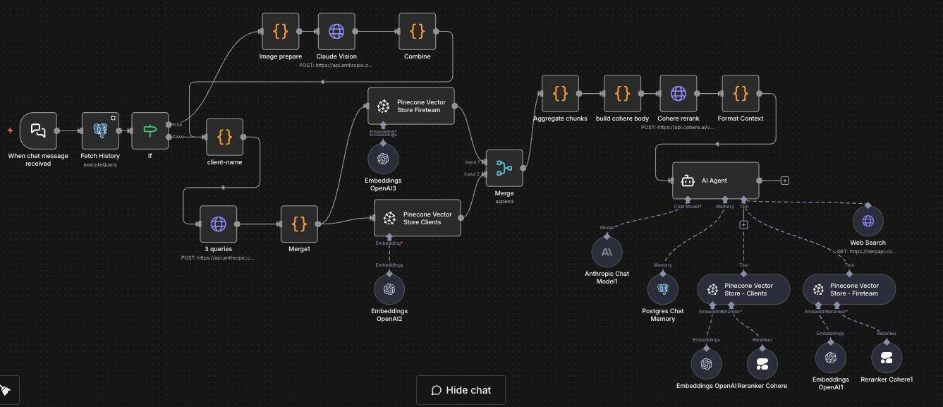
Figure 1: n8n — AI Agent with RAG, Pinecone Vector Stores, Cohere Reranking & OpenAI Embeddings

Data Pipeline: S3 → ClickHouse ETL
Stack: n8n · Amazon S3 · ClickHouse · MongoDB · Gzip · Cron Scheduler

A scheduled data pipeline that extracts compressed CSV files from Amazon S3, transforms and enriches each record with snake_case normalization and composite key generation, then bulk-inserts into ClickHouse — processing over 10,000 items per run with full job tracking and result summaries.
Flow: Schedule Trigger (2 AM) → Prepare Parameters → Download S3 File → Decompress Gzip → Parse CSV → Loop Over Items → Snake Case & Enrich → Generate Composite Key → ClickHouse Insert → Job Results
Key Capabilities
- Scheduled trigger (daily at 2:00 AM) with parameterized S3 file targeting
- On-the-fly Gzip decompression and structured CSV parsing
- Automatic snake_case normalization with fuzzy key matching for ad-platform data
- Loop-based batch processing (100 items per batch) with composite key generation
- Dual-destination writes: MongoDB upsert and ClickHouse bulk insert in parallel
- Job result tracking with total rows, duration, and rows-per-second metrics
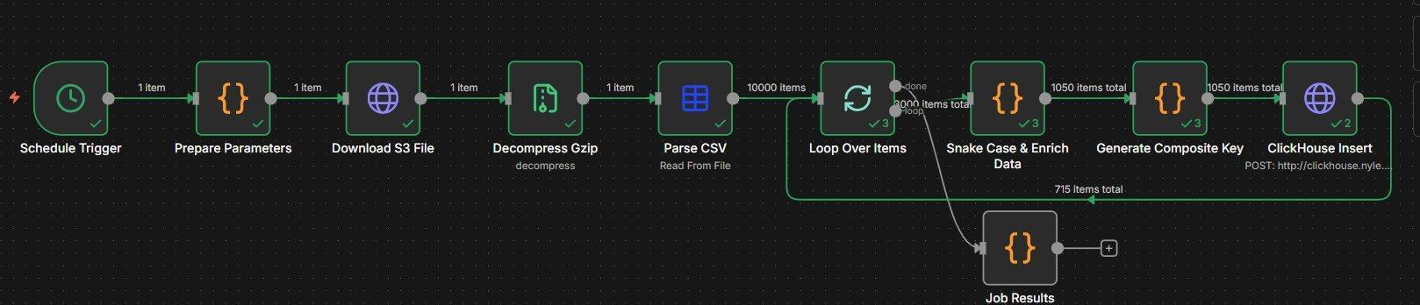
Figure 2: n8n — Scheduled S3 Download, Gzip Decompress, CSV Parse & ClickHouse Bulk Insert Pipeline

AI Slack Bot with Google Gemini
Stack: n8n · Slack API · Google Gemini 1.5 Flash · Webhook · Window Buffer Memory

An intelligent Slack bot powered by Google Gemini that receives messages via a POST webhook, processes them through an AI Agent with conversational memory, and sends contextual responses back to the originating Slack channel. The bot maintains conversation history using the Slack token as a session identifier, enabling multi-turn conversations.
Flow: Slack POST Webhook → AI Agent (Gemini + Buffer Memory) → Send Response to Slack Channel
Key Capabilities
- POST webhook endpoint configured with HTTPS for Slack event subscriptions
- AI Agent with customizable system prompt for company-specific assistance
- Window Buffer Memory with 10-message context window for conversation continuity
- Session management using Slack body token as the unique chat session identifier
- Asynchronous response pattern: sends new message to avoid Slack’s 3-second timeout
- Extensible architecture — ready for custom tools and data source integrations
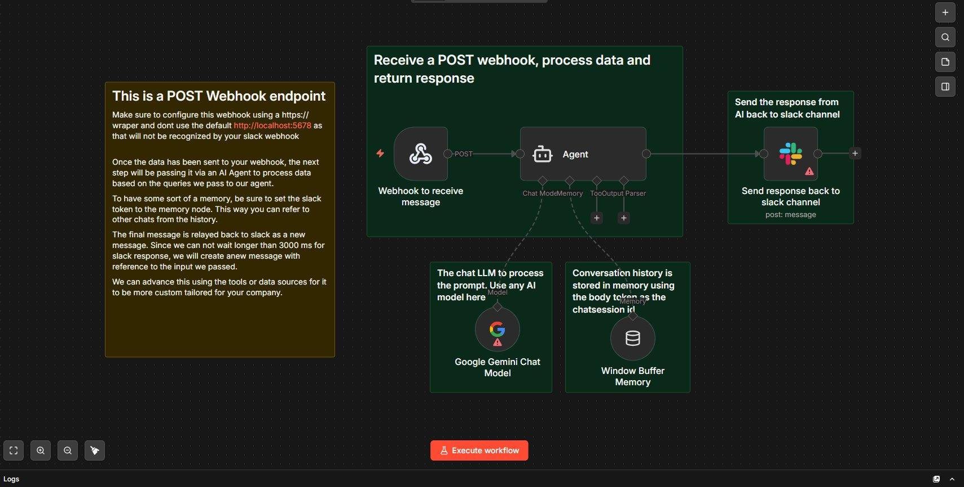
Figure 3: n8n — AI Slack Bot with Google Gemini, Webhook & Conversational Memory

Harvest Time Tracking Analysis & Slack Reporting
Stack: n8n · Harvest API · Google Gemini · Anthropic Claude · Slack API

An automated time tracking analysis pipeline that pulls daily time entries from Harvest, aggregates data by project, task, user, and client, then sends the data to an AI model (Google Gemini or Claude) for executive-level analysis. The final formatted report — with billable/non-billable breakdowns and AI-generated insights — is posted directly to a Slack leadership channel.
Flow: Manual Trigger → Workflow Config → Get Harvest Entries (234 items) → Filter Fields → Aggregate Data → Analyze with AI → Send Report to Slack
Key Capabilities
- Pulls all time entries from Harvest for the previous day with configurable date range
- Aggregates hours by project, task, user, and client with billable vs. non-billable split
- Ranks top 10 projects, tasks, and clients by total hours logged
- AI-powered analysis via Google Gemini (with Anthropic Claude as backup) producing executive summaries
- Formatted Slack message with quick stats, top 5 projects, and AI-generated insights
- Dual-LLM architecture: easily switchable between Gemini and Claude models
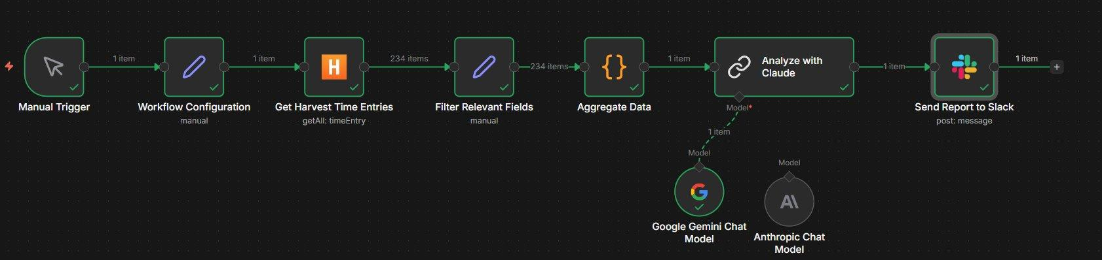
Figure 4: n8n — Harvest Time Tracking → AI Analysis → Slack Report Pipeline

WhatsApp Order Automation
Stack: n8n · WhatsApp Business API · Webhook · REST API · Custom Code

A conversational commerce workflow that enables customers to browse menus, place orders, and track deliveries entirely via WhatsApp. The system listens for incoming messages through a webhook, routes them through a multi-branch decision tree based on message content, and interacts with a backend order management API.
Flow: WhatsApp Webhook → Message Router → [Menu: Get Products → Send Menu] / [Order: Parse → Create Order] / [Track: Get Customer Orders]
Key Capabilities
- Three-branch message routing: “menu” for browsing, order patterns (e.g. “2x3”) for placing, “track” for status
- Regex-based order parsing: extracts item IDs and quantities from natural text patterns
- Dynamic menu generation: fetches live product catalog from backend API and formats for WhatsApp
- Automatic order creation via REST API with customer phone number association
- Order tracking by phone number lookup for existing customer records
- Always-on webhook for real-time message processing with zero downtime
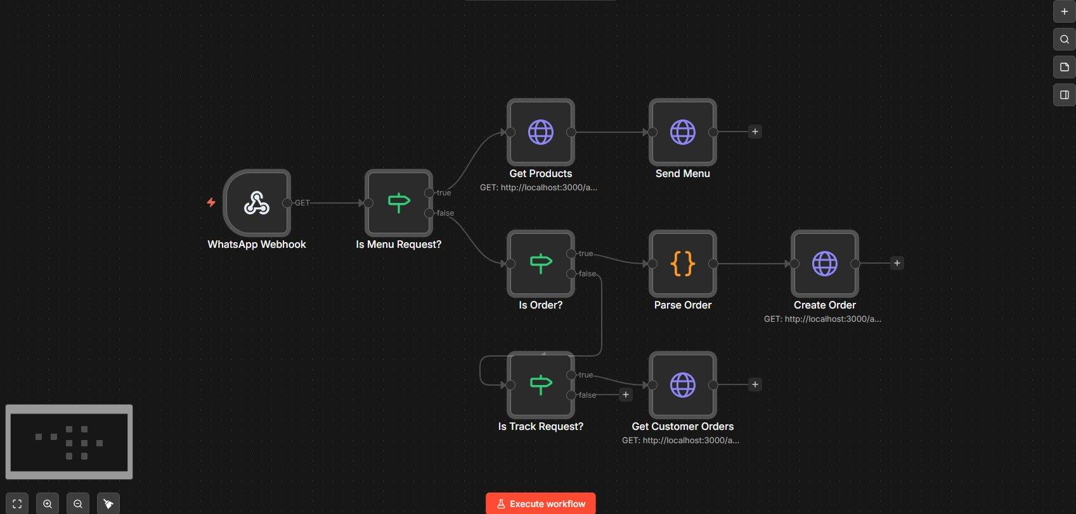
Figure 5: n8n — WhatsApp Order Automation with Menu, Order & Tracking Flows

e-Boekhouden Invoice Automation
Stack: n8n · e-Boekhouden API · Webhook · Custom Code · 39 Nodes

A complex invoicing automation workflow that integrates a webshop with the e-Boekhouden accounting platform. When a new booking or order arrives via webhook, the system authenticates with e-Boekhouden, checks if the customer already exists, creates new relations if needed, and generates invoices across multiple service types with automatic discount calculations.
Flow: Webshop Webhook → New Session → Get Templates/Ledgers → Find or Create Relation → Route by Type → [Branch 1: TGD Invoice] / [Branch 2: Nicole Invoice] / [Branch 3: TGD2 Invoice] → Calculate Discounts → Create Invoice
Key Capabilities
- Webshop webhook triggers the full invoicing pipeline on each new order
- Session-based authentication with the e-Boekhouden API (token management)
- Automatic customer lookup by email with conditional relation creation for new clients
- Multi-type invoice routing: splits orders into TGD invoices vs. Nicole Den Harder invoices based on service type
- Three parallel invoice creation branches handling different service categories
- Automatic discount calculations, item aggregation, and invoice summary generation
- Full template support: pulls email templates, invoice templates, and ledger codes dynamically
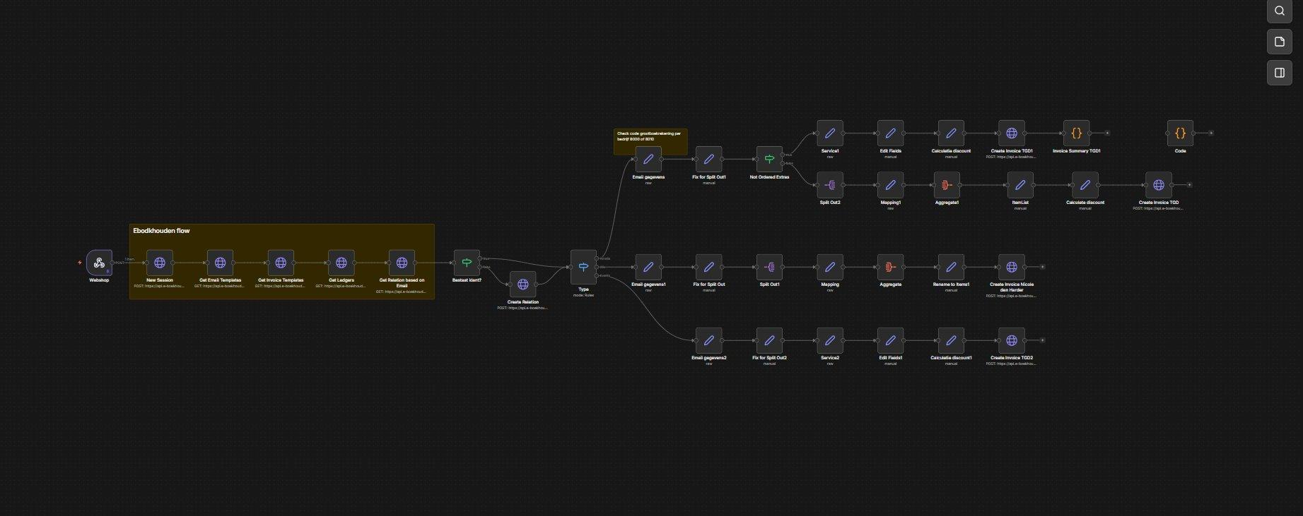
Figure 6: n8n — e-Boekhouden Invoice Automation (39 nodes, multi-branch invoicing pipeline)

Microsoft Power Automate — Case Study
Power Automate is our platform of choice for Microsoft 365-integrated workflows, enterprise approval chains, and communication-driven automations. Below is a live production deployment we delivered — a fully closed-loop Appointment Automation & Patient Engagement System.

Appointment Automation & Patient Engagement System
Stack: Power Automate · Azure Functions (Python) · Twilio · SharePoint · Microsoft Graph API · Outlook

The system automates the entire patient journey across three phases — Outreach, Booking, and Retention — eliminating manual scheduling overhead and reducing no-show rates through timely reminders. Deployed for Still Waters Professional Counseling Services.

Phase 1 — Outreach: Automated Invitation Dispatch
- Power Automate flow runs on a daily recurrence trigger (9:00 AM)
- Reads the SharePoint Excel Master List and filters patients where Invite_Sent ≠ ‘Yes’
- Triggers Twilio SMS to each new referral containing a personalised booking web link
- Immediately updates the Excel row to Invite_Sent = ‘Yes’ — ensuring zero duplicate messages

Phase 2 — Booking: Azure-Powered Scheduling Backend
- Patient clicks the SMS link and views real-time slot availability fetched from Outlook Calendar via Azure Functions (Python 3.9+)
- On slot selection, Azure Function creates the calendar event and blocks capacity
- Intake flow targets the single ‘Clinic Schedule’ calendar; Physician flow supports multi-capacity concurrent bookings
- Azure Function locates the patient record in SharePoint Excel by phone number and writes booking confirmation

Phase 3 — Retention: 24-Hour Reminder Automation
- Second Power Automate flow runs daily at 8:00 AM
- Queries SharePoint for all rows where Booked = ‘True’
- Calculates time delta between Appointment_Date and current time — fires if appointment is within 24 hours
- Sends Twilio SMS reminder with dynamic appointment slot variable
- Sends Outlook Email reminder to the patient’s registered email address

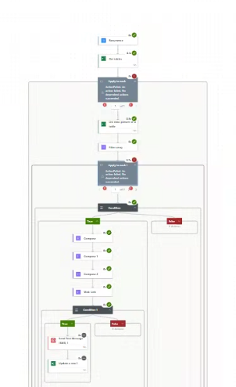
Figure 7: Power Automate — Appointment Automation Flow (Outreach, Booking & Reminder)

