Spec-Driven Development (SDD)
A brief: how we can run SDD in our own environment, on an internal AI platform
The idea
SDD makes the SPEC the single source of truth. A conceptual design becomes a precise spec (behaviour + acceptance criteria); the implementation is built to that spec with AI assistance; nothing is “done” until it is PROVEN against the spec. Everyone works from the spec, not from someone's code. The language or stack is irrelevant — the method is what matters.
Why it is safe here — the discipline
The core rule: access is not acceptance — acceptance is earned through proof. Every change is classified honestly (done / partially done / scaffolded / unproven) and must meet a proof bar appropriate to its type before it is called shipped. That is what makes AI-assisted delivery trustworthy in a regulated environment: speed without losing truth. The enemy we explicitly guard against is false completion — work claimed done but not proven.
It fits our environment — no new infrastructure
It runs on the internal, sanctioned AI platform we already have, inside the security boundary. No data leaves the building. No new model to procure. SDD is a method, not a tool stack — it rides on top of our existing versioning, CI/CD, containers, and vendor delivery, and composes with the BA → dev → QA pipeline rather than replacing any of it.
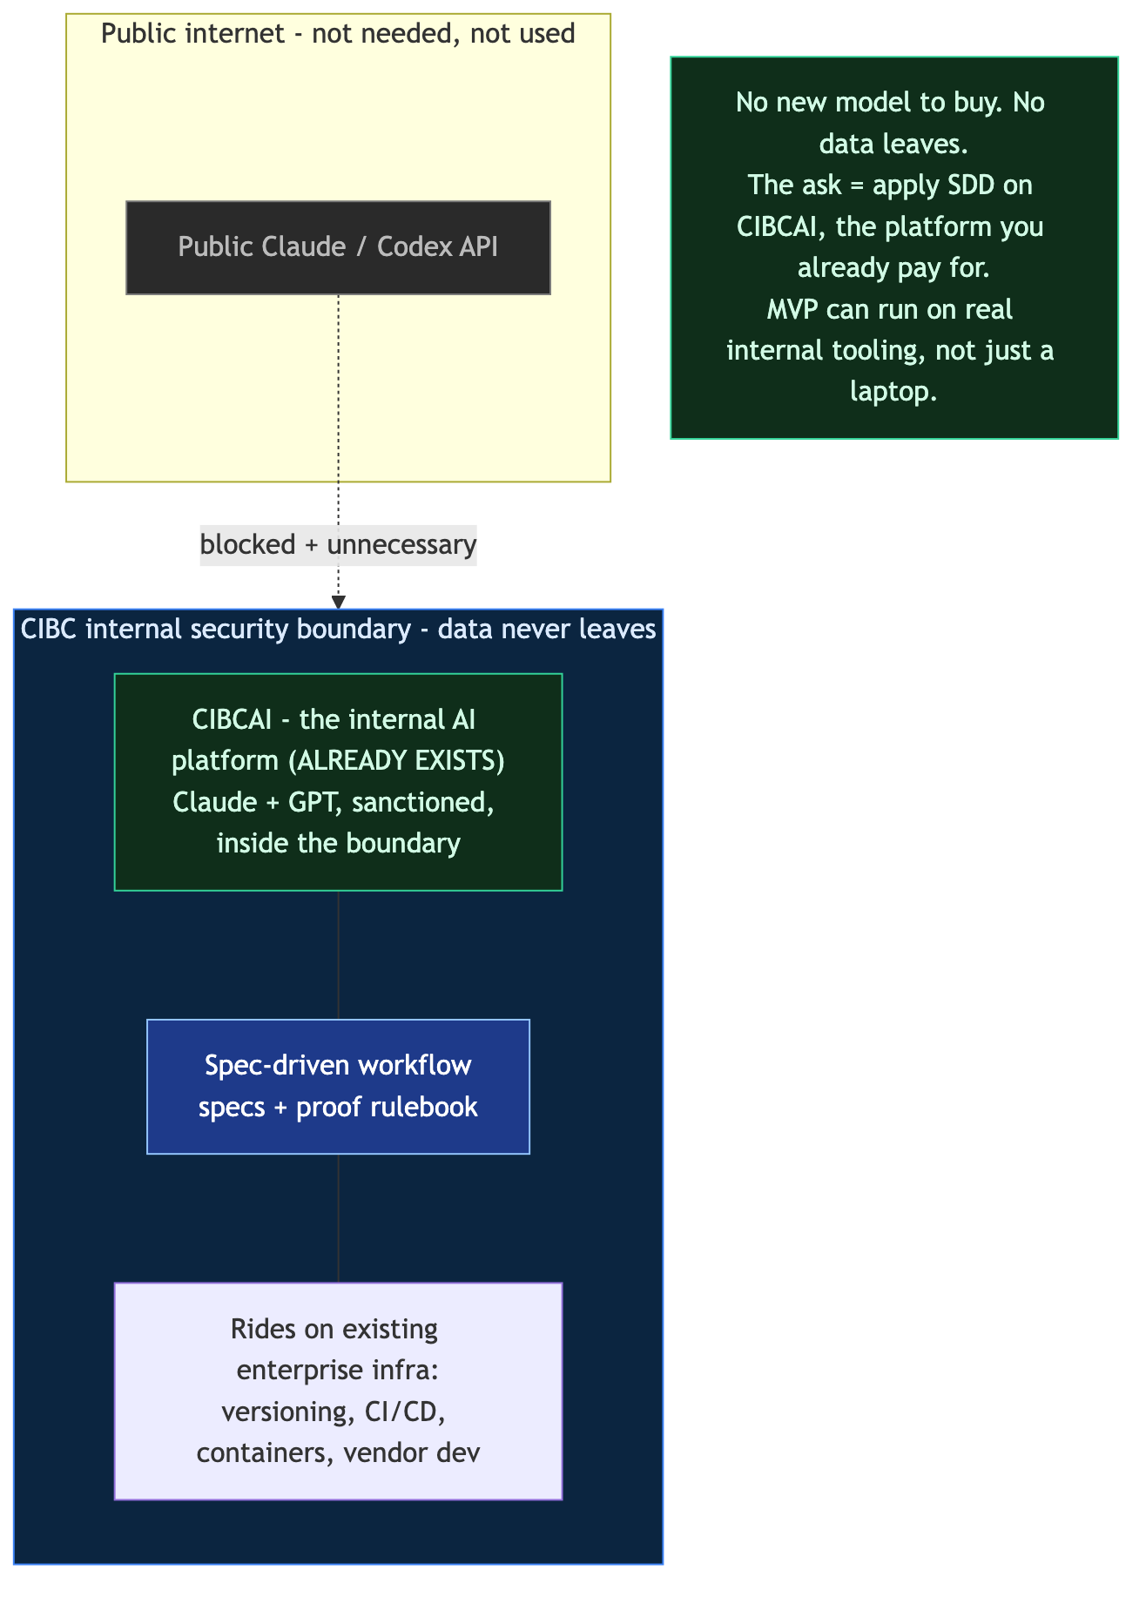
The method, one loop
Orient (read the map) → write the spec with acceptance criteria → build to the spec → prove against the criteria → persist the decisions back into the docs so context compounds. Repeat.
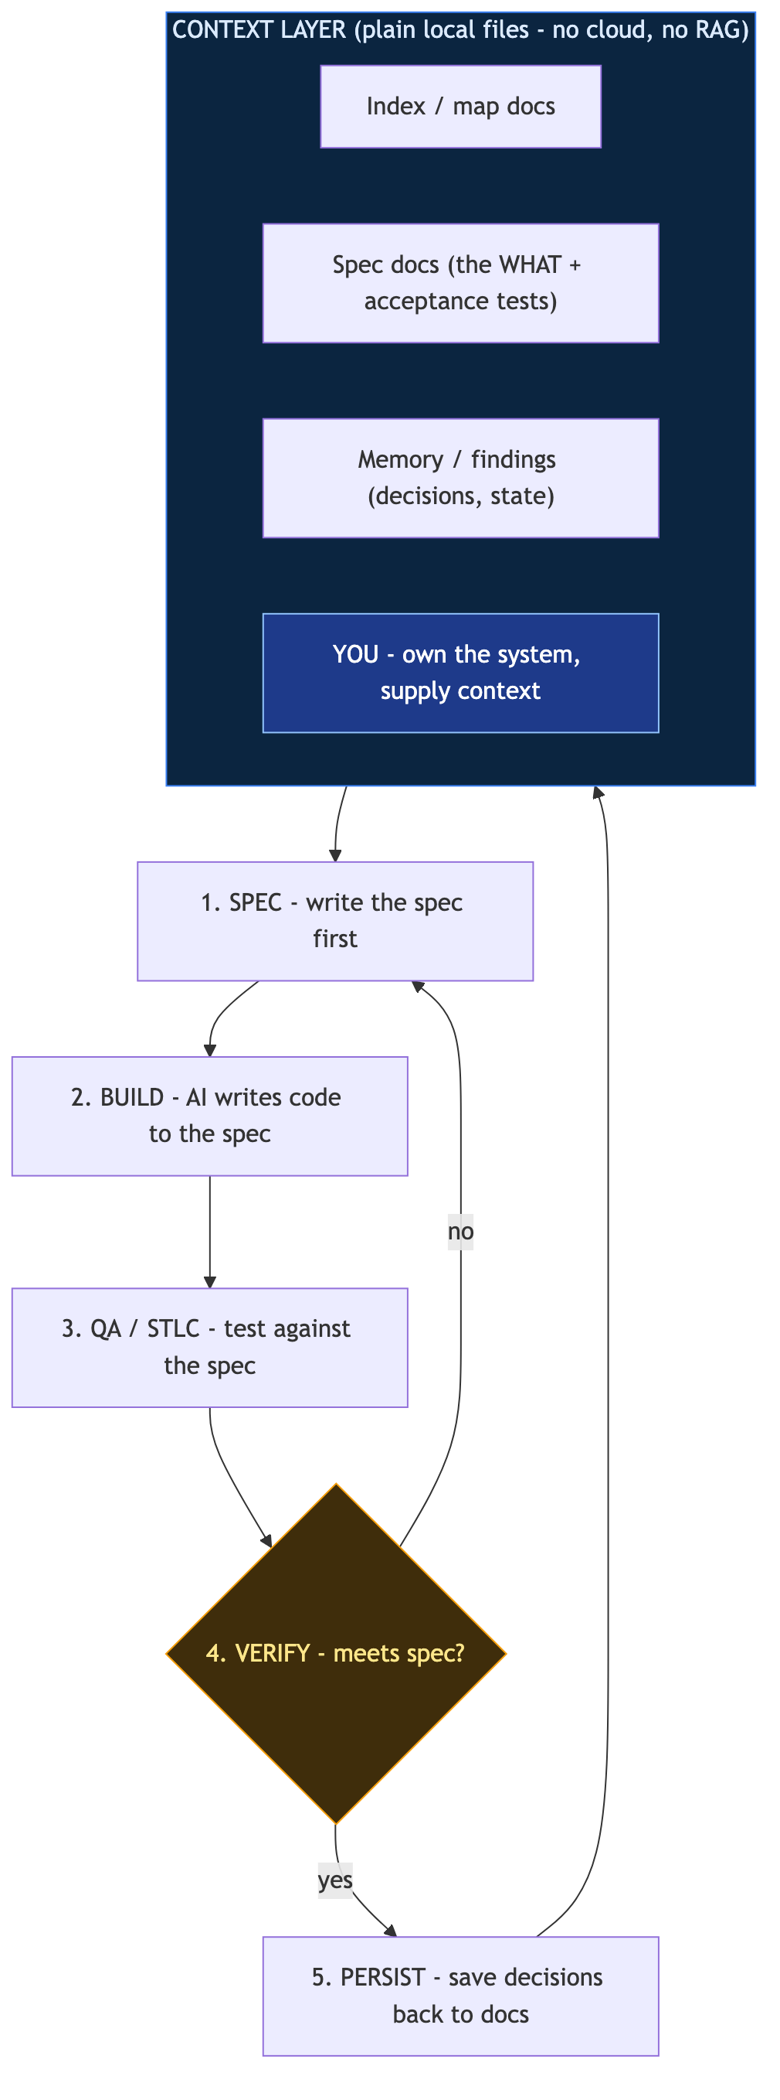
The MVP proposal (bounded)
Take ONE well-bounded function for which a conceptual design already exists, derive its spec, and produce proven logic via SDD — small, self-contained, in days not months. A concrete demonstration that the method works inside our environment on a real, bounded piece of work. (The function and its spec come from the team — nothing assumed here.)
The ask
A small bounded slice + access to the internal AI platform for the demo. Outcome: a working, proven artifact plus a repeatable method the existing BA / dev / QA pipeline can adopt.

