

Database Systems (IT3020)

3rd Year, 1st Semester

Assignment 1

Submitted to

Sri Lanka Institute of Information Technology

IT18116052

D.D.T.D.Dureksha

Bachelor of Science Special Honors Degree in Information Technology

06.04.2020

Table of Contents

Function Description 3

Document data requirements 4

EER Diagram 5

Object Relational Model 6

Develop a Database in Oracle and Insert Sample data 7

Type creation queries 7

Table creation queries 9

Insertion queries 10

Member methods 14

SQL queries that are useful for end users of the System 20

All Tables details 25

Screen prints 28

# Function Description

1. Adolescent details management

Each and every adolescent referred to a doctor to his treatments. Adolescent has a special schedule that has to strictly follow. All adolescents have a guardian. To some adolescents can be having more than one guardian. guardian should pay the payments for adolescent. Guardians who do not have receive “Samurdhi” fund are entitled to a discount on payments and other guardians pay the full amount.

1. Doctor management

The database contains the details of all doctors. Every doctor has a patient for treatments. There can be many Adolescents assigned to a doctor. However, at least there should be a one patient. the doctor should prepare a medical report after examining the patient. there is a prescribed fee for each visit to the doctor. The fee is based on channeling hours. As the hours increase, the doctor will receive an additional fee. If doctor provide extra service time, the fee increases at a prescribed OT rate.

1. Medical record management

Doctors are created medical records according to the patient. medical records are contained the Adolescents details, report issuing date and name of the issuing doctor.

1. Schedule management

Adolescent patients have to follow schedule. The schedule is provided by doctor. There are three main parts of schedule. Those are leisure schedule, study schedule and social schedule. Schedule has activities.

1. Activity management

Adolescents can manage their leisure, study and social time activities according to the schedule. Doctors are able to add new activities for adolescents. Guardians and doctors are able to see adolescents’ activity completion progress. Application will suggest most preferred activities when adolescent get bored. Adolescent are able to select their preferred activities. Each and every activity has a measurement rate. The rate goes up depending on the adolescent performance.

# Document data requirements

This system will bring the Adolescents, Guardians and Doctors together. So that the adolescents’ in need of attention are monitored effectively.

The doctors, in this system has special treating methods for adolescents, with different types of mental disorders varying from mild to severe. One of the main non medicinal method, doctors use to help these adolescents is making sure that they perform day to day activities of an adolescent under the supervision of their guardians or doctors. Day to day activities means social activities and leisure time activities.

Consider on ADOLESCENT_PSYCHIATRIST database system in which actors (Adolescents, Doctors and Guardians) participate in the treatments system. The data requirements for this system are summarized as follows:

* The system has adolescents, each of whom is identified by a unique adolescent number (ano) and is described by a name, date of birth and his/her payment free.
* An adolescent has a guardian. Some times it can be more guardians. Guardian has name. income, mobile and mention whether he has or not Samurdhi.
* Every adolescent assigned to a doctor. Doctor identify by a doctor ID (doctorid), doctor name, description and also, he/she has a charge per visit.
* Adolescent has medical record which create doctor. Information about medical records include record ID (recordid) and recorded date.
* Every adolescent has to follow schedule. The schedule can be categorized into leisure and social. (ISA relationship). Information about schedule includes schedule number (schedule_no), schedule type and schedule type.
* Schedule has many activities. Activity number (activity_no), activity name and rate for the activity (arate) are recorded under Activity.
* Activity has grades and also adolescent has to earn those grades. Grade contains grade id (gradeid), grade that adolescent earn and the date that grade has earnt.

# EER Diagram

has

# Object Relational Model

**Object types**

**Guardian_T(**gname**:**VARCHAR2**(**30**),**gmobile**:**VARCHAR2**(**30**),**gincome**:**number**(**8**,**2**),** samurdhi**:**char**(**1**),** RELATIONSHIP**:**VARCHAR2**(**30**))**

Guardian_T_TABLE **AS** **TABLE** **OF** Guardian_T

**Doctor_t(**doctorid**:**int **,** docname**:**varchar2**(**50**),** dspecialization**:**varchar2**(**30**),**visitChg**:**float**)**

**Adolescents_T(**ano**:**number**(**4**),** aname**:**varchar2**(**15**),** dob**:**date **,**

adoctor**:ref** Doctor_t**,**paymentfee**:**number**(**8**,**2**),**Guardian Guardian_T_TABLE**)**

**schedule_T(**schedule_no**:**number**(**2**),**schedule_name**:**varchar2**(**12**),**

schedule_type**:**varchar2**(**12**),**scheduled_adolescent**:ref** Adolescents_T**)** **not** final

**Activity_t(**activity_no**:**number**(**4**),**activity_name**:**varchar2**(**15**),**

aschedule**:ref** schedule_T**,**arate**:**number**(**2**))**

**medicalRecord_T(**Recordid:number**(**3**),**rAdolescent**:ref** Adolescents_T **,**rdoctor**:ref** Doctor_t, rdate:date**)**

**social_schedule** **under** schedule_T

**leisure_schedule** **under** schedule_T

**Grades_T(** Gradeid**:**number**(**4**),**gAdolescent**:ref** Adolescents_T **,**

gactivity**:ref** Activity_t**,** gdoctor**:ref** Doctor_t**,**grade**:**number**(**3**))**

**Table types**

schedule OF schedule_T(schedule_no PRIMARY KEY)

Adolescents of Adolescents_T(ano primary key)nested table Guardian store as Guardian_tb;

Activity OF Activity_t(activity_no primary key)

Doctor of doctor_t(doctorid primary key)

Grades of Grades_T(Gradeid primary key)

medicalRecord of medicalRecord_T(recordid primary key)

# Develop a Database in Oracle and Insert Sample data

## Type creation queries

---------------------------types--------------------

**CREATE** **TYPE** Guardian_T **AS** **OBJECT(**

gname VARCHAR2**(**30**),**

gmobile VARCHAR2**(**30**),**

gincome number**(**8**,**2**),**

samurdhi char**(**1**),**

RELATIONSHIP VARCHAR2**(**30**)**

**)**

**/**

**CREATE** **TYPE** Guardian_T_TABLE **AS** **TABLE** **OF** Guardian_T

**/**

**CREATE** **OR** **REPLACE** **TYPE** schedule_T

**/**

**CREATE** **OR** **REPLACE** **TYPE** Doctor_t **AS** **OBJECT(**

doctorid int **,**

docname varchar2**(**50**),**

dspecialization varchar2**(**30**),**

visitChg float

**)**

**/**

**CREATE** **OR** **REPLACE** **TYPE** Adolescents_T **AS** **OBJECT** **(**

ano number**(**4**),**

aname varchar2**(**15**),**

dob date**,**

adoctor **ref** Doctor_t**,**

paymentfee number**(**8**,**2**),**

Guardian Guardian_T_TABLE

**)**

**/**

**CREATE** **OR** **REPLACE** **TYPE** schedule_T **AS** **OBJECT(**

schedule_no number**(**2**),**

schedule_name varchar2**(**12**),**

schedule_type varchar2**(**12**),**

scheduled_adolescent **ref** Adolescents_T

**)not** final

**/**

**CREATE** **OR** **REPLACE** **TYPE** Activity_t **AS** **OBJECT** **(**

activity_no number**(**4**),**

activity_name varchar2**(**15**),**

aschedule **ref** schedule_T**,**

arate number**(**2**)**

**)**

**/**

**CREATE** **OR** **REPLACE** **TYPE** medicalRecord_T **AS** **OBJECT(**

Recordid number**(**3**),**

rAdolescent **ref** Adolescents_T **,**

rdoctor **ref** Doctor_t**,**

rdate date

**)**

**/**

**Create** **type** social_schedule **under** schedule_T**()**

**/**

**Create** **type** leisure_schedule **under** schedule_T**()**

**/**

**CREATE** **OR** **REPLACE** **TYPE** Grades_T **AS** **OBJECT(**

Gradeid number**(**4**),**

gAdolescent **ref** Adolescents_T **,**

gactivity **ref** Activity_t**,**

gdoctor **ref** Doctor_t**,**

grade number**(**3**)**

**)**

## Table creation queries

----------------------tables--------------------

**CREATE** **TABLE** schedule **OF** schedule_T**(**

schedule_no **PRIMARY** **KEY**

**)**

**/**

**CREATE** **TABLE** Adolescents **of** Adolescents_T**(**

ano **primary** **key)**

nested **table** Guardian store **as** Guardian_tb

**/**

**ALTER** **TABLE** schedule

**MODIFY** scheduled_adolescent **REFERENCES** Adolescents**;**

**CREATE** **TABLE** Activity **OF** Activity_t**(**

activity_no **primary** **key,**

aschedule **references** schedule

**)**

**/**

**CREATE** **TABLE** Doctor **of** Doctor_t**(**

doctorid **primary** **key**

**)**

**/**

**CREATE** **TABLE** medicalRecord **of** medicalRecord_T**(**

Recordid **primary** **key,**

rAdolescent **references** Adolescents**,**

rdoctor **references** Doctor

**)**

**/**

**CREATE** **TABLE** Grades **of** Grades_T**(**

Gradeid **primary** **key,**

gAdolescent **references** Adolescents**,**

gactivity **references** Activity**,**

gdoctor **references** Doctor

**)**

**/**

## Insertion queries

----------------------------------insert in to doctor--------------------

**INSERT** **INTO** Doctor **VALUES(**Doctor_t**(**10**,**'Dr.K.Alvis'**,**'Psychologist'**,**'1500.00'**))**

**/**

**INSERT** **INTO** Doctor **VALUES(**Doctor_t**(**11**,**'Dr.L.Dasun'**,**'Psychiatrist'**,**'2500.00'**))**

**/**

**INSERT** **INTO** Doctor **VALUES(**Doctor_t**(**12**,**'Dr.N.Saduni'**,**'therapist'**,**'1000.00'**))**

**/**

**INSERT** **INTO** Doctor **VALUES(**Doctor_t**(**13**,**'Dr.J.Sudath'**,**'Psychologist'**,**'1700.00'**))**

**/**

**INSERT** **INTO** Doctor **VALUES(**Doctor_t**(**14**,**'Dr.K.Avishka'**,**'counselor'**,**'1200.00'**))**

**/**

------------------------insert into Adolescents table-----------------

**INSERT** **INTO** Adolescents **VALUES(**1112**,**'JACK'**,**'21-JAN-97'**,(select** **ref(**d**)** **from** Doctor d **where** d**.**doctorid **=** 10**),**10000.00**,**

Guardian_T_TABLE**(**Guardian_T**(**'piyal'**,**'0717036280'**,**20000.00 **,**'Y' **,**'FATHER' **),**

Guardian_T**(**'martha'**,**'0717936281'**,**0.00**,**'N'**,**'MOTHER'**)))**

**/**

**INSERT** **INTO** Adolescents **VALUES(**1113**,**'dureksha'**,**'07-FEB-20'**,(select** **ref(**d**)** **from** Doctor d **where** d**.**doctorid **=** 11**),**20000.00**,**

Guardian_T_TABLE**(**Guardian_T**(**'saman'**,**'0717045280'**,**30000.00**,**'N'**,**'FATHER'**),**

Guardian_T**(**'sunil'**,**'0727966281'**,**25000.00**,**'N'**,**'UNCLE'**),**

Guardian_T**(**'kanthi'**,**'0768836280' **,**0.00 **,** 'N' **,**'MOTHER'**)))**

**/**

**INSERT** **INTO** Adolescents **VALUES(**1114**,**'thilini'**,**'21-AUG-97'**,(select** **ref(**d**)** **from** Doctor d **where** d**.**doctorid **=** 12**),**30000.00**,**

Guardian_T_TABLE**(**Guardian_T**(**'nimal' **,** '0777816280' **,** 50000.00 **,** 'N' **,** 'FATHER' **),**

Guardian_T**(**'nilani'**,**'0717936000'**,**0.00**,**'N'**,**'MOTHER'**)))**

**/**

**INSERT** **INTO** Adolescents **VALUES(**1115**,**'sonal'**,**'26-JAN-98'**,(select** **ref(**d**)** **from** Doctor d **where** d**.**doctorid **=** 10**),**20000.00**,**

Guardian_T_TABLE**(**Guardian_T**(**'asela' **,** '0722816280' **,** 40000.00 **,** 'Y' **,** 'UNCLE' **)))**

**/**

**INSERT** **INTO** Adolescents **VALUES(**1116**,**'Chamal'**,**'10-NOV-98'**,** **(select** **ref(**d**)** **from** Doctor d **where** d**.**doctorid **=** 14**),**120000.00**,**

Guardian_T_TABLE**(**Guardian_T**(**'sumana' **,** '0712216280' **,** 46000.00 **,** 'N' **,** 'AUNTY' **)))**

**/**

--------------------------insert into schedule ----------------------

**INSERT** **INTO** schedule **VALUES(**schedule_T**(**01**,**'schedule1'**,**'morning'**,(select** **ref(**a**)** **from** Adolescents a **where** a**.**ano**=** 1112**)))**

**/**

**INSERT** **INTO** schedule **VALUES(**schedule_T**(**02**,**'schedule2'**,**'evening'**,(select** **ref(**a**)** **from** Adolescents a **where** a**.**ano**=** 1113**)))**

**/**

**INSERT** **INTO** schedule **VALUES(**schedule_T**(**03**,**'schedule3'**,**'affternoon'**,(select** **ref(**a**)** **from** Adolescents a **where** a**.**ano**=** 1113**)))**

**/**

**INSERT** **INTO** schedule **VALUES(**schedule_T**(**04**,**'schedule5'**,**'night'**,(select** **ref(**a**)** **from** Adolescents a **where** a**.**ano**=** 1112**)))**

**/**

**INSERT** **INTO** schedule **VALUES(**schedule_T**(**05**,**'schedule3'**,**'affternoon'**,(select** **ref(**a**)** **from** Adolescents a **where** a**.**ano**=** 1114**)))**

**/**

**INSERT** **INTO** schedule **VALUES(**schedule_T**(**06**,**'schedule1'**,**'morning'**,(select** **ref(**a**)** **from** Adolescents a **where** a**.**ano**=** 1115**)))**

**/**

**INSERT** **INTO** schedule **VALUES(**schedule_T**(**07**,**'schedule1'**,**'morning'**,(select** **ref(**a**)** **from** Adolescents a **where** a**.**ano**=** 1116**)))**

**/**

**INSERT** **INTO** schedule **VALUES(**schedule_T**(**08**,**'schedule3'**,**'affternoon'**,(select** **ref(**a**)** **from** Adolescents a **where** a**.**ano**=** 1112**)))**

**/**

**INSERT** **INTO** schedule **VALUES(**schedule_T**(**09**,**'schedule1'**,**'morning'**,(select** **ref(**a**)** **from** Adolescents a **where** a**.**ano**=** 1115**)))**

**/**

**INSERT** **INTO** schedule **VALUES(**schedule_T**(**10**,**'schedule1'**,**'morning'**,(select** **ref(**a**)** **from** Adolescents a **where** a**.**ano**=** 1116**)))**

**/**

---------------------------insert in to Activity table----------------

**INSERT** **INTO** Activity **VALUEs(**Activity_t**(**0001**,**'speaking'**,(select** **ref** **(**s**)** **from** schedule s **where** s**.**schedule_no**=**01**),**07**))**

**/**

**INSERT** **INTO** Activity **VALUEs(**Activity_t**(**0002**,**'reading'**,(select** **ref** **(**s**)** **from** schedule s **where** s**.**schedule_no**=**02**),**05**))**

**/**

**INSERT** **INTO** Activity **VALUEs(**Activity_t**(**0003**,**'writing'**,(select** **ref** **(**s**)** **from** schedule s **where** s**.**schedule_no**=**04**),**05**))**

**/**

**INSERT** **INTO** Activity **VALUEs(**Activity_t**(**0004**,**'listeing'**,(select** **ref** **(**s**)** **from** schedule s **where** s**.**schedule_no**=**05**),**10**))**

**/**

**INSERT** **INTO** Activity **VALUEs(**Activity_t**(**0005**,**'speach'**,(select** **ref** **(**s**)** **from** schedule s **where** s**.**schedule_no**=**06**),**05**))**

**/**

---------------------------insert in to medicalRecord-------------------

**INSERT** **INTO** medicalRecord **VALUEs(**medicalRecord_T**(**0001**,(select** **ref(**a**)** **from** Adolescents a **where** a**.**ano**=** 1113**),(select** **ref** **(**d**)** **from** Doctor d **where** d**.**doctorid**=**11**),**'27-JAN-19'**))**

**/**

**INSERT** **INTO** medicalRecord **VALUEs(**medicalRecord_T**(**0002**,(select** **ref(**a**)** **from** Adolescents a **where** a**.**ano**=** 1114**),(select** **ref** **(**d**)** **from** Doctor d **where** d**.**doctorid**=**12**),**'01-FEB-20'**))**

**/**

**INSERT** **INTO** medicalRecord **VALUEs(**medicalRecord_T**(**0003**,(select** **ref(**a**)** **from** Adolescents a **where** a**.**ano**=** 1112**),(select** **ref** **(**d**)** **from** Doctor d **where** d**.**doctorid**=**10**),**'20-MAR-20'**))**

**/**

**INSERT** **INTO** medicalRecord **VALUEs(**medicalRecord_T**(**0004**,(select** **ref(**a**)** **from** Adolescents a **where** a**.**ano**=** 1115**),(select** **ref** **(**d**)** **from** Doctor d **where** d**.**doctorid**=**10**),**'21-NOV-19'**))**

**/**

**INSERT** **INTO** medicalRecord **VALUEs(**medicalRecord_T**(**0005**,(select** **ref(**a**)** **from** Adolescents a **where** a**.**ano**=** 1116**),(select** **ref** **(**d**)** **from** Doctor d **where** d**.**doctorid**=**14**),**'03-DCE-19'**))**

**/**

**INSERT** **INTO** medicalRecord **VALUEs(**medicalRecord_T**(**0006**,(select** **ref(**a**)** **from** Adolescents a **where** a**.**ano**=** 1112**),(select** **ref** **(**d**)** **from** Doctor d **where** d**.**doctorid**=**10**),**'03-DEC-19'**))**

**/**

**INSERT** **INTO** medicalRecord **VALUEs(**medicalRecord_T**(**0007**,(select** **ref(**a**)** **from** Adolescents a **where** a**.**ano**=** 1113**),(select** **ref** **(**d**)** **from** Doctor d **where** d**.**doctorid**=**11**),**'03-DEC-19'**))**

**/**

**INSERT** **INTO** medicalRecord **VALUEs(**medicalRecord_T**(**0008**,(select** **ref(**a**)** **from** Adolescents a **where** a**.**ano**=** 1114**),(select** **ref** **(**d**)** **from** Doctor d **where** d**.**doctorid**=**12**),**'16-FEB-20'**))**

**/**

**INSERT** **INTO** medicalRecord **VALUEs(**medicalRecord_T**(**0009**,(select** **ref(**a**)** **from** Adolescents a **where** a**.**ano**=** 1112**),(select** **ref** **(**d**)** **from** Doctor d **where** d**.**doctorid**=**10**),**'27-OCT-19'**))**

**/**

**INSERT** **INTO** medicalRecord **VALUEs(**medicalRecord_T**(**0010**,(select** **ref(**a**)** **from** Adolescents a **where** a**.**ano**=** 1115**),(select** **ref** **(**d**)** **from** Doctor d **where** d**.**doctorid**=**10**),**'06-NOV-19'**))**

**/**

**INSERT** **INTO** medicalRecord **VALUEs(**medicalRecord_T**(**0011**,(select** **ref(**a**)** **from** Adolescents a **where** a**.**ano**=** 1116**),(select** **ref** **(**d**)** **from** Doctor d **where** d**.**doctorid**=**14**),**'02-AUG-19'**))**

**/**

**INSERT** **INTO** medicalRecord **VALUEs(**medicalRecord_T**(**0012**,(select** **ref(**a**)** **from** Adolescents a **where** a**.**ano**=** 1112**),(select** **ref** **(**d**)** **from** Doctor d **where** d**.**doctorid**=**10**),**'25-JAN-20'**))**

**/**

-------------------------insert into grades insert------------------------

**INSERT** **INTO** Grades **VALUES** **(**Grades_T**(**01**,(select** **ref(**a**)** **from** Adolescents a **where** a**.**ano**=** 1116**),(select** **ref(**a**)** **from** Activity a **where** a**.**activity_no **=** 0001**),(select** **ref(**d**)** **from** Doctor d **where** d**.**doctorid **=** 10**),**74**))**

**/**

**INSERT** **INTO** Grades **VALUES** **(**Grades_T**(**02**,(select** **ref(**a**)** **from** Adolescents a **where** a**.**ano**=** 1112**),(select** **ref(**a**)** **from** Activity a **where** a**.**activity_no **=** 0002**),(select** **ref(**d**)** **from** Doctor d **where** d**.**doctorid **=** 11**),**81**))**

**/**

**INSERT** **INTO** Grades **VALUES** **(**Grades_T**(**03**,(select** **ref(**a**)** **from** Adolescents a **where** a**.**ano**=** 1113**),(select** **ref(**a**)** **from** Activity a **where** a**.**activity_no **=** 0003**),(select** **ref(**d**)** **from** Doctor d **where** d**.**doctorid **=** 12**),**60**))**

**/**

**INSERT** **INTO** Grades **VALUES** **(**Grades_T**(**04**,(select** **ref(**a**)** **from** Adolescents a **where** a**.**ano**=** 1115**),(select** **ref(**a**)** **from** Activity a **where** a**.**activity_no **=** 0004**),(select** **ref(**d**)** **from** Doctor d **where** d**.**doctorid **=** 10**),**34**))**

**/**

**INSERT** **INTO** Grades **VALUES** **(**Grades_T**(**05**,(select** **ref(**a**)** **from** Adolescents a **where** a**.**ano**=** 1115**),(select** **ref(**a**)** **from** Activity a **where** a**.**activity_no **=** 0005**),(select** **ref(**d**)** **from** Doctor d **where** d**.**doctorid **=** 10**),**23**))**

**/**

**INSERT** **INTO** Grades **VALUES** **(**Grades_T**(**06**,(select** **ref(**a**)** **from** Adolescents a **where** a**.**ano**=** 1113**),(select** **ref(**a**)** **from** Activity a **where** a**.**activity_no **=** 0001**),(select** **ref(**d**)** **from** Doctor d **where** d**.**doctorid **=** 11**),**95**))**

**/**

**INSERT** **INTO** Grades **VALUES** **(**Grades_T**(**07**,(select** **ref(**a**)** **from** Adolescents a **where** a**.**ano**=** 1112**),(select** **ref(**a**)** **from** Activity a **where** a**.**activity_no **=** 0002**),(select** **ref(**d**)** **from** Doctor d **where** d**.**doctorid **=** 11**),**85**))**

**/**

**INSERT** **INTO** Grades **VALUES** **(**Grades_T**(**08**,(select** **ref(**a**)** **from** Adolescents a **where** a**.**ano**=** 1114**),(select** **ref(**a**)** **from** Activity a **where** a**.**activity_no **=** 0003**),(select** **ref(**d**)** **from** Doctor d **where** d**.**doctorid **=** 10**),**68**))**

**/**

**INSERT** **INTO** Grades **VALUES** **(**Grades_T**(**09**,(select** **ref(**a**)** **from** Adolescents a **where** a**.**ano**=** 1114**),(select** **ref(**a**)** **from** Activity a **where** a**.**activity_no **=** 0004**),(select** **ref(**d**)** **from** Doctor d **where** d**.**doctorid **=** 10**),**63**))**

**/**

**INSERT** **INTO** Grades **VALUES** **(**Grades_T**(**10**,(select** **ref(**a**)** **from** Adolescents a **where** a**.**ano**=** 1113**),(select** **ref(**a**)** **from** Activity a **where** a**.**activity_no **=** 0001**),(select** **ref(**d**)** **from** Doctor d **where** d**.**doctorid **=** 11**),**83**))**

# Member methods

* This function is to find out the adolescents grades belongs to which type , which mean adolescents who is earn less than 45 marks will return poor , between 45 – 64 will return average ,between 65-74 will return good , between 75 -84 will return very good and between 85-100 will return excellent as a results

**ALTER** **TYPE** Grades_T

**ADD** MEMBER **FUNCTION**

GradeValue1 **return** CHAR

**CASCADE;**

**/**

**CREATE** **OR** **REPLACE** **TYPE** **BODY** Grades_T **AS**

MEMBER **FUNCTION** GradeValue1

**RETURN** CHAR **IS**

**BEGIN**

**IF** **(** self**.**grade **<** 45 **)** **THEN**

**RETURN** 'poor'**;**

**ELSIF** **(** self**.**grade **>=** 45 **AND** 65 **>** self**.**grade **)** **THEN**

**RETURN** 'avarge'**;**

**ELSIF** **(** self**.**grade **>=** 65 **AND** 75 **>** self**.**grade **)** **THEN**

**RETURN** 'good'**;**

**ELSIF** **(** self**.**grade **>=** 75 **AND** 85 **>** self**.**grade **)** **THEN**

**RETURN** 'very good'**;**

**ELSIF** **(** self**.**grade **>=** 85 **AND** 100 **>=** self**.**grade **)** **THEN**

**RETURN** 'excellent'**;**

**ELSE**

**RETURN** 'invalid GRADE'**;**

**END** **IF;**

**END;**

**END;**

**select** g**.**gAdolescent**.**aname**,**g**.**gactivity**.**activity_name**,**g**.**gdoctor**.**docname**,**g**.**grade**,**

g**.**GradeValue1**()**

**from** Grades g**;**

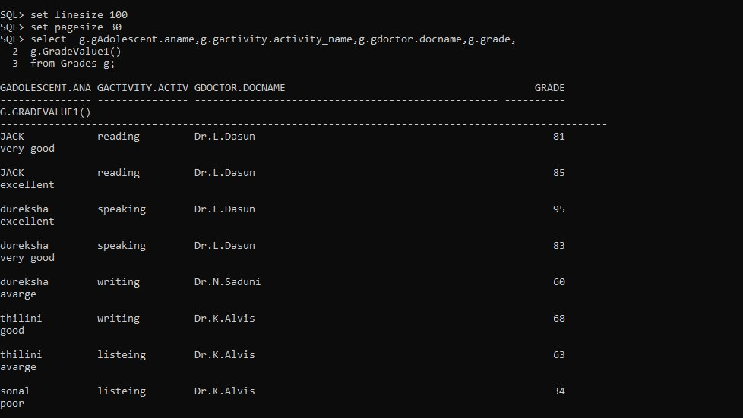

I tried so many times forget a better view by changing the line size and page size, but it doesn’t work

Then I move to Oracle sql developer

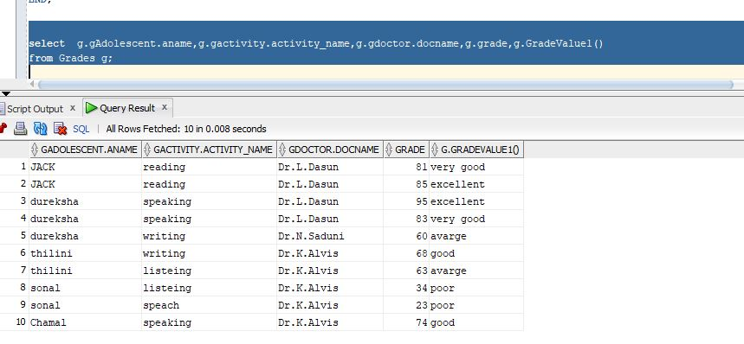

**select** g**.**gAdolescent**.**aname**,**g**.**GradeValue1**()**

**from** Grades g

**where** g**.**gAdolescent**.**aname**=**'dureksha'**;**

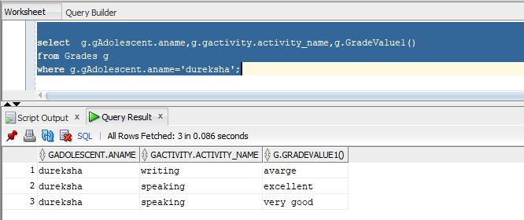

* This member method to compute the Adolescents payment fee discount with his/her Guardian. The discount is calculated at the 2% of payment fee for each Guardian which does not have 'samurdhi'. And this will compute the TAX amount of Adolescents, TAX will be calculated by multiplying the payment fee with a rate percentage given as a parameter

**ALTER** **TYPE** Adolescents_T

**ADD** MEMBER **FUNCTION**

calclDiscount **RETURN** FLOAT

**CASCADE;**

**/**

**ALTER** **TYPE** Adolescents_T

**ADD** MEMBER **FUNCTION**

taxPayment**(**RATE FLOAT**)** **RETURN** FLOAT

**CASCADE;**

**/**

**ALTER** **TYPE** Adolescents_T

**ADD** MEMBER **FUNCTION**

TotalPayment_withTAX**(**RATE FLOAT**)** **RETURN** FLOAT

**CASCADE;**

**/**

**CREATE** **OR** **REPLACE** **TYPE** **BODY** Adolescents_T **AS**

MEMBER **FUNCTION** calclDiscount **RETURN** FLOAT **IS**

discount FLOAT**;**

**BEGIN**

**SELECT** **SUM(**0.02 **\*** SELF**.**paymentfee**)** **INTO** discount

**FROM** **TABLE(**SELF**.**Guardian**)** d

**WHERE** d**.**samurdhi **=** 'N'**;**

**RETURN** SELF**.**paymentfee **-** discount**;**

**END;**

MEMBER **FUNCTION** taxPayment**(**RATE FLOAT**)** **RETURN** FLOAT **IS**

**BEGIN**

**RETURN** SELF**.**paymentfee **\*** RATE**\***0.01**;**

**END;**

MEMBER **FUNCTION** TotalPayment_withTAX**(**RATE FLOAT**)** **RETURN** FLOAT **IS**

tax float**;**

**BEGIN**

tax**:=** SELF**.**paymentfee **\*** RATE**\***0.01**;**

**return** SELF**.+**tax**;**

**END;**

**END;**

**/**

**SELECT** a**.**aname**,**a**.**paymentfee**,**a**.**calclDiscount**()**

**FROM** adolescents a**;**

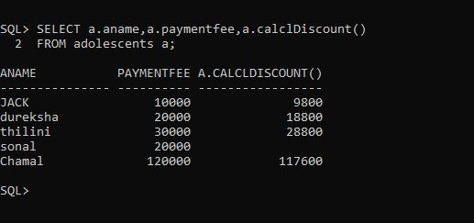

**SELECT** a**.**aname**,**a**.**paymentfee**,**a**.**taxPayment**(**5**),**a**.**TotalPayment_withTAX**(**5**)**

**FROM** adolescents a**;**

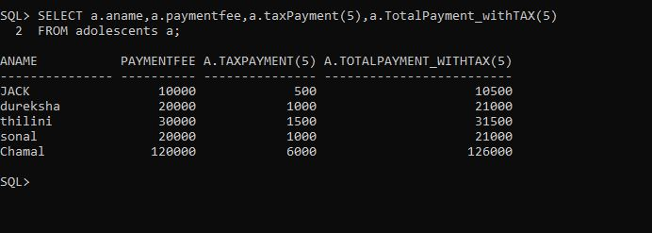

* Below method to compute the extra hour charges of doctor, additional OT charge will be calculated by multiplying the doctor's visiting Charge with extra hours and a rate percentage given as a parameter**.**

**ALTER** **TYPE** Doctor_t

**ADD** MEMBER **FUNCTION** aditionalOTcharge**(**rate FLOAT**,**othours FLOAT**)**

**RETURN** FLOAT **CASCADE;**

**/**

**ALTER** **TYPE** Doctor_t

**ADD** MEMBER **FUNCTION** TotalCharge_WithOT**(**rate FLOAT**,**othours FLOAT**)**

**RETURN** FLOAT **CASCADE;**

**/**

**CREATE** **OR** **REPLACE** **TYPE** **BODY** Doctor_t **AS**

MEMBER **FUNCTION**

aditionalOTcharge**(**rate FLOAT**,** othours FLOAT**)**

**RETURN** FLOAT **IS**

**BEGIN**

**return** rate**\*** othours **\*** SELF**.**visitChg**;**

**END** aditionalOTcharge**;**

MEMBER **FUNCTION**

TotalCharge_WithOT**(**rate FLOAT**,**othours FLOAT**)**

**RETURN** FLOAT **IS**

x float**;**

**BEGIN**

x **:=** rate **\*** othours **\***SELF**.**visitChg**;**

**RETURN** x**+**SELF**.**visitChg**;**

**END** TotalCharge_WithOT**;**

**END;**

**/**

**select** d**.**docname**,**d**.**dspecialization**,**d**.**visitChg**,**d**.**aditionalOTcharge**(**0.05**,**3**),**

d**.**TotalCharge_WithOT**(**0.05**,**3**)**

**from** doctor d

**WHERE** d**.**docname**=**'Dr.J.Sudath'**;**

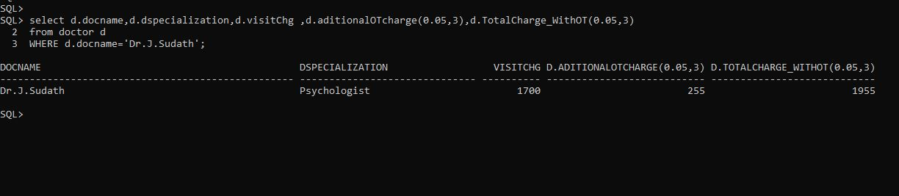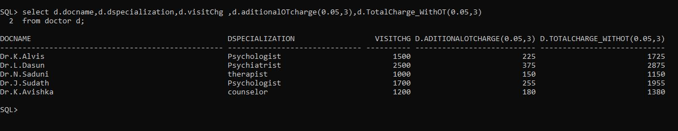

**select** d**.**docname**,**d**.**dspecialization**,**d**.**visitChg**,**d**.**aditionalOTcharge**(**0.05**,**3**),**

d**.**TotalCharge_WithOT**(**0.05**,**3**)**

**from** doctor d**;**

# SQL queries that are useful for end users of the System

**Report 1**

**Report that contain adolescents’ detail with payment fee which his/her guardian is a Co-operate grants (samurdhi)**

**Select**

a**.**ano **AS** **No** **,**

a**.**aname **AS** Adolescent_Name **,**

a**.**paymentfee paymentFee**,**

a**.**TotalPayment_withTAX**(**5**)** **as** Payment_With_tax**,**

g**.**gname **AS** Guardian_Name **,**

g**.**RELATIONSHIP **AS** RELATIONSHIP

**From**

Adolescents a**,**

**TABLE(**a**.**Guardian**)** g

**where**

g**.**samurdhi**=**'Y'

**/**

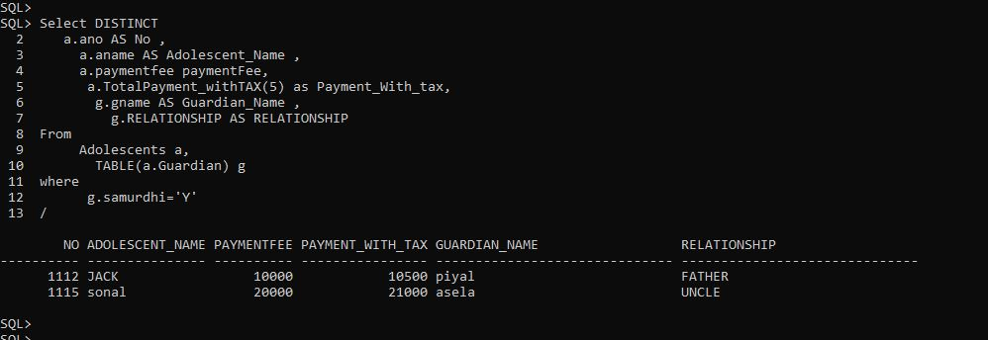

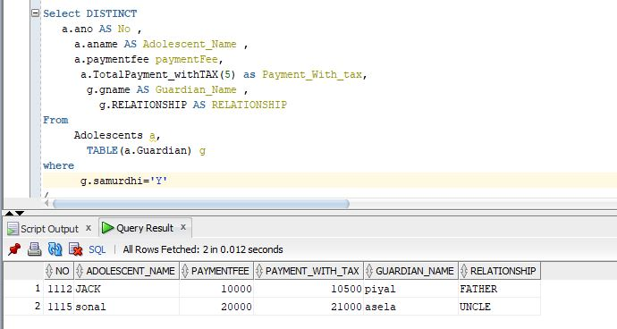

**Report 2**

**report that contain Adolescents details who is (age >21) with their grades**

**SELECT** a**.**aname**,** **TO_NUMBER(TO_CHAR(SYSDATE,**'YYYY'**))** **-** **TO_NUMBER(TO_CHAR(**a**.**dob**,**'YYYY'**))** **AS** AGE

**from** Adolescents a

**group** **by** a**.**aname **,** **TO_NUMBER(TO_CHAR(SYSDATE,**'YYYY'**))** **-** **TO_NUMBER(TO_CHAR(**a**.**dob**,**'YYYY'**))**

**having** **TO_NUMBER(TO_CHAR(SYSDATE,**'YYYY'**))** **-** **TO_NUMBER(TO_CHAR(**a**.**dob**,**'YYYY'**))>**21

**order** **by** a**.**aname**;**

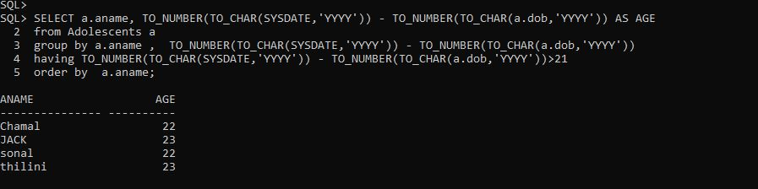

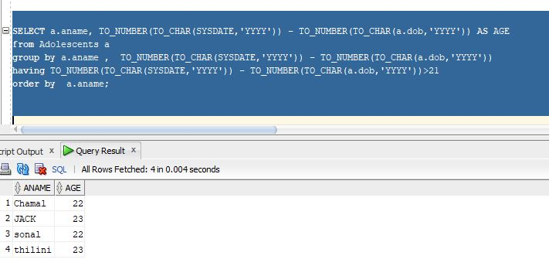

**Report 3**

**this report contains doctors who have assigned for more than one patient**

**SELECT**

a**.**adoctor**.**doctorid **AS** Doctor_ID**,**

a**.**adoctor**.**docname **AS** Doctor_Name**,**

**count(**a**.**adoctor**.**doctorid**)** **AS** No_of_patient

**FROM**

adolescents a

**group** **by**

a**.**adoctor**.**doctorid**,**a**.**adoctor**.**docname

**HAVING**

**count(**a**.**adoctor**.**doctorid**)** **>** 1**;**

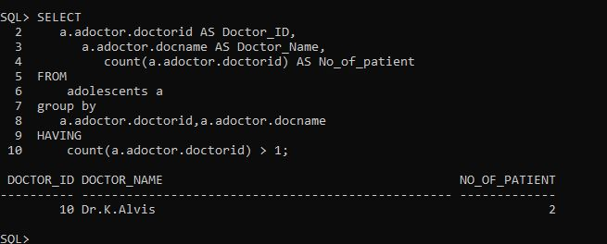

**Report 4**

**this report contains doctor details with their created report count**

**select** **DISTINCT**

r**.**rdoctor**.**docname **AS** Doctor_name **,**

**count(**r**.**rdoctor**.**doctorid**)** Report_COUNT

**From**

medicalRecord r

**GROUP** **by** r**.**rdoctor**.**docname **;**

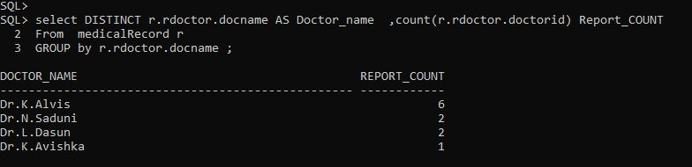

**Report 5**

**this report contains doctor details, who is created more medical reports**

**select** **DISTINCT** r**.**rdoctor**.**docname **AS** Doctor_name **,** **count(**r**.**rdoctor**.**doctorid**)** **AS** Report_COUNT

**From** medicalRecord r

**GROUP** **by** r**.**rdoctor**.**docname

**Having** **count(**r**.**rdoctor**.**doctorid**)** **>=**

**All(** **SELECT count(**r**.**rdoctor**.**doctorid**)**

**From** medicalRecord r

**GROUP** **by** r**.**rdoctor**.**docname **);**

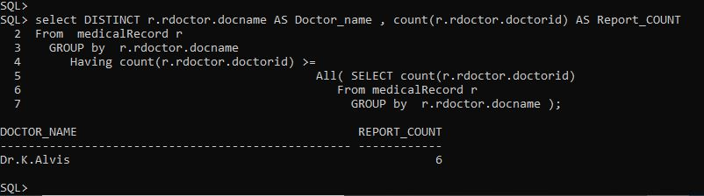

# All Tables details

**Adolescents – Nested table**

**Select** **a.ano , g.\***

**From** **Adolescents a, TABLE( a.Guardian) g**

/

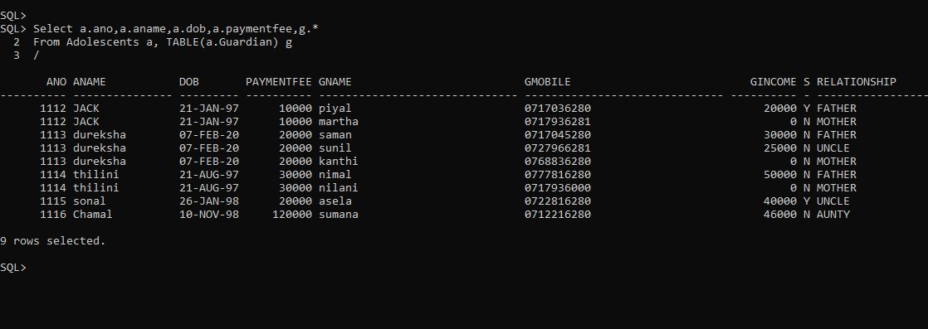

**Doctor-table**

**select \***

**from doctor;**

/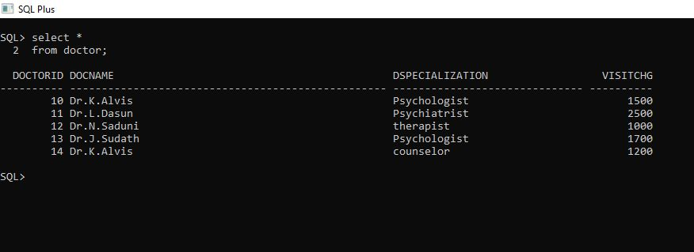

**Schedule - table**

select s.schedule_no,s.schedule_name,s.schedule_type,s.scheduled_adolescent.aname

from schedule s;

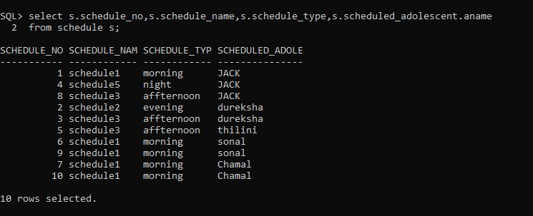

**Activity - table**

select a.activity_no,a.activity_name,a.aschedule.schedule_name,a.arate

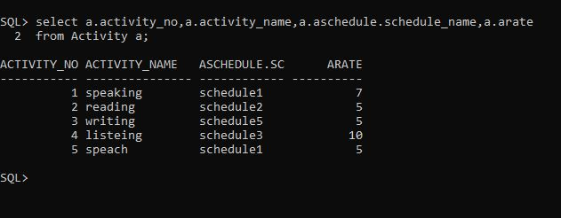from Activity a;

**medicalRecord-table**

select r.rdate,r.rAdolescent.aname,r.rdoctor.docname

from medicalRecord r;

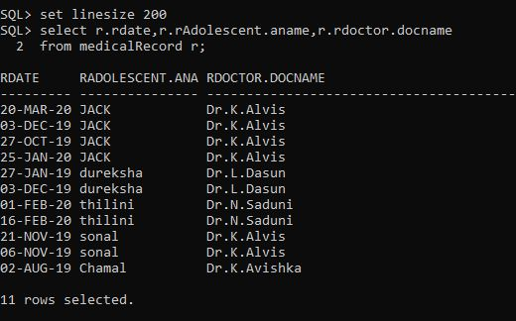

# Screen prints

Types

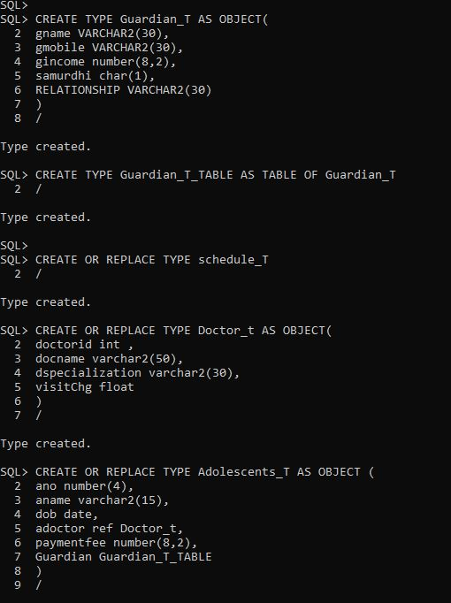

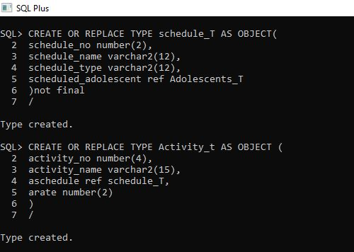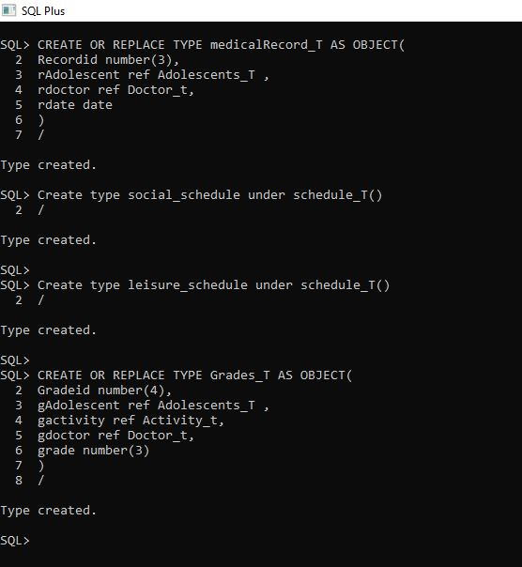

Table

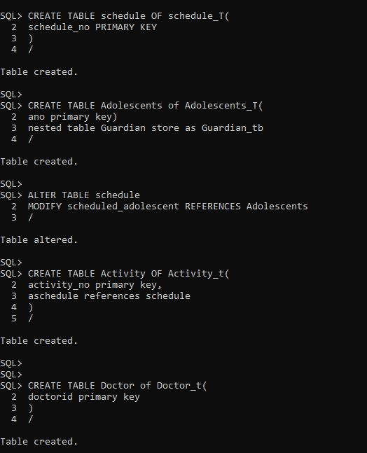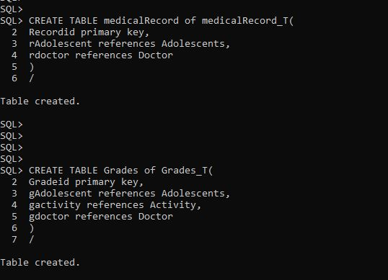

Insert Queries

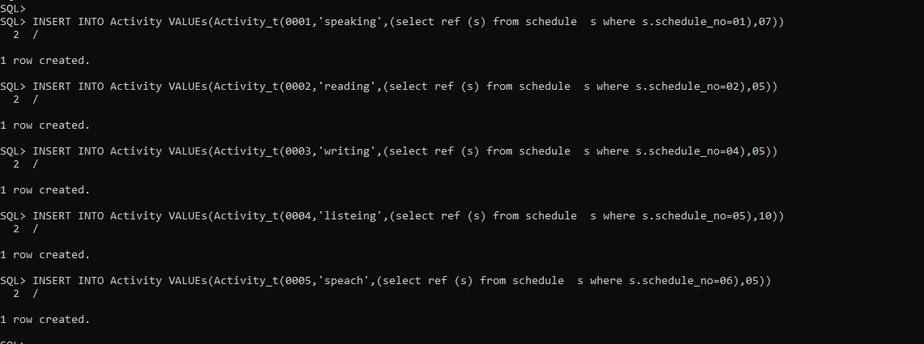**activity**

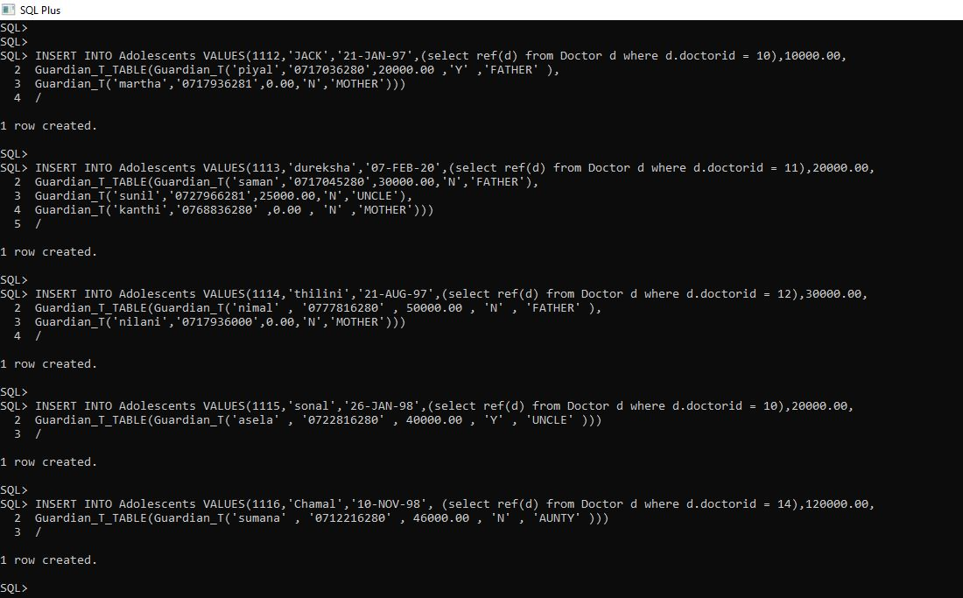**adolescent**

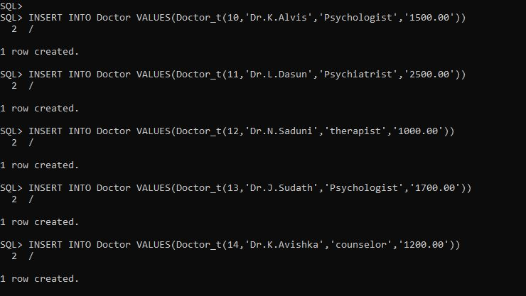**doctor**

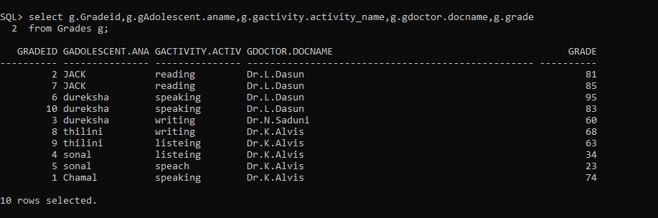**grade table**

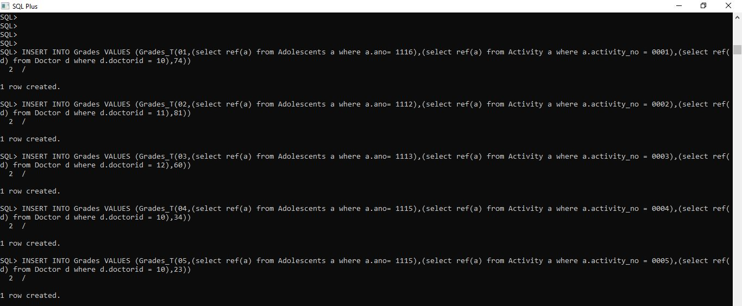**grades**

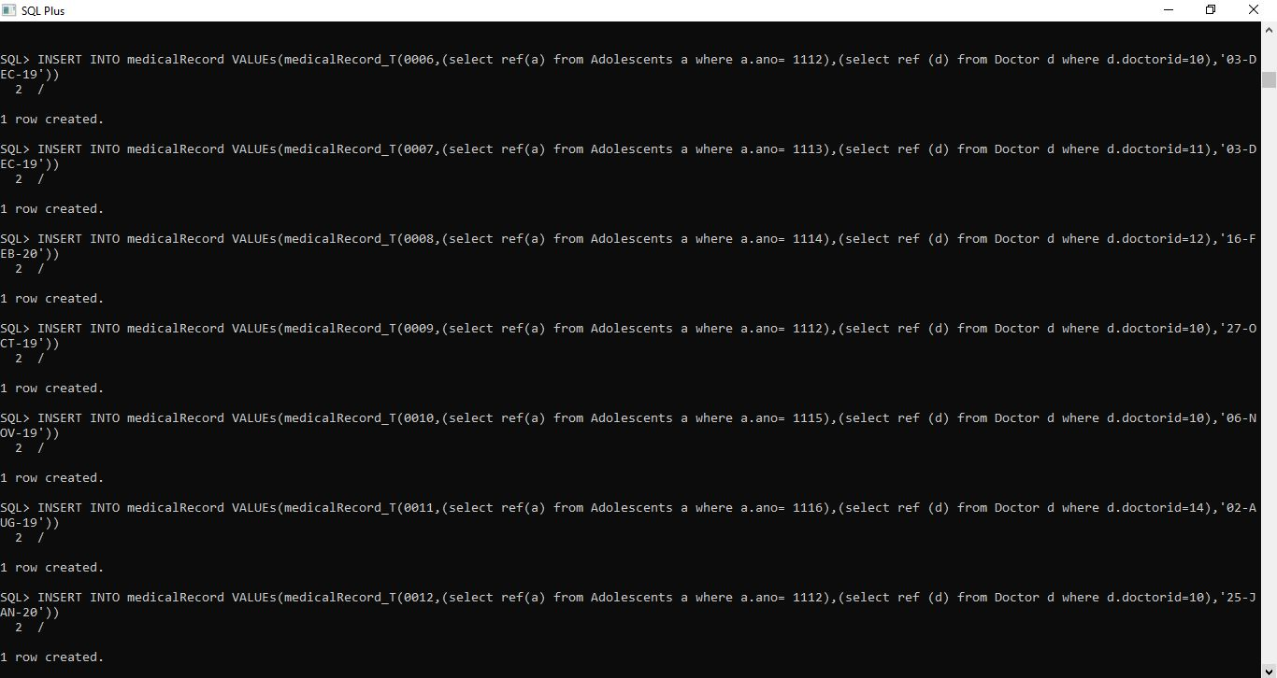**medical records 1**

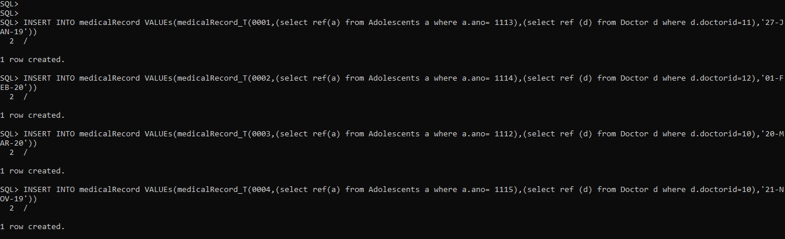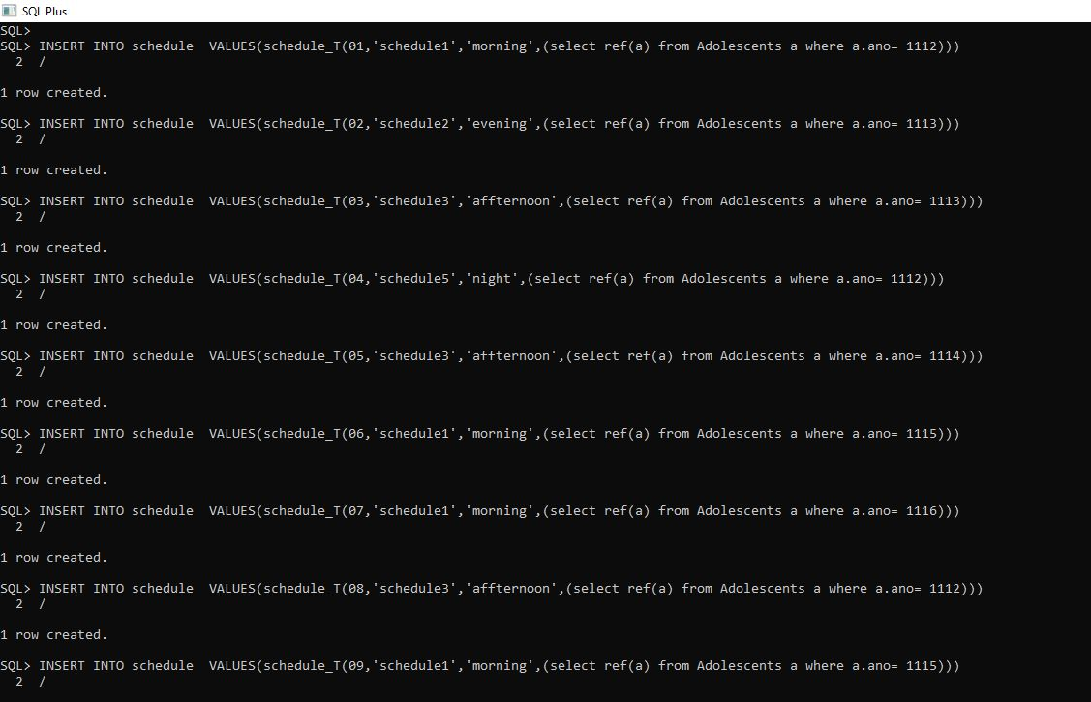**medical records 2**

**schedule**

**other**

