**Process Improvement Idea Submission**

**Content submission tool for users outside of GPS**

Prepared by:

Janith Jayawardana

GPS Colombo

28/02/2022

**Situation**

Currently, updating FX rates on country websites are done with several touch points. A representative from the respective business area, sends an e-mail to #**CMB_web_management** group where a Web Production Officer or a Web Content Manager will update the content on the website through Sitecore.

This process include several touch points; In some cases, a staff member to create and authorize the new FX rates, a coordinating staff to send and follow up the requests sent to GPS and finally a web production officer at GPS to update the content on the live website.

**Proposed Solution**

Create a front-end platform which is easy to navigate and with minimal privileges which non GPS staff could use to update their websites directly. The toolkit can be used to manage simple routinely tasks such as updating daily FX rates, uploading regulatory files to set locations(website pages) etc.

**Steps Involved**

1. User access the toolkit through a dedicated domain/subdomain.
2. Select the update option (update FX rates, upload documents etc).
3. Add required information. Either upload a template PDF or update manually.
4. User verify and submit the information.
5. Information gets captured by Sitecore and pushed to the live website.

**Benefits**

* Enabling a customer(internal) facing platform, would cut down on unnecessary touch points on routine tasks.
* Simplify the process of managing daily/ routine website editing tasks.
* Centralize and detach minor tasks out of GPS, where GPS can support the business by being the QC point instead being the production support.
* Using a data extraction tool, which is been proposed in this document to extract table data from a template PDF (to update FX rates) could pave way to adopting machine learning initiatives and handle more extensive tasks for the business.

**Potential Obstacles**

* Gaining access to Sitecore developer API.
* Even though a demo app has already been developed to demonstrate how the platform handle these tasks on the front-end, a tech stack needs to be identified which can be used to sync with internal resources with no incompatibilities.
* Total time associated with development and testing the platform. Even though I have highlighted this as an obstacle, the benefits this could render will surpass the initial investment.
* Current functionalities of the platform, support text-based PDFs and not scanned PDFs.Therefore further development would require to extend it’s features to handle text recognition and optical character recognition.

**Demo App**

I have created a demo app to show basic functionalities of the proposed platform. The application is currently been hosted at <https://dailyfxupdates.herokuapp.com/>.

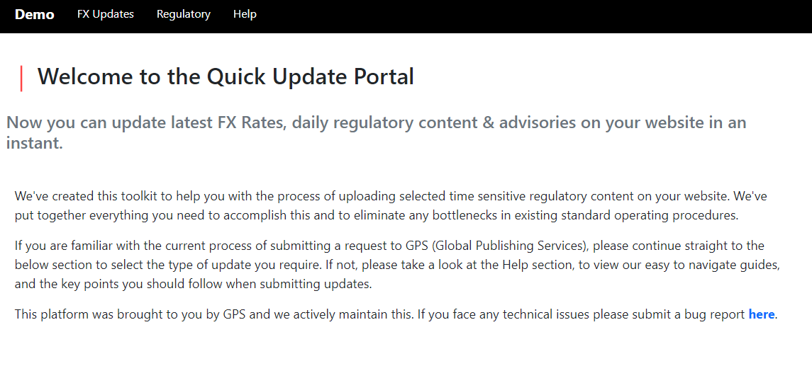

Front page

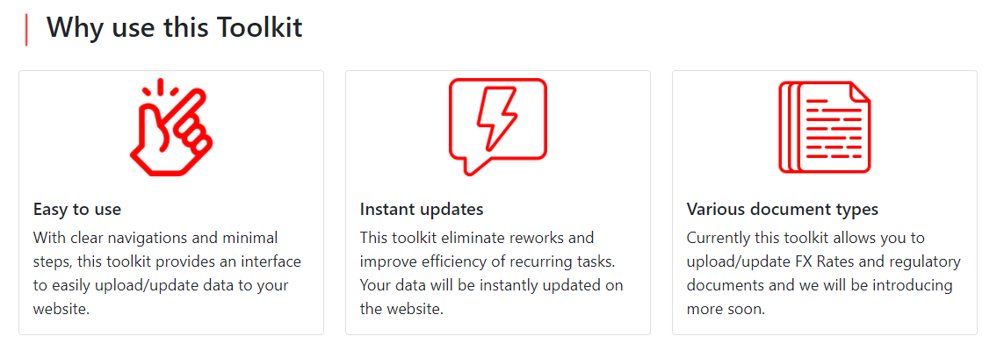

Features

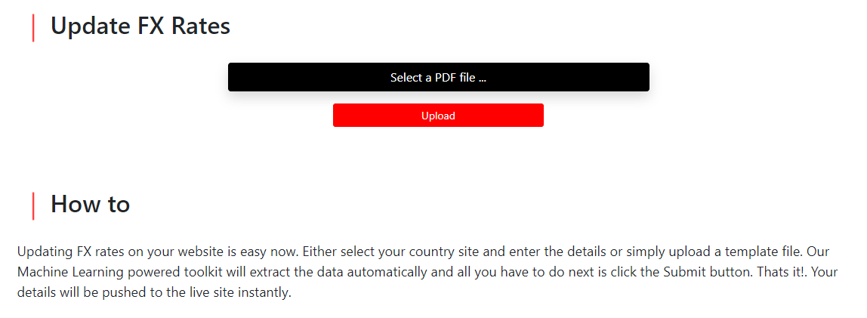

Simple front-end

The platform hosts easy to use upload feature where the user can select the template PDF file to be uploaded.

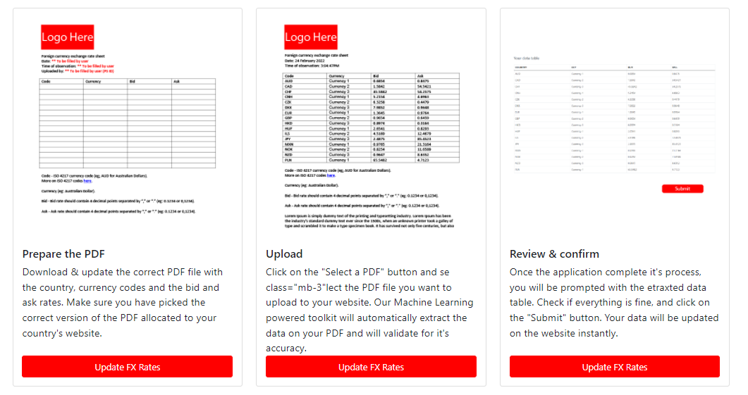

How to’s

A ‘how to’ section is displayed on the home page to guide users on the process of uploading their data.

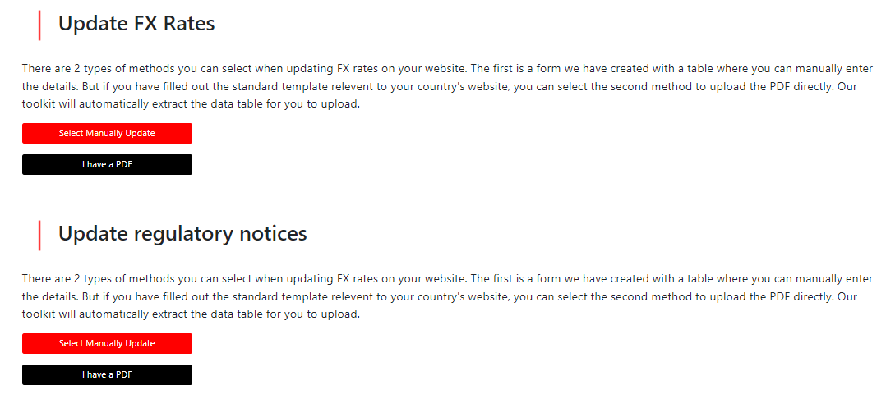

Upload options

In the ‘update’ page, for each scenario, users can select either to upload a template PDF file or to use the on page table to manually add the FX rates.

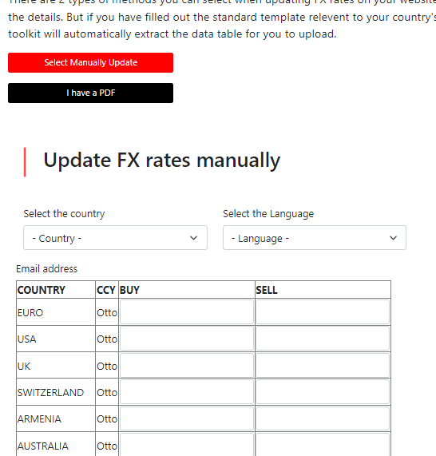

Manual update table

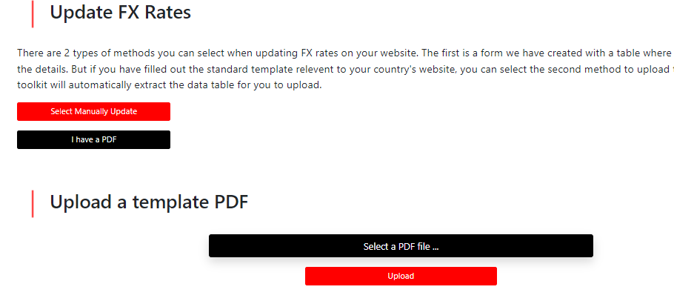

Upload PDF