**The Problem**

With the changes of the inflow of volumes to the department(or Queue), especially during seasonal periods, the management face difficulties to proactively manage required resources.

**The Solution**

Adapt a forecasting model which can monitor volumes and predict future inflow.

**QPredictor**

QPredictor includes 3 parts; volume prediction, a server & the front-end.

**Volume Prediction**

QPredictor use Facebook Prophet to forecast future volume.

Prophet is a procedure for forecasting time series data based on an additive model where non-linear trends are fit with yearly, weekly, and daily seasonality.

**Server**

A Node.js server act as the back-end web server to feed information to the user through the front-end. It also use a Mongo Database to store the predicted daily values from the forecasting model.

**Front-end**

Provides a visual interface for users. It displays the forecasting charts, predicted volumes, historical data, trends, seasonality etc.

**Why Prophet**

**Performance:**

Prophet is optimized for business forecast tasks where typically have characteristics of using a small data set, multiple seasonalities, trend changes & trends that are non-linear growths.

**Tunable Forecasts:**

The Prophet procedure includes many possibilities for users to tweak and adjust forecasts. You can use human-interpretable parameters to improve your forecast by adding your domain knowledge.

**Forecasting in work**

I have used a randomly generated data set with 180 data points to forecast 7 days volume inflow in to the future.

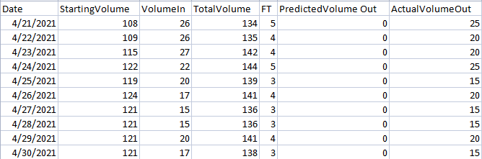

**Analyzing “Volume In”**

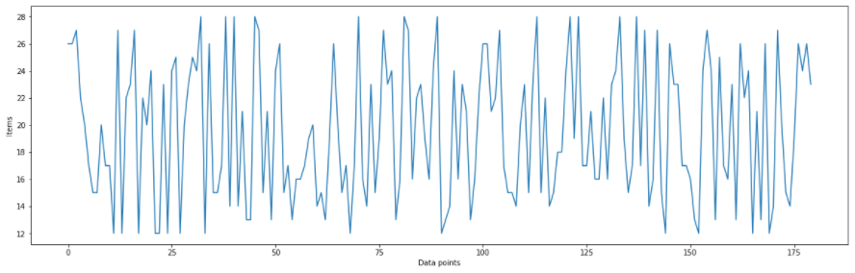

**Forecast using a model**

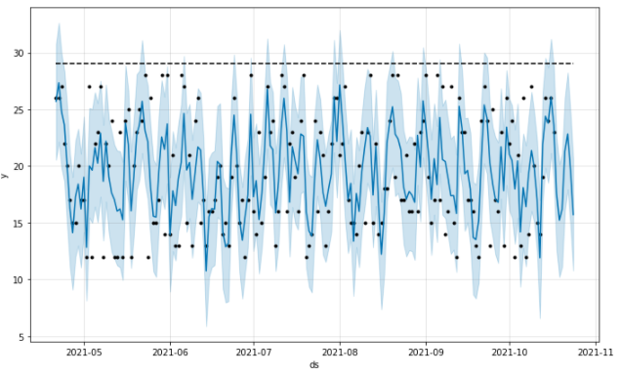

**Update Database**

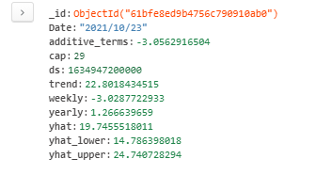

**Display data on front-end**

