1. d.

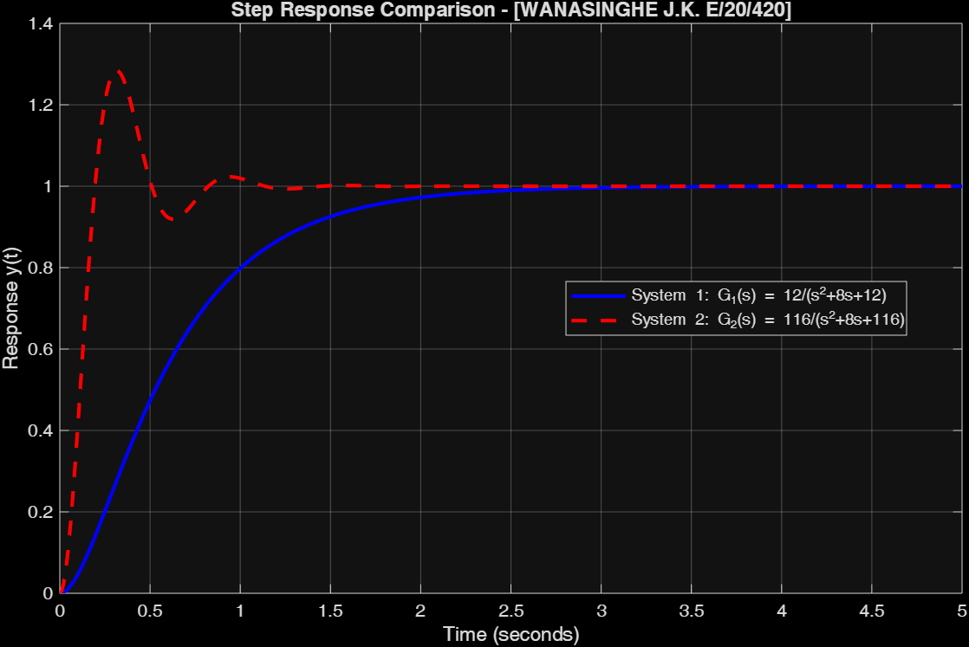

Figure 1:STEP RESPONSE COMPARISON

% Define transfer functions for both systems

% System 1: G1(s) = 12/(s^2 + 8s + 12)

num1 = 12;

den1 = [1 8 12];

G1 = tf(num1, den1);

% System 2: G2(s) = 116/(s^2 + 8s + 116)

num2 = 116;

den2 = [1 8 116];

G2 = tf(num2, den2);

% Create time vector for plotting

t = 0:0.01:5; % 5 seconds with 0.01 step size

% Calculate step responses

[y1, t1] = step(G1, t);

[y2, t2] = step(G2, t);

% Create the plot

figure;

plot(t1, y1, 'b-', 'LineWidth', 2);

hold on;

plot(t2, y2, 'r--', 'LineWidth', 2);

grid on;

xlabel('Time (seconds)');

ylabel('Response y(t)');

title('Step Response Comparison - [WANASINGHE J.K. E/20/420]');

legend('System 1: G_1(s) = 12/(s^2+8s+12)', 'System 2: G_2(s) = 116/(s^2+8s+116)', 'Location', 'best');