**EE 387 – Signal Processing**

**Lab 4: Filter Design Using MATLAB**

**E/20/420 – WANASINGHE J.K.**

## Part 1: Design the Butterworth filter with the following specifications: Fp = 1000 Hz; Fs = 5000 Hz;

clear all;

clc;

Fp = 1000; % Passband frequency in Hz

Fs = 5000; % Stopband frequency in Hz

Rp = 1; % Passband ripple in dB

Rs = 40; % Stopband attenuation in dB

Wp = 2 * pi * Fp; % Passband edge angular frequency

Ws = 2 * pi * Fs; % Stopband edge angular frequency

% Butterworth filter design based on specs

[N1, Wn1] = buttord(Wp, Ws, Rp, Rs, 's');

[num1, den1] = butter(N1, Wn1, 's');

disp(['Calculated Order N = ' num2str(N1)]);

% Frequency response

H1 = tf(num1, den1);

figure;

bode(H1);

grid on;

title(['Butterworth Filter (Calculated Order N = ' num2str(N1) ')']);

>> Calculated Order N = 4

Order of Butterworth Filter = 4

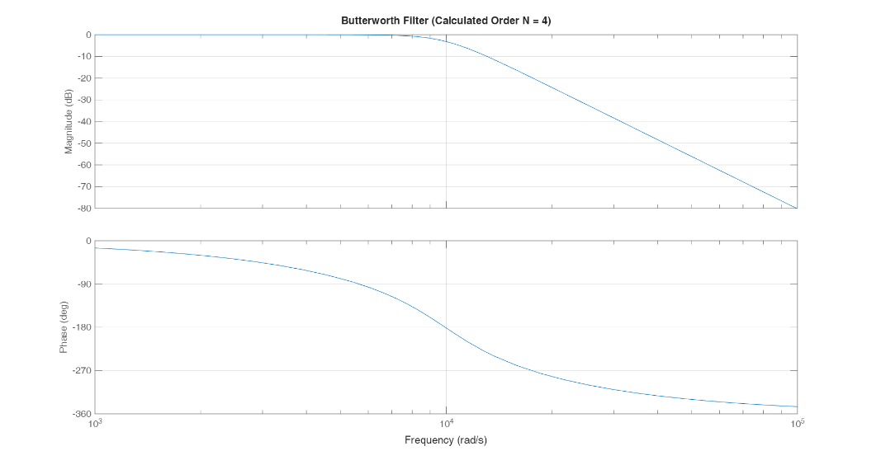

Figure

The buttord function computed the required filter order as **N = 4** and returned the 3-dB cutoff angular frequency. The Butterworth filter was then generated using the butter function in the analog domain.

The Bode plot confirms the filter’s maximally flat behavior in the passband, with a smooth roll-off starting after the cutoff frequency. The roll-off is gradual, but it satisfies the attenuation requirement at 5000 Hz. This makes the filter ideal for applications requiring clean passband behavior without ripple.

# Part 2: Design the Butterworth filter with Fp = 1000 Hz, N = 4;

clear all;

clc;

Fp = 1000; % Passband frequency in Hz

N = 4; % Filter order

Wp = 2 * pi * Fp; % Passband edge angular frequency

[num2, den2] = butter(N, Wp, 's');

H = tf(num2, den2);

figure;

bode(H);

grid on;

title(['Butterworth Filter (N = ' num2str(N) ', Fp = ' num2str(Fp) ' Hz)']);

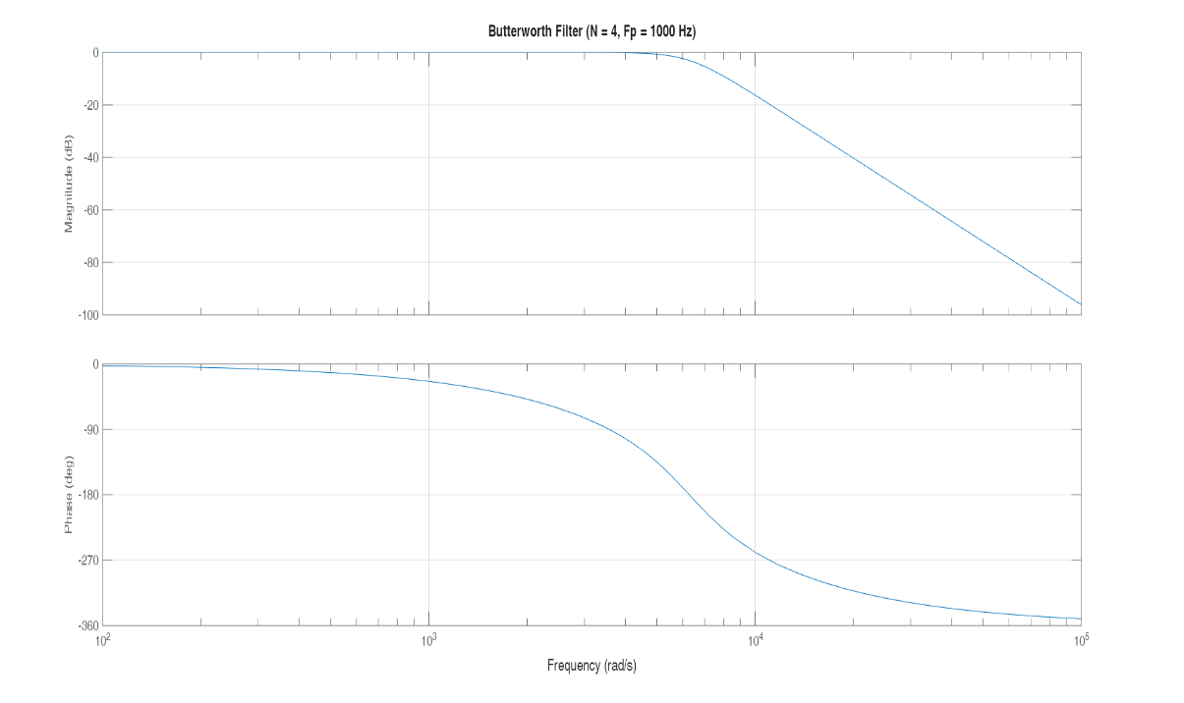

Figure

Here, a Butterworth filter of order N = 4 was manually designed using a passband edge at 1000 Hz, without calculating the optimal order. Although the same order as Part 1 was used, the cutoff frequency was directly set to 2π×1000 rad/s. As expected, the frequency response also shows a smooth, monotonic decrease after the cutoff frequency, maintaining the classic Butterworth characteristics. However, without taking into account the stopband attenuation explicitly, this design may not guarantee the same performance as the optimized filter in Part 1. It demonstrates the trade-off when using fixed filter order rather than one calculated from performance specifications.

# Part 3: Design Chebyshev Type 1 filter with N = 4, Rp = 2 ; Fp = 1000.

clear all;

clc;

Fp = 1000; % Passband frequency in Hz

Rp = 2; % Passband ripple in dB

N = 4; % Filter order

Wp = 2 * pi * Fp; % Passband edge angular frequency

[num3, den3] = cheby1(N, Rp, Wp, 's');

H3 = tf(num3, den3);

figure;

bode(H3);

grid on;

title('Chebyshev Type I Filter (N = 4, Rp = 2 dB)');

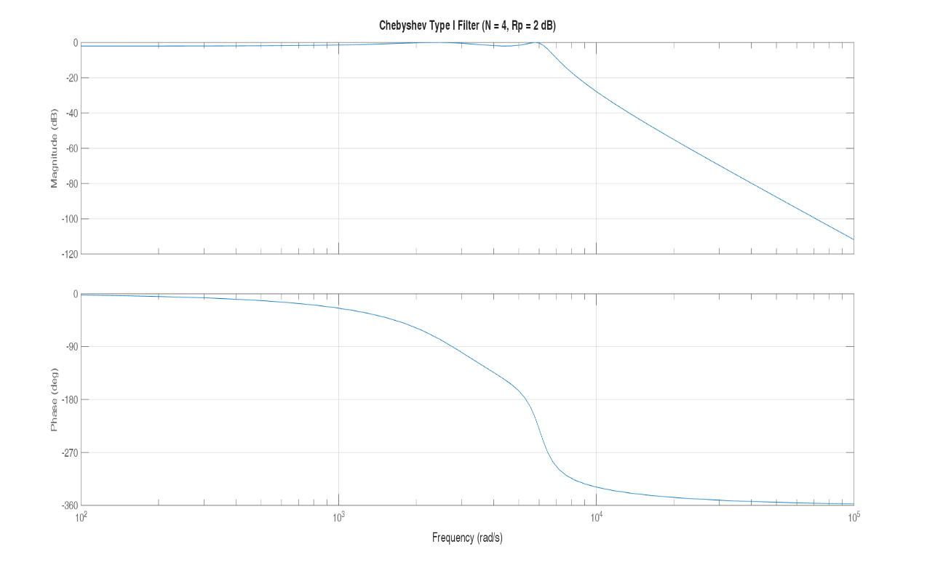

Figure

Unlike Butterworth, this filter allows some ripple in the passband, which results in a sharper roll-off after the cutoff. This is clearly seen in the Bode plot, where the slope of attenuation beyond the cutoff is steeper than in the Butterworth filter.

This trade-off between passband flatness and transition sharpness makes Chebyshev filters suitable for applications where higher stopband attenuation is critical and small passband distortion is acceptable.