Phishing Email Detection & Awareness Report
Prepared By: Janith Sai
Introduction
Phishing is a social engineering attack used to trick users into revealing sensitive information such as passwords, OTPs, banking credentials, or downloading malicious files.

Objective
To analyze phishing email samples and identify common phishing indicators used in cyber attacks.

Scope
This assessment focuses on:
- phishing email analysis
- phishing indicators
- awareness guidelines
- prevention recommendations
No malicious activity or exploitation was performed.

Tools Used
- Browser
- GitHub
- Microsoft Word
- Google Header Analyzer

Sample Email 1 — Fake Fax Message
Subject
Monday, March 7 2022
Sender
attack@attacker.example.com
Recipient
janithsai2005@example.com
Phishing Indicators Identified
✔ Suspicious sender email
✔ Fake attachment lure
✔ Generic recipient greeting
✔ Social engineering tactics
✔ Unexpected fax notification
Risk Classification
Phishing
Explanation
This phishing email attempts to trick users into opening a fake fax attachment. The sender domain appears suspicious and does not belong to a legitimate organization.
Recommendation
Users should avoid opening unexpected attachments and verify sender authenticity before interacting with suspicious emails.
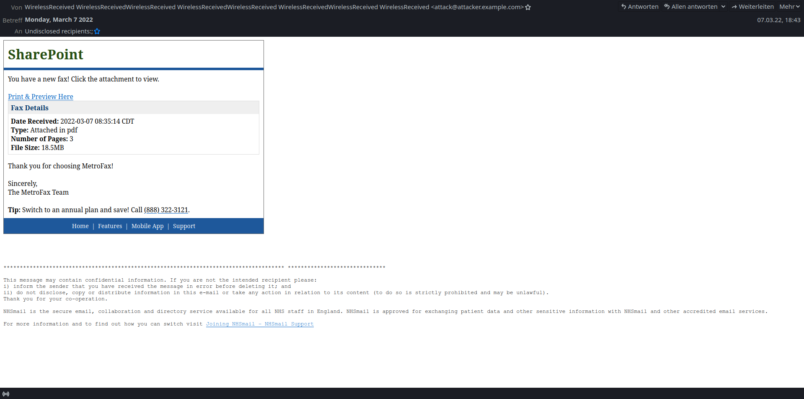

Sample Email 2 — Fake Voice Message
Subject
Voice Message Access for Clients
Sender
noreply@target.example.com
Recipient
janithsai2005@example.com
Phishing Indicators Identified
✔ Fake Office 365 branding
✔ Suspicious voice message notification
✔ Attachment download lure
✔ Social engineering tactics
✔ Unknown sender context
Risk Classification
Phishing
Explanation
This phishing email impersonates an Office 365 notification and attempts to trick users into downloading a malicious voice message attachment.
Recommendation
Users should avoid downloading unexpected attachments and verify message authenticity before interacting with suspicious emails.
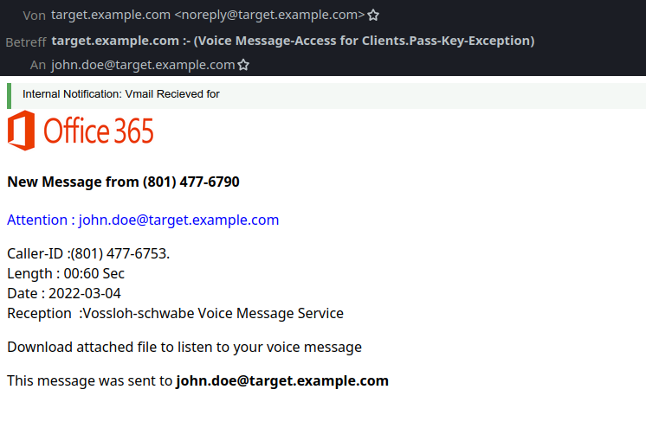

Common Phishing Indicators
- Suspicious sender domains
- Urgent or fear-based language
- Unexpected attachments
- Fake login pages
- Generic greetings
- Requests for passwords or OTPs

Prevention Guidelines
✔ Verify sender email addresses
✔ Avoid clicking suspicious links
✔ Do not download unknown attachments
✔ Enable multi-factor authentication
✔ Report suspicious emails immediately

Do’s and Don’ts
Do’s
- Verify sender identity
- Contact official support
- Use strong passwords
- Enable MFA
Don’ts
- Don’t click unknown links
- Don’t share OTPs/passwords
- Don’t open suspicious attachments

Conclusion
The phishing email samples analyzed contained multiple malicious indicators including suspicious links, fake branding, and social engineering tactics. Proper awareness training significantly reduces phishing risks in organizations.

Ethical Note
This project was conducted strictly for educational and awareness purposes. No malicious activity was performed.

