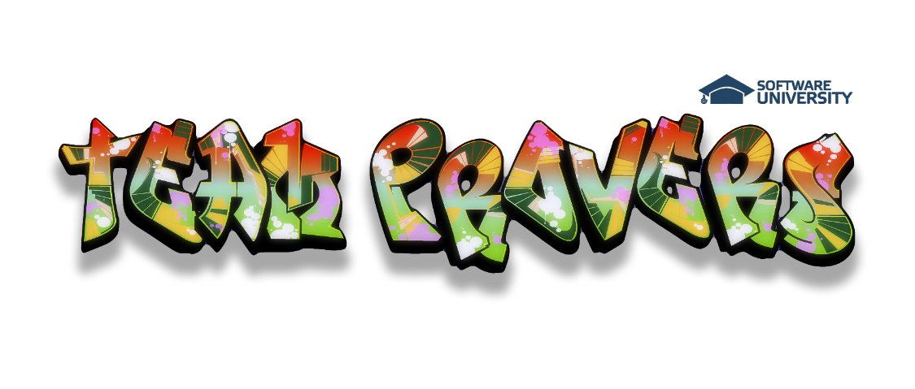

**Software Requirements Specification**

**Product – CRM PROVERS**

# Introduction

## Purpose

This document provides an overview of a Customer Relationship Management (CRM) system from a functional perspective, highlights some technical considerations relating to the application, and also highlights some technical and organizational implementation issues.

## Scope

The scope of this project is the creation of a CRM system. “Team Provers” will develop a CRM system that provides information for managing the business/sales process, monitor, analyze, integrated requests module, employee’s communication and improve all the related activities. The most advantageous feature is, all the activities and their respective summary reports are management informative for decision-making, paperless and with least effort. It provides an effective approach of managing a company’s interaction with current and future customers. It often involves using technology to organize, automate, and synchronize sales, marketing, customer service, and technical support

## Overview

The rest of this document contains the overall description of the Customer Relationship Management system and the specific requirements for the system.

# Overall Description

## Product Perspective

CRM PROVERS will be an off-the shelf software product. Customers will need to buy the product and customize it to reflect their organizations sales model before deploying it enterprise-wide. Once the system has the enterprise sales model it can become operational. End users only need any conventional web browser to use the system. The interface is intuitive and requires minimal training. The CRM will run on dedicated webserver available 24/7 hosted by the software provider.

## Product functions

### Enables effective contact management:

CRM PROVERS enables sales to customize, manage, and schedule sales generation activities such as cold-call, mail literature, follow-up, sales-call, etc. The effectiveness of CRM PROVERS contact management functionality comes from the fact that the underlying sales generation activities are 100% customizable. This feature allows organizations to define sales generation activities suitable to their own business environment.

### Offers a single, uniform view of customer information:

In an environment with multiple sales people, lack of centralized contact management system results in un-coordinated sales efforts. Everyone works on their own. Further, organizations don't have one single database of its sales generation activities. This prevents organizations from capitalizing on its historical sales generation data for generating new sales. With centralized management of information, CRM PROVERS offers a single and uniform view of customer information across multiple processes.

### Establishes well-defined responsibilities:

In a scenario where responsibilities are not clearly defined, there is often confusion among the participants as to who is supposed to do what and when. This confusion translates into slower (or lack of) response to customer needs. By unifying processes and resources under one business model, CRM PROVERS enable organizations to clearly set rules and responsibilities in terms of who is to handle what kind of work and when. This results in improved productivity and better respond to customer requirements.

### Eliminates manual handling of documents:

Manual handling of documents often leads to documents reaching wrong destinations (or disappearing altogether somewhere in the flow). With CRM PROVERS, documents are stored in the central repository, and their URIs (Uniform Resource Identifiers) is automatically delivered to the correct destinations every time.

## Constraints

**The following are the constraints:**

* The project must be completed within the budget
* The project must be completed within a specified period of time.
* The system should be up 24/7.
* The system should enforce user authentication security and guarantee reliability.

## Assumptions and dependencies

Initially, companies already having significant sales operations and running enterprise software will be targeted. This would lead to the faster growth of sales of CRM, as deployment would be easiest in these organizations.

# Flow Chart

**Applications**

* **Market Place**
* **All Applications**

**Customer**

**Workgroups**

**Login**

**Company**

* **Employees**
* **Company Drive**
* **Company Structure**
* **Absense Drive**
* **Administrative Workflows**

**Settings**

* **Intranet Settings**
* **Manage E-mail Accounts**
* **Subscription**

**Activity Stream**

**Tasks**

**Calendar**

**My Drive**

**Telephony**

* **Balance and Statistics**
* **Phone Numbers**
* **Telephony Users**
* **SIP Phones**
* **Other Settings**
* **Stream**
* **Activities**
* **Contacts**
* **Companies**
* **Deals**
* **Quotes**
* **Invoices**
* **Leads**
* **Reports**
* **Sales Funnel**
* **History**
* **Products**
* **Settings**
* **Message**
* **Task**
* **Meeting**
* **Email**

**My Photos**

**Conversion**s

**CRM**

**Webmail**

**Workflow**

**My Requests**

# Specific Requirements

## Product Functions

CRM Software should support the following use cases:

|  |  |  |  |
| --- | --- | --- | --- |
| CLASS OF USE CASES | № | USE CASES | DESCRIPTION OF USE CASES |
| Related to System Authentication | 1 | **Login** | *Login into the CRM system* |
| 2 | **Change Password** | *Changes the login password* |
| Related to Activity Stream | 3 | **Post Message** | *Posts a Message to the Activity Stream* |
| 4 | **Delete Message** | *Delete Message from Activity Stream* |
| 5 | **Processes** | *Requests an Approval from Manager* |
| Related to Tasks | 6 | **New Task** | *Creates a task for execution* |
| 7 | **Execute Task** | *Executes the task* |
| 8 | **Finish Task** | *Finishes the task* |
| 9 | **Delete Task** | *Deletes the task* |
| Related to Calendar | 10 | **New Event** | *Creates an event in the Calendar* |
| 11 | **Delete Event** | *Deletes the event from the Calendar* |
| Related to CRM | 12 | **Create Contact** | *Creates a Contact in the CRM* |
| 13 | **Delete Contact** | *Deletes the Contact from the CRM* |
| 14 | **Create Company** | *Creates a Company in the CRM* |
| 15 | **Delete Company** | *Delete the Company from CRM* |
| 16 | **Create Activity** | *Creates an Activity* |
| 17 | **Finish Activity** | *Finishes an Activity* |
| 18 | **Delete Activity** | *Deletes an Activity* |
| Related to Information Display | 19 | **Display Message** | *Display information about the message* |
| 20 | **Display Request** | *Display information about the request* |
| 21 | **Display Task** | *Display information about the task* |
| 22 | **Display Event** | *Display information about the event* |
| 23 | **Display Contact** | *Display information about the contact* |
| 24 | **Display Company** | *Display information about the company* |
| 25 | **Display Activity** | *Display information about the activity* |

## Functional Requirements

We describe the functional requirements by giving various use cases.

*Use cases related to System Authentication:*

*Use Case №1:* Login  
*Primary Actor*: User  
*Pre Condition*: Installed browser and active internet connection   
*Main scenario*:

1. User initiates browser
2. User specifies web address for accessing the CRM
3. User gives the login and password ( refer to next chapters section “User Screens” )
4. System does authentication
5. Activity Stream is displayed

*Alternate scenario:*  
 4.1 Authorization fails – wrong username/password  
 4.1.1 Prompt the user that he typed the username/password wrong  
 4.1.2 Allow him to re-enter the username/password  
 4.2 Authorization fails – forgotten username/password  
 4.2.1 Prompt the user to enter his registered email  
 4.2.2 User receives an email with instructions about his login credentials

*Use Case №2*: Change password  
*Primary Actor*: User  
*Pre Condition*: User logged in   
*Main scenario*:

1. User goes to Bitrix24.Network Page from the profile menu located at the top pane ( refer to next chapters section “User Screens” )
2. User goes to Edit Profile
3. User initiates “Change Password” functionality
4. User provides current password, new password and confirm new password
5. System displays message for successful change

*Alternate scenario:*  
 4.1 Authorization fails – wrong password  
 4.1.1 Prompt the user that he typed the password wrong  
 4.1.2 Allow him to re-enter the password  
 4.2 Authorization fails – new password and confirm new password do not match  
 4.2.1 Prompt the user that new password and confirm new password do not match  
 4.2.2 Allow him to re-enter the attributes.  
 4.3 Authorization fails – new password and confirm password are less than 6 chars  
 4.3.1 Prompt the user that password must be at least 6 characters  
 4.3.2 Allow him to re-enter new and confirm password

*Use cases related to Activity Stream:*

*Use Case №3:* Post Message   
*Primary Actor*: User  
*Pre Condition*: User logged in   
*Main scenario*:

1. User initiates “Post Message” functionality from Activity Stream ( refer to next chapters section “User Screens” )
2. User enters message text
3. User specifies attachments (if necessary)
4. User specifies recipients
5. User posts the message
6. Message is created
7. All recipients receive notification

*Alternate scenario:*  
 5.1 Post Message Cancellation  
 5.1.1. User cancels Post Message functionality  
 5.1.2. Post Message canceled

*Use Case №4:* Delete Message   
*Primary Actor*: User  
*Pre Condition*: User logged in   
*Main scenario*:

1. User initiates “Delete Message” functionality from selected message
2. System displays a confirmation message
3. System displays a successful deletion message
4. Message is deleted

*Use Case №5:* Processes   
*Primary Actor*: User  
*Secondary Actor*: User - Approver  
*Pre Condition*: Users logged in   
*Main scenario*:

1. User initiates “Processes” functionality from Activity Stream ( refer to next chapters section “User Screens” )
2. User selects type of needed approval
3. User specifies absence type
4. User specifies reasons
5. User sends the request approval
6. Request is created
7. Approver receives a notification about the request
8. User receives approvers decision

*Alternate scenario:*  
 5.1 Request Approval cancellation  
 5.1.1. User cancels Request Approval functionality  
 5.1.2. Request Approval canceled

*Use cases related to Tasks:*

*Use Case №6:* New Task  
*Primary Actor*: User  
*Pre Condition*: User logged in   
*Main scenario*:

1. User initiates the “New Task” functionality from Tasks ( left pane, refer to next chapters section “User Screens” )
2. User enters a name for the task
3. User specifies responsible person
4. User specifies deadline for completion
5. User enters the task description
6. Task is created
7. System creates and assigns the task to the responsible person
8. System sends notification to the responsible person

*Alternate scenario:*  
 6.1 New Task cancellation  
 6.1.1. User cancels New Task functionality  
 6.1.2. New Task canceled

*Use Case №7:* Execute Task  
*Primary Actor*: User  
*Pre Condition*: User logged in   
*Scenario*:

1. User selects task from Tasks ( left pane, refer to next chapters section “User Screens” )
2. User initiates the “Execute Task” functionality from the task itself
3. Task execution is started

*Use Case №8:* Finish Task  
*Primary Actor*: User  
*Pre Condition*: User logged in   
*Scenario*:

1. User selects task from Tasks ( left pane, refer to next chapters section “User Screens” )
2. User initiates the “Finish Task” functionality from the task itself
3. System marks the task as completed

*Use Case №9:* Delete Task  
*Primary Actor*: User  
*Pre Condition*: User logged in   
*Main scenario*:

1. User selects task from Tasks ( left pane, refer to next chapters section “User Screens” )
2. User initiates the “Delete Task” functionality from the task itself
3. System displays a confirmation message
4. Task is deleted

*Use cases related to Calendar:*

*Use Case №10:* New Event  
*Primary Actor*: User  
*Pre Condition*: User logged in   
*Main scenario*:

1. User initiates the “New Event” functionality from Calendar ( left pane, refer to next chapters section “User Screens” )
2. User enters start and end time and sets reminders
3. User specifies event name and location
4. User specifies event description
5. User adds participants (if needed)
6. User submits the event
7. Event is created
8. System sends notifications to the participants
9. System sends reminders

*Alternate scenario:*  
 6.1 New Event cancellation  
 6.1.1. User cancels New Event functionality  
 6.1.2. New Task canceled

*Use Case №11:* Delete Event  
*Primary Actor*: User  
*Pre Condition*: User logged in   
*Main scenario*:

1. User selects the event from Calendar ( left pane, refer to next chapters section “User Screens” )
2. User initiates the “Delete Event” functionality from the event itself
3. System displays a confirmation message
4. Event is deleted

*Use cases related to CRM:*

*Use Case №12:* Add Contact  
*Primary Actor*: User  
*Pre Condition*: User logged in   
*Main scenario*:

1. User initiates the “Add Contact” functionality from CRM/Contacts ( left pane, refer to next chapters section “User Screens” )
2. User specifies first and last names of the contact
3. User specifies email
4. User specifies phone
5. User specifies Company (if necessary)
6. User specifies contact type
7. User specifies responsible person
8. A contact is created

*Alternate scenario:*  
 8.1. Add Contact cancelation  
 8.1.1. “Add Contact” functionality is canceled  
 8.2. Contact with the same information exists  
 8.2.1. System asks the user for different information  
 8.2.1. Contact is created  
 8.2.2. System asks the user for merging with existing contact  
 8.2.1. Contact is merged  
 8.2.3. System cancels the “Add Contact” functionality

*Use Case №13:* Delete Contact  
*Primary Actor*: User  
*Pre Condition*: User logged in   
*Main scenario*:

1. User selects the contact from CRM/Contacts ( left pane, refer to next chapters section “User Screens” )
2. User initiates the “Delete Contact” functionality from the contact itself
3. System displays a confirmation message
4. Contact is deleted

*Use Case №14:* Add Company  
*Primary Actor*: User  
*Pre Condition*: User logged in   
*Main scenario*:

1. User initiates the “Add Company” functionality from CRM/Companies ( left pane, refer to next chapters section “User Screens” )
2. User specifies company name
3. User specifies responsible person
4. User specifies company information
5. User associates employees / contacts (if present)
6. User submits the company form

*Alternate scenario:*  
 6.1. Add Company cancelation  
 6.1.1. “Add Company” functionality is canceled  
 6.2. Company with the same information exists  
 6.2.1. System asks the user for different information  
 6.2.1. Company is created  
 6.2.2. System asks the user for merging with existing Company  
 6.2.1. Company is merged  
 6.2.3. System cancels the “Add Company” functionality

*Use Case №15:* Delete Company  
*Primary Actor*: User  
*Pre Condition*: User logged in   
*Main scenario*:

1. User selects the company from CRM/Companies ( left pane, refer to next chapters section “User Screens” )
2. User initiates the “Delete Company” functionality from the company itself
3. System displays a confirmation message
4. Company is deleted

*Use Case №16:* Create Activity  
*Primary Actor*: User  
*Pre Condition*: User logged in   
*Main scenario*:

1. User initiates the “Create Activity” functionality from CRM/Activities ( left pane, refer to next chapters section “User Screens” )
2. User selects the activity type (new call or new meeting)
3. User specifies date and reminder
4. User specifies where/with information
5. User specifies subject and information
6. User specifies responsible person
7. An activity is created
8. System sends notification and reminders

*Alternate scenario:*  
 7.1 Create Activity cancellation  
 7.1.1. User cancels Create Activity functionality  
 7.1.2. Create Activity canceled

*Use Case №17:* Finish Activity  
*Primary Actor*: User  
*Pre Condition*: User logged in   
*Scenario*:

1. User selects the activity from CRM/Activities ( left pane, refer to next chapters section “User Screens” )
2. User initiates the “Finish Activity” functionality from the activity itself
3. System marks the activity as finished

*Use Case №18:* Delete Activity  
*Primary Actor*: User  
*Pre Condition*: User logged in   
*Main scenario*:

1. User selects the activity from CRM/Activities ( left pane, refer to next chapters section “User Screens” )
2. User initiates the “Delete Activity” functionality from the activity itself
3. System displays a confirmation message
4. Activity is deleted

*Use cases related to Information Display:*

*Use Case №19:* Display Message  
*Primary Actor*: User  
*Pre Condition*: User logged in   
*Scenario*:

1. Message is displayed in Activity Stream ( refer to next chapters section “User Screens” )

*Use Case №20:* Display Request  
*Primary Actor*: User  
*Pre Condition*: User logged in   
*Scenario*:

1. Request is displayed in Activity Stream

*Use Case №21:* Display Task  
*Primary Actor*: User  
*Pre Condition*: User logged in   
*Scenario*:

1. User selects task from Tasks ( left pane, refer to next chapters section “User Screens” )
2. System displays the Task information

*Use Case №22:* Display Event  
*Primary Actor*: User  
*Pre Condition*: User logged in   
*Scenario*:

1. User selects an event from Calendar ( left pane, refer to next chapters section “User Screens” )
2. System displays the event information

*Use Case №23:* Display Contact  
*Primary Actor*: User  
*Pre Condition*: User logged in   
*Scenario*:

1. User selects a contact from CRM/Contacts ( left pane, refer to next chapters section “User Screens” )
2. System displays the contact information

*Use Case №24:* Display Company  
*Primary Actor*: User  
*Pre Condition*: User logged in   
*Scenario*:

1. User selects a company from CRM/Companies ( left pane, refer to next chapters section “User Screens” )
2. System displays the contact information

*Use Case №25:* Display Activity  
*Primary Actor*: User  
*Pre Condition*: User logged in   
*Scenario*:

1. User selects an activity from CRM/Activities ( left pane, refer to next chapters section “User Screens” )
2. System displays the activity information

## User Screens

1. Login

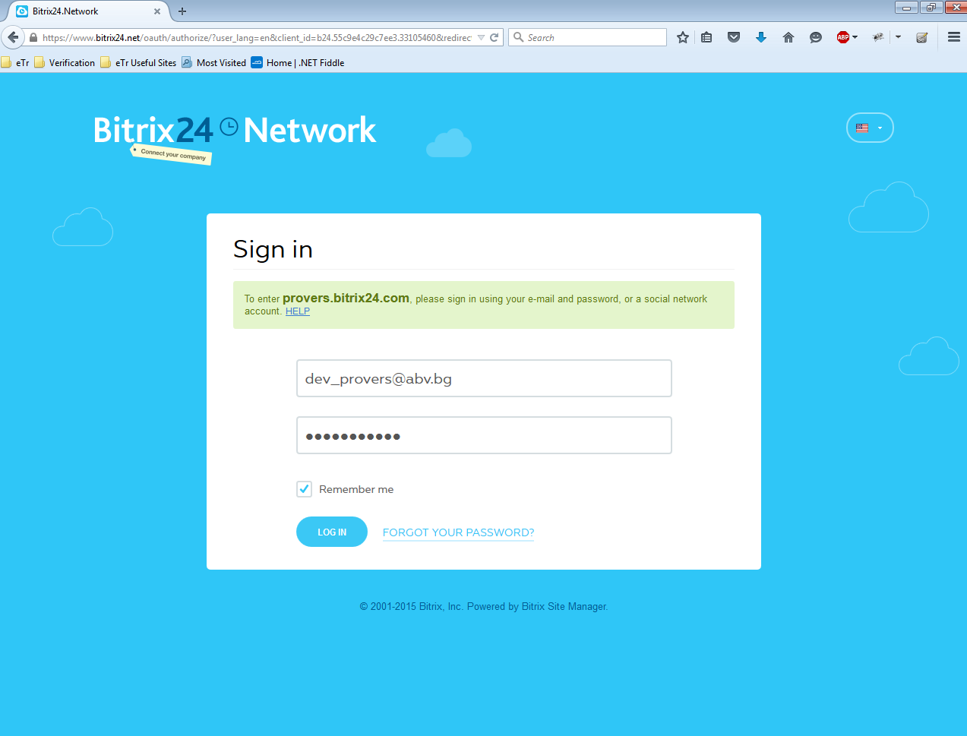

1. Bitrix Network

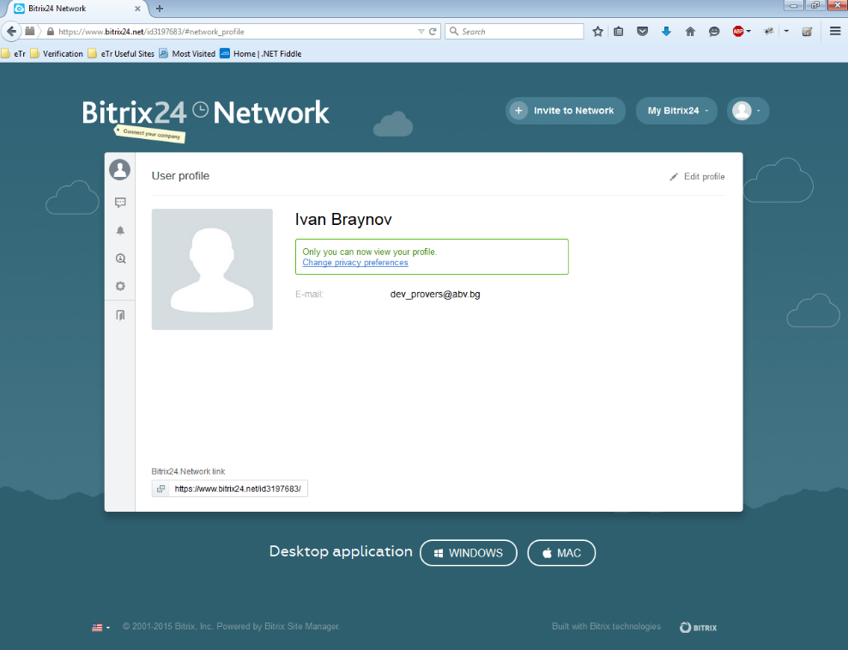

1. Activity Stream

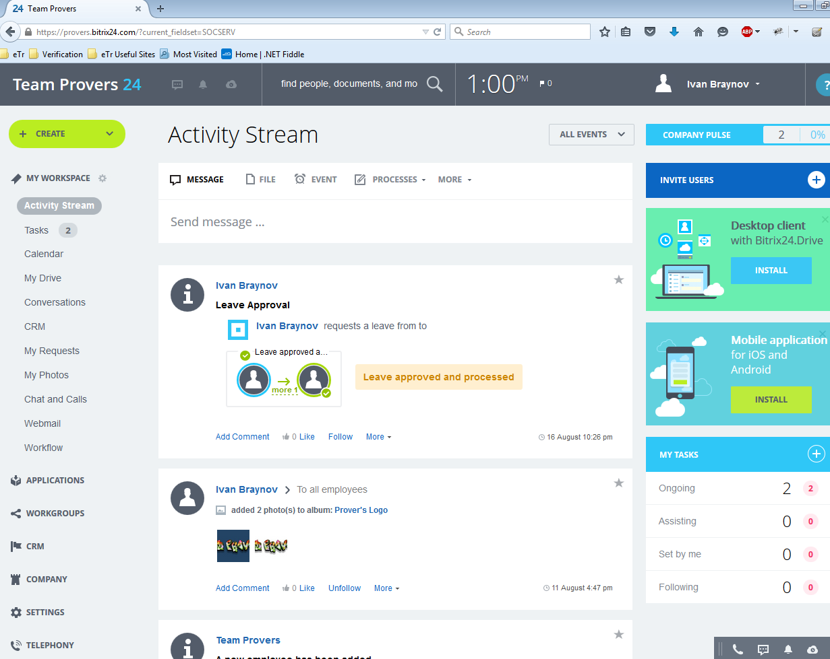

1. Tasks

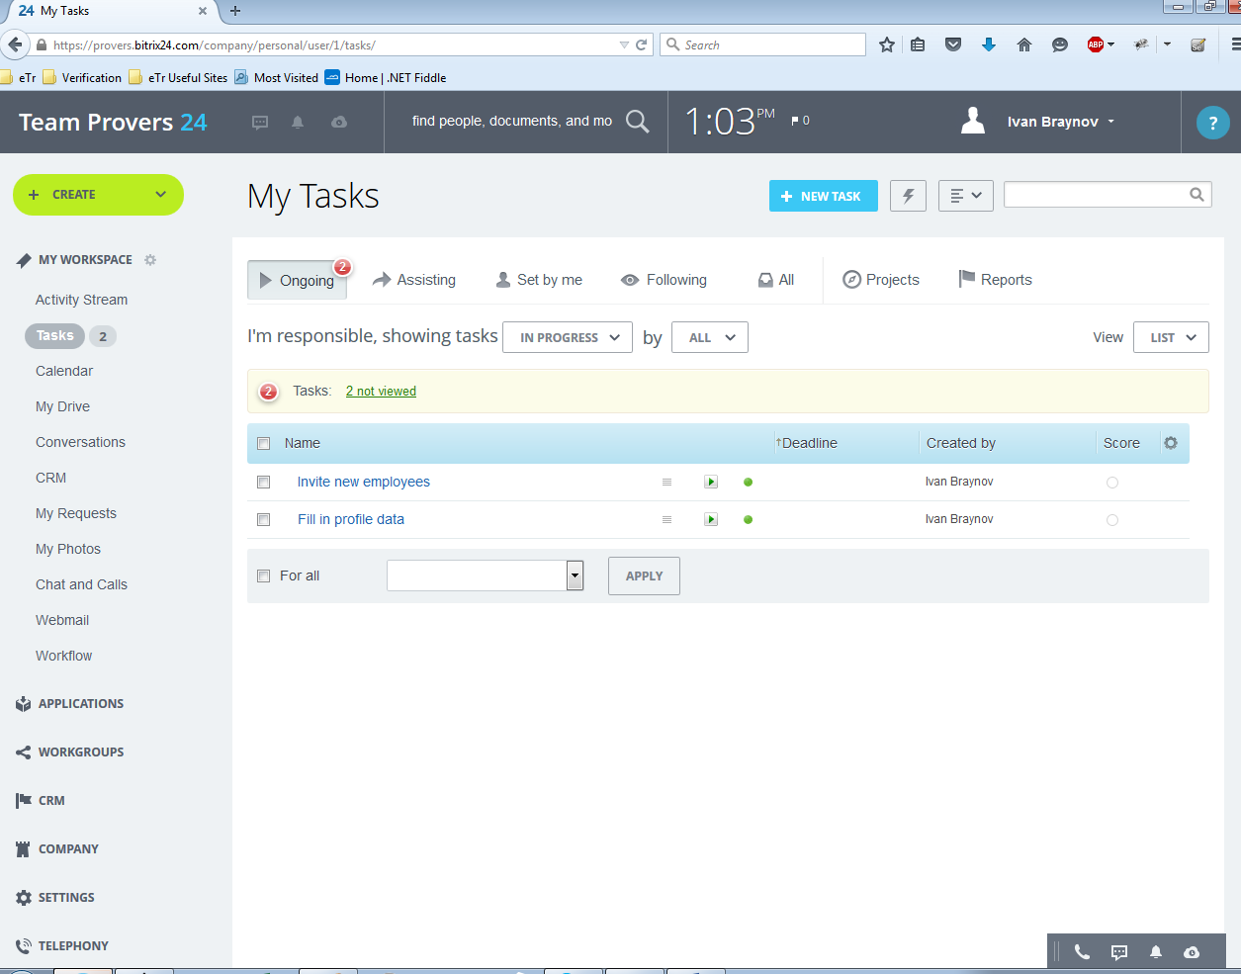

1. Calendar

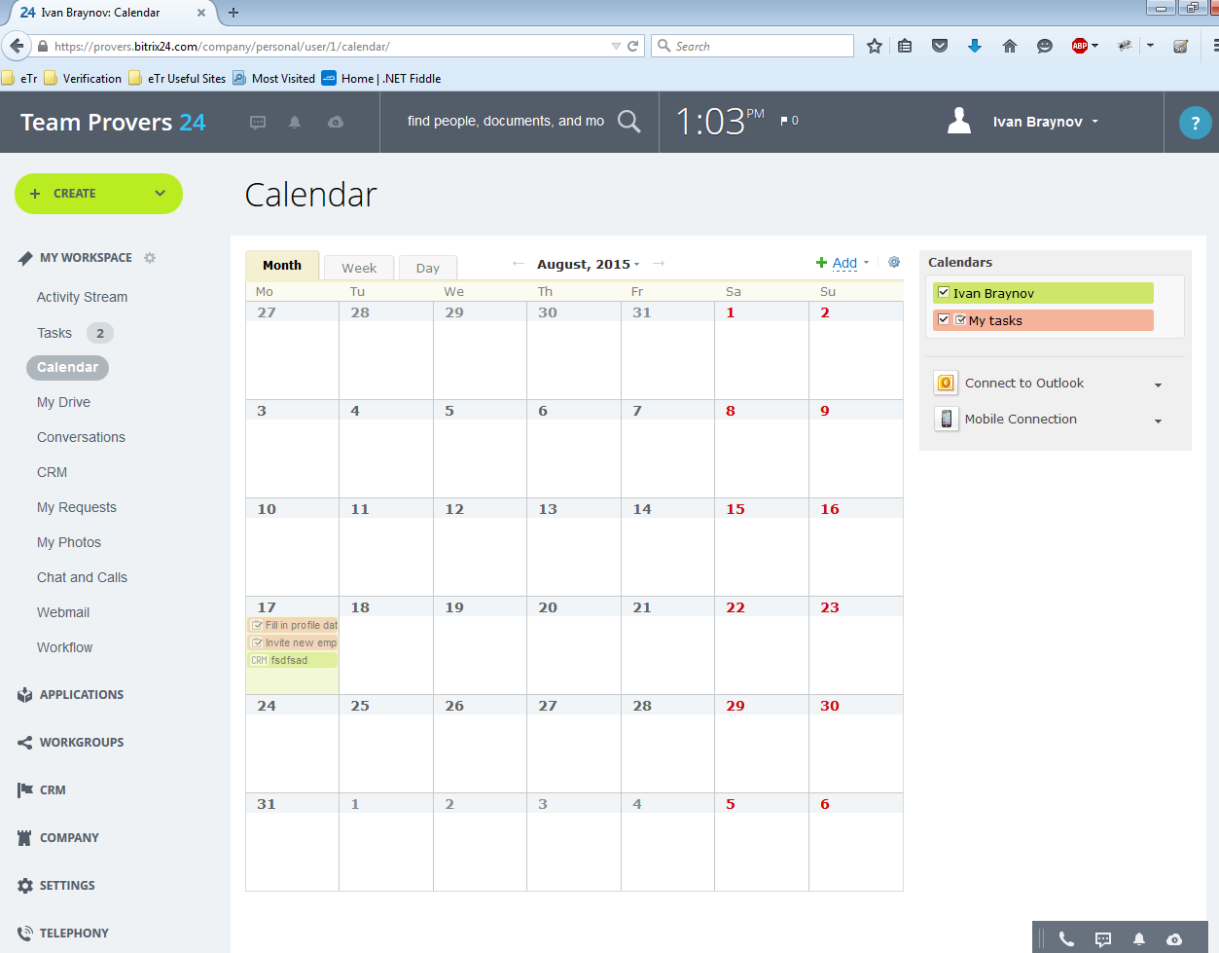

1. CRM

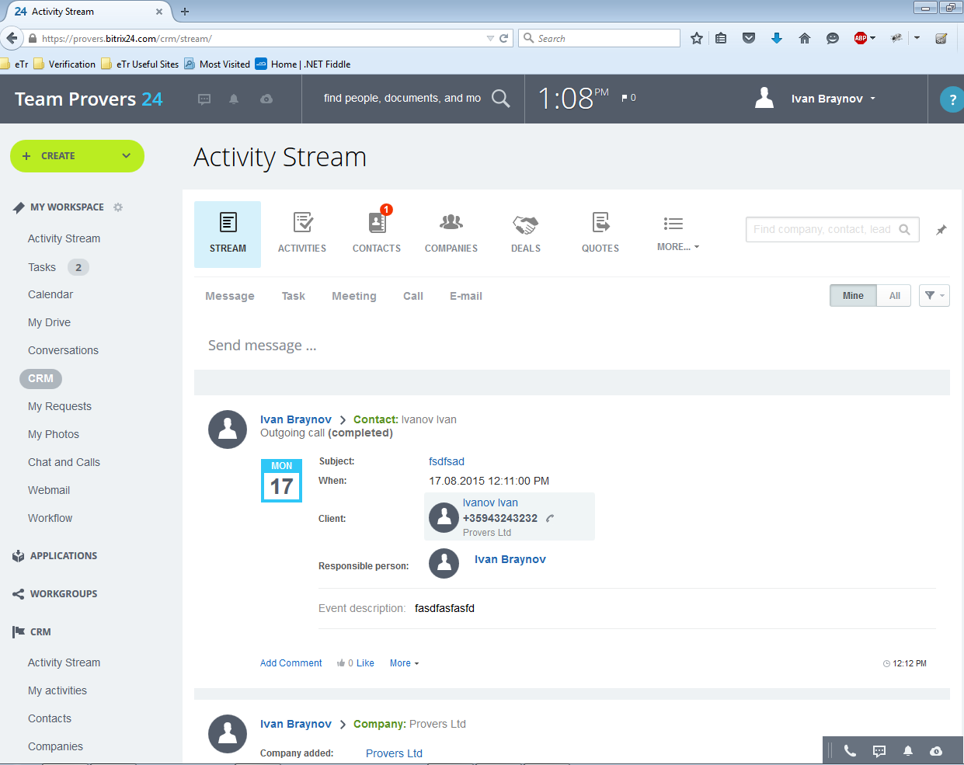

1. CRM/Contacts

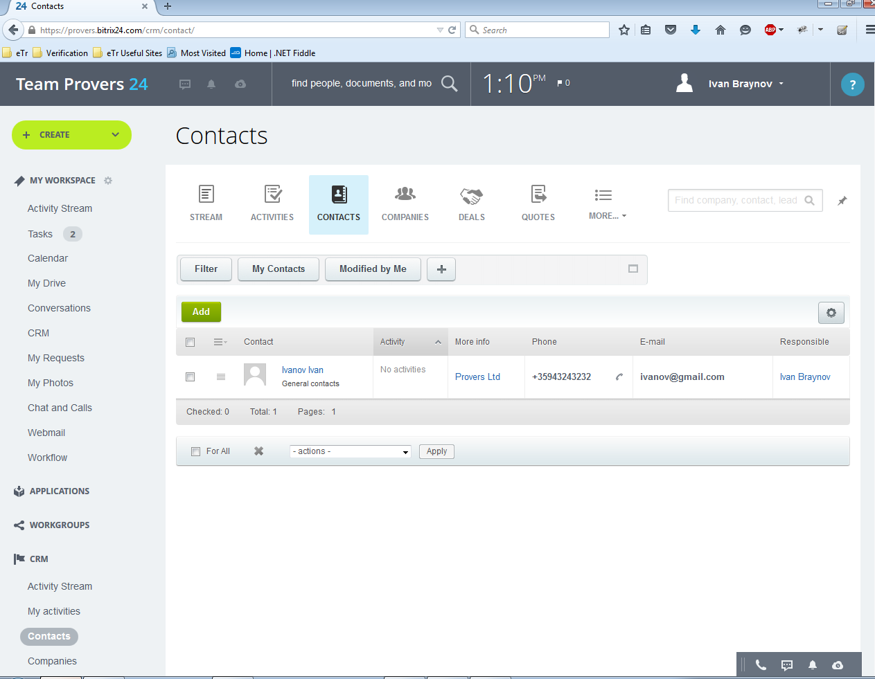

1. CRM/Companies

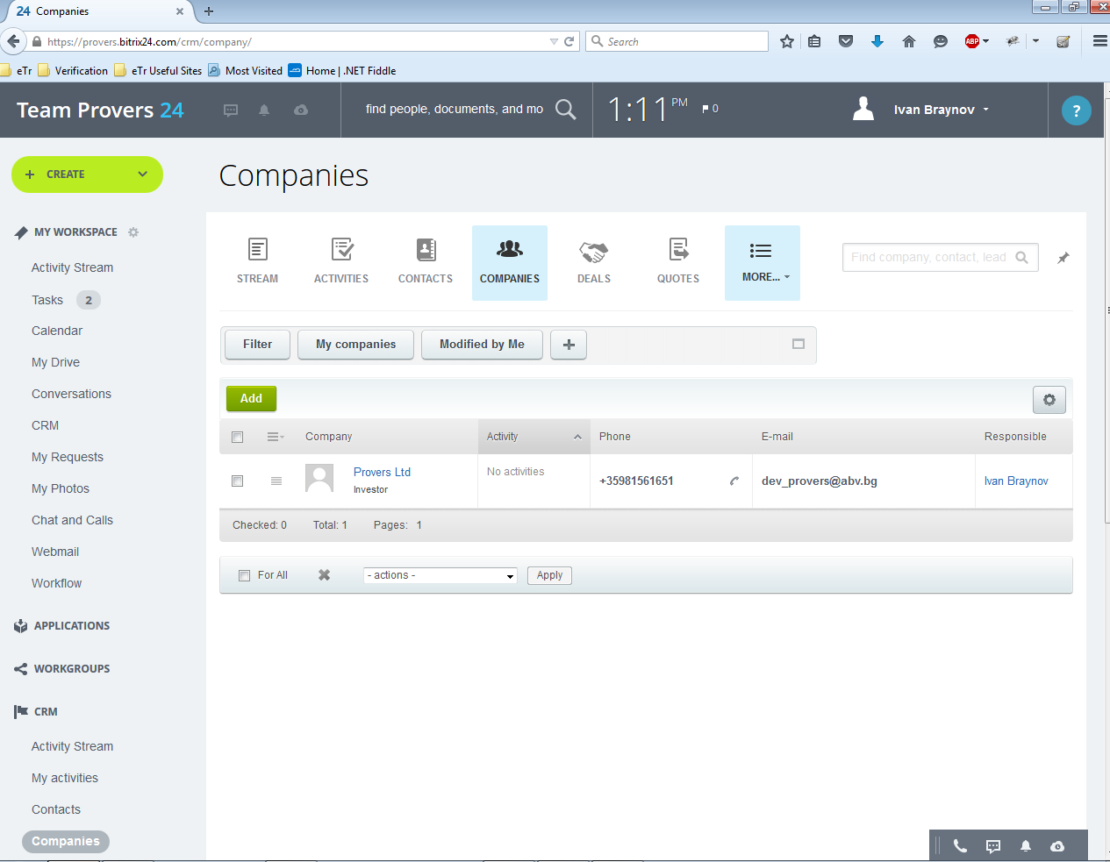

1. CRM/Activities  
   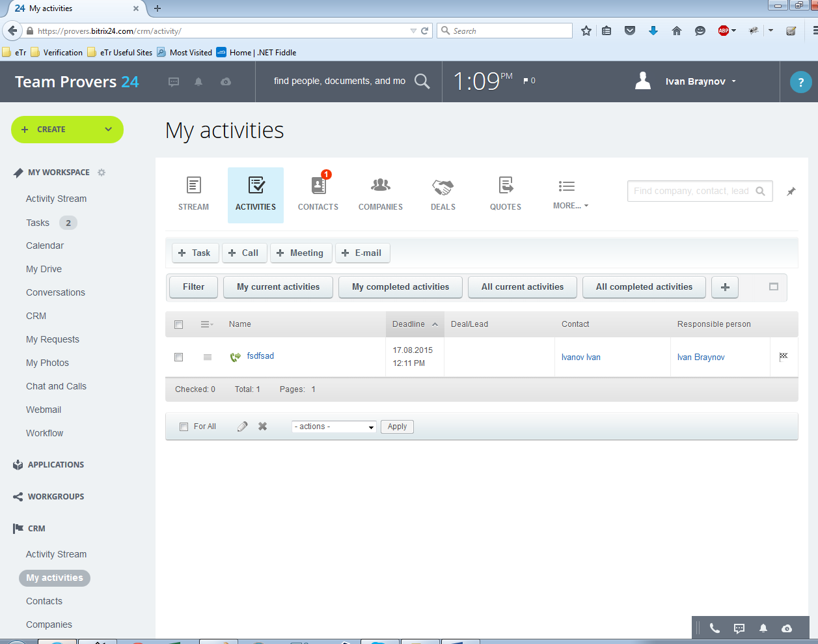

## Reliability

Reliability is an important factor to make CRM trustable. Some issues should be considered as following:

### Availability:

CRM should be available 24 hours per day, 7 days per week. Maintenance access period is a month. Database is backed up.

### Mean Time Between Failures (MTBF):

3 month.

### Mean Time to Repair (MTTR):

2 hours

### Maximum Bugs or Defect Rate:

Less than 1minor bug per 1000 lines of code.

### Bugs or Defect Rate:

No critical bug that causes data loss or system crash is allowed.

## Performance

### The information retrieval should be as fast as possible for customer satisfaction.

To ensure this, the consumer should be able to download a page in 5 seconds with a 33.6 Kbps modem. The form submission should not take a long time to be processed, especially in the CRM module case, in which form applications play a major role.

### The server should be able to serve 25 percent of registered customers

The server should be able to serve 25 percent of registered customers simultaneously, which may be about several thousand for a medium scaled electronic enterprise.

### Separation of connection handling and data processing

Separation of connection handling and data processing would definitely improve the overall system performance as well as cost incurred.

### Software runs on an online platform

Slow data retrieval because of poor programming must be absolutely discarded since the software runs on an online platform.

### Minimize the data transfer time

The size of data sent to the user can be limited to an upper bound, especially for the multimedia files, to minimize the data transfer time.

### Size of the secondary storage

The larger the primary memory, the faster the applications would run. Moreover the size of the secondary storage should be sufficient for data swapping, recovery and backup procedures.

## Supportability

### Compatible with Operating Systems

* Windows
* Linux
* Sun Solaris

### Compatible with Browsers

* Microsoft Internet Explorer
* Mozilla Firefox
* Google Chrome
* Opera
* Safari

## On-line User Documentation and Help System Requirements

### User Manual

User manuals: will be self-explanatory guide to installation and troubleshooting of CRM. It will allow users to install system using 3 major installation options, namely:

Minimal-Meeting the need of users with limited resources or resource constraint product installation requirements.

Typical: For standard installations

Custom: For expert installations

CD-ROM: Includes the CRM product setup files, with help files and configuration files and Read me.

### Online Help

Online help is available to all registered users. Internet downloadable, online instructions guide is available on web. Online guide also provide complete system description and technologies.

## Licensing Requirements

CRM will be sold with fewer than two licenses policies. Evaluation Use License, which will give a fully functional trial copy for 30 days after which to use the product, it has to be upgraded to a Production Use License. Each copy sold is for installation with one application server. The number of users that can connect to CRM is unlimited. Purchase of an Annual Maintenance and Support contract after the first year of installation is needed to continue getting services such as

* Software upgrades and product enhancements upon their commercial release, and appropriate documentation, and
* Technical assistance with respect to the Software, including
  + Clarification of functions and features;
  + Clarification of documentation;
  + Technical support and guidance in the operation of the Software; and
  + Software error analysis and correction.