Software Requirements Specification

<Natural Milk>

Software Requirements Specification

<1>

<4/12/2016>

Jana Bancheva

Petra Djigolova

Borislav Gotsev

Georgi Purvanov

Boiko Andonov

Desislava Belishka

Prepared for

**Natural Milk Corporation**

**Revision History**

|  |  |  |  |
| --- | --- | --- | --- |
| **Date** | **Description** | **Author** | **Comments** |
| <date> | <Version 1> | <Your Name> | <First Revision> |
|  |  |  |  |
|  |  |  |  |
|  |  |  |  |

**Document Approval**

The following Software Requirements Specification has been accepted and approved by the following:

|  |  |  |  |
| --- | --- | --- | --- |
| **Signature** | **Printed Name** | **Title** | **Date** |
|  |  |  |  |
|  |  |  |  |
|  |  |  |  |

**Contents:**

1 Introduction

1.1 Purpose

1.2 Scope

1.3 Definitions, Acronyms, and Abbreviations

1.4 References

2 Overview

2.1 Product Perspective

2.2 Product Functions

2.3 General Constraints

2.4 Assumptions and Dependencies

3 Functional requirements

3.1 Provide comprehensive product details:

3.2 Detailed product Categorizations

3.3 Provide Search facility

3.4 Maintain customer profile

3.5 Email confirmation

3.6 Provide shopping cart facility

3.7 Allow online change or cancellation of order

3.8 Provide detailed sitemap

3.9 Online Purchase of products

3.10 Use cases

4 User Screens:

5 Non Functional Requirements

5.1 Usability

5.2 Performance

5.3 Reliability

5.4 Security

5.4.1 Data Transfer

5.4.2 Data Storage

5.5 Software Interfaces

5.5.1 Hardware Interfaces

5.5.2 Communications Interfaces

5.6 Legal and Other Notices

5.7 Portability

5.7.1 Examples[edit]

5.8 Inverse Requirements

5.9 Design Constraints

6 Analysis model

6.1 Sequence diagrams

6.2 State - Transition diagrams

6.2.1 State Transition Testing Example in Software testing:

6.3 Data flow diagrams

7 Change Management Requirements

# 1 Introduction

This section gives a complete description and overview of everything included in this SRS document. Also, the purpose of this document is described and a list of abbreviations and definitions is provided. The developers and the QA can use this document as a reference for developing the design and test plan documents.

## 1.1 Purpose

The purpose of this document is to present a detailed description of the NaturalMilk’s website main functionalities. It will explain the purpose and features of the system, the interfaces of the system, what the system will do, the constraints under which it must operate and how the system will react to external stimuli. This document is intended for both the stakeholders and the developers and QA engineers. This will give a clear idea on how the software should be developed by the development team for the end users. This SRS will provide a solid base or foundation for the project. From this SRS, the designers (Paco Raban) can design low level design documents and the testers can create test plans and various test case documents. The main goal of the project is to design a scalable and extensible system for managing the sales of the organic products.

## 1.2 Scope

The software to be produced is an Online Organic (bio) store which will help the customers of the NaturalMilk be able to purchase products such as meat, milk, eggs and so on, from anywhere in Bulgaria. The core part of the project is the selling and shipping system to keep track of the sales and a well-designed user interface. This will be explained in detail in “Functional Requirements” section. There are three types of the end users for this online store NaturalMilk. The first one is the customer who uses the system for the purchasing of foods. The other end users are the admin user who are given separate authentication to the website.

## 1.3 Definitions, Acronyms, and Abbreviations

|  |  |
| --- | --- |
| **Ecwid** | E-commerce platform enabling individuals and businesses to create online store or add those to existing websites |
| **Shopping Cart** | An object that lists a Customer's selected Items, their applied  promotions and gives them an option to check out |
| **Barcode** | A unique identifier assigned to single items |
| **User** | The person who operates the software product. User might be or might not be a registered customer |
| **Admin** | The person who manages the software. Admin can delete/add/update pics, product info and so on |
| **Customer** | A person that is a user of the system but has created an account |
| **Item** | An object that holds items available for purchase by the Customer |
| **Reorder** | The system process that automatically orders new stock of an item |
| **Transaction** | The information related to a customer's purchase that is logged |
| **Checkout** | The process a Customer goes through to purchase an Item |
| **Checkbox** | A user interface element that allows a User to inform the system that  he/she selected a particular item |
|  |  |

## 1.4 References

* Website: [https://naturalmilk.ecwid.com](https://naturalmilk.ecwid.com/)
* http://myndset.com/2[012/03/what-are-the-ecommerce-business-models/](http://myndset.com/2012/03/what-are-the-ecommerce-business-models/) Minter Dial
* 1. Making business sense of the Internet by Shikar Ghosh. Harvard Business Review (March April 1998).
* 2. Understanding the Concept of Value by Mark Holleman. A Business Blog. Febrary 2011.
* 3. The Concept of value by Kevin Vincent. MLMKnowHow. 1998.
* 4. Business Model Generation: A Handbook for Visionaries, Game Changers, and Challengers. By

# 2 Overview

This SRS will provide a description of "NaturalMilk" system. It will provide an outline of the requirements. It will also provide an overview of the characteristics and constraints of the "NaturalMilk" system.

## 2.1 Product Perspective

This application is going to be developed using HTML5 to create user interface and GUI components like graphics, buttons, containers, labels, text and anything that the user will deal with or watch. Also we are going to use JPEG, PNG, SVG to create the better visual idea of the food we are selling so the user can see when searching for a certain product, adding products like chicken, milk, eggs and so on to shopping cart, browsing categories. Here is more detailed information of tools:

Website Background - Ecwid E-commerce Shopping

Content Management System, based on PHP and MySQL.

WordPress 4.4.2

Server-side Programming Language - PHP

Client-side Programming Language -JavaScript

JavaScript Library - JQuery 1.11.3

Markup Language -HTML5

Character Encoding - UTF-8

Image File Formats - JPEG, PNG, SVG

Site Elements - External CSS; Embedded CSS; Inline CSS

HTTP Strict Transport Security

SSL Certificate Authority - Comodo

Social Widgets – None (possible enhancement)

Web Server- Nginx

Top Level Domain - .com

Server Location - Bulgaria

Content Language - Bulgarian

## 2.2 Product Functions

For all of the following functions, these assumptions have been made:

The code needs to be highly maintainable, as software engineering and design methodology is constantly evolving. If this software product is to be updated or maintained in a time and cost effective manner, the code needs to be highly maintainable. The performance of a number of functions is described as being interactive. This is defined as the user being able to get continuous and quick-to-respond feedback on the operation that they are performing. Secure registration and profile management facilities for Customers Browsing through the website to see the items that are there in each category of products Adequate searching mechanisms for easy and quick access to particular products. Creating a Shopping cart so that customers can shop ‘n’ go. of items and checkout finally with the entire shopping carts. Regular updates to new product items, new arrivals. Maintaining database of regular customers of different needs. Shop employees are responsible for internal affairs like processing orders, assure home delivery, getting customer's delivery-time feedback, updating order's status and answering client's queries online.

User Characteristics

Users of the website must know how to navigate in a website.

Users of the website must know how to create own profile in the online store.

Users of the website have to know how to place order.

Users of the website have to know how to get ”Shipping details” and choоse delivery method.

Users of the website must possess readiness to pay for the purchasing of foods.

## 2.3 General Constraints

General design/implementation constraints include:

* All code shall be written in WordPress 4.4.2;
* Database files shall be used for all data storage and reporting;
* The documentation and code shall be in accordance with the Web Style Standards and Technical Style Standards.

Global limitations or constraints that have a significant impact on the design of the system's software (and describe the associated impact). Such constraints may be imposed by any of the following (the list is not exhaustive):

* End-user environment;
* Standards compliance;
* Data repository and distribution requirements;
* Security requirements (or other such regulations);
* Performance requirements;
* Network communications;
* Verification and validation requirements (testing);
* Other requirements described in the requirements specification.

## 2.4 Assumptions and Dependencies

These may concern such issues as:

* Food quality;
* Durability;
* Time for delivery;
* Available in stock goods;
* Possible discounts.

# 3. Functional requirements

## 3.1 Provide comprehensive product details:

The system shall display detailed information of the selected products.

The system shall provide browsing options to see product details.

## 3.2 Detailed product Categorizations

The system shall display detailed product categorisation to the user.

## 3.3 Provide Search facility

The system shall enable user to enter the search text on the screen.

The system shall enable user to select multiple options on the screen to search.

The system shall display all the matching products based on the search

The system shall display all matching result on the current screen.

The system shall enable user to navigate between the search results.

The system shall notify the user when no matching product is found on the search.

## 3.4 Maintain customer profile

The system shall allow user to create profile and set his credential.

The system shall authenticate user credentials to view the profile.

The system shall allow user to update the profile information.

## 3.5 Email confirmation

The system shall maintain customer email information as a required part of customer profile.

The system shall send an order confirmation to the user through email.

## 3.6 Provide shopping cart facility

The system shall provide shopping cart during online purchase.

The system shall allow user to add/remove products in the shopping cart.

## 3.7 Allow online change or cancellation of order

The system shall display the orders that are eligible to change.

The system shall allow user to select the order to be changed.

The system shall allow user to cancel the order

The system shall allow user to change shipping, payment method.

The system shall notify the user about any changes made to the order.

The system must stored contents for 30 days.

## 3.8 Provide detailed sitemap

The system shall allow user to view detailed sitemap.

Offer online promotions and rewards.

The system shall display all the available promotions to the user.

The system shall allow user to select available promotion.

## 3.9 Online Purchase of products

The system shall allow user to confirm the purchase.

The system shall enable user to enter the payment information.

## 3.10 Use cases

We describe the functional requirements by giving various use cases.

Use cases related to System Authentication:  
  
Use Case №1: Login like Guest user (without registration)  
Primary Actor: User  
Pre Condition: Installed browser and active internet connection   
Main scenario:  
1. User initiates browser  
2. User specifies web address  
3. The user has access to the system   
  
Alternate scenario:  
 The user log in like registration user  
  
  
Use Case №2: Login like Registration user  
Primary Actor: User  
Pre Condition: Installed browser and active internet connection   
Main scenario:  
  
1. User initiates browser  
2. User specifies web address  
3. User gives e-mail and password ( refer to next chapters section “User Screens” )  
4. System does authentication  
5. The user has access to the system like registration user  
Alternate scenario:  
 4.1 Authorization fails – wrong username/password  
 4.1.1 Prompt the user that he typed the username/password wrong  
 4.1.2 Allow him to re-enter the username/password  
 4.2 Authorization fails – forgotten username/password  
 4.2.1 Prompt the user to enter his registered email  
 4.2.2 User receives an email with instructions about his login credentials

Use Case №3: Forgotten password  
Primary Actor: User  
Pre Condition: Installed browser and active internet connection   
Main scenario:  
  
1. User initiates browser  
2. User specifies web address  
3. User enter e-mail  
4. User has forgotten his password  
5. User goes to “Forgot your password?”  
6. User enter your email, which is registered  
7. User click “Reset password” button  
8. User receives an email with instructions about his login credentials  
  
  
Use Case №4: Change password  
Primary Actor: User  
Pre Condition: User logged in   
Main scenario:  
  
1. User goes to the main page and click link “Your account” ( refer to next chapters section “User Screens” )  
2. User goes to menu “Settings”  
3. User initiates field “Old Password”, “New Password” and “”Retype New Password”  
4. User provides current password, new password and confirm new password  
5. System displays message for successful change

Alternate scenario:  
 4.1 Authorization fails – wrong password  
 4.1.1 Prompt the user that he typed the password wrong  
 4.1.2 Allow him to re-enter the password  
 4.2 Authorization fails – new password and confirm new password do not match  
 4.2.1 Prompt the user that new password and confirm new password do not match  
 4.2.2 Allow him to re-enter the attributes.  
 4.3 Authorization fails – new password and confirm password are less than 6 chars  
 4.3.1 Prompt the user that password must be at least 5 characters  
 4.3.2 Allow him to re-enter new and confirm password

Use Case №5: Register as a user  
Primary Actor: User  
Pre Condition: Installed browser and active internet connection   
Main scenario:

1. User initiates browser  
2. User specifies web address  
3. User goes to Sign in ( refer to next chapters section “User Screens” )  
4. User goes to “Create new account”  
5. User enters a name (must contain less than 5 characters, no more than 255 characters)  
6. User enter a email   
7. User enter a password no less than 5 characters, no more than 200 characters

8. User confirm a password  
9. Press “Register” button  
10. The user has access to the system like registration user

Alternate scenario:  
 8.1 The user choose already registered username  
 8.1.1 The system displays an error message  
 8.1.2 Allow him to re-enter new e-mail  
  
Use cases related to navigate in site:  
  
Use Case №6:  
Primary Actor: User  
Pre Condition: User logged in   
Main scenario:  
  
1. User goes to main page  
2. User choose any product category shopping: Dairy products, Chickens and eggs, Meat products, Fruits and vegetables, Organic fruits from Greece, Other products.  
3. System displays а Selected category or subcategory  
4. User choose some product  
5. System displays picture of product and description with price for the product  
  
  
Use cases related to buy in site like registration user:  
  
Use Case №7:  
Primary Actor: User  
Pre Condition: User logged in with username and password  
Main scenario:  
  
1. User goes to main page  
2. User choose any product category shopping  
3. System displays а Selected category or subcategory  
4. User choose some product  
5. System displays picture of product and description with price for the product  
6. User selects the quantity and delivery date  
7. Press “Add to Bag” button  
8. Press ”Go to Checkout” button  
9. System displays а menu ”Shipping details”, where registration user has ready adress book and User choose delivery method  
10. Press ”Checkout” button  
11. System displays a menu ”Payment details”  
12. Press ”Continue” button  
13. System displays a last menu ”Place Order”  
14. Press ”Place order” button  
15. System displays message for successful order

16.User will receive e-mail confirm the order

17. User can see the status of his orders in “Your account” in tab “Orders”  
  
Alternate scenario:  
1. User log in to buy in site without registration  
  
  
Use cases related to buy in site like Guest user (without registration):

Use Case №8:  
Primary Actor: User  
Pre Condition: User logged in without username and password  
Main scenario:  
  
1. User goes to main page  
2. User choose any product category shopping  
3. System displays а Selected category or subcategory  
4. User choose some product  
5. System displays picture of product and description with price for the product  
6. User selects the quantity and delivery date  
7. Press “Add to Bag” button  
8. Press ”Go to Checkout” button  
9. System displays а menu ”Shipping details” , where user Enter shipping address and User choose delivery method  
10. Press ”Checkout” button  
11. System displays a menu ”Payment details”  
12. Press ”Continue” button  
13.System displays a last menu ”Place Order” 14. Press ”Place order” button  
15. System displays message for successful order

16.User will receive e-mail confirm the order

Alternate scenario:  
1. User log in to buy in site with registration  
  
  
Use cases related to add to Shopping Bag and how to finish order

Use Case №9:  
Primary Actor: User  
Pre Condition: User logged in  
Main scenario:  
  
1. User goes to main page  
2. User choose any product category shopping  
3. System displays а Selected category or subcategory  
4. User choose some product  
5. System displays picture of product and description with price for the product  
6. User selects the quantity and delivery date  
7. Press “Add to Bag” button  
8. Press “Checkout” button  
9. System displays а menu, which shows how many and what are the selected products  
  
Alternate scenario:  
 9.1 The user choose to add more products to Shopping Bag  
 9.2 User choose to clear bag  
   
  
  
Use cases related to add to Shopping Bag and continue shopping

Use Case №10:  
Primary Actor: User  
Pre Condition: User logged in   
Main scenario:  
  
1. User goes to main page  
2. User choose any product category shopping  
3. System displays а Selected category or subcategory  
4. User choose some product  
5. System displays picture of product and description with price for the product  
6. User selects the quantity and delivery date  
7. Press “Add to Bag” button  
8. Press “Continue Shopping” button  
9. System returns user in the previous page for choose more product  
  
Alternate scenario:  
 9.1 The user choose to finish shopping and go out the page  
 9.2 User choose to return to Shopping Bag  
  
  
Use cases related to cancel order

Use Case №11:  
Primary Actor: User  
Pre Condition: User logged in   
Main scenario:  
  
1. User goes to main page  
2. User choose any product category shopping  
3. System displays а Selected category or subcategory  
4. User choose some product  
5. System displays picture of product and description with price for the product  
6. User selects the quantity and delivery date  
7. Press “Add to Bag” button  
8. User log out the page  
9. If the user log in again, the previous choose product will stay in Shopping bag, independently if the user log in with registration or without registration  
  
Alternate scenario:  
7.1 User add to Shopping Bag and continue shopping

Use cases related to Administration:  
  
Use Case № 12: Access to edit the Product Catalog  
Primary Actor: Administrator  
Pre Condition: The Natural Milk product web page is loaded and the Administrator is logged into the system.   
Main scenario:  
I. The system prompts the user to select the menu “Manage Catalog”.  
II. The user selects the “Manage Catalog” menu and the system prompts him/her to select one of the following three options:  
1. Add new item;  
2. Modify existing item – update product details;  
3. Remove/Delete item.  
  
Use Case № 13: Add items  
Primary Actor: Administrator  
Pre-Condition: Previous use case #1 steps are completed  
Main scenario:  
1. User selects the “Add new item” option from the Manage Catalog menu.  
2. The system prompts the user to select an appropriate category and product (or create a new category/product if one does not exist) to place the item)  
3. The user select the appropriate category and product.  
4. The system prompts the user to enter the item details like Item Name, Quantity Available, Price and Item Image.  
5. The user keys in the requested item details and clicks “Submit”.  
6. The system updates the item in the selected category/product in the database.  
Alternate scenario:  
1. Administrator cancels the addition by clicking “Cancel”.  
  
Use Case № 14: Modify items  
Primary Actor: Administrator  
Pre-Condition: Use case #1 steps are completed  
Main scenario:  
  
1. The user selects the “Modify Existing Item” option.  
2. The system prompts the user to navigate to the appropriate item.  
3. The user navigates to the item that he wants to modify.  
4. The user modifies the Item Name, Price (discount), Quantity or Item Image and clicks Update.  
5. The system updates the information in the database.  
Alternate scenario:  
1. Administrator cancels the changes by clicking “Cancel”.

Use Case № 15: Remove/Delete items  
Primary Actor: Administrator  
Pre-Condition: Use case #1 steps are completed  
Main scenario:  
  
a) The user selects the “Remove/delete Item” option:  
a) The system prompts the user to navigate to the appropriate item.  
b) The user navigates to the item that he wants to remove.  
c) The user removes the item from the catalog by clicking “Remove Item” and clicks Update.  
d) The system updates the information in the database.  
Alternate scenario:  
1. Administrator cancels the deletion/removal by clicking “Cancel”.

Use cases related to Search Catalog  
  
This use case describes how the User can search the e-store catalog.  
  
Use Case № 16: Search Catalog  
Primary Actor: User  
Pre Condition: The Natural Milk product web page is loaded  
  
  
This use case describes how the User can search the e-store catalog.  
  
Desired condition: User-friendly interface and fast searching speed.  
User can find some specific product in catalog and add items to the cart successfully   
* searching is only successful when writing in the Bulgarian language only.   
Post Conditions:   
‘Product Screen’ displays items and corresponding list prices for the searched product.   
Item Screen’ displays detailed information about an individual item for sale, including a photo, if one is available.  
‘Cart Screen’ displays the various items added to the cart, the quantity and list price of each item and the Subtotal.  
  
Main scenario:  
 1. User enters text in text box next to Search button and clicks on Search button.  
 2. System displays the matching text products.  
 3. User clicks on the desired link. User can navigate back to the earlier pages if wishes.  
   
Alternate scenario:  
1. If search returns no results, System displays the message “No matching results”.

# 4 User Screens:

* Main webpage

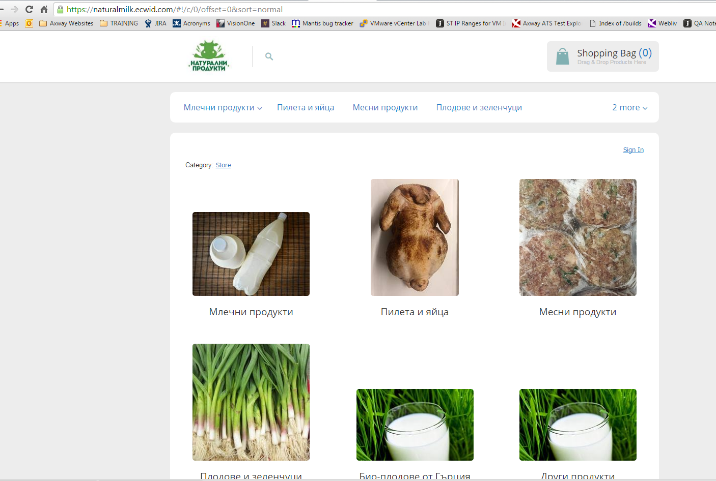

* Login Screen:

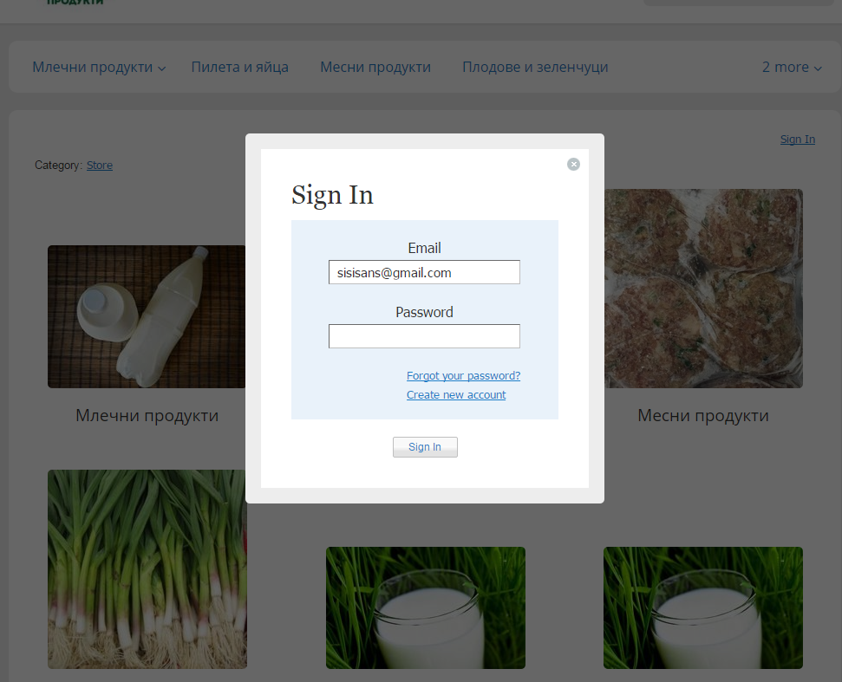

* Registration Screen:

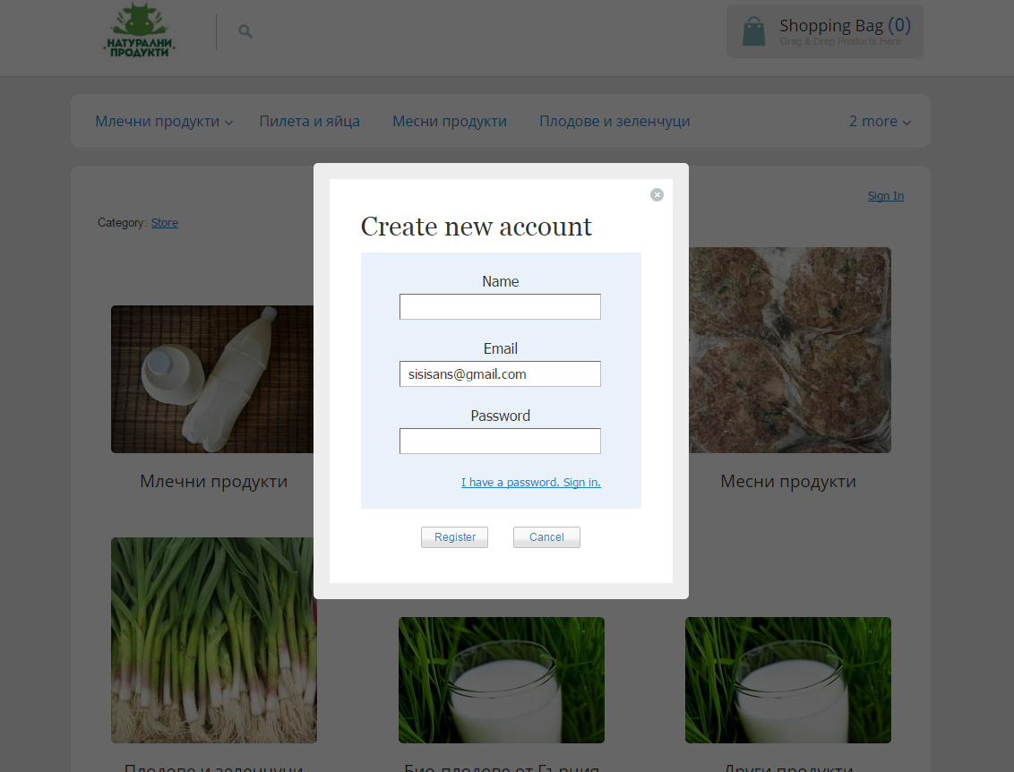

* Forgotten password screen

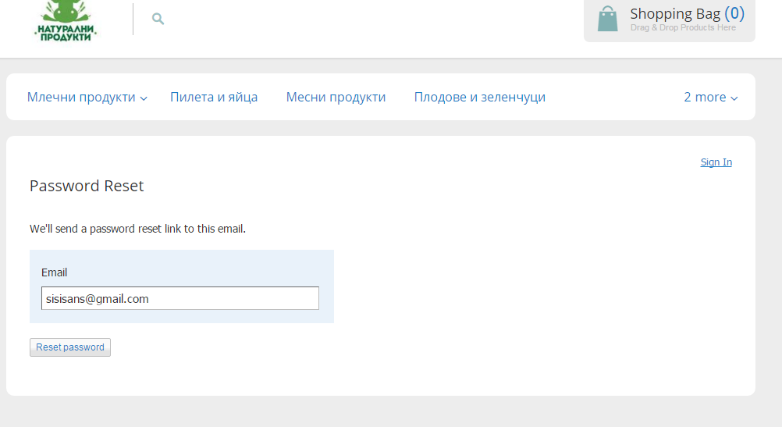

* Product screen before order page

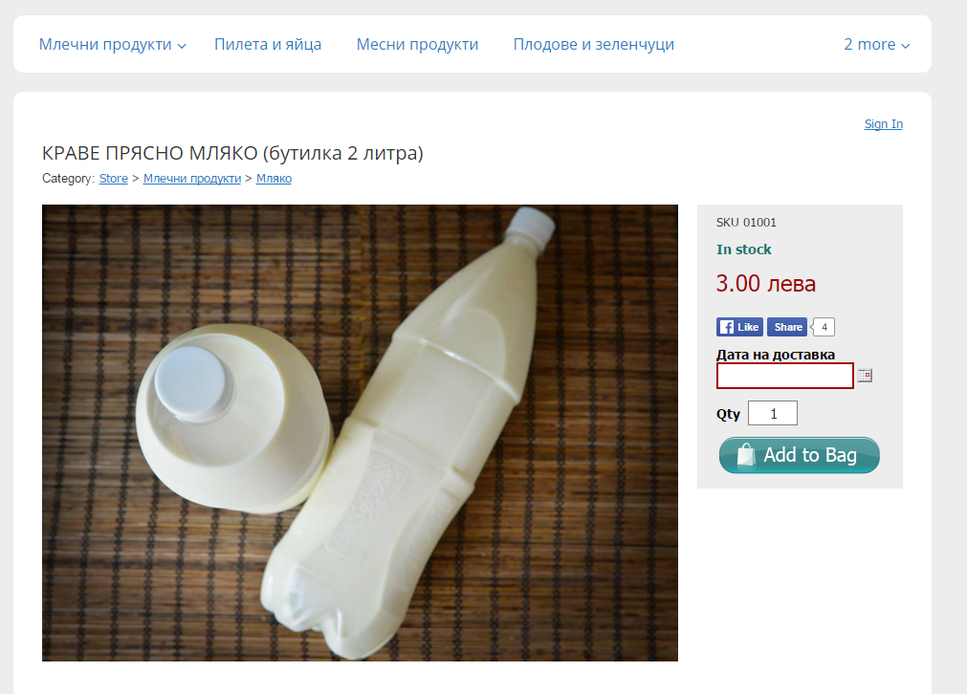

* Purchase Screen: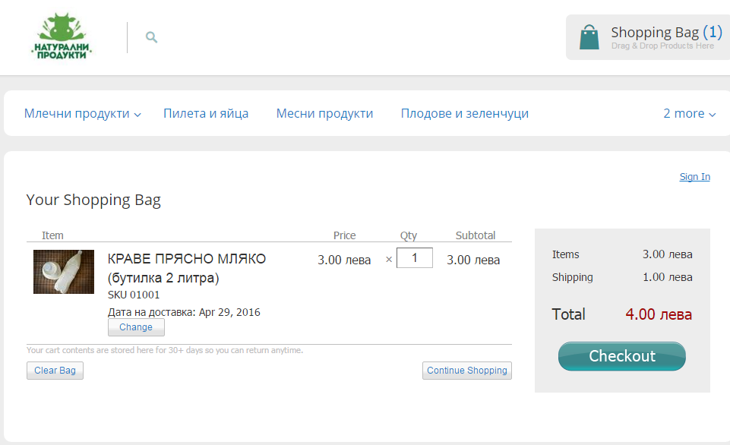 Checkout Screen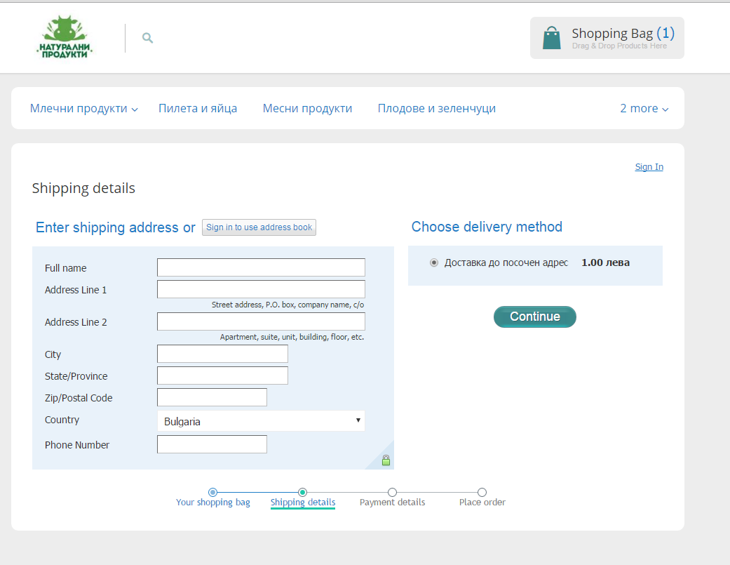
* Check status of order

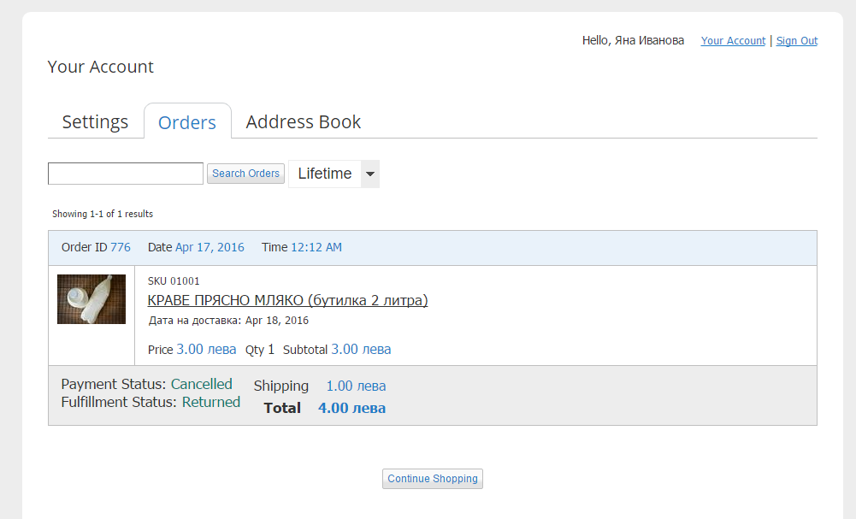

* Search Screen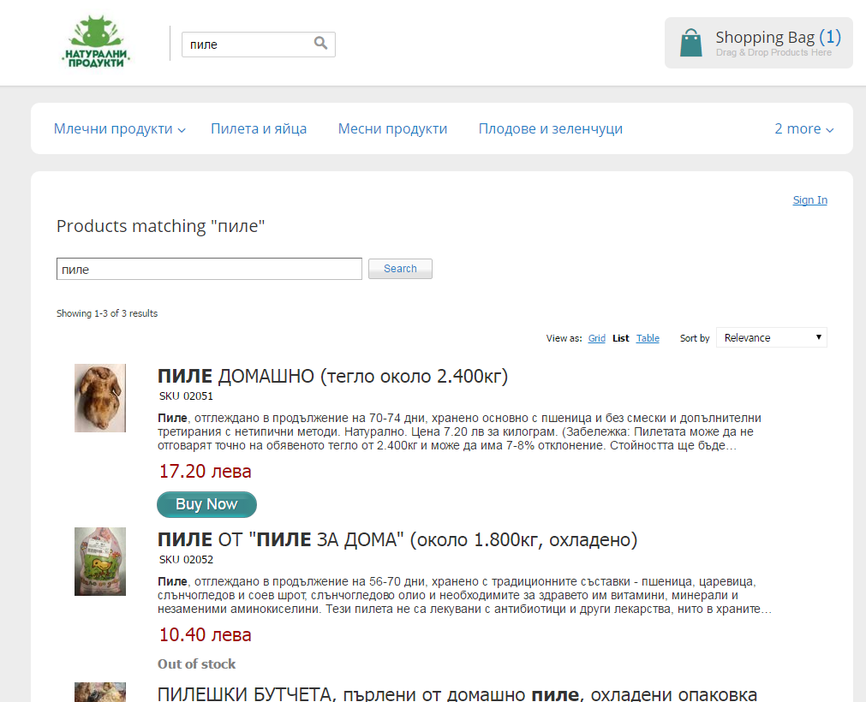
* Admin screens:

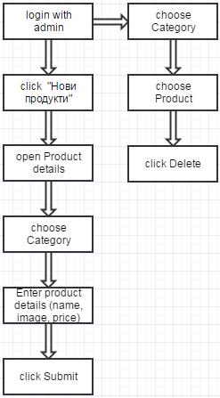

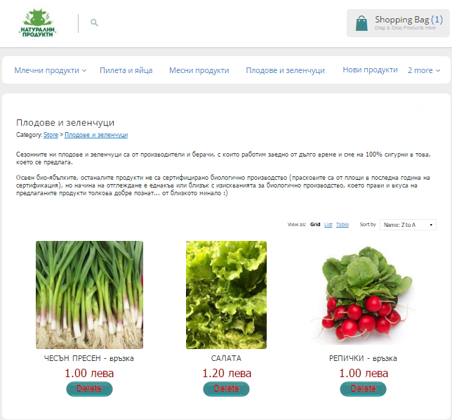

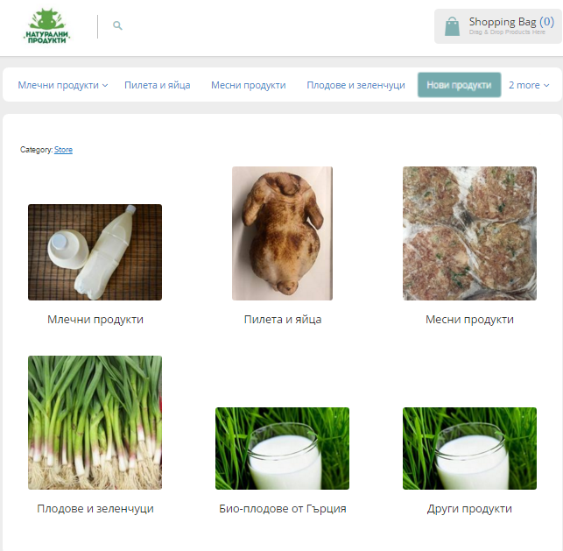

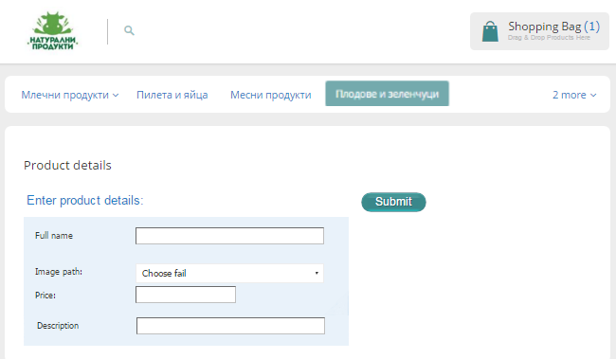

# 5. Non Functional Requirements

## 5.1 Usability

Usability testing is the best way to understand how real users experience your website or application.

Unlike interviews or focus groups that attempt to get users to accurately self-report their own behavior or preferences, a well-designed user test measures actual performance on mission-critical tasks. If the user cannot figure out how to complete a purchase, no amount of “but I really like the website!” comments are going to make up for it. Usability testing should be conducted at various times throughout the iterative design process to ensure that all usability requirements have been met in the final product.

Graphical User Interface requirements:

The system shall provide a uniform look and feel between all the web pages.

The system shall provide a digital image for each product in the product catalog.

The system shall provide use of icons and toolbars.

## 5.2 Performance

The product shall be based on web and has to be run from a web server.

The product shall take initial load time depending on internet connection strength which also depends on the media from which the product is run.

The performance shall depend upon hardware components of the client/customer.

The “Natural Milk” Corp’ s online shop is the main trade method of the company. Therefore the shop should provide good performance, to ensure the best user experience and satisfaction.

First of all the shop will operate mainly with users from Bulgaria, so the server should be built in Bulgaria. This is set by the fact, that the distance between user’s machine and the server is counted in the loading speeds.

The server should be as powerful as it has to support at least 10 users at a time, a requirement, set by the marketing research of the company.

## 5.3 Reliability

The “Natural Milk” Corp.’s online shop shouldn’t crash in the daytime, due to the big amount of client orders. The marketing research says, that the biggest customer daytime flow wouldn’t exceed 10 users at a time.

Maintenance could be done at nighttime, due to drop of the client flow.

Maintenance team should consider server availability for supporting the last stable version of Natural Milk’s website in case of bug, technical issue or website crash.

## 5.4 Security

The system should enforce user authentication security and guarantee reliability.

### 5.4.1 Data Transfer

The system shall use secure sockets in all transactions that include any confidential customer information.

The system shall automatically logout all customers after a period of inactivity.

The system shall confirm all transactions with the customer’s web browser.

The system shall not leave any cookies on the customer’s computer containing the user’s password.

The system shall not leave any cookies on the customer’s computer containing any of the user’s confidential information.

### 5.4.2 Data Storage

The customer’s web browser shall never display a customer’s password. It shall always be echoed with special characters representing typed characters.

The system’s back­end servers shall never display a customer’s password. The customer’s password may be reset but never shown.

The system’s back­end servers shall only be accessible to authenticated administrators.

The system’s back­end databases shall be encrypted.

## 5.5 Software Interfaces

The user interface for the software shall be compatible with browsers such as Internet Explorer, Mozilla or Chrome by which user can access to the system.

The user interface shall be implemented using any tool or software package like Java Applet, MS Front Page, etc.

### 5.5.1 Hardware Interfaces

Since the application must run over the internet, all the hardware shall require to connect internet will be hardware interface for the system. As for e.g. Modem, WAN – LAN, Ethernet Cross­Cable.

### 5.5.2 Communications Interfaces

The re­store system shall use the HTTP protocol for communication over the internet and for the intranet communication will be through TCP/IP protocol suite.

## 5.6 Legal and Other Notices

E-­store should display the disclaimers and trademark of the Producer.

It should also clearly state the right to return as per the local e­-commerce legal requirements.

## 5.7 Portability

Portability testing is the process of determining the degree of ease or difficulty to which a [software component](https://en.wikipedia.org/wiki/Software_component) or application can be effectively and efficiently transferred from one hardware, software or other operational or usage environment to another. The test results, defined by the individual needs of the system, are some measurement of how easily the component or application will be to integrate into the environment and these results will then be compared to the [software system's](https://en.wikipedia.org/wiki/Software_system) [non-functional requirement](https://en.wikipedia.org/wiki/Non-functional_requirement) of [portability](https://en.wikipedia.org/wiki/Software_portability) for correctness. The levels of correctness are usually measured by the [cost](https://en.wikipedia.org/wiki/Cost_estimation_models) to adapt the software to the new environment compared to the cost of redevelopment.

### 5.7.1 Examples

* Software designed to run on Macintosh OS X and Microsoft Windows operating systems.
* Applications developed to be compatible with Google Android and Apple iOS phones
* Software that should be compatible with Google Chrome and Mozilla Firefox browsers..

## 5.8 Inverse Requirements

Be judicious in the use of inverse requirements, which describe things that the system will not do. The underlying concern in this example seems to pertain to protecting the file contents from inadvertent damage or loss.

## 5.9 Design Constraints

Software requirements that limit the options available to the system designer.

# 6. Analysis model

Package "Use Cases"

This package contains a description of all the use cases that can be played by external actors to use the system.

Use cases related to the client's shopping activities

Account Management

Use cases related to the management of accounts: creation, deletion...

Catalog Management

Use cases related to the management of the product catalog.

Product Management

Use cases related to the management of products for sale online.

Order Management

Supplier order management use cases

Package "Analysis" from Package ShoppingCart This package contains the models used to analyse the business and its context in order to properly scope what the system must do.

Clients or entities external to the system interacting with the system. Processes Main processes describing the online shopping system core business. Use Cases Use case for interacting with the shopping cart system.

## 6.1 Sequence diagrams

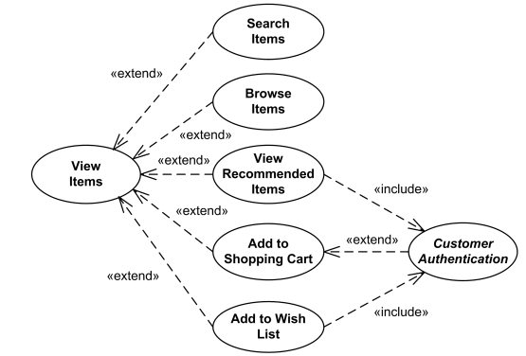

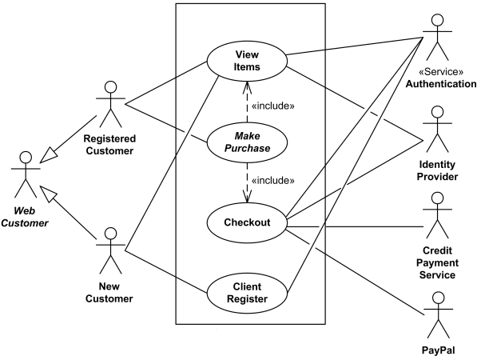

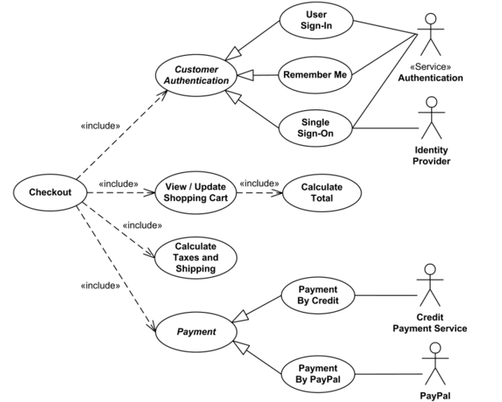

## 6.2 State - Transition diagrams

State transition technique is a dynamic testing technique, which is used when the system is defined in terms of a finite number of states and the transitions between the states is governed by the rules of the system.

Or in other words, this technique is used when features of a system are represented as states which transforms to other state. The transformations are determined by the rules of the software. The pictorial representation can be shown as:

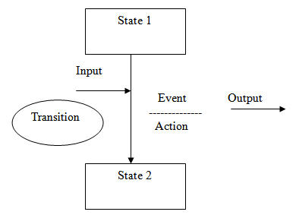

So here we see that an entity transitions from State 1 to State 2 because of some input condition, which leads to an event and results to an action and finally gives the output.To explain it with an example: You visit an ATM and withdraw $1000. You get your cash. Now you run out of balance and make exactly the same request of withdrawing $1000. This time ATM refuses to give you the money because of insufficient balance. So here the transition, which caused the change in state is the earlier withdrawal.

### **6.2.1 State Transition Testing Example in Software testing:**

In practical scenario, testers are normally given the state transition diagrams and we are required to interpret it. These diagrams are either given by the Business Analysts or a stakeholder and we use these diagrams to determine our test cases.

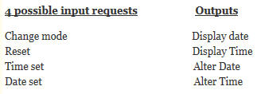

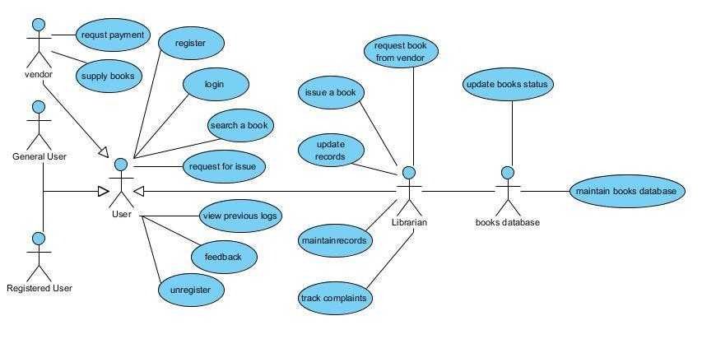

**States of a shopping cart**

|  |  |
| --- | --- |
| **State** | **Description** |
| **Empty** | **The shopping cart does not contain any products.** |
| **Collecting** | **The cart contains some products.** |
| **Show summary** | **Overview of the shopping cart contents are shown.** |
| **Checkout** | **Cart contents are ordered.** |

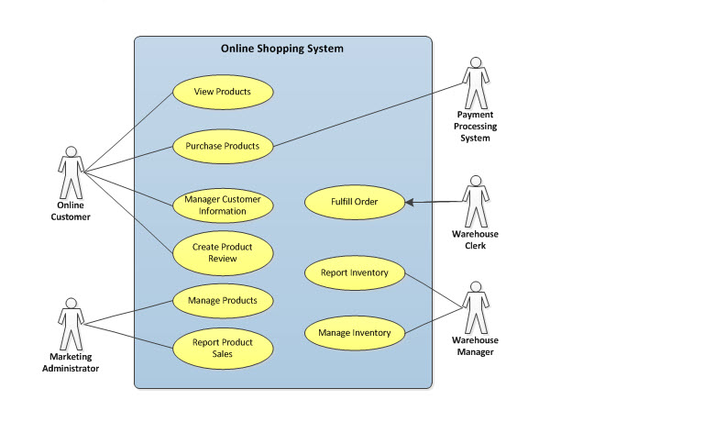

## 6.3 Data flow diagrams

There are several common modeling rules that I follow when creating DFDs:

1. All processes must have at least one data flow in and one data flow out.
2. All processes should modify the incoming data, producing new forms of outgoing data.
3. Each data store must be involved with at least one data flow.
4. Each external entity must be involved with at least one data flow.
5. A data flow must be attached to at least one process.

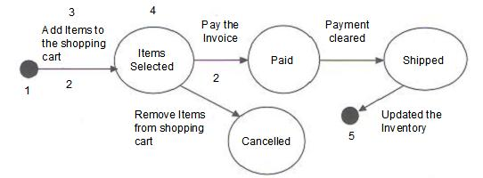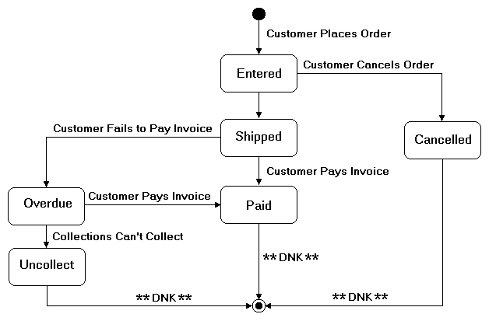

# 

# 

# 

# 7. Change Management Requirements

Change management is a process in quality control that keeps track of all changes made throughout the duration of a project. This means that if an employee finds a defect in a product, and changes are made to repair it, then these changes must be documented. The change could cause issues with other requirements being met further down the line of production. Keeping track of changes that occur should always be documented. Change management documentation should be labeled according to the phase of the project, name of the change, etc. The information included in a change management document should record the exact steps taken to make the change, and should be as succinct and detailed as possible.

Change management needs to occur because changes often impact many people in a big way. For example, when several departments are building a product and each department is in charge of working on a piece of the project that will ultimately fit together like a puzzle. If even one minor change is made, the pieces may no longer fit together properly. One change can affect the entire project. If there is not communication about changes made then the entire quality control process experiences difficulties which can lead to a disaster.

You must meet customer requirements when you are developing a product for customers. Small changes can also impact these requirements. If a website that you are building doesn’t work on a Mac platform but it works on a PC, a change will be required. If the developer goes ahead and recodes the website without documenting it, even more problems could arise. What if once the developer makes the site work on a Mac it no longer works with a specific browser? He may have forgotten the exact changes he made, and it could take hours to figure out how to fix this new issue. Change must be controlled in a quality control environment if your company’s goal is total quality.

Quality control requires organization of processes. A very part of this process that should be in place is change management. It is important to keep track of changes in an organized fashion so they are easy to go back to and review. Changes can make a big impact on the end result of a product or service.

Hardly would any software development project be completed without some changes being asked of the project. The changes can stem from changes in the environment in which the finished product is envisaged to be used, business changes, regulation changes, errors in the original definition of requirements,limitations in technology, changes in the security environment and so on. The activities of Requirements Change Management include receiving the change requests from the stakeholders, recording the received change requests, analyzing and determining the desirability and process of implementation, implementation of the change request, quality assurance for the implementation and closing the change request. Then the data of change requests be compiled, analyzed and appropriate metrics are derived and dovetailed into the organizational knowledge repository. What is Change Management?

* Change management involves the selection of strategies to facilitate the transition of individuals, teams, or organizations from a current state of operation to the new, desired state. More specifically, it involves a process and set of techniques to manage the feelings, perceptions, and reactions of the people affected by the change being introduced. The impetus of any organizational change initiative is to improve some aspect of operations or longer term outcomes. Change projects result in new policies, processes, protocols, or systems to which staff must become accustomed, and change management is used to facilitate the transition.
* **Culture of Quality and Change Management**
* Change management is essential to sustaining a culture of quality. Quality improvement (QI) is about designing system and process changes that lead to operational improvements, and an organizational culture of quality is one in which concepts of quality are ingrained in organizational values, goals, practices, and processes. In the context of quality, change could be something as discrete as a revised contracts approval process resulting from a QI project, or it could be something as transformational as a complete shift to an organizational strategy and culture that embraces quality. In both cases, structural and process changes are introduced and change management is key to facilitate employee transition to the new state.
* **The Process and Human Sides of Change**
* For successful organizational change, attention must be given to both the “process” and “human” sides of change. The “process” side involves the specific project management related activities required for moving from the current to desired state (e.g., develop plans, build the infrastructure, change processes or systems, redefine job roles). In the example of a revised contracts approval process, the “process” side of change may involve budgeting for new technology, a revised contracting process map, or redefined employee responsibilities. The “human**”** side of change involves strategies to help employees impacted by the change understand and adopt it as a part of their jobs (e.g., alleviate staff resistance, meet training needs, secure buy-in). In the contracting example, employees engaged in any aspect of contracting must understand the urgency for a revised process, have input into the new process, and be trained in the new process.
* Both aspects of change should be integrated and occur simultaneously for successful change, however, the change leader(s) may need to think of the “process” and “human” changes distinctly when assessing and addressing roadblocks. For example, an organization may have full employee buy-in for a particular change initiative but adequate resources and planning efforts have not been put in place to support the change. Alternatively, appropriate structures and processes may be in place but employees remain resistant to the initiative.