**Test Plan**

for

***Natural Milk corporation***

Version 1.0

April 23, 2016

**Table of Contents**

**1.** **INTRODUCTION**

1.1 Test Objectives

1.2 Scope of Testing

1.3 System Overview

1.4 Definitions/Acronyms

*1.4.1* *Definitions*

1.5 References

**2.** **APPROACH**

2.1 Coverage

*2.1.1* *Requirements*

2.2 Test Type

**3.** **PLAN**

3.1 Test Team

3.2 Environmental Needs

*3.2.1* *Test Environment*

**4.** **FEATURES TO BE TESTED**

**5.** **FEATURES NOT TO BE TESTED**

**6.** **TESTING PROCEDURES**

6.1 Test Execution

*6.1.1* *Test Cases*

# **Introduction**

The Test Plan has been created to communicate the test approach to team members. It includes the objectives, scope, schedule, risks and approach. This document will clearly identify what the test deliverables will be and what is deemed in and out of scope.  
Test plans determine the overall approach for testing an application and outline the strategy, scope, team, risks, approaches to testing, and other pertinent information.

## ***Test Objectives***

Thе Test plan should validate from both the requirements perspective (described in the SRS) and business perspective that:  
  
- All requirements from business perspective are supported and developed.  
- All functions work correctly.  
- The NaturalMilk is easy to use by the end-users.

## ***Scope of Testing***

The test of the NaturalMilk system will include the complete testing of registration, navigation, login and shopping through the site user and tests related to Administration.

## ***System Overview***

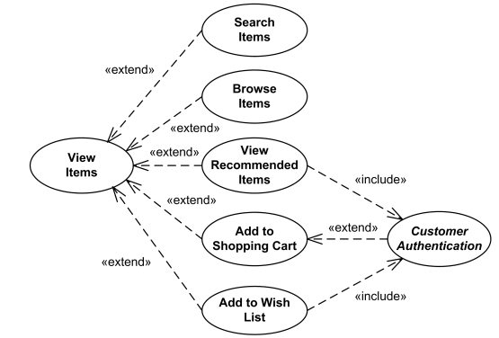

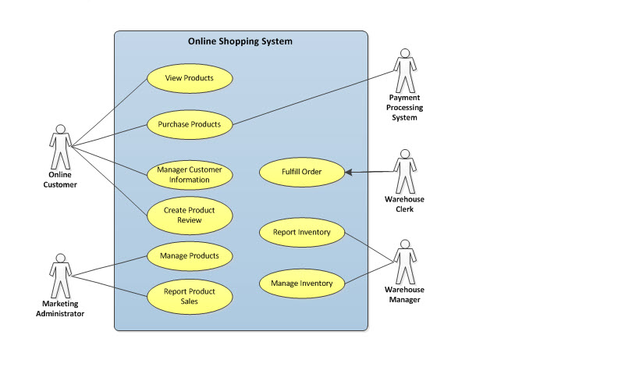

## ***Definitions/Acronyms***

### **Definitions**

|  |  |
| --- | --- |
| **Regression Testing** | Testing to ensure that unchanged parts of the software work the same as before a change was made. |
| **Requirement** | Something that the system should do or be. May be based on user, business, or technical needs. |
| **Static Test** | Verification performed without execution on a computer. For example, reviewing a document for accuracy. |
| **Test Tool** | Any vehicle that assists in testing. |
| **Unit Testing** | A level of testing in which the smallest units of a system (i.e., modules) are separately tested. |

## ***References***

* NaturalMilk SRS document_1

# **Approach**

Quality Control approach is focused on the process whereas the problems that customers may face can also occur elsewhere in the production   
and distribution chain.  
A quality assurance approach therefore, includes the whole production and distribution system, from the suppliers of important goods, foods, through the internal  
business management to the customer.   
Quality assurance systems should be documented in a simple way to show who has responsibility for doing what and when.   
The focus of quality assurance is prevention and this should mean that action is taken to meet a specification and prevent failures   
from occurring a second time. This is done by planning, management action, agreements with key suppliers and other people in the distribution chain.  
The test approach will include positive and negative (break-it) functional tests. In addition, to ensure reliability throughout the iterative software   
development cycle, regression tests will be performed on all iterations of the application.  
This Test Approach and the Test Plan, Test Cases were created using the Business Requirements.  
To ensure reliability, the test approach will include positive and negative (break-it) functional tests. In addition, to ensure reliability throughout   
the iterative software development cycle, regression tests will be performed on all iterations of the application.  
A part of the approach in testing will be to initially perform a ‘Smoke Test’ upon delivery of the application for testing.  
Testing will be performed from a black-box approach, not based on any knowledge of internal design or code. Tests will be designed around requirements   
and functionality.

∙

## ***Coverage***

### **Requirements**

All user requirements as specified in the Requirements Specification Document will be test.

## ***Test Type***

The following types of testing will be performed during system integration testing:

* Functional testing, by performing test cases based on testable requirements
* Functional testing, by performing test cases based on business functions
* Regression testing, to ensure that a change to the system does not introduce new defects.

# **Plan**

## ***Test Team***

The following people will be on the system integration test team:

|  |  |  |  |
| --- | --- | --- | --- |
| Name | Title | Level of involvement | Responsibilities |
| Jana Bancheva | Team Leader - Independent Test Team | 40 hrs/wk | Lead all testing activities, including test planning, test execution, and status reporting. |
| Petra Djigolova | QA Test Team | 40 hrs/wk | Design and execute test cases, create test data, write test summary report |
| Borislav Gotsev | Developer | 40 hrs/wk | Designs the application, Technical assistance as needed during the test |
| Georgi Purvanov | QA Test Team | 40 hrs/wk | Design and execute test cases, create test data, write test summary report |
| Boyko Andonov | PM | 40 hrs/wk | accomplishing the stated project objectives |
| Desislava Belishka | Developer | 40 hrs/wk | Designs the application, Technical assistance as needed during the test |

## ***Environmental Needs***

### **Test Environment**

Windows

Windows 7 SP1

Windows Server 2012 and 2012 R2 (64-bit)

RAM: 128 MB

Disk space: 124 MB for JRE; 2 MB for Java Update

Processor: Minimum Pentium 2 266 MHz processor

Browsers: Internet Explorer 9 and above, Firefox, Chrome

Mac OS X

Intel-based Mac running Mac OS X 10.8.3+, 10.9+

Administrator privileges for installation

64-bit browser

A 64-bit browser (Safari, Firefox, or Chrome for example) is required to run Oracle Java on Mac OS X.

Linux

Ubuntu Linux 14.x (8u25 and above)

Browsers: Firefox

All test cases will be executed on the Bration Development Server in the QA database environment.

Technologies Overview:

**Java : JRE 1.8.0_77, IntelliJ IDEA 2016.1.1;   
 Other tools:** Maven

# **Features to be tested**

**Black-box testing**

Test cases are built around specifications and requirements, i.e., what the application is supposed to do.

Testing will consist the following aspects of the NaturalMilk Web site:

· Accessibility

· Content

· Functional

· Navigation

· Performance

· Reliability

· Security

· Usability

# **Features Not to be Tested**

It is the intent that all of the individual test cases contained in each test plan will be performed.

However, if time does not permit, some of the low priority test cases may be dropped.

# **Testing Procedures**

## ***Test Execution***

### **Test Cases**

For each requirement, business need, the tester will execute a set of pre-defined test cases. Each test case will have a series of actions and expected results filled in the process book. As each action is performed, the results are evaluated. If the observed results are equal to the expected results, a checkmark is placed in the “pass” column. If the observed results are not equal to the expected results, a checkmark is placed in the “fail” column.