Normalisation Form
These figures below are cited from Kaggle and generated/download as CSV files:

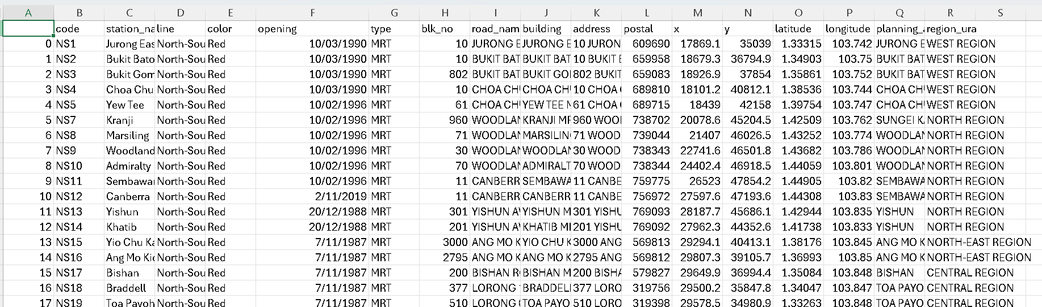Figure 1: Singapore MRT & LRT Stations Details (Updated in January 2025)

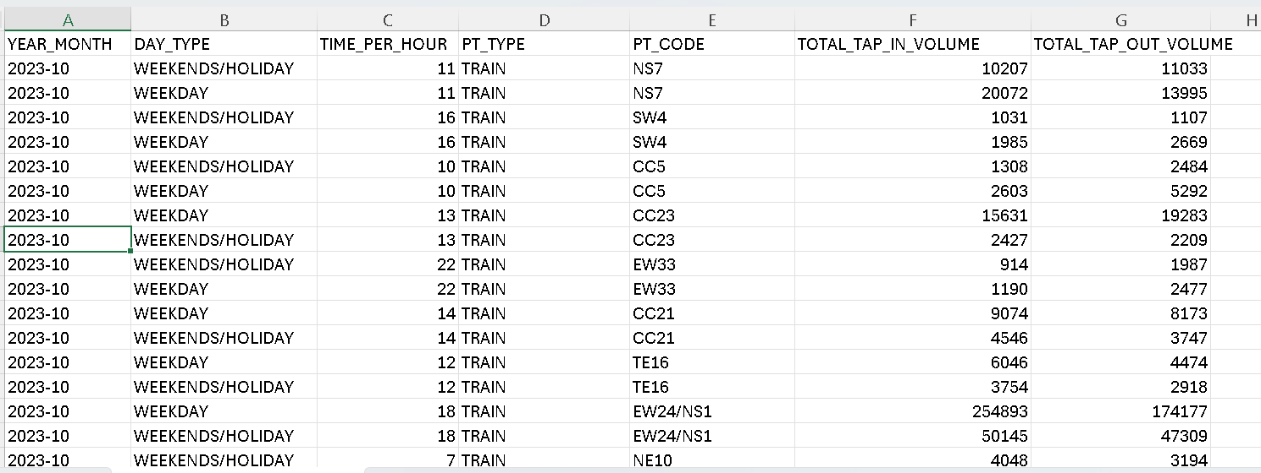
Figure 2: Singapore MRT & LRT Passenger Volume in October 2023

Normalisation Process
FORM: Figure 1

UNF
TRAIN (train_code, train_name, train_line_name, train_start_operation, train_station_address, train_station_lat, train_station_long, ura_area, ura_region)

1NF
TRAIN (train_code, train_name, train_line_name, train_start_operation, train_station_address, train_station_lat, train_station_long, ura_area, ura_region)

CKs:
- train_code
- train_ name, train_line_name
- train_station_address, train_line_name

Partial Dependencies:
train_station_address train_station_lat, train_station_long, ura_area, ura_region

2NF

TRAIN (train_code, train_ name, train_line_name, train_start_operation, train_station_address)
TRAIN_STATION (train_station_address, train_station_lat, train_station_long, ura_area, ura_region)

Transitive Dependencies:
ura_area ura_region

3NF

TRAIN (train_code, train_ name, train_line_name, train_start_operation, train_station_address)
TRAIN_STATION (train_station_address, train_station_lat, train_station_long, ura_area)
URA (ura_area, ura_region)

Full Dependencies:
train_code train_ name, train_line_name, train_start_operation, train_station_address
train_station_address train_station_lat, train_station_long, ura_area
ura_area ura_region

FORM: Figure 2

UNF
TRAIN_VOLUME ( train_volume_year, train_volume_month, train_volume_day, train_volume_hour, train_code, train_tap_in, train_tap_out)

1NF
TRAIN_VOLUME ( train_volume_year, train_volume_month, train_volume_day, train_volume_hour, train_code, train_tap_in, train_tap_out)

CK:
train_volume_year, train_volume_month, train_volume_day, train_volume_hour, train_code

Note: year and month must be included as if the data stored continuously, will include different year and month. Unless the database store it differently every month

Partial Dependencies:
None

2NF
TRAIN_VOLUME ( train_volume_year, train_volume_month, train_volume_day, train_volume_hour, train_code, train_tap_in, train_tap_out)

Transitive Dependencies:
None

3NF
TRAIN_VOLUME ( train_volume_year, train_volume_month, train_volume_day, train_volume_hour, train_code, train_tap_in, train_tap_out)

Full Dependencies:

train_volume_year, train_volume_month, train_volume_day, train_volume_hour, train_code train_tap_in, train_tap_out

FINAL 3NF Relations:
TRAIN (train_code, train_ name, train_line_name, train_start_operation, train_station_address)
TRAIN_STATION (train_station_address, train_station_lat, train_station_long, ura_area)
URA (ura_area, ura_region)
TRAIN_VOLUME ( train_volume_year, train_volume_month, train_volume_day, train_volume_hour, train_code, train_tap_in, train_tap_out)

