**Art of Chinese**

Suitable for：children & beginners

Designed by a Taiwan company . Aim to teach Chinese characters.

This app interprets how Chinese characters develop from the inscriptions on bones or tortoise shells of the Shang Dynasty to the present versions, which can strengthen the understanding about the characters and Chinese culture. It also provides handwriting exercises with an excellent sense of design.

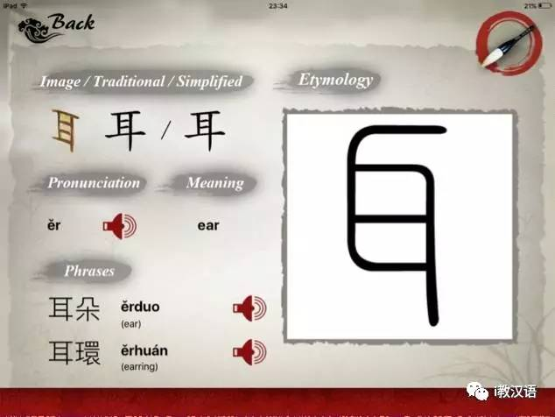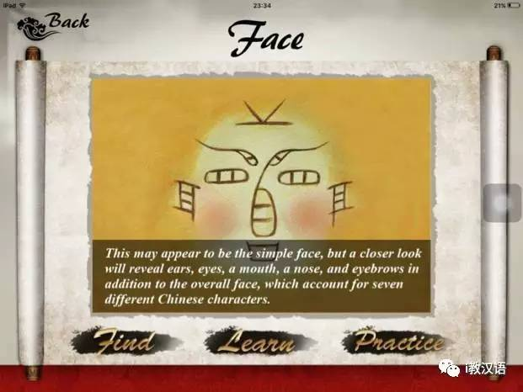

**Fun with Chinese Characters**

Desined by Sinolingua, **Fun with Chinese Characters** is an IPad application based on IOS operating system which can be easily used by Native English speakers with zero Chinese characters. It captures 50 characters in total and there is a game about every character. The users have to pass the former game before unlocking the next one. The design and interaction of this app is also quite amazing!!!

华语教学出版社开发的基于iOS操作系统的iPad应用，汉字零起点的英语母语者可以轻松操作。应用精选50个汉字，并将这50个汉字的演变过程分别开发成独立的小游戏，用户过关后汉字解锁，展示汉字演变过程的英文释义及典型字体。此外用户还可以利用这些解锁文字制作“中国画”在社交媒体上分享。

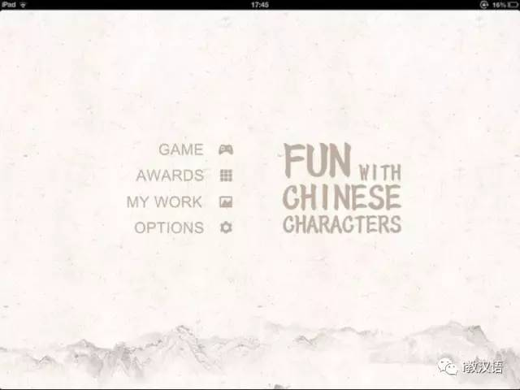

（“Fun with Chinese Characters”App）

It combines traditional pictures with Chinese characters. You will find it beyond your imagination!

用户点击进入GAME版块后，出现多幅中国山水画，用户通过左右滑动界面任意选择。以下图为例，用户点击进入以下界面，出现了月、云、竹、舟、鱼五个汉字，五个汉字的甲骨文有机组成了一幅渔人月下垂钓水墨画。

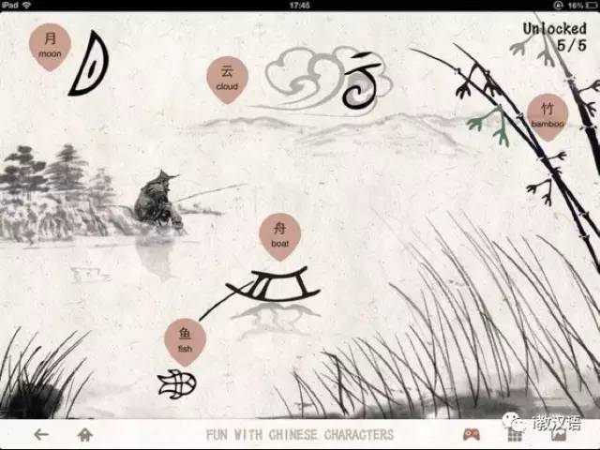

Provide handwriting exercises as you can see from here~

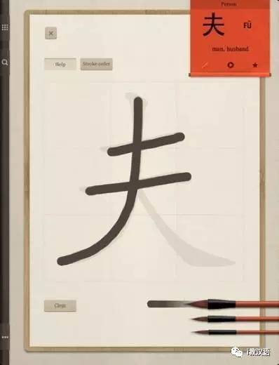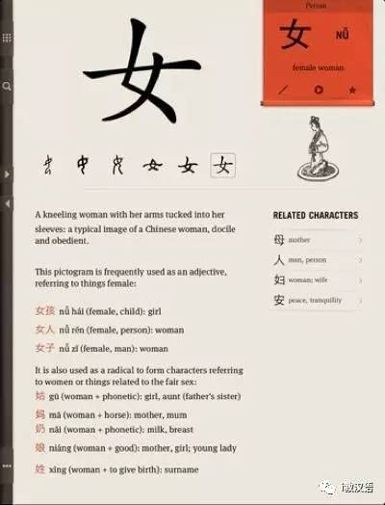

**Pleco**

Including 130,000 Chinese words and 20,000 Pin-in example sentences, providing real-time translation and OCR function, Pleco is a translation application made by an American company. It will give you more and more convenience.

Pleco 是一款功能强大的翻译软件，它包含130000个中文单词和20000个拼音例句，提供即时的中文转英文功能，是学习中文的好软件。同时还支持手写和语音输入，读取文件直接翻译等。最新的Pleco中文辞典增加了OCR功能，只要将手机摄像头对准想要翻译的中文文字，无需拍照，屏幕上立即会显示出它的简繁体标准文字、拼音拼写和英文翻译结果。

其基本功能足够强大，可以通过中文，英文，拼音，手写，字形等方法进行查询，词语解释也很丰富，提供大量相关词组，并且简繁字都予以标出，还会列出外观相近的汉字。

