**Jan Karl Galia**

**DE 1**

**Intro to VLSI**

**9/7/2022**

**Professor James Moulic**

**Part A**

8 micron meters by 5.4 micron meters

**2.4K ohm using P+ diffusion  
1. First, I created a 8 micron meters by 1 micron meters using the P+ diffusion for the resistance which gave me a 2.4k ohm resistor.**

**4.99 fF using Metal 1**

**2.** **I created a 4.99 fF using Metal 1 and meandered the capacitor. The size was 8 microns meter by 4.2 microns meter.**

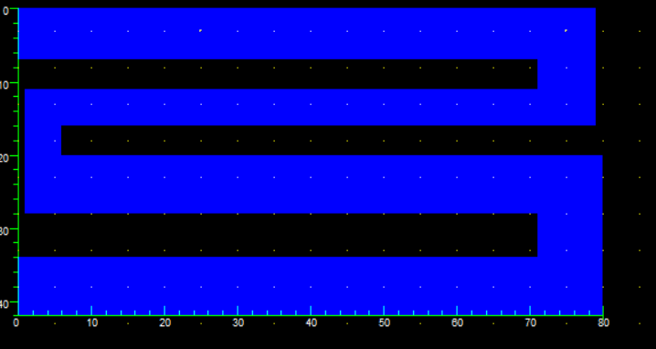

**Part B**

**2.**

**NMOS’s Effective Resistance = 2351 Ohms**

**3.**

**4. Effective Gate Capacitance = 5.01 fF**

**5. The gate capacitance has almost the same capacitance as my capacitor which is approximately around 5 fF. The active components take less space but has more different types of materials and has different layers while the passive components take up a lot of space but is made of one material and is one layer.**