**Jan Karl Galia**

**DE 2**

**Intro to VLSI**

**9/18/2022**

**Professor James Moulic**

**Part A**

**PMOS & NMOS = 17 lambda by 2 lambda**

**Voltage Vs. time**

**Current Vs. Time**

**6. The rise and time delays are different because the rise depends on the PMOS which depends on holes which moves slower than electrons. On the other hand, the fall depends on electrons which moves faster than holes, hence why the fall is faster.**

**PART B**

**PMOS(42 Lambda by 2 Lambda), NMOS (20 Lambda by 2 Lambda)**

**Voltage Vs. Time( Output Rise = 18 ps, Output Fall 28ps)**

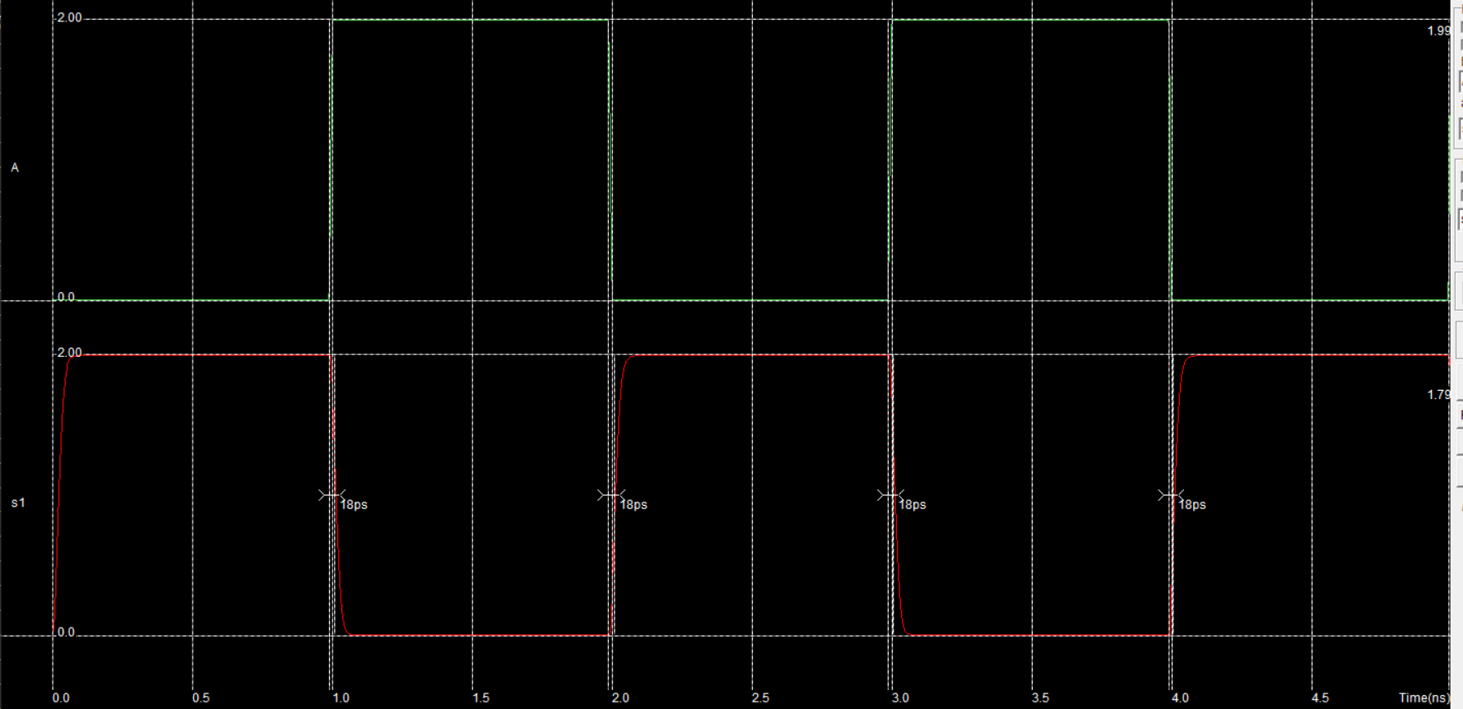

**Current Vs. Time**

**7. The rise and fall times approximately the same because the PMOS width is twice that of the NMOS width. The mobility of electrons is twice that of holes and so to make the fall and rise equal, we would need to double the PMOS.**

**PART C (BONUS)**

**Voltage Vs. Time  
**

**Current Vs. Time**

**3. The rise and fall time delays are the same because the inverters are connected in series and each inverters have the same PMOS and NMOS widths and lengths.**