GitHub is a code hosting platform for version control and collaboration.

git clone  
git status  
git add  
git commit -m “ “  
git push

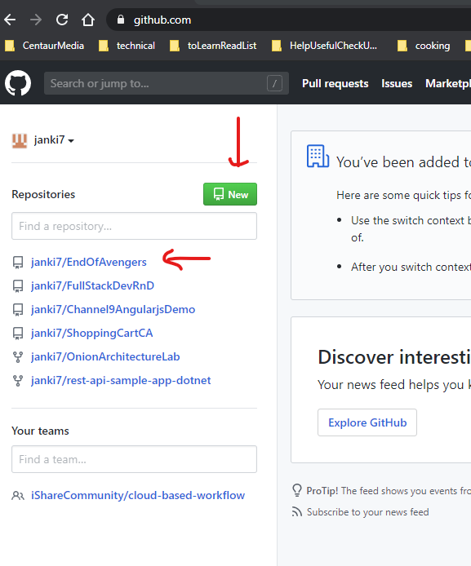

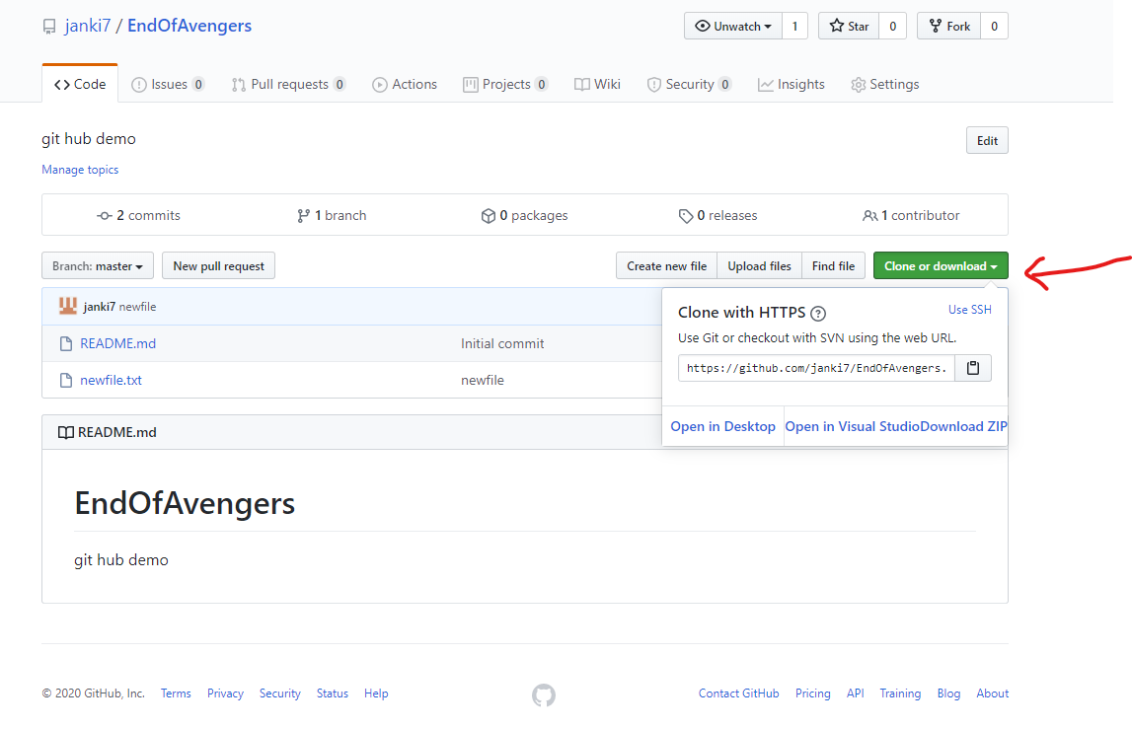

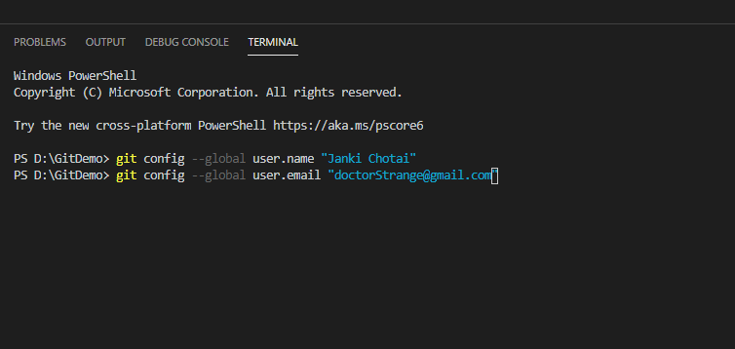

CLONE

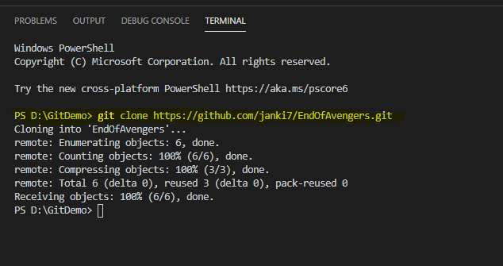

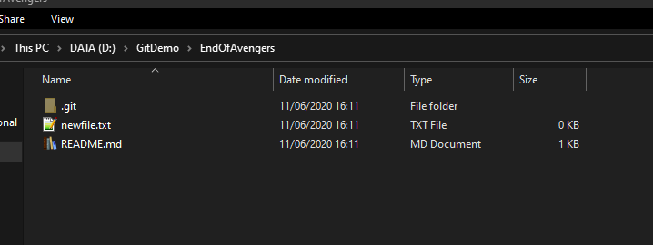

ADD File :

eg. Here Thanos.txt

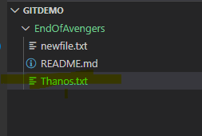

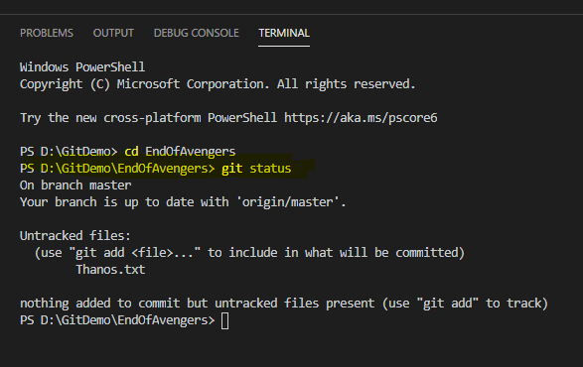

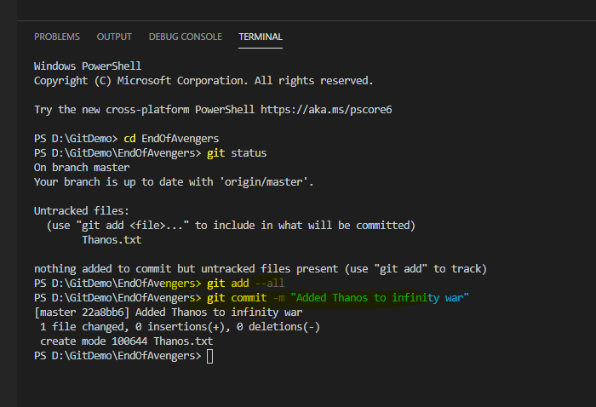

You’re committing the changes to the HEAD, but not to the remote repository. (Make sure you replace that message in quotes with your own.) After you make a change, you take a “snapshot” of the repository with the “commit” command. You‘ll include a message on that “snapshot” with -m.

When you save a change, that’s called a commit. When you make a commit, you’ll include a message about what you changed and/or why you changed it. This is a great way to let others know what you’ve changed and why.

Now your changes are in the head of your local working copy. To send the changes to your remote repository, run

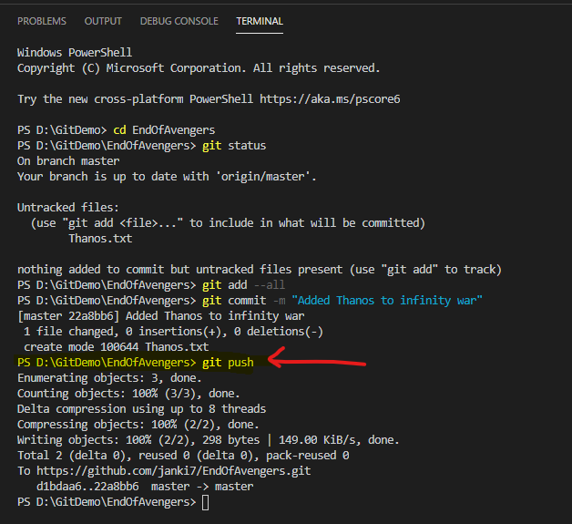

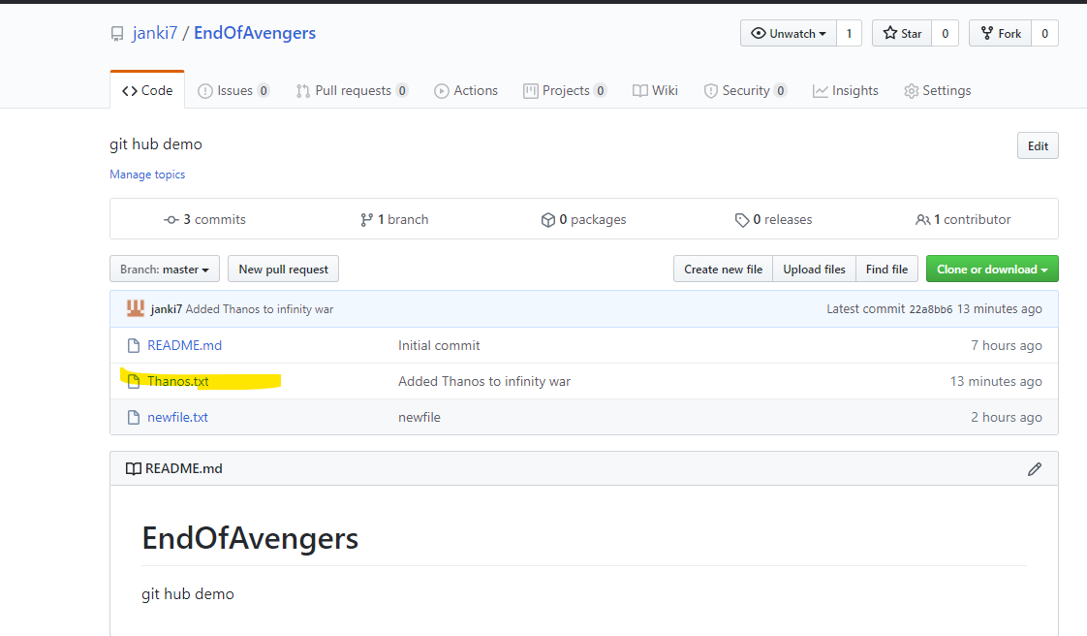

* Commit – snapshot – like saving your stage on a video game. Go back to commit F1. Commit F2. Delete F2

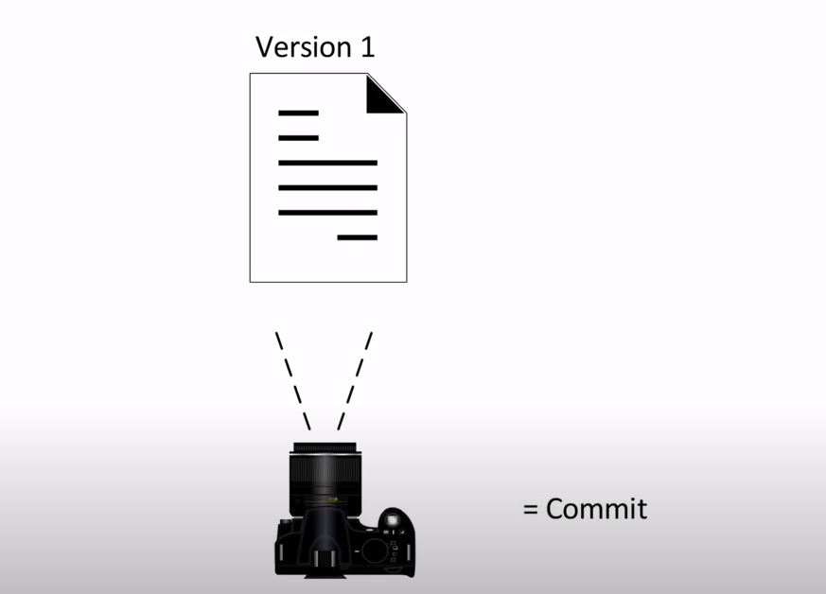

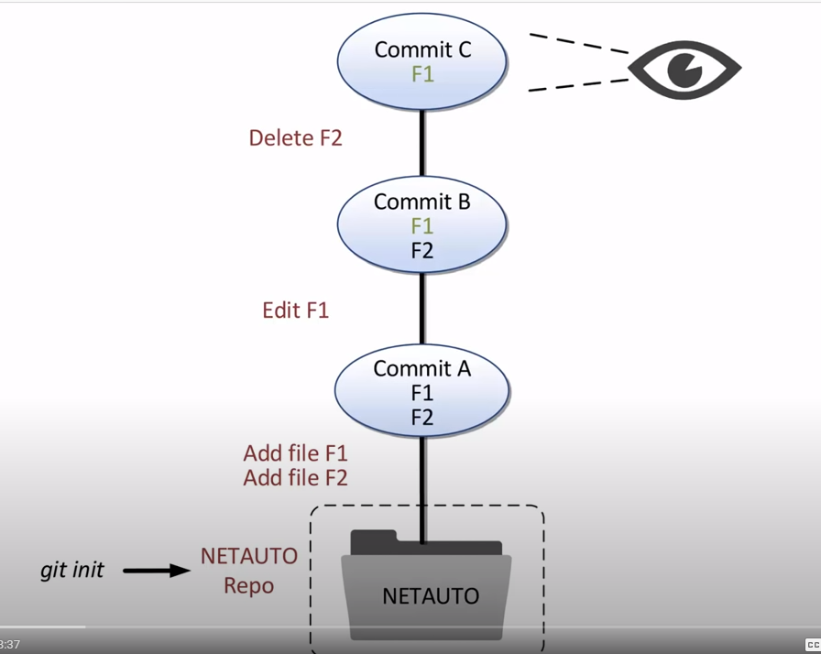

Login to git hub and create new Repositories- if needed. We don’t need this for P2.

References :

<https://towardsdatascience.com/getting-started-with-git-and-github-6fcd0f2d4ac6>

<https://www.youtube.com/watch?v=uR6G2v_WsRA>