**Assignment 2 Unit 2**

Pro 1 : Take 3 Scrollbars including Values of Red,Green and Blue colors from 0 to 255. Take 3 labels to show the values of the scroll bars. Depending upon values selected by the user with the hrlp of scrollbars make color and shows it in the picture box . Place a button having text ‘Apply color’, and on the click event of the button apply that color to the form.

Code:

using System;

using System.Collections.Generic;

using System.ComponentModel;

using System.Data;

using System.Drawing;

using System.Linq;

using System.Text;

using System.Windows.Forms;

namespace U2P1

{

public partial class Form1 : Form

{

public Form1()

{

InitializeComponent();

}

private void hScrollBarRed_Scroll(object sender, ScrollEventArgs e)

{

pictureBox1.BackColor = Color.FromArgb(hScrollBarRed.Value, hScrollBarGreen.Value, hScrollBarBlue.Value);

label1.Text = Convert.ToString(hScrollBarRed.Value);

}

private void hScrollBarGreen_Scroll(object sender, ScrollEventArgs e)

{

pictureBox1.BackColor = Color.FromArgb(hScrollBarRed.Value, hScrollBarGreen.Value, hScrollBarBlue.Value);

label2.Text = Convert.ToString(hScrollBarGreen.Value);

}

private void hScrollBarBlue_Scroll(object sender, ScrollEventArgs e)

{

pictureBox1.BackColor = Color.FromArgb(hScrollBarRed.Value, hScrollBarGreen.Value, hScrollBarBlue.Value);

label3.Text = Convert.ToString(hScrollBarBlue.Value);

}

private void btncolor_Click(object sender, EventArgs e)

{

this.BackColor = pictureBox1.BackColor;

}

}

}

Output:

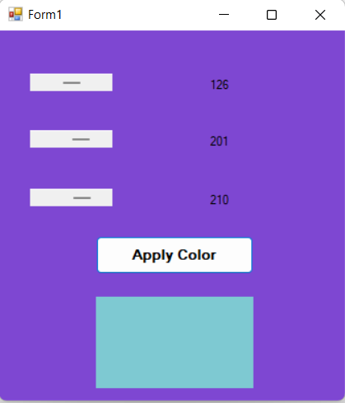

Pro 2: Implement Textpad application using rich textbox. Makes menus like file (new, open, save, Saveas and Exit) , Edit ( Cut, Copy, Paste, Undo, Redo), Format(Bold, Italic, Underline, Font, Color) etc. Use all common dialog controls and implement functionalities.

Code:

using System;

using System.Collections.Generic;

using System.ComponentModel;

using System.Data;

using System.Drawing;

using System.Linq;

using System.Text;

using System.Windows.Forms;

namespace U2P2

{

public partial class Form1 : Form

{

public Form1()

{

InitializeComponent();

}

private void newToolStripMenuItem_Click(object sender, EventArgs e)

{

richTextBox1.Clear();

}

private void cutToolStripMenuItem_Click(object sender, EventArgs e)

{

richTextBox1.Cut();

}

private void copyToolStripMenuItem_Click(object sender, EventArgs e)

{

richTextBox1.Copy();

}

private void pasteToolStripMenuItem_Click(object sender, EventArgs e)

{

richTextBox1.Paste();

}

private void undoToolStripMenuItem_Click(object sender, EventArgs e)

{

richTextBox1.Undo();

}

private void redoToolStripMenuItem_Click(object sender, EventArgs e)

{

richTextBox1.Redo();

}

private void boldToolStripMenuItem_Click(object sender, EventArgs e)

{

richTextBox1.SelectionFont = new Font(richTextBox1.Font, FontStyle.Bold);

}

private void italicToolStripMenuItem_Click(object sender, EventArgs e)

{

richTextBox1.SelectionFont = new Font(richTextBox1.Font, FontStyle.Italic);

}

private void underlineToolStripMenuItem_Click(object sender, EventArgs e)

{

richTextBox1.SelectionFont = new Font(richTextBox1.Font, FontStyle.Underline);

}

private void openToolStripMenuItem_Click(object sender, EventArgs e)

{

OpenFileDialog op = new OpenFileDialog();

//op.tital = "Open";

// junu.filter="Text Document(*.txt)\*.txt\All Files(*.*)|*.*";

if(op.ShowDialog()==DialogResult.OK)

richTextBox1.LoadFile(op.FileName,RichTextBoxStreamType.PlainText);

this.Text=op.FileName;

}

private void saveToolStripMenuItem_Click(object sender, EventArgs e)

{

SaveFileDialog sf = new SaveFileDialog();

// sf.Tital = "Save";

// junu.filter="Text Document(*.txt)\*.txt\All Files(*.*)|*.*";

if (sf.ShowDialog() == DialogResult.OK)

richTextBox1.SaveFile(sf.FileName, RichTextBoxStreamType.PlainText);

this.Text = sf.FileName;

}

private void exitToolStripMenuItem_Click(object sender, EventArgs e)

{

Close();

}

private void fontToolStripMenuItem_Click(object sender, EventArgs e)

{

FontDialog fnt = new FontDialog();

if (fnt.ShowDialog() == DialogResult.OK)

richTextBox1.Font = fnt.Font;

}

private void colorToolStripMenuItem_Click(object sender, EventArgs e)

{

ColorDialog c = new ColorDialog();

if (c.ShowDialog() == DialogResult.OK)

richTextBox1.ForeColor = c.Color;

}

private void saveAsToolStripMenuItem_Click(object sender, EventArgs e)

{

SaveFileDialog sf = new SaveFileDialog();

// sf.Tital = "Save";

// junu.filter="Text Document(*.txt)\*.txt\All Files(*.*)|*.*";

if (sf.ShowDialog() == DialogResult.OK)

richTextBox1.SaveFile(sf.FileName, RichTextBoxStreamType.PlainText);

this.Text = sf.FileName;

}

}

}

Output:

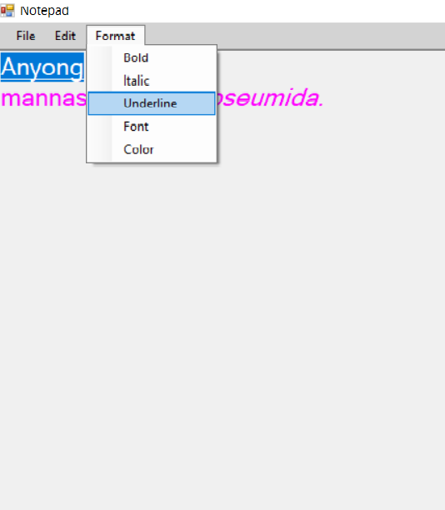

Pro 3: Take a Rich Textbox and implement Find, FindNext, Replace, and ReplaceAll functionalities.

Code:

using System;

using System.Collections.Generic;

using System.ComponentModel;

using System.Data;

using System.Drawing;

using System.Linq;

using System.Text;

using System.Windows.Forms;

namespace U2P3

{

public partial class Form1 : Form

{

int pos;

public Form1()

{

InitializeComponent();

}

private void btnfind_Click(object sender, EventArgs e)

{

pos = Convert.ToInt32(richTextBox1.Find(textBox1.Text, 0, richTextBox1.TextLength, RichTextBoxFinds.None));

if (pos >= 0)

{

richTextBox1.SelectionStart = pos;

richTextBox1.SelectionLength = textBox1.TextLength;

richTextBox1.SelectionColor = Color.Purple;

}

}

private void btnfnext_Click(object sender, EventArgs e)

{

pos = Convert.ToInt32(richTextBox1.Find(textBox1.Text, pos + 1, richTextBox1.TextLength, RichTextBoxFinds.None));

if (pos >= 0)

{

richTextBox1.SelectionStart = pos;

richTextBox1.SelectionLength = textBox1.TextLength;

richTextBox1.SelectionColor = Color.Purple;

}

}

private void btnrep_Click(object sender, EventArgs e)

{

richTextBox1.SelectedText = textBox2.Text;

}

private void btnrall_Click(object sender, EventArgs e)

{

richTextBox1.Text = richTextBox1.Text.Replace(textBox1.Text, textBox2.Text);

}

}

}

Output:

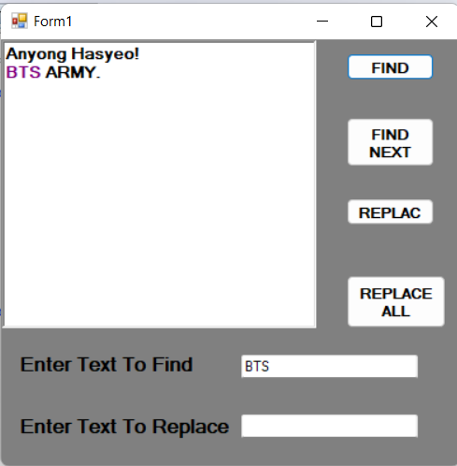

Pro 4: Write a Program to Read and Write Text File.

Code:

using System;

using System.Collections.Generic;

using System.ComponentModel;

using System.Data;

using System.Drawing;

using System.Linq;

using System.Text;

using System.Windows.Forms;

using System.IO;

namespace U2P4

{

public partial class Form1 : Form

{

public Form1()

{

InitializeComponent();

}

private void button1_Click(object sender, EventArgs e)

{

FileStream fc = new FileStream(@"E:\C#\Unit2\Demo.txt", FileMode.Create);

StreamWriter sw = new StreamWriter(fc);

sw.Write(DateTime.Now + "\r\n" + textBox1.Text);

sw.Close();

fc.Close();

}

private void button2_Click(object sender, EventArgs e)

{

FileStream fc = new FileStream(@"E:\C#\Unit2\Demo.txt", FileMode.Open);

StreamReader sr = new StreamReader(fc);

textBox2.Text = textBox2.Text + "Content of file is as follow:" + sr.ReadToEnd();

sr.Close();

fc.Close();

}

}

}

Output:

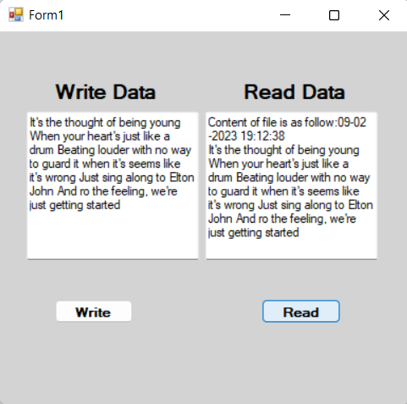

Pro 5: Write a program to Read and Write Binary File.

Code:

using System;

using System.Collections.Generic;

using System.ComponentModel;

using System.Data;

using System.Drawing;

using System.Linq;

using System.Text;

using System.Windows.Forms;

using System.IO;

namespace U2P5

{

public partial class Form1 : Form

{

public Form1()

{

InitializeComponent();

}

private void btnwrite_Click(object sender, EventArgs e)

{

FileStream fc = new FileStream(@"E:\C#\Unit2\Demo2.dat", FileMode.Create);

BinaryWriter bw = new BinaryWriter(fc);

bw.Write(Convert.ToInt32(textBox1.Text));

bw.Write(textBox2.Text);

bw.Write(Convert.ToDouble(textBox3.Text));

bw.Close();

fc.Close();

MessageBox.Show("Data written to binary file Successfully", "Informtion", MessageBoxButtons.OK, MessageBoxIcon.Information);

}

private void btnread_Click(object sender, EventArgs e)

{

FileStream fc = new FileStream(@"E:\C#\Unit2\Demo2.dat", FileMode.Open);

BinaryReader br = new BinaryReader(fc);

int s = br.ReadInt32();

String s1 = br.ReadString();

Double cont = br.ReadDouble();

labOutput.Text = labOutput.Text +"\n"+ "Student`s RollNo:" + s+"\n"+ "Student`s Name:" + s1+"\n"+ "Student`s ContactNo:" + cont;

br.Close();

fc.Close();

}

}

}

Output:

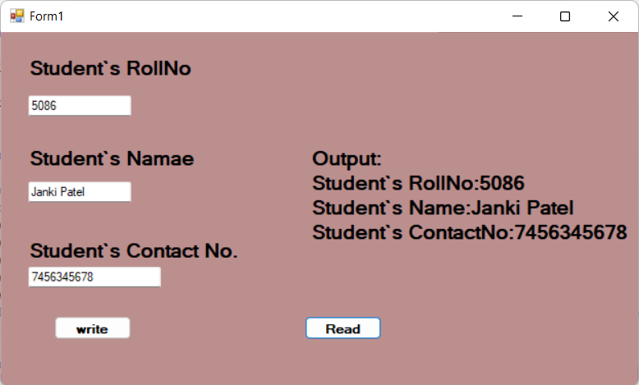

Pro 6: Accept no form user and perform following operations using defined sub routines or functions: 1. Factorial of number 2. Odd/Even

Code:

using System;

using System.Collections.Generic;

using System.ComponentModel;

using System.Data;

using System.Drawing;

using System.Linq;

using System.Text;

using System.Windows.Forms;

namespace U2P6

{

public partial class Form1 : Form

{

public Form1()

{

InitializeComponent();

}

public int fact()

{

int f = 1;

for (int i = 1; i <= int.Parse(textBox1.Text); i++)

{

f = f * i;

}

return f;

}

private void btnFact_Click(object sender, EventArgs e)

{

labFactOut.Text = fact().ToString();

}

public int oddEven()

{

int i=int.Parse(textBox1.Text);

if (i % 2 == 0)

{

MessageBox.Show("Number is Even", "Infrmation", MessageBoxButtons.OK, MessageBoxIcon.Information);

}

else

{

MessageBox.Show("Number is Odd", "Infrmation", MessageBoxButtons.OK, MessageBoxIcon.Information);

}

return i;

}

private void btnOddEven_Click(object sender, EventArgs e)

{

labOddEven.Text = oddEven().ToString();

}

}

}

Output:

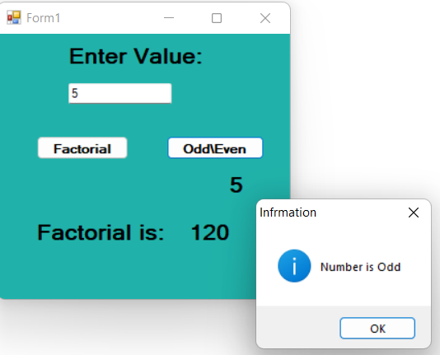

Pro 7: Create MDI form. It must have File menu with option open, close and exit. It should also have window menu to arrange the child forms like Tile Horizontal, Tile Vertical, Cascade and Arrange Icons.

Code:

using System;

using System.Collections.Generic;

using System.ComponentModel;

using System.Data;

using System.Drawing;

using System.Linq;

using System.Text;

using System.Windows.Forms;

namespace U2P7

{

public partial class Form1 : Form

{

public Form1()

{

InitializeComponent();

}

private void openToolStripMenuItem_Click(object sender, EventArgs e)

{

Form2 child1 = new Form2();

child1.MdiParent = this;

child1.Show();

Form3 child2 = new Form3();

child2.MdiParent = this;

child2.Show();

Form4 child3 = new Form4();

child3.MdiParent = this;

child3.Show();

}

private void cascadeToolStripMenuItem_Click(object sender, EventArgs e)

{

this.LayoutMdi(MdiLayout.Cascade);

}

private void tileHorizontalToolStripMenuItem_Click(object sender, EventArgs e)

{

this.LayoutMdi(MdiLayout.TileHorizontal);

}

private void tileVerticalToolStripMenuItem_Click(object sender, EventArgs e)

{

this.LayoutMdi(MdiLayout.TileVertical);

}

private void arrangeIconsToolStripMenuItem_Click(object sender, EventArgs e)

{

this.LayoutMdi(MdiLayout.ArrangeIcons);

}

private void closeToolStripMenuItem_Click(object sender, EventArgs e)

{

foreach (Form f1 in this.MdiChildren)

{

f1.Close();

}

}

private void exitToolStripMenuItem_Click(object sender, EventArgs e)

{

Application.Exit();

}

}

}

Output:

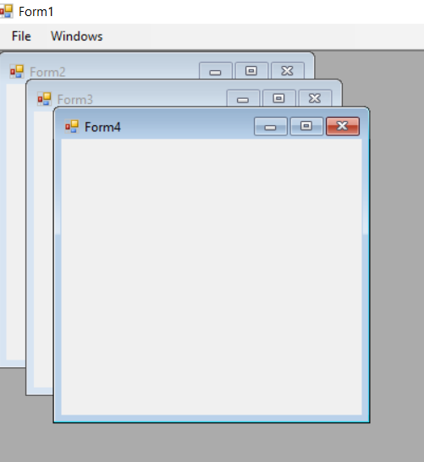

Pro 8: Create MDI form. It must have file menu with option Open, Close, and Exit and one picture box. Allow user to open any picture using open dialog box, that picture should be displayed in the picture box.

Code:

using System;

using System.Collections.Generic;

using System.ComponentModel;

using System.Data;

using System.Drawing;

using System.Linq;

using System.Text;

using System.Windows.Forms;

namespace U2P8

{

public partial class Form1 : Form

{

public Form1()

{

InitializeComponent();

}

private void openToolStripMenuItem_Click(object sender, EventArgs e)

{

DialogResult result = openFileDialog1.ShowDialog();

if (result == DialogResult.OK)

{

openFileDialog1.Filter = "jpg files(*.jpg) | *.jpg";

pictureBox1.Image = Image.FromFile(openFileDialog1.FileName);

}

}

private void closeToolStripMenuItem_Click(object sender, EventArgs e)

{

Close();

}

private void exitToolStripMenuItem_Click(object sender, EventArgs e)

{

Application.Exit();

}

}

}

Output:

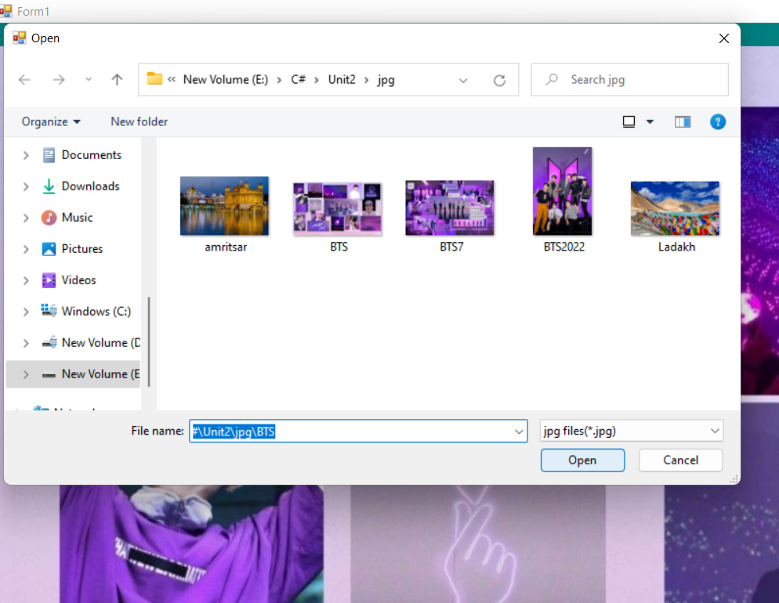

Pro 9: Write function or subroutine to find maximum, minimum value from an array and also to sort an array.

Code:

using System;

using System.Collections.Generic;

using System.ComponentModel;

using System.Data;

using System.Drawing;

using System.Linq;

using System.Text;

using System.Windows.Forms;

namespace U2P9

{

public partial class Form1 : Form

{

public Form1()

{

InitializeComponent();

}

int[] n = new int[5];

private void btndisplay_Click(object sender, EventArgs e)

{

n[0] = 10;

n[1] = 5;

n[2] = 7;

n[3] = 31;

n[4] = 30;

for (int i = 0; i < 5; i++)

textBox1.Text += Convert.ToString(n[i]) + "\t\n";

}

private void btnSort_Click(object sender, EventArgs e)

{

Array.Sort(n);

for (int i = 0; i < 5; i++)

textBox2.Text += Convert.ToString(n[i]) + "\t\n";

}

public int min()

{

n[0] = 10;

n[1] = 5;

n[2] = 7;

n[3] = 31;

n[4] = 30;

int min = n[0];

for (int i = 0; i < 5; i++)

{

if (n[i] < min)

min = n[i];

}

return min;

}

private void btnmin_Click(object sender, EventArgs e)

{

labMinMax.Text = "Minimum Value:" + min().ToString();

}

public int max()

{

n[0] = 10;

n[1] = 5;

n[2] = 7;

n[3] = 31;

n[4] = 30;

int max = n[0];

for (int i = 0; i < 5; i++)

{

if (n[i] > max)

max = n[i];

}

return max;

}

private void btnMax_Click(object sender, EventArgs e)

{

labMinMax.Text = "Maximum Value:" + max().ToString();

}

}

}

Output:

