UNIT 1

Program 1: Design interface and implement for Airthmetic Calculator with power, square, log, factorial, square root and clear functionalities.

**Code:**

using System;

using System.Collections.Generic;

using System.ComponentModel;

using System.Data;

using System.Drawing;

using System.Linq;

using System.Text;

using System.Windows.Forms;

namespace WinApp1

{

public partial class Cal : Form

{

double value1,value2;

String sign;

public Cal()

{

InitializeComponent();

}

private void btn0_Click(object sender, EventArgs e)

{

textBox1.Text = textBox1.Text + '0';

}

private void btn1_Click(object sender, EventArgs e)

{

textBox1.Text = textBox1.Text + '1';

}

private void btn2_Click(object sender, EventArgs e)

{

textBox1.Text = textBox1.Text + '2';

}

private void btn3_Click(object sender, EventArgs e)

{

textBox1.Text = textBox1.Text + '3';

}

private void btndot_Click(object sender, EventArgs e)

{

textBox1.Text = textBox1.Text + '.';

}

private void btn4_Click(object sender, EventArgs e)

{

textBox1.Text = textBox1.Text + '4';

}

private void btn5_Click(object sender, EventArgs e)

{

textBox1.Text = textBox1.Text + '5';

}

private void btn6_Click(object sender, EventArgs e)

{

textBox1.Text = textBox1.Text + '6';

}

private void btn9_Click(object sender, EventArgs e)

{

textBox1.Text = textBox1.Text + '9';

}

private void btn8_Click(object sender, EventArgs e)

{

textBox1.Text = textBox1.Text + '8';

}

private void btn7_Click(object sender, EventArgs e)

{

textBox1.Text = textBox1.Text + '7';

}

private void btnplus_Click(object sender, EventArgs e)

{

value1 = Double.Parse(textBox1.Text);

textBox1.Clear();

textBox1.Focus();

sign = "+";

}

private void btnmin_Click(object sender, EventArgs e)

{

value1 = Double.Parse(textBox1.Text);

textBox1.Clear();

textBox1.Focus();

sign = "-";

}

private void btnmul_Click(object sender, EventArgs e)

{

value1 = Double.Parse(textBox1.Text);

textBox1.Clear();

textBox1.Focus();

sign = "X";

}

private void btndiv_Click(object sender, EventArgs e)

{

value1 = Double.Parse(textBox1.Text);

textBox1.Clear();

textBox1.Focus();

sign = "/";

}

private void btnmod_Click(object sender, EventArgs e)

{

value1 = Double.Parse(textBox1.Text);

textBox1.Clear();

textBox1.Focus();

sign = "%";

}

private void btnequal_Click(object sender, EventArgs e)

{

value2 = Double.Parse(textBox1.Text);

double ans;

if (sign == "+")

{

ans = value1 + value2;

textBox1.Text = Convert.ToString(ans);

}

else if (sign == "-")

{

ans = value1 - value2;

textBox1.Text = Convert.ToString(ans);

}

else if (sign == "X")

{

ans = value1 * value2;

textBox1.Text = Convert.ToString(ans);

}

else if (sign == "/")

{

ans = value1 / value2;

textBox1.Text = Convert.ToString(ans);

}

else

{

ans = value1 % value2;

textBox1.Text = Convert.ToString(ans);

}

}

private void btncl_Click(object sender, EventArgs e)

{

textBox1.Clear();

textBox1.Focus();

}

private void btnlog_Click(object sender, EventArgs e)

{

double v;

v = double.Parse(textBox1.Text);

textBox1.Text = Math.Log(v).ToString();

}

private void btnsq_Click(object sender, EventArgs e)

{

double v;

v=double.Parse(textBox1.Text);

textBox1.Text = Math.Pow(v, 2).ToString();

}

private void btnpow_Click(object sender, EventArgs e)

{

double v, u;

v = double.Parse(textBox1.Text);

u = double.Parse(textBox1.Text);

textBox1.Text = Math.Pow(v,u).ToString();

}

private void btnsqrt_Click(object sender, EventArgs e)

{

double v;

v = double.Parse(textBox1.Text);

textBox1.Text = Math.Sqrt(v).ToString();

}

private void btnfac_Click(object sender, EventArgs e)

{

long f = 1;

for (long i = 1; i <= long.Parse(textBox1.Text); i++)

{

f = f * i;

}

textBox1.Text = f.ToString();

}

}

}

**Output:**

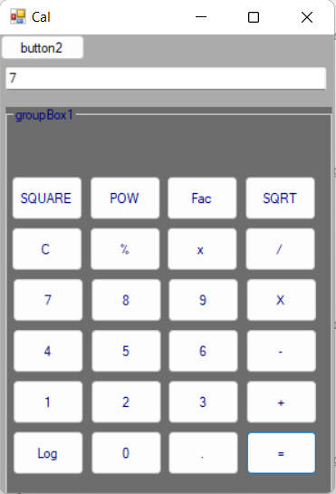

Program 2: Design interface and implement functionalities for Calculator. Take Amount, No of installments and rate of interest from the user. Also user can choose Early Pay option through a checkbox . Calculate installment amount using pmt() function. Do proper validation for inputs taken by the user.

**Code:**

using System;

using System.Collections.Generic;

using System.ComponentModel;

using System.Data;

using System.Drawing;

using System.Linq;

using System.Text;

using System.Windows.Forms;

using Microsoft.VisualBasic;

namespace LoanCal

{

public partial class Form1 : Form

{

public Form1()

{

InitializeComponent();

}

private void button1_Click(object sender, EventArgs e)

{

double amount, rate=0, insamt;

double duration=0;

amount=Convert.ToDouble(textBoxam.Text);

duration=Convert.ToDouble(textBoxin.Text)*12;

rate=Convert.ToDouble(textBoxra.Text);

if (CheckBox1.Checked == true)

{

insamt = Financial.Pmt(rate / (12 * 100), duration, -amount, 0, DueDate.BegOfPeriod);

}

else

{

insamt = Financial.Pmt(rate / (12 * 100), duration, -amount, 0, DueDate.EndOfPeriod);

}

label4.Text = Convert.ToString(insamt);

}

}

}

**Output:**

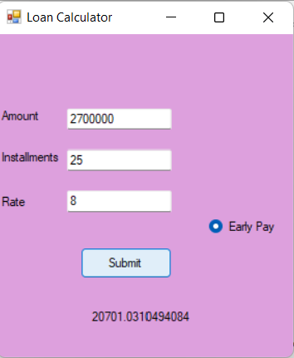

Program 3: Design an application which will have 2 radio buttons. One will convert the Celsius to Fahrenheit and another convert Fahrenheit to Celsius. Show the appropriate output depends on the user’s selection. (Use radio button to take user choice and use textbox to enter value).

**Code:**

using System;

using System.Collections.Generic;

using System.ComponentModel;

using System.Data;

using System.Drawing;

using System.Linq;

using System.Text;

using System.Windows.Forms;

namespace Application3

{

public partial class Form1 : Form

{

double t, c = 0, f;

public Form1()

{

InitializeComponent();

}

private void labelcon_Click(object sender, EventArgs e)

{

t = double.Parse(textBox1.Text);

if (rdbc.Checked)

{

c = (t - 32) * 5 / 9;

lablout.Text = Convert.ToString(c);

}

else if (rdvf.Checked)

{

f = (t * 9) / 5 + 32;

lablout.Text = Convert.ToString(f);

}

}

}

}

**Output:**

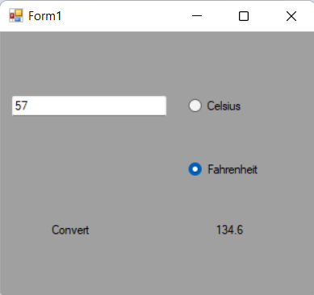

**Pro 4:** Design a form having two text boxes, Combo box and a lable. Make the validation so that user can enter only numbers in textboxes, if user has entered both numerical values make the combo box visible. The combo box has options like ‘ADD’,’SUB’,’MUL’ and ‘DIV’. According to user’s coic form from combo, result will display in lable.

**Code:**

using System;

using System.Collections.Generic;

using System.ComponentModel;

using System.Data;

using System.Drawing;

using System.Linq;

using System.Text;

using System.Windows.Forms;

namespace U1P4

{

public partial class Form1 : Form

{

int a, b;

public Form1()

{

InitializeComponent();

}

private void comboBox1_SelectedIndexChanged(object sender, EventArgs e)

{

a=Convert.ToInt32(textBox1.Text);

b = Convert.ToInt32(textBox2.Text);

if (comboBox1.Text == "ADD")

{

label3.Text=Convert.ToString(a+b);

}

else if (comboBox1.Text == "SUB")

{

label3.Text = Convert.ToString(a - b);

}

else if (comboBox1.Text == "MUL")

{

label3.Text = Convert.ToString(a * b);

}

else

{

label3.Text = Convert.ToString(a / b);

}

}

private void textBox1_KeyPress(object sender, KeyPressEventArgs e)

{

if (!char.IsControl(e.KeyChar) && !char.IsDigit(e.KeyChar) && (e.KeyChar != '.'))

{

e.Handled = true;

MessageBox.Show("Enter only numeric data", "Information", MessageBoxButtons.OKCancel, MessageBoxIcon.Error);

}

textBox2.Visible = true;

}

private void textBox2_KeyPress(object sender, KeyPressEventArgs e)

{

if (!char.IsControl(e.KeyChar) && !char.IsDigit(e.KeyChar) && (e.KeyChar != '.'))

{

e.Handled = true;

MessageBox.Show("Enter only numeric data", "Information", MessageBoxButtons.OKCancel, MessageBoxIcon.Error);

}

comboBox1.Visible = true;

label3.Visible = true;

}

}

}

**Output:**

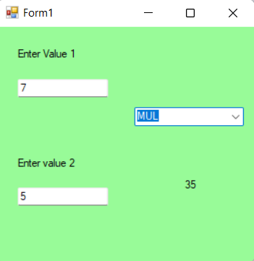

**Pro: 5** create an application with user can enter a sentence then displays

1. Number of vowels
2. Number of spaces
3. Number of digits
4. Number of special symbols

When user press “analysis “ button.

**Code:**

using System;

using System.Collections.Generic;

using System.ComponentModel;

using System.Data;

using System.Drawing;

using System.Linq;

using System.Text;

using System.Windows.Forms;

namespace U1P5

{

public partial class Form1 : Form

{

public Form1()

{

InitializeComponent();

}

private void button1_Click(object sender, EventArgs e)

{

String str;

int vowel,space,spcial,digit;

str = textBox1.Text;

vowel = 0;

space = 0;

spcial = 0;

digit = 0;

for (int i = 0; i < str.Length; i++)

{

char ch = str[i];

if (ch >= '0' && ch <= '9')

{

digit++;

}

else if(ch=='a'||ch=='A'|| ch=='e'||ch=='E'|| ch=='i'||ch=='I'|| ch=='o'||ch=='O'|| ch=='u'||ch=='U')

{

vowel++;

}

else if(ch==' ')

{

space++;

}

else if(!char.IsLetterOrDigit(ch.ToString(),0))

{

spcial++;

}

}

label5.Text=Convert.ToString(vowel);

label6.Text=Convert.ToString(space);

label7.Text=Convert.ToString(digit);

label8.Text=Convert.ToString(spcial);

}

}

}

**Output:**

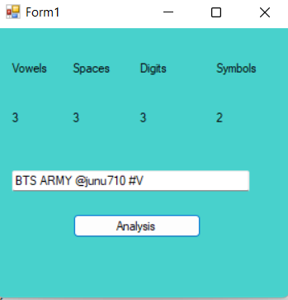

**Pro 6: Design and implement a Tic Tack Toe game(Two Players).**

**Code:**

using System;

using System.Collections.Generic;

using System.ComponentModel;

using System.Data;

using System.Drawing;

using System.Linq;

using System.Text;

using System.Windows.Forms;

namespace U1P6

{

public partial class Form1 : Form

{

Boolean Checker=false;

public Form1()

{

InitializeComponent();

}

void Enable_False()

{

btn1.Enabled = false;

btn2.Enabled = false;

btn3.Enabled = false;

btn4.Enabled = false;

btn5.Enabled = false;

btn6.Enabled = false;

btn7.Enabled = false;

btn8.Enabled = false;

btn9.Enabled = false;

}

void score()

{

if (btn1.Text == "X" && btn2.Text == "X" && btn3.Text == "X")

{

btn1.BackColor = Color.DarkBlue;

btn2.BackColor = Color.DarkBlue;

btn3.BackColor = Color.DarkBlue;

MessageBox.Show("The winner is Player X","Tic Tock",MessageBoxButtons.OK,MessageBoxIcon.Information);

Enable_False();

}

if (btn4.Text == "X" && btn5.Text == "X" && btn6.Text == "X")

{

btn4.BackColor = Color.DarkBlue;

btn5.BackColor = Color.DarkBlue;

btn6.BackColor = Color.DarkBlue;

MessageBox.Show("The winner is Player X", "Tic Tock", MessageBoxButtons.OK, MessageBoxIcon.Information);

Enable_False();

}

if (btn7.Text == "X" && btn8.Text == "X" && btn9.Text == "X")

{

btn7.BackColor = Color.DarkBlue;

btn8.BackColor = Color.DarkBlue;

btn9.BackColor = Color.DarkBlue;

MessageBox.Show("The winner is Player X", "Tic Tock", MessageBoxButtons.OK, MessageBoxIcon.Information);

Enable_False();

}

if (btn1.Text == "X" && btn4.Text == "X" && btn7.Text == "X")

{

btn1.BackColor = Color.DarkBlue;

btn4.BackColor = Color.DarkBlue;

btn7.BackColor = Color.DarkBlue;

MessageBox.Show("The winner is Player X", "Tic Tock", MessageBoxButtons.OK, MessageBoxIcon.Information);

Enable_False();

}

if (btn2.Text == "X" && btn5.Text == "X" && btn8.Text == "X")

{

btn2.BackColor = Color.DarkBlue;

btn5.BackColor = Color.DarkBlue;

btn8.BackColor = Color.DarkBlue;

MessageBox.Show("The winner is Player X", "Tic Tock", MessageBoxButtons.OK, MessageBoxIcon.Information);

Enable_False();

}

if (btn3.Text == "X" && btn6.Text == "X" && btn9.Text == "X")

{

btn3.BackColor = Color.DarkBlue;

btn6.BackColor = Color.DarkBlue;

btn9.BackColor = Color.DarkBlue;

MessageBox.Show("The winner is Player X", "Tic Tock", MessageBoxButtons.OK, MessageBoxIcon.Information);

Enable_False();

}

if (btn1.Text == "X" && btn5.Text == "X" && btn9.Text == "X")

{

btn1.BackColor = Color.DarkBlue;

btn5.BackColor = Color.DarkBlue;

btn9.BackColor = Color.DarkBlue;

MessageBox.Show("The winner is Player X", "Tic Tock", MessageBoxButtons.OK, MessageBoxIcon.Information);

Enable_False();

}

if (btn3.Text == "X" && btn5.Text == "X" && btn7.Text == "X")

{

btn3.BackColor = Color.DarkBlue;

btn5.BackColor = Color.DarkBlue;

btn7.BackColor = Color.DarkBlue;

MessageBox.Show("The winner is Player X", "Tic Tock", MessageBoxButtons.OK, MessageBoxIcon.Information);

Enable_False();

}

if (btn1.Text == "0" && btn2.Text == "0" && btn3.Text == "0")

{

btn1.BackColor = Color.DarkBlue;

btn2.BackColor = Color.DarkBlue;

btn3.BackColor = Color.DarkBlue;

MessageBox.Show("The winner is Player X", "Tic Tock", MessageBoxButtons.OK, MessageBoxIcon.Information);

Enable_False();

}

if (btn4.Text == "0" && btn5.Text == "0" && btn6.Text == "0")

{

btn4.BackColor = Color.DarkBlue;

btn5.BackColor = Color.DarkBlue;

btn6.BackColor = Color.DarkBlue;

MessageBox.Show("The winner is Player X", "Tic Tock", MessageBoxButtons.OK, MessageBoxIcon.Information);

Enable_False();

}

if (btn7.Text == "0" && btn8.Text == "0" && btn9.Text == "0")

{

btn7.BackColor = Color.DarkBlue;

btn8.BackColor = Color.DarkBlue;

btn9.BackColor = Color.DarkBlue;

MessageBox.Show("The winner is Player X", "Tic Tock", MessageBoxButtons.OK, MessageBoxIcon.Information);

Enable_False();

}

if (btn1.Text == "0" && btn4.Text == "0" && btn7.Text == "0")

{

btn1.BackColor = Color.DarkBlue;

btn4.BackColor = Color.DarkBlue;

btn7.BackColor = Color.DarkBlue;

MessageBox.Show("The winner is Player X", "Tic Tock", MessageBoxButtons.OK, MessageBoxIcon.Information);

Enable_False();

}

if (btn2.Text == "0" && btn5.Text == "0" && btn8.Text == "0")

{

btn2.BackColor = Color.DarkBlue;

btn5.BackColor = Color.DarkBlue;

btn8.BackColor = Color.DarkBlue;

MessageBox.Show("The winner is Player X", "Tic Tock", MessageBoxButtons.OK, MessageBoxIcon.Information);

Enable_False();

}

if (btn3.Text == "0" && btn6.Text == "0" && btn9.Text == "0")

{

btn3.BackColor = Color.DarkBlue;

btn6.BackColor = Color.DarkBlue;

btn9.BackColor = Color.DarkBlue;

MessageBox.Show("The winner is Player X", "Tic Tock", MessageBoxButtons.OK, MessageBoxIcon.Information);

Enable_False();

}

if (btn1.Text == "0" && btn5.Text == "0" && btn9.Text == "0")

{

btn1.BackColor = Color.DarkBlue;

btn5.BackColor = Color.DarkBlue;

btn9.BackColor = Color.DarkBlue;

MessageBox.Show("The winner is Player X", "Tic Tock", MessageBoxButtons.OK, MessageBoxIcon.Information);

Enable_False();

}

if (btn3.Text == "0" && btn5.Text == "0" && btn7.Text == "0")

{

btn3.BackColor = Color.DarkBlue;

btn5.BackColor = Color.DarkBlue;

btn7.BackColor = Color.DarkBlue;

MessageBox.Show("The winner is Player X", "Tic Tock", MessageBoxButtons.OK, MessageBoxIcon.Information);

Enable_False();

}

}

private void btn1_Click(object sender, EventArgs e)

{

if (Checker == false)

{

btn1.Text = "X";

Checker = true;

}

else

{

btn1.Text = "0";

Checker = false;

}

score();

btn1.Enabled = false;

}

private void btn2_Click(object sender, EventArgs e)

{

if (Checker == false)

{

btn2.Text = "X";

Checker = true;

}

else

{

btn2.Text = "0";

Checker = false;

}

score();

btn2.Enabled = false;

}

private void btn3_Click(object sender, EventArgs e)

{

if (Checker == false)

{

btn3.Text = "X";

Checker = true;

}

else

{

btn3.Text = "0";

Checker = false;

}

score();

btn3.Enabled = false;

}

private void btn4_Click(object sender, EventArgs e)

{

if (Checker == false)

{

btn4.Text = "X";

Checker = true;

}

else

{

btn4.Text = "0";

Checker = false;

}

score();

btn4.Enabled = false;

}

private void btn5_Click(object sender, EventArgs e)

{

if (Checker == false)

{

btn5.Text = "X";

Checker = true;

}

else

{

btn5.Text = "0";

Checker = false;

}

score();

btn5.Enabled = false;

}

private void btn6_Click(object sender, EventArgs e)

{

if (Checker == false)

{

btn6.Text = "X";

Checker = false;

}

else

{

btn6.Text = "0";

Checker = false;

}

score();

btn6.Enabled = false;

}

private void btn7_Click(object sender, EventArgs e)

{

if (Checker == false)

{

btn7.Text = "X";

Checker = true;

}

else

{

btn7.Text = "0";

Checker = false;

}

score();

btn7.Enabled = false;

}

private void btn8_Click(object sender, EventArgs e)

{

if (Checker == false)

{

btn8.Text = "X";

Checker = true;

}

else

{

btn8.Text = "0";

Checker = false;

}

score();

btn8.Enabled = false;

}

private void btn9_Click(object sender, EventArgs e)

{

if (Checker == false)

{

btn9.Text = "X";

Checker = true;

}

else

{

btn9.Text = "0";

Checker = false;

}

score();

btn9.Enabled = false;

}

}

}

**Output:**

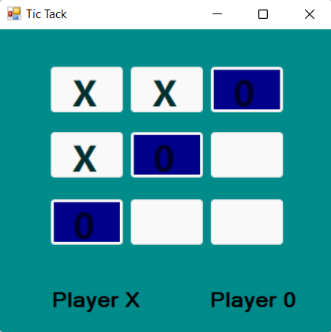

**Pro 7: write a program to transfer an item from First ListBox to Second ListBox and from Second ListBox to First.**

**Code:**

using System;

using System.Collections.Generic;

using System.ComponentModel;

using System.Data;

using System.Drawing;

using System.Linq;

using System.Text;

using System.Windows.Forms;

namespace U1P7

{

public partial class Form1 : Form

{

public Form1()

{

InitializeComponent();

}

private void button1_Click(object sender, EventArgs e)

{

listBox2.Items.Add(listBox1.SelectedItem);

listBox1.Items.Remove(listBox1.SelectedItem);

}

private void button2_Click(object sender, EventArgs e){

for (int i = listBox1.SelectedIndices.Count - 1; i >= 0; i--)

{

int idx = listBox1.SelectedIndices[i];

listBox2.Items.Add(listBox1.Items[idx]);

listBox1.Items.RemoveAt(idx);

}

}

private void button3_Click(object sender, EventArgs e)

{

listBox2.Items.AddRange(listBox1.Items);

listBox1.Items.Clear();

}

private void button6_Click(object sender, EventArgs e)

{

listBox1.Items.Add(listBox2.SelectedItem);

listBox2.Items.Remove(listBox2.SelectedItem);

}

private void button5_Click(object sender, EventArgs e)

{

for (int i = listBox2.SelectedIndices.Count - 1; i >= 0; i--)

{

int idx = listBox2.SelectedIndices[i];

listBox1.Items.Add(listBox2.Items[idx]);

listBox2.Items.RemoveAt(idx);

}}

private void button4_Click(object sender, EventArgs e)

{

listBox1.Items.AddRange(listBox2.Items);

listBox2.Items.Clear();

}

}

}

**Output:**

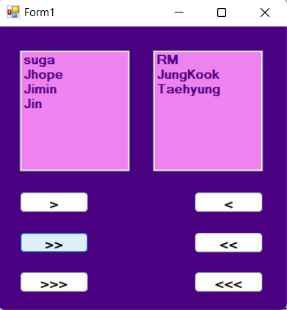

**Pro 8: Print multiplication table into Listbox. For multiplication take value using Numeric up down.**

**Code:**

using System;

using System.Collections.Generic;

using System.ComponentModel;

using System.Data;

using System.Drawing;

using System.Linq;

using System.Text;

using System.Windows.Forms;

namespace U1P8

{

public partial class Form1 : Form

{

public Form1()

{

InitializeComponent();

}

private void numericUpDown1_ValueChanged(object sender, EventArgs e)

{

listBox1.Items.Clear();

for (int i = 1; i <= 10; i++)

{

int s = Convert.ToInt32(numericUpDown1.Value);

listBox1.Items.Add(s + "*" + i + "=" + s * i);

}

}

}

}

**Output:**

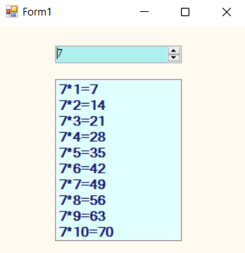

**Pro 9: Take 3 Rdio Buttons showing the name of 3 Countries. Load the image of the Flag of the country selected by the user from given Radio Buttons in the Picture box.**

**Code:**

using System;

using System.Collections.Generic;

using System.ComponentModel;

using System.Data;

using System.Drawing;

using System.Linq;

using System.Text;

using System.Windows.Forms;

namespace U1P9

{

public partial class Form1 : Form

{

public Form1()

{

InitializeComponent();

}

private void radioButton1_CheckedChanged(object sender, EventArgs e)

{

this.pictureBox1.ImageLocation = @"C:\Users\janki\Downloads\WhatsApp Image 2023-01-23 at 7.04.50 PM.jpeg";

}

private void radioButton2_CheckedChanged(object sender, EventArgs e)

{

this.pictureBox1.ImageLocation = @"C:\Users\janki\Downloads\WhatsApp Image 2023-01-23 at 7.04.50 PM (1).jpeg";

}

private void radioButton3_CheckedChanged(object sender, EventArgs e)

{

this.pictureBox1.ImageLocation = @"C:\Users\janki\Downloads\WhatsApp Image 2023-01-23 at 7.05.48 PM.jpeg";

}

}

}

**Output:**

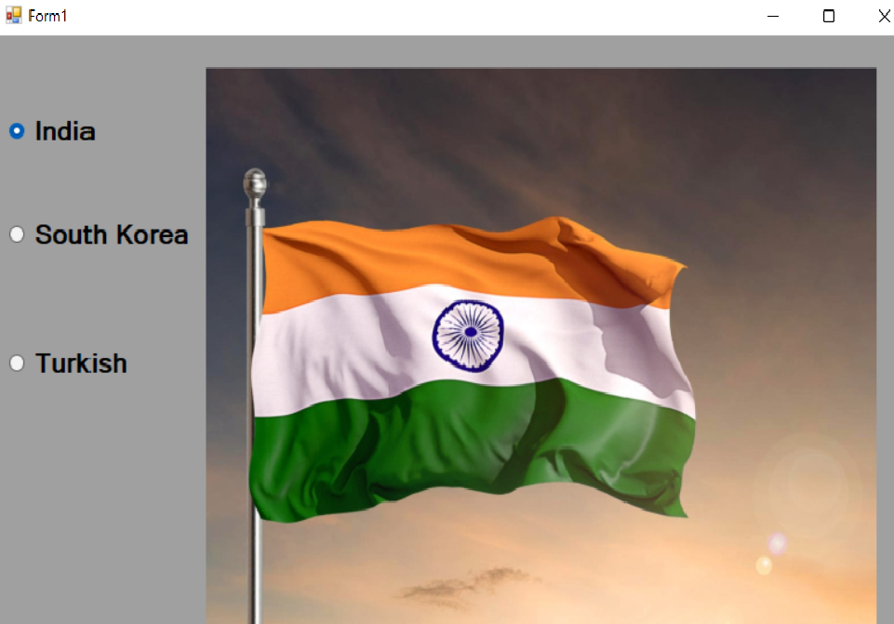

**Pro 10: Take a Timer Control which will delay to load MainForm by 10 seconds . Show the progress bar in the wait time. Also use time control to scroll a label having text “Gujarat University” ,also take two more labels to show date and time on the tick event of the timer.**

**Code:**

using System;

using System.Collections.Generic;

using System.ComponentModel;

using System.Data;

using System.Drawing;

using System.Linq;

using System.Text;

using System.Windows.Forms;

namespace U1P10

{

public partial class Form1 : Form

{

int x = 255, y = 1;

public Form1()

{

InitializeComponent();

}

private void timer1_Tick(object sender, EventArgs e)

{

if (progressBar1.Value < 1000)

{

progressBar1.Value = progressBar1.Value + 10;

}

label1.SetBounds(x,y,10,10);

x++;

if (x >= 800)

{

x = 1;

}

label2.Text = Convert.ToString(DateTime.Now);

}

private void Form1_Load(object sender, EventArgs e)

{

progressBar1.Minimum = 0;

progressBar1.Maximum = 1000;

timer1.Interval = 1;

timer1.Start();

}

}

}

**Output:**

