Technical Design Document (TDD) - OFAC / Watchlist Screening Platform
Prudential
Version: 1.0
Date: 2026-02-28
Repo: ofac-screening-aws
Tapan Bhavsar
2026
Contents
Technical Design Document (TDD): OFAC / Watchlist Screening Platform 1
1. System Overview 1
2. AWS Architecture (Deployed View) 1
2.1 Logical Diagram (Text) 1
2.2 Key AWS Components 2
3. Security Design 2
3.1 Authentication 2
3.2 Authorization 2
3.3 Token Validation 3
4. Component Responsibilities 3
4.1 Frontend 3
4.2 Backend API 3
4.3 Worker 3
5. API Design 3
6. Process Flows (Text) 3
6.1 OIDS Login 4
6.2 Single Screening (Sync) 4
6.2 Batch Screening (Async) 5
6.3 Daily Screening 6
7. Operational Design 7

1. System Overview
- Single Screening (Sync): immediate response for interactive use.
- Batch Screening (Async): file-based screening returns immediately with a job id; worker processes in background.
- Daily Screening: selected batches re-screened daily shortly after midnight Eastern time.
- AuthN/AuthZ: OIDC login and role-based authorization.
- Audit Trail: key user/system actions recorded with timestamps.

2. AWS Architecture (Deployed View)

2.1 Logical Diagram (Text)

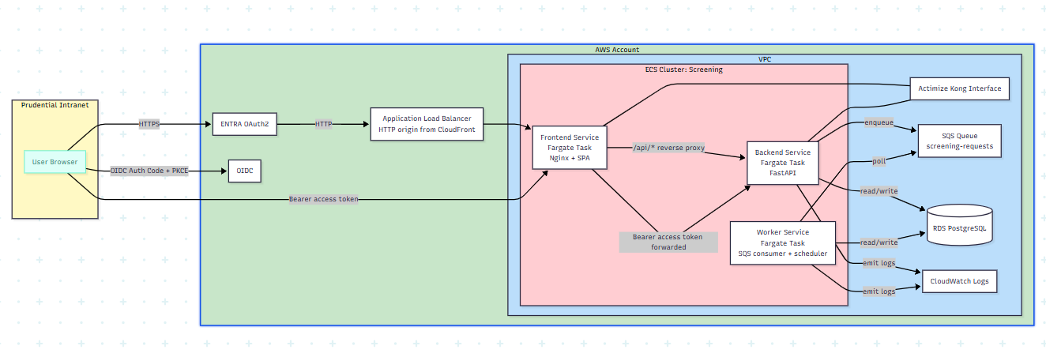

User Browser
|
| HTTPS
v
CloudFront (HTTPS)
|
| HTTP (origin)
v
ALB
|
v
ECS/Fargate Frontend Service (Nginx + SPA)
|\
| \__ /api/* reverse proxy (internal)
| v
| ECS/Fargate Backend Service (FastAPI) --read/write--> RDS PostgreSQL
| |
| +--enqueue--> SQS queue (screening-requests)
|
+--(OIDC in browser)--> Cognito User Pool (or enterprise IdP federation)

ECS/Fargate Worker Service
|
+--poll--> SQS queue
+--read/write--> RDS PostgreSQL
+--screen calls--> Screening Engine Adapter (single-type per request, 32 TPS throttled)

2.2 Key AWS Components
- CloudFront: provides HTTPS required for OIDC PKCE and a single public entrypoint.
- ALB: forwards to frontend target group; backend is reached internally via reverse proxy.
- ECS/Fargate: frontend, backend, worker services.
- Cloud Map: backend resolves as backend.screening.internal from frontend tasks.
- SQS: buffers batch work and decouples submission from processing.
- RDS PostgreSQL: jobs, items, schedules, audit events.
- Enta(oAuth2): login and token issuance (or federation).
- CloudWatch Logs: central logs per service.

3. Security Design

3.1 Authentication
- Browser uses OIDC Authorization Code + PKCE.
- Frontend sends Authorization: Bearer <access_token> to backend APIs.

3.2 Authorization
Roles are derived from token claims (e.g., Cognito groups or mapped enterprise groups).
- viewer: screening only in mock mode.
- analyst: single + batch screening.
- compliance: analyst + daily screening management.
- admin: compliance + user admin + audit visibility.

3.3 Token Validation
- Validate JWT signature with JWKS.
- Validate issuer and allowed algorithms.
- Audience compatibility for Cognito access tokens: accept app client id in aud or client_id or azp.

4. Component Responsibilities

4.1 Frontend
- UI for Single/Batch/Daily and results.
- OIDC login/logout and session handling.
- Calls backend under /api/v1 via /api reverse proxy.
- Polls batch jobs and renders progress.

4.2 Backend API
- Accepts requests and performs synchronous screening.
- Creates batch jobs and enqueues work.
- Provides polling endpoints and daily schedule endpoints.
- Writes audit events for traceability.

4.3 Worker
- Consumes SQS messages and processes screening items.
- Calls screening engine one type at a time and merges results.
- Enforces 32 TPS throughput limit.
- Triggers due daily schedules to create new batch jobs.

5. API Design
Base path: /api/v1
- GET /health
- POST /screenings/match (sync)
- POST /screenings/jobs (async batch)
- GET /screenings/jobs/{job_id} (poll progress/results)
- GET /screenings/daily-schedules
- DELETE /screenings/daily-schedules/{schedule_id}
- GET /audit-events

6. Process Flows (Text)

6.1 OIDS Login

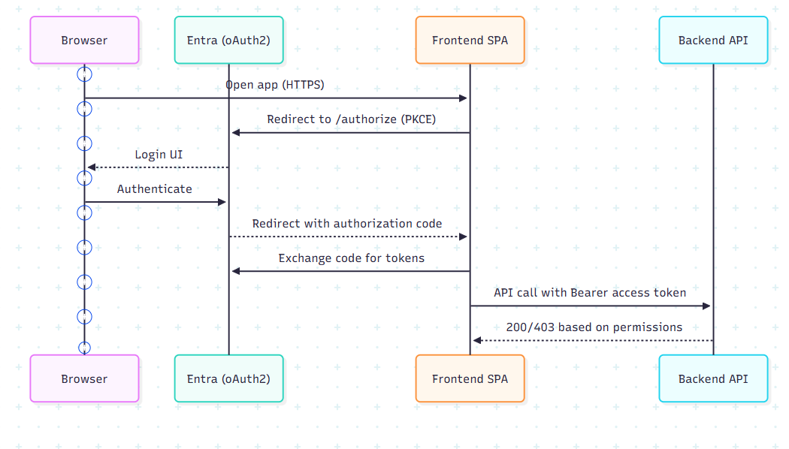

sequenceDiagram

participant B as Browser

participant C as Entra (oAuth2)

participant FE as Frontend SPA

participant API as Backend API

B->>FE: Open app (HTTPS)

FE->>C: Redirect to /authorize (PKCE)

C-->>B: Login UI

B->>C: Authenticate

C-->>FE: Redirect with authorization code

FE->>C: Exchange code for tokens

FE->>API: API call with Bearer access token

API-->>FE: 200/403 based on permissions

6.2 Single Screening (Sync)

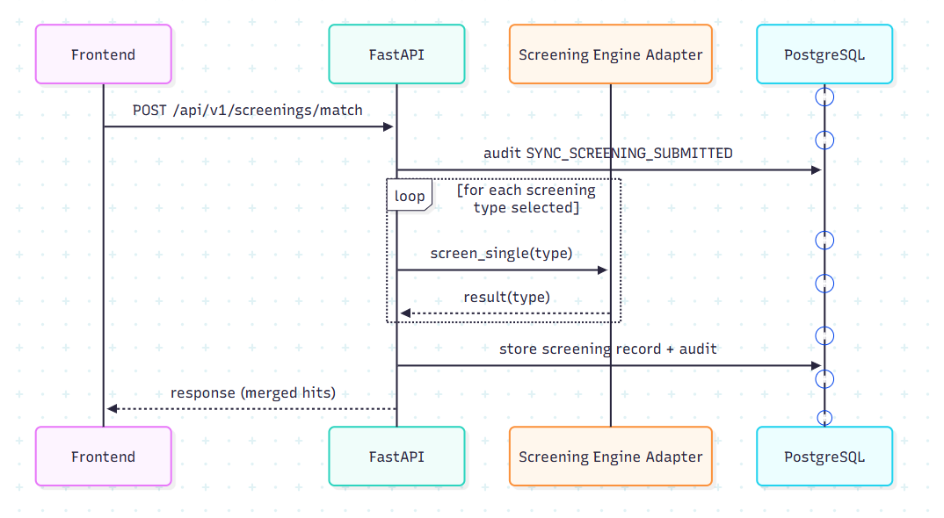

UI -> API: POST /screenings/match
API -> DB: write audit SYNC_SCREENING_SUBMITTED
API -> Engine: call one request per screening type (Sanction/PEP/AME/etc.)
API -> DB: persist result
API -> UI: return merged response ordered by score

6.2 Batch Screening (Async)

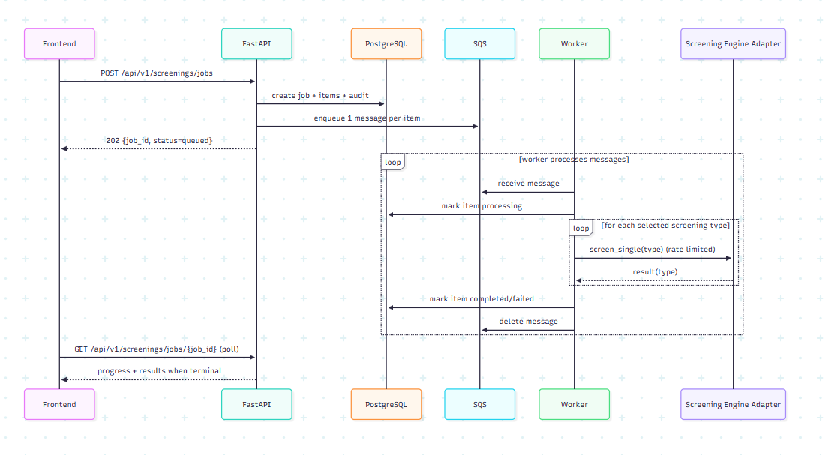

UI -> API: POST /screenings/jobs
API -> DB: create job + items + audit
API -> SQS: enqueue one message per item (includes screening_types list)
API -> UI: 202 Accepted with job_id

Worker -> SQS: receive message
Worker -> DB: mark item processing
Worker -> Engine: call one request per screening type (rate limited to 32 TPS)
Worker -> DB: mark item completed/failed
Worker -> SQS: delete message

UI -> API: GET /screenings/jobs/{job_id} (poll)
API -> UI: queued/processing/completed/failed + results when terminal

6.3 Daily Screening

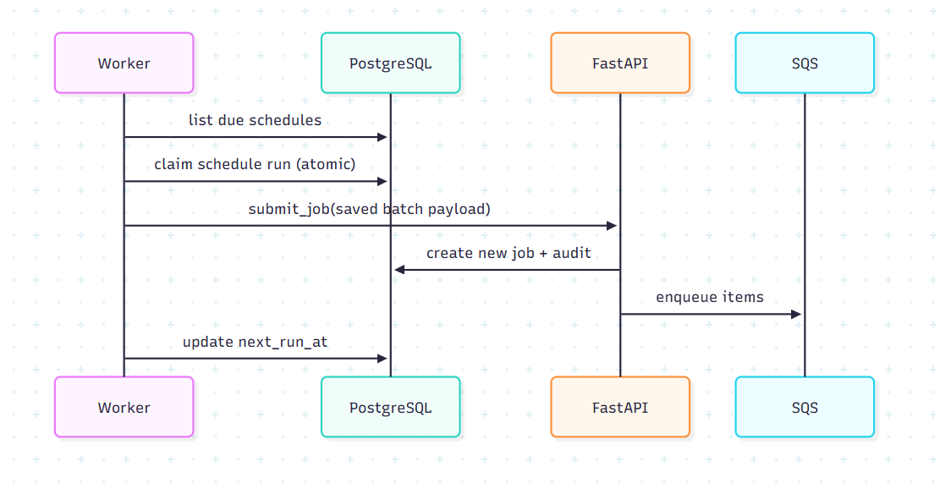

Worker (scheduler loop) -> DB: list due daily schedules
Worker -> DB: claim schedule run (atomic compare-and-set)
Worker -> API: submit job using saved batch payload
API -> DB: create job + audit
API -> SQS: enqueue items
Worker -> DB: update next_run_at

7. Operational Design
- Throughput: worker throttles outbound engine calls to 26 TPS.
- Observability: logs in CloudWatch; audit events in DB.
- Cost controls (dev): worker desired count can be 0 when not testing batch/daily.
Markdown version with Mermaid diagrams: docs/technical-design-document.md

