Technical Design Document (TDD): OFAC / Watchlist Screening Platform
Version: 2.2 Date: 2026-05-19 Repo: ofac-screening-aws
This document describes the current technical design for the OFAC / watchlist screening platform. It is aligned to the latest repository code for the FastAPI backend, React/Vite frontend, SQS worker, PostgreSQL schema, and AWS deployment artifacts.

Document Control
Field | Value
Document Name | OFAC / Watchlist Screening Platform Technical Design Document
Current Version | 2.2
Version Date | 2026-05-19
Repository | `ofac-screening-aws`
Primary Audience | Engineering, QA, DevOps, Security, Compliance stakeholders
Source of Truth | Latest committed and in-work repository code plus deployment artifacts
Generated Output | `docs/technical-design-document.docx`

Version History
Version | Date | Change Summary
2.2 | 2026-05-19 | Added explicit OIDC authentication flow, Actimize authentication behavior, and end-to-end API flow diagram.
2.1 | 2026-05-19 | Added database ER diagram source and rendered image under the Data Model section.
2.0 | 2026-05-19 | Aligned TDD to current backend, frontend, worker, split queue dispatcher, paged daily schedule admin, BU-scoped screening types, Actimize callback handling, and updated QA coverage. Added architecture image, document index, and explicit version history.
1.9 | 2026-05-06 | Documented backend-parsed batch uploads, large-batch `JOB_DISPATCH`, summary/results split, materialized views, audit access logs, raw upstream logging, worker retries, structured name/alias mapping, and DB-driven screening-type mapping.
1.8 and earlier | Before 2026-05-06 | Earlier architecture and workflow baseline for single screening, batch screening, scheduled screening, AWS deployment, and core data model.

Versioning Policy
- TDD versions use major.minor numbering.
- Increment the minor version for additive architecture, API, workflow, QA, or operational documentation updates.
- Increment the major version for material platform redesigns, incompatible API contracts, or major deployment topology changes.
- Update the Version History table whenever regenerating technical-design-document.docx for release or stakeholder review.

Index
Section | Title
1 | System Overview
2 | Deployed AWS Architecture
3 | Security, Authentication, and API Flows
4 | Roles and Permissions
5 | Frontend Application
6 | Backend API Catalog
7 | Backend and Worker Processing Flows
8 | Data Model and ER Diagram
9 | Screening Type and Actimize Mapping
10 | Batch File Rules
11 | Operational Configuration
12 | Quality and Test Coverage Notes

Revision Summary
- Daily schedule administration now uses paged APIs and UI controls:
- GET /api/v1/screenings/daily-schedules?page=N returns DailyScheduleInfoPage with a fixed backend page size of 10.
- GET /api/v1/screenings/daily-schedules/batch-runs?page=N returns DailyScheduleBatchRunStatusPage with a fixed backend page size of 50.
- Daily schedule admin now displays the schedule owner (Scheduled By), source file, frequency, next-run time, and admin batch-run status across users.
- Ad-hoc schedule rerun is exposed through POST /api/v1/screenings/daily-schedules/{schedule_id}/rerun.
- Schedule result subscriptions are exposed through GET, POST, and DELETE endpoints under /api/v1/screenings/daily-schedules/{schedule_id}/subscriptions.
- Screening type options can be requested with business_unit_code so the UI can load business-unit-aware options.
- Batch upload remains backend parsed: the frontend submits source file plus metadata; backend validates CSV/XLSX rows and returns row_meta.
- Large immediate batch upload remains S3/SQS backed through a JOB_DISPATCH control message to avoid proxy/origin timeouts.
- Queue configuration now supports separate dispatch and screening queues with AWS_DISPATCH_SQS_QUEUE_NAME and AWS_SCREENING_SQS_QUEUE_NAME; the legacy AWS_SQS_QUEUE_NAME remains the default for both when split queues are not configured.
- worker_app.dispatcher can run as a dispatch-only worker that consumes JOB_DISPATCH messages, expands large jobs into the screening queue, and forwards unexpected SCREEN_ITEM messages when queues are split.
- Worker health now exposes /health on the configured worker health host/port and tracks recent worker activity.
- Worker retry behavior includes retry attempt tracking, delayed SQS requeue for transient upstream errors, and visibility timeout extension for in-flight items.
- Backend audit/event APIs include paged retrieval with errors_only, access logging, retention cleanup, and high-risk external API failure audit alerts.
- Business unit administration includes CRUD for business units and user-to-business-unit mappings.
- The Actimize alert callback endpoint accepts review status callbacks and applies alert status back to stored item responses.
- Runtime validates database schema on startup; schema creation/migration is expected to run as a separate setup/deployment step.
- Added a database ER diagram to the Data Model section for stakeholder review.
- Added explicit OIDC authentication, Actimize authentication, and API flow documentation for review.

1. System Overview
The platform supports these primary workflows:
- Single Screening (Sync): a user submits one entity through POST /api/v1/screenings/match and receives a normalized response immediately.
- Batch Screening (Async): a user uploads a CSV/XLSX file through POST /api/v1/screenings/batch-upload; backend stores upload metadata, creates a job, and enqueues work.
- Large Batch Dispatch: for large immediate uploads, backend stores the source file and generated query payload in S3, then sends a single JOB_DISPATCH SQS message for the worker to expand into SCREEN_ITEM messages.
- Scheduled Screening: compliance/admin users create daily, weekly, or monthly schedules. The worker checks due schedules, claims them, submits new jobs, and updates next-run timestamps.
- Result Review: users load summary counters, recent results, job progress, schedule status, and audit information through backend APIs.
- Administration: admin/useradmin users manage business units, user mappings, audit visibility, and operational review.

2. Deployed AWS Architecture
%%{init: {"theme": "base", "flowchart": {"curve": "linear", "nodeSpacing": 45, "rankSpacing": 55}}}%%
flowchart TB
classDef browser fill:#EAF4FF,stroke:#2F74B5,stroke-width:1px,color:#0F243E;
classDef edge fill:#F3ECFF,stroke:#7B61FF,stroke-width:1px,color:#251A4A;
classDef compute fill:#EFFFF4,stroke:#2E8B57,stroke-width:1px,color:#14351F;
classDef queue fill:#FFF4E5,stroke:#C77700,stroke-width:1px,color:#3D2600;
classDef data fill:#F7F7F7,stroke:#666666,stroke-width:1px,color:#202020;
classDef external fill:#FFECEC,stroke:#B94A48,stroke-width:1px,color:#4A1515;
U["User Browser"]:::browser
EDGE["CloudFront + ALB<br/>public HTTPS entry"]:::edge
COG["Cognito / Enterprise IdP<br/>OIDC + PKCE"]:::edge
FE["Frontend ECS Service<br/>React + Nginx"]:::compute
API["Backend ECS Service<br/>FastAPI API"]:::compute
ASYNC["Async Processing<br/>SQS dispatch/screening queues<br/>dispatcher + worker ECS services"]:::queue
AWS["AWS Shared Services<br/>RDS PostgreSQL, S3 uploads<br/>SNS notifications, CloudWatch logs"]:::data
ACT["Actimize Watchlist API"]:::external
U --> EDGE --> FE --> API
U -.-> COG
COG -.-> API
API --> ASYNC
API --> ACT
API --> AWS
ASYNC --> AWS
ASYNC --> ACT
ACT -.-> API
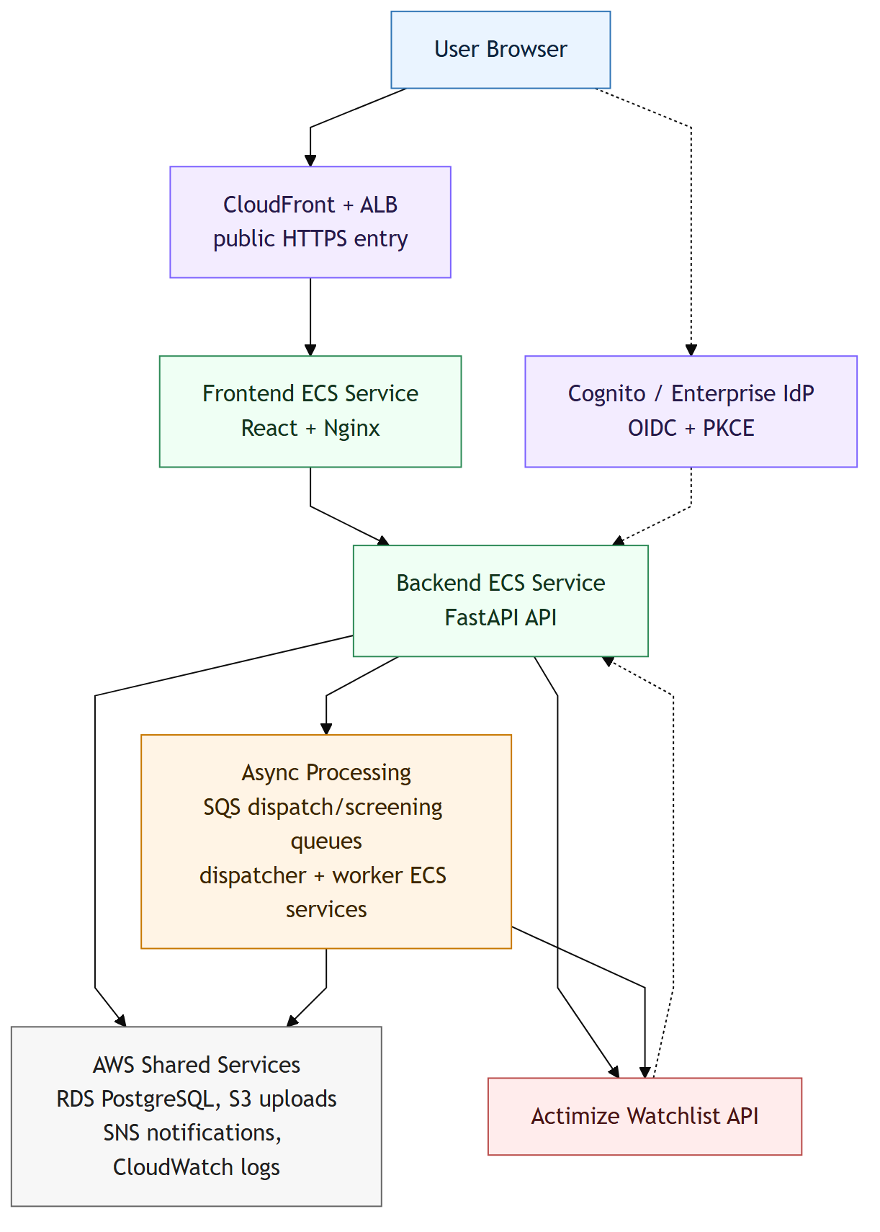

AWS Components
Component | Responsibility
CloudFront | Public HTTPS entrypoint and browser-compatible origin for OIDC/PKCE flow.
ALB | Routes public app traffic to the frontend service.
Frontend ECS service | Serves static SPA assets and reverse-proxies `/api/*` to backend.
Backend ECS service | FastAPI REST API, sync screening, upload handling, audit/access logging.
Dispatcher ECS runtime | Optional split-queue consumer for `JOB_DISPATCH` messages that expands large jobs into screening items.
Worker ECS service | SQS consumer, schedule loop, retry/requeue handling, notification dispatch.
SQS | Async work queues for `SCREEN_ITEM` and `JOB_DISPATCH` messages. Deployments may use one queue or split dispatch/screening queues.
RDS PostgreSQL | Persistent data store for jobs, schedules, audit, uploads, mappings, and results.
S3 | Source upload storage and large-batch `queries.json` payload storage.
SNS | Optional scheduled screening email notification transport.
Cognito / IdP | OIDC login, token issuance, and role/group claims.
CloudWatch | Runtime logs, troubleshooting, and raw upstream log stream destination.

3. Security, Authentication, and API Flows

Frontend
- Uses OIDC Authorization Code + PKCE via react-oidc-context.
- Stores OIDC session in sessionStorage or localStorage based on VITE_OIDC_CLEAR_SESSION_ON_CLOSE.
- Sends Authorization: Bearer <access_token> for backend calls.
- Hides or disables UI actions based on decoded permissions, but backend remains the enforcement point.
- Does not call the worker directly.

Backend
- Enforces endpoint permissions with require_any_scope.
- Validates JWT issuer, signature, expiration, allowed algorithms, and audience-like claims (aud, client_id, or azp) when AUTH_ENABLED=true.
- Provides local-dev fallback principal with admin-like scopes when AUTH_ENABLED=false; deployment configuration must explicitly enable auth for protected environments.
- Logs /api/v1/* access events with correlation id, sanitized query strings, status code, latency, auth state, user context, and selected error details.
- Redacts sensitive query keys such as token, password, secret, access token, and client secret.

OIDC Authentication Flow
1. Browser loads the React SPA through CloudFront, ALB, and the frontend ECS service. 2. When frontend auth is enabled, the SPA starts OIDC Authorization Code + PKCE against Cognito or an enterprise IdP federation endpoint. 3. After successful login, the browser receives the authorization-code redirect and exchanges it with the PKCE verifier for ID/access tokens. 4. The frontend stores the OIDC session according to VITE_OIDC_CLEAR_SESSION_ON_CLOSE and related VITE_OIDC_* settings. 5. Frontend API calls send Authorization: Bearer <access_token> to backend /api/v1/* endpoints. 6. Backend validates the token with configured issuer, JWKS URL, allowed algorithms, and audience-like claims (aud, client_id, or azp). 7. Backend derives roles from token scopes/groups/claims, maps them to application permissions, and applies endpoint-level require_any_scope checks plus business-unit authorization where required.

Actimize Authentication and API Flow
- Browser clients never call Actimize directly; all screening calls go through backend or worker/dispatcher services.
- The Actimize client sends JSON requests to {ACTIMIZE_BASE_URL}/entity-screenings with Content-Type: application/json and a generated X-Request-ID.
- Outbound authentication is selected in this order:
- Static bearer token from ACTIMIZE_BEARER_TOKEN.
- OAuth client_credentials access token from ACTIMIZE_TOKEN_URL using either ACTIMIZE_CLIENT_SECRET or a JWT client assertion built from ACTIMIZE_CLIENT_ASSERTION_*.
- API key fallback from ACTIMIZE_API_KEY.
- OAuth access tokens are cached until shortly before expiry to avoid requesting a token for every screening item.
- Transient Actimize failures (408, 429, 500, 502, 503, 504) are retried by the Actimize client; worker-side retry/requeue handles retryable per-item failures.
- Raw request/response logging is optional and redacts token, API key, client secret, client assertion, password, and authorization fields before writing to CloudWatch.
- Actimize alert review callbacks enter through /api/v1/integrations/actimize/alerts/callback; callback authenticity should be protected by deployment-level identity or network controls.

End-to-End Flow Diagram
Mermaid source: docs/authentication-api-flow.mmd.
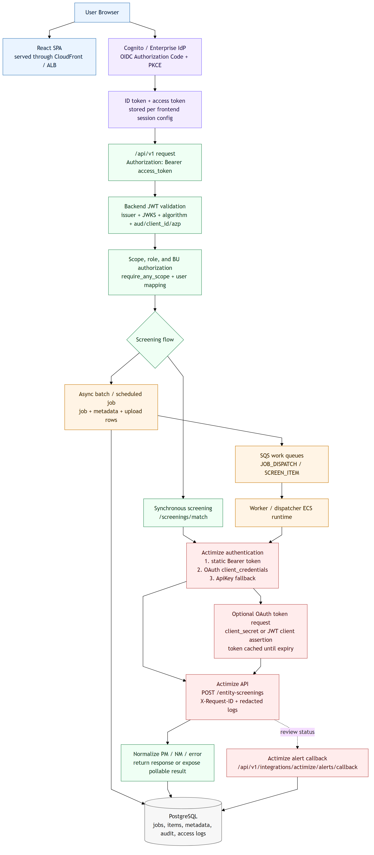

Worker
- Has no browser-facing API other than its local health endpoint.
- Trusts work that was already authorized by backend before enqueue.
- Uses ECS task role / AWS permissions for SQS, S3, SNS, and DB access.
- In split-queue mode, the normal worker consumes the screening queue while worker_app.dispatcher consumes the dispatch queue and expands large jobs into the screening queue.

External Callbacks
- POST /api/v1/integrations/actimize/alerts/callback accepts Actimize alert review callbacks and applies status back to stored screening item responses.
- The callback payload includes unique_key, alert_id, status_cd, and optional screening/source metadata.
- Production deployments should protect the callback path at the network or identity layer and validate callback authenticity before accepting mutations.

4. Roles and Permissions
Role Intent | Effective Capability
Viewer | Read access plus mock single screening only.
Analyst | Single and batch screening.
Compliance | Analyst permissions plus scheduled screening and schedule administration.
User Admin | Business unit and user mapping administration.
Admin | Full compliance, user administration, audit, and operational visibility.
Backend scope checks are the source of truth. Frontend role checks are used for navigation and ergonomics only.

5. Frontend Application

Routes
Route | Screen | Purpose
`/` | Redirect | Redirects to `/intro`.
`/intro` | Intro page | Application landing/overview for authenticated users.
`/screening` | Screening workspace | Single, batch, schedule creation, results, and summary views.
`/daily-schedules` | Daily schedule admin | Active schedule list, paged schedule table, batch run status, remove, rerun.
`/manage-users` | User administration | Business unit CRUD and user-to-BU mappings.
`/audit-logs` | Audit log page | Paged audit and errors-only review for admin/useradmin users.
`/signed-out` | Signed-out flow | Post-logout screen and sign-in again action.

Frontend Runtime Configuration
The frontend container writes /usr/share/nginx/html/app-config.js at startup from VITE_* environment variables. Nginx also generates reverse-proxy configuration at startup and forwards /api/ to BACKEND_UPSTREAM.
Important frontend settings:
Variable | Purpose
`VITE_SCREENING_API_BASE_URL` | API base path, default `/api/v1`.
`VITE_SCREENING_POLL_INTERVAL_MS` | Job polling interval.
`VITE_SCREENING_JOB_TIMEOUT_MS` | Job wait timeout for UI helper flows.
`VITE_AUTH_ENABLED` | Enables OIDC in frontend.
`VITE_OIDC_*` | OIDC authority, client id, redirect URIs, scope, and session settings.
`VITE_ACTIMIZE_REVIEW_ALERT_URL` | Optional review-alert navigation URL used in result/review flows.

6. Backend API Catalog
Endpoint | Method | Scope | Response / Behavior
`/health` | GET | Public | Basic backend health response.
`/api/v1/screenings/match` | POST | `screening.write` or `screening.single.mock` or `screening.admin` | Synchronous screening. Viewer-style users are limited to mock mode. Requires mapped business unit.
`/api/v1/screenings/jobs` | POST | `screening.write` or `screening.daily` or `screening.admin` | Creates async job from JSON payload and enqueues item work.
`/api/v1/screenings/batch-upload` | POST | `screening.write` or `screening.daily` or `screening.admin` | Accepts CSV/XLSX upload and metadata; backend parses rows; scheduled uploads require daily/admin scope.
`/api/v1/screenings/jobs/{job_id}` | GET | `screening.read` | Returns job counts, terminal responses, and status.
`/api/v1/screenings/summary` | GET | `screening.read` | Returns aggregate counts for current user.
`/api/v1/screenings/results?limit=N` | GET | `screening.read` | Returns normalized recent result rows, default `1000`, max `5000`.
`/api/v1/screenings/submissions?limit=N` | GET | `screening.read` | Returns user submission history.
`/api/v1/screenings/types?business_unit_code=BU` | GET | `screening.read` | Returns active screening-type options, optionally scoped by business unit.
`/api/v1/screenings/daily-schedules?page=N` | GET | `screening.read` | Returns `DailyScheduleInfoPage`; backend page size `10`.
`/api/v1/screenings/daily-schedules/batch-runs?page=N` | GET | `screening.admin` | Returns `DailyScheduleBatchRunStatusPage`; backend page size `50`.
`/api/v1/screenings/daily-schedules/{schedule_id}` | DELETE | `screening.daily` or `screening.admin` | Deactivates an active schedule and writes audit event.
`/api/v1/screenings/daily-schedules/{schedule_id}/rerun` | POST | `screening.daily` or `screening.admin` | Creates an ad-hoc run from the stored schedule.
`/api/v1/screenings/daily-schedules/{schedule_id}/subscriptions` | GET | `screening.read` | Lists current user's subscriptions for a schedule.
`/api/v1/screenings/daily-schedules/{schedule_id}/subscriptions?email=` | POST | `screening.read` | Subscribes an allowed email address for schedule completion notices.
`/api/v1/screenings/daily-schedules/{schedule_id}/subscriptions?email=` | DELETE | `screening.read` | Removes a schedule subscription.
`/api/v1/business-units` | GET | `screening.read` | Lists active business units mapped to current user.
`/api/v1/admin/business-units` | GET | `screening.admin` or `screening.useradmin` | Lists all business units, optionally including inactive rows.
`/api/v1/admin/business-units` | POST | `screening.admin` or `screening.useradmin` | Creates a business unit.
`/api/v1/admin/business-units/{business_unit_code}` | PUT | `screening.admin` or `screening.useradmin` | Updates business unit code/name.
`/api/v1/admin/business-units/{business_unit_code}` | DELETE | `screening.admin` or `screening.useradmin` | Deactivates a business unit.
`/api/v1/admin/business-unit-mappings` | GET | `screening.admin` or `screening.useradmin` | Lists user-to-business-unit mappings.
`/api/v1/admin/business-unit-mappings/{user_id}` | PUT | `screening.admin` or `screening.useradmin` | Replaces a user's active business unit mapping set.
`/api/v1/admin/users` | GET | `screening.admin` or `screening.useradmin` | Lists known users from DB plus Cognito where available.
`/api/v1/audit-events` | GET | `screening.admin` or `screening.useradmin` | Legacy offset/limit audit list.
`/api/v1/audit-events/page` | GET | `screening.admin` or `screening.useradmin` | Paged audit API with `errors_only`.
`/api/v1/integrations/actimize/alerts/callback` | POST | Integration controlled | Records Actimize review callback and updates matching item responses.

7. Backend and Worker Processing Flows

7.1 Single Screening
1. Browser submits an entity payload to /api/v1/screenings/match. 2. Backend checks auth scope, mock-mode constraints, and business unit mapping. 3. Backend resolves DB-driven screening type mappings. 4. Backend calls Actimize for each selected screening type. 5. Backend normalizes response into EntityMatchResponse, writes audit/access events, and returns the result.

7.2 Immediate Batch Upload
1. Browser posts CSV/XLSX plus metadata to /api/v1/screenings/batch-upload. 2. Backend validates multipart size, extension, screening types, business unit, schedule flags, and file body. 3. Backend stores file metadata in batch_file_uploads. 4. If S3 is enabled, backend uploads source file and generated query payload. 5. Backend returns BatchUploadAccepted with job_id, source_upload_id, and row_meta. 6. Worker consumes queued messages and writes job_items status/results.

7.3 Large Batch JOB_DISPATCH
1. Backend creates a job quickly and enqueues one JOB_DISPATCH message. 2. In single-queue mode, the worker consumes the dispatch message directly. In split-queue mode, worker_app.dispatcher consumes it from AWS_DISPATCH_SQS_QUEUE_NAME. 3. Dispatcher/worker downloads generated queries.json from S3. 4. Dispatcher/worker bulk-inserts item records and enqueues SCREEN_ITEM messages into the screening queue in SQS batches. 5. If a dispatch-only runtime receives a SCREEN_ITEM while queues are split, it forwards that item to the configured screening queue and audits the forwarding action. 6. Standard worker item processing completes each record from the screening queue.

7.4 Scheduled Screening
1. Compliance/admin creates or updates a schedule from the Schedule tab or batch-upload schedule path. 2. Backend persists daily_schedules with cadence, timezone, next run, upload/source metadata, and business unit. 3. Worker loop checks list_due_daily_schedules. 4. Worker atomically claims due schedule run. 5. Worker submits a new job from stored schedule/upload state. 6. Worker updates last_run_at and next_run_at. 7. Notification logic records/publishes completion messages once per scheduled job.

7.5 Worker Item Retry
1. Worker receives SCREEN_ITEM. 2. Worker extends visibility timeout for long work. 3. Retryable upstream failures (429, 500, 502, 503, 504) may be requeued with incremented retry_attempt. 4. Delay uses bounded exponential backoff from SCREENING_ITEM_RETRY_INITIAL_DELAY_S to SCREENING_ITEM_RETRY_MAX_DELAY_S. 5. Once max attempts are exhausted or failure is non-retryable, the item is marked failed.

8. Data Model

Core Tables
Table | Purpose
`app_users` | Stable internal user ids plus external/old id, name, email, active flag.
`jobs` | Top-level screening run state and counters.
`job_items` | Per-record request, response, status, parsed status, and error text.
`job_metadata` | UI/history metadata such as mode, selected screening types, schedule id, source file, deferred state, and business unit.
`daily_schedules` | Recurring schedule definition, owner, source upload, next run, active state, and BU.
`batch_file_uploads` | Source upload traceability, file hash, S3 locations, generated query payload locations, and record count.
`schedule_record_state` | Schedule-level dedupe state for incremental rescreening.
`schedule_subscriptions` | Per-user/email subscription rows for scheduled run completion notices.
`job_schedule_notifications` | Idempotency guard for schedule completion notification dispatch.
`schedule_notifications` | Notification outbox/audit trail.
`business_units` | Business unit catalog.
`user_business_units` | Active user-to-business-unit mappings.
`actimize_screening_type_mappings` | DB-driven screening-type mapping and display metadata.
`business_unit_screening_types` | Optional active screening-type allowlist by business unit.
`audit_events` | Compliance and operational audit trail.
`api_access_logs` | Request-level access logging for `/api/v1/*`.
`external_api_errors` | Upstream/API failure telemetry and alerting source.
`actimize_alert_callbacks` | Inbound Actimize review callback audit trail.

Entity Relationship Diagram
The diagram below focuses on application-owned relational tables and key relationships. Audit, access, notification, and integration telemetry tables are grouped where that keeps the TDD readable; the full table inventory remains in the table above and deployment DDL.
%%{init: {"theme": "base", "flowchart": {"defaultRenderer": "elk", "curve": "linear", "nodeSpacing": 35, "rankSpacing": 50}}}%%
flowchart TB
classDef identity fill:#EAF4FF,stroke:#2F74B5,stroke-width:1px,color:#0F243E;
classDef reference fill:#F3ECFF,stroke:#7B61FF,stroke-width:1px,color:#251A4A;
classDef core fill:#EFFFF4,stroke:#2E8B57,stroke-width:1px,color:#14351F;
classDef schedule fill:#FFF4E5,stroke:#C77700,stroke-width:1px,color:#3D2600;
classDef ops fill:#F7F7F7,stroke:#666666,stroke-width:1px,color:#202020;
classDef external fill:#FFECEC,stroke:#B94A48,stroke-width:1px,color:#4A1515;
U["app_users<br/>PK user_id<br/>UK old_id"]:::identity
BU["business_units<br/>PK business_unit_code"]:::reference
UBU["user_business_units<br/>PK user_ref_id + business_unit_code"]:::reference
STM["actimize_screening_type_mappings<br/>PK Screening_Type"]:::reference
BUST["business_unit_screening_types<br/>PK business_unit_code + Screening_Type"]:::reference
DS["daily_schedules<br/>PK schedule_id<br/>FK user_ref_id, business_unit_code"]:::schedule
J["jobs<br/>PK job_id<br/>AK job_seq_id<br/>FK user_ref_id, source_schedule_id"]:::core
JM["job_metadata<br/>PK/FK job_id<br/>FK daily_schedule_id, business_unit_code"]:::core
JI["job_items<br/>PK job_id + item_key<br/>FK job_id, user_ref_id"]:::core
BFU["batch_file_uploads<br/>PK upload_id<br/>FK schedule_id, job_id, user_ref_id"]:::schedule
SRS["schedule_record_state<br/>PK schedule_id + record_hash<br/>FK last_job_id"]:::schedule
SS["schedule_subscriptions<br/>PK subscription_id<br/>FK schedule_id, user_ref_id"]:::schedule
NOTIF["notification tables<br/>schedule_notifications<br/>job_schedule_notifications"]:::ops
OPS["audit and telemetry tables<br/>audit_events<br/>api_access_logs<br/>external_api_errors"]:::ops
AAC["actimize_alert_callbacks<br/>PK callback_id<br/>logical match by unique_key"]:::external
U --> UBU
BU --> UBU
BU --> BUST
STM --> BUST
U --> DS
BU --> DS
U --> J
DS --> J
BU --> JM
DS --> JM
J --> JM
J --> JI
DS --> BFU
J --> BFU
DS --> SRS
J --> SRS
DS --> SS
DS --> NOTIF
J --> NOTIF
U --> OPS
J --> OPS
AAC -.-> JI
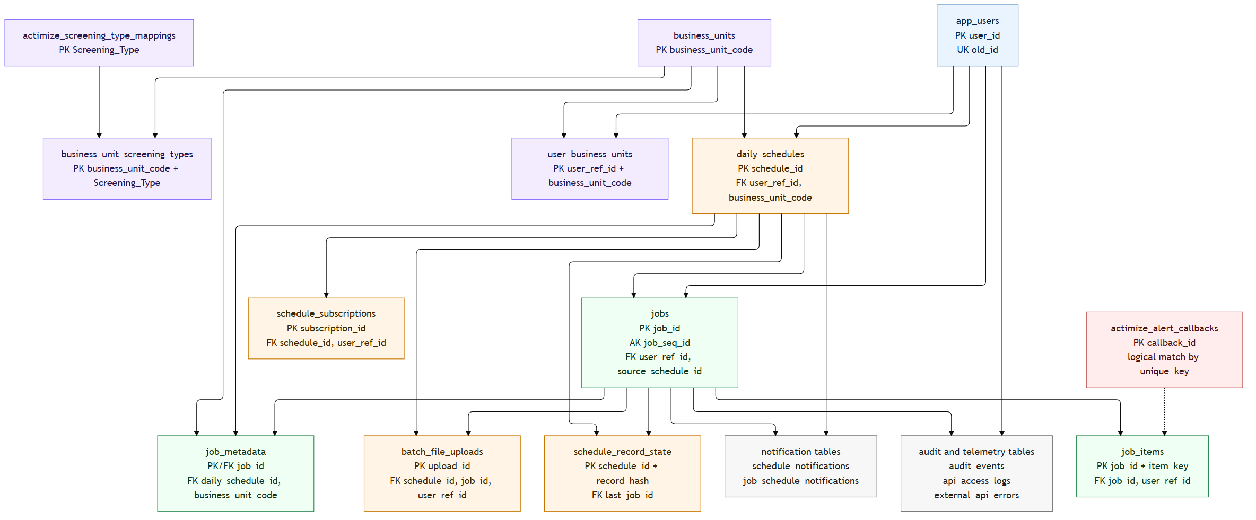

Materialized Views
View | Purpose
`mv_user_recent_results` | Fast recent result lookup per user.
`mv_user_result_summary_counts` | Fast summary counter lookup per user.
`mv_user_submission_jobs` | Fast submission history lookup.
`mv_daily_schedule_batch_runs` | Fast admin status view for schedule-triggered/ad-hoc runs.
Runtime performs best-effort refresh of known materialized views at an interval controlled by PG_RESULT_MV_REFRESH_INTERVAL_S.

9. Screening Type and Actimize Mapping
Screening type options are stored in actimize_screening_type_mappings and exposed through /api/v1/screenings/types. The API accepts an optional business_unit_code to support business-unit-aware options and validates that the current user can access the requested BU.
Actimize request construction preserves structured identity data:
Source Field | Actimize Target
`properties.partyKey` | `partyKey`
`schema` | `partyType` (`I` for person, `E` for entity)
`firstName`, `middleName`, `lastName`, `maidenName`, `fullName` | `names`
`alias`, `aliases` | `aliases[]`
`nationality`, `country` | `nationalities[]`
`address` | `addresses[]`
`idNumber`, `registrationNumber`, `ids` | `ids[]`
`birthDate` | `dateOfBirth` or `yearOfBirth`
`birthLocation` | `countryofBirth`
`gender` | Uppercase `gender`
selected screening type | Resolved `screeningType`
selected business unit | `businessUnit`
Classification rules:
- HTTP 200 with Prudential/Actimize message PM maps to potential match.
- HTTP 200 with message NM maps to clear.
- Other statuses or unexpected messages map to failed/error handling.

10. Batch File Rules
Supported source files are .csv and .xlsx. Excel parsing uses the first worksheet. Header matching is case-insensitive and separator-tolerant.
Required and important fields:
Template Field | Purpose
`PartyKey` | Required unique record key; becomes the item key and `properties.partyKey`.
`PartyType` / `CustomerType` | Determines individual vs entity schema.
`PrimaryFirstName`, `PrimaryMiddleName`, `PrimaryLastName`, `PrimaryMaidenName`, `PrimaryFullName` | Person/entity names.
`AliasName`, `Alias1*`, `Alias2*`, `Alias3*` | Free-form and structured aliases.
`DateOfBirth`, `Gender`, `CountryOfBirth`, `NationalityCountry1` | Person attributes.
`Address1*`, `Addresses`, `Countries`, `Address1Country` | Address/country attributes.
`PartyId1Value`, `PartyId1Type`, `PartyId1IDCountry` | ID attributes.
`Title`, `Notes` | Optional screening metadata.
The backend parser returns row_meta in the batch upload accepted response so the UI can display placeholders without duplicate client parsing.

11. Operational Configuration
Variable | Default | Purpose
`APP_DB_PATH` | `/tmp/screening.db` | SQLite fallback path when no PostgreSQL URL is set.
`APP_DB_URL` | empty | PostgreSQL connection URL for AWS deployments.
`DB_POOL_MIN_SIZE` | `1` | Minimum PostgreSQL pool size.
`DB_POOL_MAX_SIZE` | `8` | Maximum PostgreSQL pool size.
`DB_POOL_TIMEOUT_S` | `5.0` | DB pool acquisition timeout.
`DB_CONNECT_MAX_ATTEMPTS` | `4` | DB acquisition retry attempts.
`PG_RESULT_MV_REFRESH_INTERVAL_S` | `20` | Best-effort materialized-view refresh interval.
`CORS_ALLOW_ORIGINS` | `*` | Comma-separated backend CORS origins.
`MULTIPART_MAX_PART_SIZE` | `25m` | Backend upload form max part size.
`AWS_REGION` | `us-east-1` | AWS client region.
`AWS_SQS_QUEUE_NAME` | `screening-requests` | Legacy/base SQS queue name used when split queues are not configured.
`AWS_DISPATCH_SQS_QUEUE_NAME` | `AWS_SQS_QUEUE_NAME` | Queue for `JOB_DISPATCH` control messages.
`AWS_SCREENING_SQS_QUEUE_NAME` | `AWS_SQS_QUEUE_NAME` | Queue for per-record `SCREEN_ITEM` messages.
`AWS_ENDPOINT_URL` | empty | Optional LocalStack/custom endpoint.
`AWS_S3_UPLOAD_BUCKET` | empty | Upload bucket; required for large batch dispatch.
`AWS_S3_UPLOAD_PREFIX` | `screening-input` | S3 key prefix.
`AWS_SNS_NOTIFICATIONS_ENABLED` | `false` | Enables SNS completion notification publishing.
`AWS_SNS_SCHEDULE_TOPIC_PREFIX` | `ofac-screening-schedule` | SNS topic prefix.
`AWS_SES_SENDER_EMAIL` | empty | Sender metadata for notifications.
`ACTIMIZE_BASE_URL` | empty | Actimize/Kong base URL.
`ACTIMIZE_PROVIDER` | `prudential` | Provider label for logs/audit/errors.
`ACTIMIZE_API_KEY` | empty | Optional API-key credential.
`ACTIMIZE_BEARER_TOKEN` | empty | Optional static bearer token.
`ACTIMIZE_TOKEN_URL` | empty | OAuth token endpoint for dynamic bearer token.
`ACTIMIZE_CLIENT_ID` | empty | OAuth client id.
`ACTIMIZE_CLIENT_SECRET` | empty | OAuth client secret.
`ACTIMIZE_CLIENT_ASSERTION_*` | varies | JWT client assertion configuration.
`ACTIMIZE_SCOPE` | empty | Optional OAuth scopes.
`ACTIMIZE_SOURCE_SYSTEM` | `AMLP` | Default source system in upstream payloads.
`ACTIMIZE_REQUESTER_NAME` | `SCREENING_SYSTEM` | Default requester name.
`ACTIMIZE_ALERT_REVIEW_URL` | empty | Optional review link for notification content.
`ACTIMIZE_TIMEOUT_S` | `20.0` | Upstream HTTP timeout.
`ACTIMIZE_LOG_RAW_API_IO` | `false` | Enables redacted raw upstream request/response logs.
`ACTIMIZE_RAW_API_LOG_MAX_CHARS` | `20000` | Max raw log payload characters.
`ACTIMIZE_SCREENING_TYPE_CACHE_TTL_S` | `60` | Screening-type mapping cache TTL.
`ACTIMIZE_SCREENING_TYPE_CACHE_MAX_ENTRIES` | `512` | Screening-type mapping cache max entries.
`SCREENING_TPS` | `32` | Per-worker outbound TPS cap.
`SCREENING_PARALLEL_MESSAGES` | `1` | Per-worker in-flight message cap.
`SCREENING_RESULT_LIMIT` | `5` | Max returned matches per item.
`SCREENING_ITEM_RETRY_MAX_ATTEMPTS` | `2` | Transient upstream retry attempts.
`SCREENING_ITEM_RETRY_INITIAL_DELAY_S` | `3` | Initial delayed retry backoff.
`SCREENING_ITEM_RETRY_MAX_DELAY_S` | `60` | Max delayed retry backoff.
`SCREENING_ITEM_VISIBILITY_TIMEOUT_S` | `300` | Visibility timeout extension for picked-up items.
`WORKER_HEALTH_HOST` | `127.0.0.1` | Worker health bind host.
`WORKER_HEALTH_PORT` | `8081` | Worker health bind port.
`WORKER_HEALTHCHECK_TIMEOUT_S` | `5.0` | Healthcheck probe timeout.
`WORKER_HEALTH_MAX_AGE_S` | `180` | Max heartbeat age before worker health degrades.
`DAILY_SCREENING_TIMEZONE` | `America/New_York` | Default schedule timezone.
`DAILY_SCREENING_HOUR` | `0` | Default schedule run hour.
`DAILY_SCREENING_MINUTE` | `5` | Default schedule run minute.
`DAILY_SCREENING_CHECK_INTERVAL_S` | `30` | Worker schedule check interval.
`AUDIT_ACCESS_LOG_ENABLED` | `true` | Enables API access logging.
`AUDIT_EVENT_RETENTION_DAYS` | `3650` | Audit retention window.
`API_ACCESS_LOG_RETENTION_DAYS` | `365` | API access-log retention window.
`EXTERNAL_API_ERROR_RETENTION_DAYS` | `365` | External error retention window.
`OPERATIONAL_CLEANUP_INTERVAL_S` | `3600` | Worker cleanup interval.
`HIGH_RISK_EXTERNAL_API_ERROR_WINDOW_MINUTES` | `15` | External failure alert window.
`HIGH_RISK_EXTERNAL_API_ERROR_THRESHOLD` | `10` | External failure alert threshold.
`AUTH_ENABLED` | `false` | Backend JWT validation toggle. Must be `true` in protected deployments.
`AUTH_ISSUER` | empty | JWT issuer.
`AUTH_JWKS_URL` | empty | JWKS URL.
`AUTH_AUDIENCE` | empty | Expected audience/client id.
`AUTH_ALGORITHMS` | `RS256` | Allowed JWT algorithms.

12. Quality and Test Coverage Notes
The QA workbook should cover:
- Auth and RBAC for viewer, analyst, compliance, useradmin, and admin behavior.
- Business unit CRUD and user mapping flows.
- Sync screening validation and Actimize response normalization.
- Backend-parsed CSV/XLSX batch upload and large batch JOB_DISPATCH.
- Scheduled screening creation, dedupe, rerun, subscription, notifications, and paged admin views.
- Summary/results split and result filtering.
- Audit/access logs, errors-only paging, retention cleanup, and external API alerting.
- Worker health, retries, visibility timeout handling, and throughput limits.
- Negative cases for malformed uploads, unmapped business units, invalid callback payloads, and authorization failures.

