**ABSTRACT**

This report introduces a new and yet to be properly explored branch of technology, The Programmable Matter. Programmable Matter is a technology that enables us to control and manipulate 3‐dimensional physical artifacts. It is a method which brings the dream of synthetic reality closer to reality. This technology has reached a point where we can realistically build a programmable matter system which is guided by design principles which will allow it to ultimately scale to millions of sub‐millimetre catoms. The system, which follows the principles of a programmable matter, is **Claytronics.** Claytronics substantiate the ambition promised by phenomena of programmable matter. It is used to create dynamic 3 dimensional objects in physical state. This work is potentially revolutionary in the sense that it holds out the possibility of radically altering the relationship between computation, humans, and the physical world. This paper also introduces the hardware and software components of the Catoms, the crucial part of the claytronics system, along with their challenges and requirement. We also present a novel application of modular robotic technology. We describe an application--a 3D fax machine, which exploits inter‐module communication and computation without requiring self‐reconﬁguration. As a result, this application may be feasible sooner than applications which depend upon modules being able to move themselves.

Claytronics will be a test‐bed for solving some of the most challenging problems we face today: how to build complex, massively distributed dynamic systems. It is also a step towards truly integrating computers into our lives by having them integrated into the very artifacts around us and allowing them to interact with the world.

Claytronics is an abstract future concept that combines [nanoscale](http://en.wikipedia.org/wiki/Nanoscale) robotics and [computer science](http://en.wikipedia.org/wiki/Computer_science) to create individual nanometer-scale computers called claytronic atoms, or catoms, which can interact with each other to form tangible 3-D objects that a user can interact with. This idea is more broadly referred to as [programmable matter](http://en.wikipedia.org/wiki/Programmable_matter) Claytronics has the potential to greatly affect many areas of daily life, such as telecommunication, human-computer interfaces, and entertainment.

Claytronics is a form a programmable matter that takes the concept of modular robots to a new extreme. The concept of modular robots has been around for some time.

**INTRODUCTION TO CLAYTRONICS**

Claytronics is a form a programmable matter that takes the concept of modular robots to a new extreme. Claytronics is our name for an instance of programmable matter whose primary function is to organize itself into the shape of an object and render its outer surface to match the visual appearance of that object. Claytronics is made up of individual components, called catoms for Claytronic atoms that can move in three dimensions (in relation to other catoms), adhere to other catoms to maintain a 3D shape, and compute state information (with possible assistance from other catoms in the ensemble). The claytronics project combines modular robotics, systems nanotechnology and computer science to create the dynamic, 3‐Dimensional display of electronic information.

The enabling hardware technology behind synthetic reality is Claytronics, a form of program‐ mable matter that can organize itself into the shape of an object and render its outer surface to match the visual appearance of that object. Claytronics is made up of individual components, called catoms for Claytronic atoms that can move in three dimensions (in relation to other catoms), adhere to other catoms to maintain a 3D shape, and compute state information (with possible assistance from other catoms in the ensemble).

A Claytronics system forms a shape through the interaction of the individual catoms. For example, suppose we wish to synthesize a physical “copy” of a person. The catoms would ﬁrst determine their relative location and orientation.

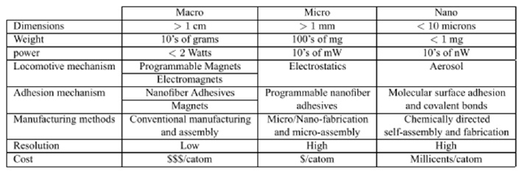

Using that information they would then form a network in a distributed fashion and organize themselves into a hierarchical structure, both to improve locality and to facilitate the planning and coordination tasks. The goal (mimicking a human form) would then be speciﬁed abstractly, perhaps as a series of “snapshots” or as a collection of virtual deforming “forces”, and then broadcast to the catoms. Compilation of the speciﬁcation would then provide each catom with a local plan for achieving the desired global shape. At this point, the catoms would start to move around each other using forces generated on‐board, either magnetically or electrostatically, and adhere to each other using, for example, a Nano ﬁber‐adhesive mechanism.

Finally, the catoms on the surface would display an image; rendering the color and texture characteristics of the source object. If the source object begins to move, a concise description of the movements would be broadcast allowing the catoms to update their positions by moving around each other. The end result is that the system appears to be a single coordinated system.

**GOALS OF CLAYTRONICS**

One of the primary goals of claytronics is to form the basis for a new media type,pario. Pario, a logical extension of audio and video, is a media type used to reproduce moving 3D objects in the real world.

The long term goal of our work is to render physical artifacts with such high ﬁdelity that our senses will easily accept the reproduction for the original. When this goal is achieved we will be able to create an environment, which we call synthetic reality, in which a user can inter‐ act with computer generated artifacts as if they were the real thing. Synthetic reality has signiﬁcant advantages over virtual reality or augmented reality. For example, there is no need for the user to use any form of sensory augmentation, e.g., head mounted displays or haptic feedback devices will be able to see, touch, pick‐up, or even use the rendered artifacts.

**ENSEMBLE PRINCIPLE**

The ensemble principle states ‘A robot module should include only enough functionality to contribute to the ensemble’s desired functionality.’ Realizing the goal requires new ways of thinking about massive numbers of cooperating millimeter-scale units. Most importantly, it demands simplifying and redesigning the software and hardware used in each catom to reduce complexity and manufacturing cost and increase robustness and reliability. For example, each catom must work cooperatively with others in the ensemble to move, communicate, and obtain power.

**SCALING AND DESIGN PRINCIPLES**

A fundamental requirement of Claytronics is that the system must scale to very large num- bers of interacting catoms. **Main goal is to form dynamic high fidelity macro scale objects**. In addition to previously stated principles for the design of modular robots we have the following four design principles:

∗ Each catom should be self-contained, in the sense of possessing everything necessary for performing its own computation, communication, sensing, actuation, locomotion, and adhesion.

∗ To support eﬃcient routing of power and avoid excessive heat dissipation, no static power should be required for adhesion after attachment.

∗ The coordination of the catoms should be performed via local control. In particular, no computation external to the ensemble should be necessary for individual catom execution.

∗ For economic viability, manufacturability, and reliability, catoms should contain no moving parts

 

Scaling is performed using **ENSEMBLE EFFECT**

**CLAYTRONIC HARDWARE**

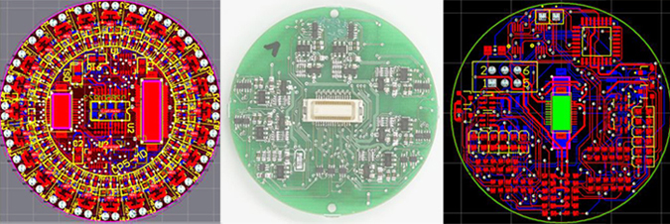

Through hardware engineering projects, researchers in the Carnegie Mellon-Intel Claytronics Project investigate the effects of scale on micro-electro-mechanical systems and model concepts for manufacturable, nanoscale modular robots capable of self-assembly. Catoms created from this research to populate claytronic ensembles will be less than a millimeter in size, and the challenge in designing and manufacturing them draws the CMU-Intel Research team into a scale of engineering where have never been built.  The team of research scientists, engineers, technicians and students who design these devices are testing concepts that cross the frontiers of computer science, modular robotics and systems nanotechnology.  
The team of research scientists, engineers, technicians and graduate and undergraduate students assembled at Carnegie Mellon and in the Pittsburgh Intel Lab to design these devices is testing the performance of concepts beyond boundaries commonly believed to prevent the engineering of such a small scale, self-actuating module that combines in huge numbers to create cooperative patterns of work.

 At the current stage of design, claytronics hardware operates from macroscale designs with devices that are much larger than the tiny modular robots that set the goals of this engineering research.  Such devices are designed to test concepts for sub-millimeter scale modules and to elucidate crucial effects of the physical and electrical forces that affect nanoscale robots.

**Types of catoms**

[**Planar catoms**](http://www.cs.cmu.edu/%7Eclaytronics/hardware/planar.html) test the concept of motion without moving parts and the design of force effectors that create cooperative motion within ensembles of modular robots.

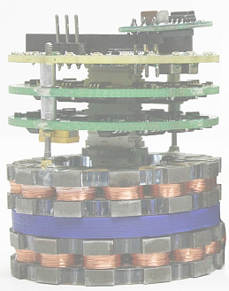

The planar catom is approximately 45 times larger in diameter than the millimeter scale catom for which its work is a bigger-than-life prototype.  It operates on a two-dimensional plane in small groups of two to seven modules in order to allow researchers to understand how micro-electro-mechanical devices can move and communicate at a scale that humans cannot yet readily perceive -- or imagine

[**Electrostatic latches**](http://www.cs.cmu.edu/%7Eclaytronics/hardware/electrostatic-latch.html) model a new system of binding and releasing the connection between modular robots, a connection that creates motion and transfers power and data while employing a small factor of a powerful force.

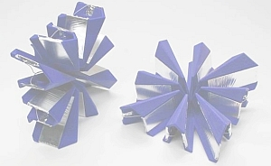

It incorporates many innovative features into a simple, robust device for attaching adjacent modules to each other in a lattice-style robotic system.  These features include a parallel plate capacitor constructed from flexible electrodes of aluminum foil and dielectric film to create an adhesion force from electrostatic pressure. Its physical alignment of electrodes also enables the latch to engage a mechanical shear force that strengthens its holding force.

The parallel alignment of the electrodes in forming the complete capacitor plate introduces a shear force - or friction - that strengthens the binding of the latch.

[**Stochastic Catoms**](http://www.cs.cmu.edu/%7Eclaytronics/hardware/stochastic.html) integrate random motion with global objectives communicated in simple computer language to form predetermined patterns, using a natural force to actuate a simple device, one that cooperates with other small helium catoms to fulfill a set of unique instructions.

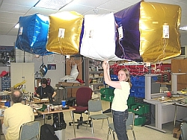

[**Giant Helium Catoms**](http://www.cs.cmu.edu/%7Eclaytronics/hardware/helium.html) provide a larger-than-life, lighter-than-air platform to explore the relation of forces when electrostatics has a greater effect than gravity on a robotic device, an effect simulated with a modular robot designed for self-construction of macro-scale structures.

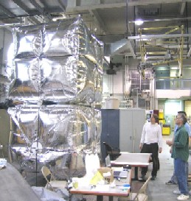

On each face, the GHC cube carries a novel electrostatic latching system that enables the device to move across the faces of other catoms and to communicate with them. The design for this latch system centers on a thin aluminum foil flap across each of the 12 edges of the Mylar cube.  This is essentially a square that crosses each of the catom's edges on a diagonal in order to create two triangular flaps lying at a right angle to each other against the two adjacent surfaces of the catom..

Among the six faces, the triangular flaps provide each catom with the means to form an electrostatic latch with another cube from 24 positions - providing the cubes with a capacity to move at right angles in any direction.  In addition to motion, the latches also equip the GHC with the means to communicate across the ensemble of catoms.  In the drawing below, one Giant Helium Catom pivots across the surface of another, revealing the positions and attachments of triangular electrostatic flaps.

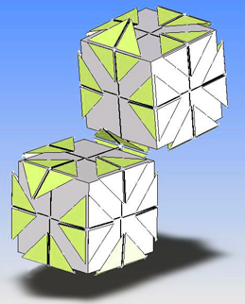

Two electrodes on each flap create the electrostatic forces that enable latches to form a capacitive couple between flaps on adjacent GHCs.  A dielectric material (Mylar) isolates the pair of electrodes (and electrical charges from them) on each flap to prevent their direct electrical contact.  This design enables voltage differences applied to the electrodes to accumulate charges, create electrostatic force on the flap and align with electrodes that carry an opposing charge on the flap of an adjacent GHC.

[**CUBES:**](http://www.cs.cmu.edu/%7Eclaytronics/hardware/cubes.html) employ electrostatic latches to demonstrate the functionality of a device that could be used in a system of lattice-style self-assembly at both the macro and nano-scale.The Cube (pictured below, right) also models the primary building block in a hypothetical system for robotic self-assembly that could be used for modular construction and employ Cubes that are larger or smaller in scale than the pictured device.

* 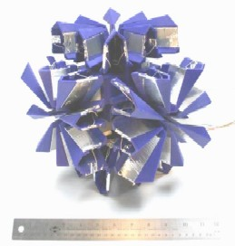

The design of a cube, which resembles a box with starbursts flowering from six sides, emphasizes several performance criteria: accurate and fast engagement, facile release and firm, strong adhesion while Cube latches clasps one module to another.  Its geometry enables reliable coupling of modules, a strong binding electrostatic force and close spacing of modules within an ensemble to create structural stability.

**Millimeter Scale Catoms**

Realizing high-resolution applications that Claytronics offers requires catoms that are in the order of millimeters. In this work, we propose millimeter-scale catoms that are electrostatically actuated and self contained. As a simplified approach we are trying to build cylindrical catoms instead of spheres.

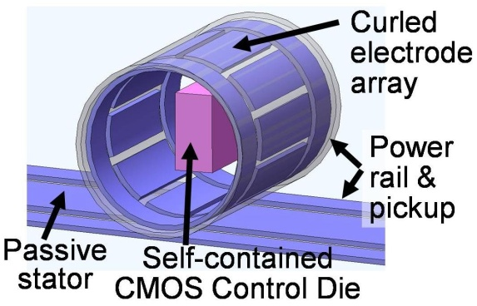

The millimeter scale catom consists of a tube and a High voltage CMOS die attached inside the tube. The tubes are fabricated as double-layer planar structures in 2D using standard photolithography. The difference in thermal stress created in the layers during the fabrication processes causes the 2D structures to bend into a 3D tubes upon release from the substrate. The tubes have electrodes for power transfer and actuation on the perimeter.

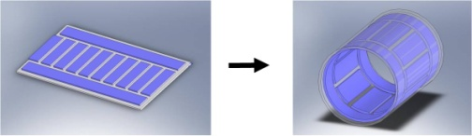

The high voltage CMOS die is fabricated separately and is manually wire bonded to the tube before release. The chip includes an AC-DC converter, a storage capacitor, a simple logic unit, and output buffers. The catom moves on a power grid (the stator) that contains rails which carry high voltage AC signals. Through capacitive coupling, an AC signal is generated on the coupling electrodes of the tube, which is then converted to DC power by the chip

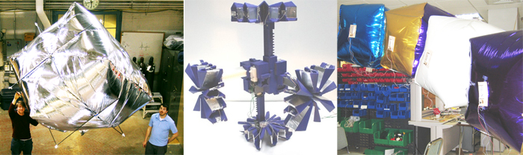

Figure shows : different catoms altogether.

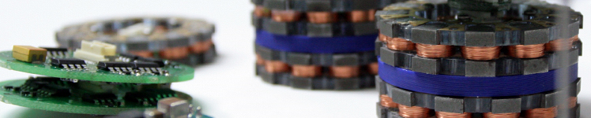

Figure shows: basic claytronic hardware

**CLAYTRONIC SOFTWARE**

|  |  |  |
| --- | --- | --- |
| http://www.cmu.edu/common/images/whiteBG.gif | | |
| Software Intro One B |  | http://www.cmu.edu/common/images/spacer.gif |

|  |
| --- |
|  |
| The essence of claytronics—a massively distributed system composed of numerous resource-limited catoms—raises significant software issues: specifying functionality, managing concurrency, handling failure robustly, dealing with uncertain information, and controlling resource usage. The software used to control claytronics must also scale to millions of catoms. Thus, current software engineering practices, even as applied to distributed systems, may not be suitable. The software issues are broken into three main categories: specification, compilation, and runtime support.  The goal is to specify the global behavior of the system in a direct and descriptive manner. The simplest model that is investigating with respect to specification is what is known as the Wood Sculpting model. In this model, a static goalshape is specified. In the first, we are compiling the specification into a planning problem. In this approach we are inspired by work done in communicating soccer robots and in the context of reconfigurable robots, by the constraint-based control framework in which a high-level description such as a particular gait which is translated to a distributed, constraint-based controller. Our second approach is based on emergent behavior.  At the highest level of abstraction a shape is specified in terms of Origami folding directives. Through a process of planning, these folding directives are translated into low-level programs for autonomous agents; achieving the shape by local communication and deformation only. Underlying the user-level software is a distributed runtime system. This system needs to shield the user from the details of using and managing the massive number of catoms. Our initial steps in this direction use emergent behaviour to determine a catoms location and orientation with respect to all catoms as well as to build a hierarchical network for communication between catoms. Efficient localization is achieved by having the catoms determine their relative location and orientation in a distributed fashion. Then as regions of localized catoms join up they unify their coordinate systems.  Our algorithm takes O(1) time if the network is capable of broadcast. With a network limited to point-to-point connections the algorithm takes *O*( 3*√n*) time in 3D . Once catoms are localized we form a hierarchical communication network,again using simple local programs on each catom. A tree is formed in parallel by having nodes join with their neighbours until all the nodes are in a single tree. This simple algorithm produces a surprisingly efficient tree from which can then befurther optimized.  [**Programming Languages**](http://www.cs.cmu.edu/%7Eclaytronics/software/programming.html)  Researchers in the Claytronics project have also created Meld and LDP.  These new languages for declarative programming provide compact linguistic structures for cooperative management of the motion of millions of modules in a matrix. Programming Claytronics with Locally Distributed Predicates (LDP) Locally Distributed Predicates (LDP) approaches the distributed programming problem using pattern-matching techniques. LDP provides programmers the ability to specify distributed state configurations, based on combinations of the state found on connected subgroups of catoms. The LDP runtime automatically detects occurrences of these distributed configurations, and triggers user-specified actions in response to the detection event. LDP also allows for the expression of distributed event sequences, as well as the expression of particular shapes. These facilities, combined with an array of mathematical and logical operators, allow programmers to express a wide variety of distributed conditions. As with Meld, LDP produces dramatically shorter code than traditional high-level languages (C++, Java, etc.). LDP has been used to implement several motion planning algorithms, as well as a variety of low-level utilities such as gradient fields and distributed aggregation.  Meld Programming Claytronics with Meld Meld is a programming language designed for robustly programming massive ensembles. Meld was designed to give the programmer an ensemble-centric viewpoint, where they write a program for an ensemble rather than the modules that make it up. A program is then compiled into individual programs for the nodes that make up the ensemble. In this way the programmer need not worry about the details of programming a distributed system and can focus on the logic of their program.  Because Meld is a declarative programming language (specifically, a logic programming language), the programs written in Meld are concise. Both the localization algorithm and the metamodule planning algorithms are implemented in Meld in only a few pages of code. Because the implementations are so concise, we've found it practical to prove them correct. We have proved correctness of the metamodule planning algorithm as written in Meld. We found this proof to be easier to carry out than a proof on psuedo code. Furthermore, these implementations are inherently fault-tolerant. They can recover from modules that experience FAIL-STOP errors as the Meld runtime automatically recovers from these errors without any need for the programmer to think about them.  **ALGORITHMS**  [**SHAPE**](http://www.cs.cmu.edu/%7Eclaytronics/software/sculpting.html) **SCULPTING ALGORITHM**  The team's extensive work on catom motion, collective actuation and hierarchical motion planning addresses the need for algorithms that convert groups of catoms into primary structures for building dynamic, 3-dimensional representations.   Such structures work in a way that can be compared to the muscles, bones and tissues of organic systems.  In claytronics, this special class of algorithms will enable the matrix to work with templates suitable to the representations it renders.  In this aspect of claytronics development, researchers develop algorithms that will give structural strength and fluid movement to dynamic forms.  **Planar Catom Magnets** The Ensemble Rises To gather height and volume from the array of a million catoms lying alongside each other within a level plane, the ensemble must not only overcome the resistance of local inertia but also mass sufficient internal force to oppose gravity -- perhaps the most difficult challenge facing claytronic algorithm designers.  Thus far, in this demonstration of the capacity of self-actuating modular robots, the claytronic architect works with forces that can be manipulated with the mass of two catoms sharing equal amounts of work.   The catoms generate motion, for example, by employing their round shapes to form a simple lever between them, one that exchanges a small electrostatic force across matching sensors to create a rotational (or kinetic) force, which is sufficient to shift the mass of one catom around the pivot point of its spherical shape. To rise above the level plane, however, the ensemble must multiply its catom forces (the mass of a single catom plus the electrostatic energy that each device can carry) to overcome gravitational force, which increases resistance by the mass of catoms needed to form a specific shape in the 3rd dimension.  Thus, to accomplish the lifting of more than one catom, the ensemble needs the algorithmic equivalent of ropes and pulleys in order to lift multiple catoms and build a taller structure.  Each Catom must be able to change colors for visual correctness of ensemble and co-operate to represent proper volume and motion of 3-D objects. It should have sufficient mobility and strength to overcome gravity and inertial forces.  [**LOCALIZATION**](http://www.cs.cmu.edu/%7Eclaytronics/software/localization.html) **ALGORITHM**  The team’s software researchers are also creating algorithms that enable catoms to localize their positions among thousands to millions of other catoms in an ensemble.  This relational knowledge of individual catoms to the whole matrix is fundamental to the organization and management of catom groups and the formation of cohesive and fluid shapes throughout the matrix. The algorithm is critical for function and visual correctness of ensemble.It is critical in cooperation with other Catoms .It is complicated by constant motion.It should be Global with respect to the ensemble and the Localization is done with respect to it’s neighbors .  ***Determining module locations from noisy observations***  localized ensemble  One of the first tasks for a modular robot is to understand where its modules are located relative of one to another. This knowledge is very useful: For example, motion planning and control will often shift many modules from one location to another, and knowing the module locations helps robot properly allocate the resources. The knowledge of module locations will also be useful to identify a human user.  In order to determine their locations, the modules need to rely on noisy observations of their immediate neighbors. These observations are obtained from sensors onboard the modules, such as short-range IR sensors. Unlike many other systems, a modular robot may not have access to long distance measurements, such as wireless radio or GPS. Furthermore, the robot's modules will often form irregular, non-lattice structures. Therefore, the robot needs to employ sophisticated probabilistic techniques to estimate the location of each its module from noisy data.  The algorithm has a number of attractive properties: It can handle errors that arise from uncertain observations. As we scale the ensemble to increasingly finer resolutions, the accuracy of the localization remains roughly constant. Furthermore, the algorithm is sufficiently simple that it permits a distributed implementation. Therefore, the locations are estimated directly by the modules themselves, without relying on an external, centralized processing unit.  On the technical side, our algorithm leverages two insights. One key idea is to hierarchically decompose the ensemble into smaller parts. The parts are localized first, and the partial solutions are then merged to obtain an estimate for the entire ensemble. Importantly, the ensemble is split in such a way that the partial solutions do not accumulate too much error. Thus, when the partial solutions are merged, the algorithm only needs to exercise a minimal effort to compute an accurate overall solution. The second key idea employed in our work is to limit the amount of communication sent between the modules. Much like in a flock of birds, each module needs to communicate information about itself to others in the ensemble, but should avoid communicating with everybody. In our case, many operations in the algorithm are implemented by communicating aggregate statistics about progressively larger parts of the ensemble. In this manner, the communication complexity of our algorithm scales logarithmically.  [**Dynamic Simulation**](http://www.cs.cmu.edu/%7Eclaytronics/software/simulation.html)  As a first step in developing software to program a claytronic ensemble, the team created DPR-Simulator, a tool that permits researchers to model, test and visualize the behavior of catoms.  The simulator creates a world in which catoms take on the characteristics that researchers wish to observe.  The simulated world of DPRSim manifests characteristics that are crucial to understanding the real-time performance of claytronic ensembles.  Most important, the activities of catoms in the simulator are governed by laws of the physical universe.  Thus simulated catoms reflect the natural effects of gravity, electrical and magnetic forces and other phenomena that will determine the behavior of these devices in reality.  DPRSim also provides a visual display that allows researchers to observe the behavior of groups of catoms. DPRSim allows researchers to model conditions under which they wish to test actions of catoms.  Demonstrating the validity of claytronics requires extensive observation of cooperative behaviors among nanoscale modular robots.  The research task is made uniquely challenging by the absence of physical prototypes that can serve as demonstration platforms for these tiny devices, which are no larger than a grain of sand.  Between concept and engineering conception, there is the need for extensive trial and error with real devices, and, necessarily, that testing of concept requires very clear representations of a vast number of effects in a tiny world that cannot be directly observe  . |

http://www.cmu.edu/common/images/spacer.gif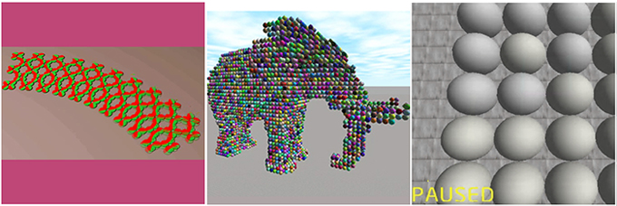

|  |  |  |
| --- | --- | --- |
| http://www.cmu.edu/common/images/spacer.gif | http://www.cmu.edu/common/images/lvl_2colContent_bot.gif | http://www.cmu.edu/common/images/spacer.gif |

**APPLICATION OF CLAYTRONICS**

**3D FAX MACHINE**

A 3D fax machine which exploits inter-module communication and computation without requiring self-reconﬁguration. As a result, this application may be feasible sooner than applications which depend upon modules being able to move themselves. In this new approach to 3D faxing, a large number of sub millimetre robot modules form intelligent “clay” which can be reshaped via the external application of mechanical forces.

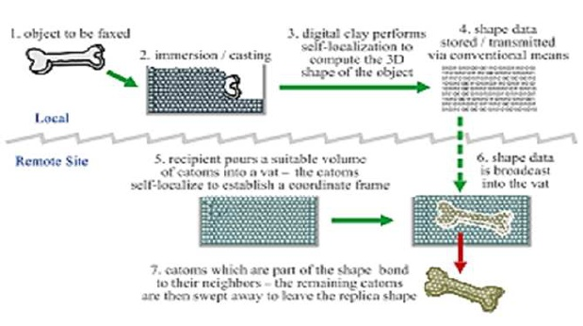

This clay can act as a novel input device, using intermodal localization techniques to acquire the shape of a 3D object by casting. Key properties, required by such a material would be:

Physical Characteristics:

Suppose this material is composed of tiny, sub millimetre particles that stick together, e.g., spheres covered with a self‐ cleaning Nano ﬁber adhesive. The combination of discrete parts and adhesion would permit the required malleability for this application. In an alternative implementation, the spheres could be covered with thin insulated plates, permitting thespheres to adhere to each other under software control through the establishment of an appropriate electric ﬁeld on each plate.

Electronic properties:

Suppose further that each of these particles is actually a micro‐fabricated silicon sphere, its surface covered with electronic circuitry. A 300 micron (radius) sphere has a surface area of 1.13mm .Current embedded microprocessors can be fabricated in only 0.26mm using mature process technology. With specialized design and modest process improvements it is feasible that an entire system can be embedded on such a sphere, including microprocessor, memory, communications, power distribution, and sensor circuits.

Although other technologies have been pro‐ posed to implement 3D faxing, the modular micro robot approach has certain distinct advantages, notably size and speed. In contrast to 3D fax machine approaches using serial (raster) input and output devices such as a laser scanner and 3D printer, programmable matter would acquire the 3D input shape and generate the 3D output shape in parallel. Thus, rather than taking hours to days the process could take seconds to minutes. Laser scanners and 3D printers also remain many times bulkier than the object being scanned/ reproduced despite years of commercial development

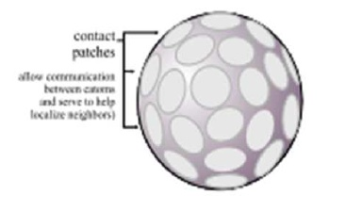

**OVERVIEW OF WORKING OF 3D FAX MACHINE**

The process of remotely reproducing a facsimile of an object requires three phases: acquisition, transmission, and reproduction. In the ﬁrst phase, the system senses the object and creates a digital representation of the visible, external structure. The shape information is then transmitted to the remote site. Finally, using the transmitted data, a facsimile of the object is reconstructed at the remote site.

In the nomenclature of Claytronics system, a connected volume of programmable matter is termed an ensemble, a word we use inter‐ changeably here with mass. Individual units are termed atoms, and in this paper we also use module and particle to mean the same thing as catom.

**SHAPE ACQUISITION**

A variety of structured light approaches, most based on scanning lasers, are capable of producing medium to high resolution digital representations of the 3D external structure of an object.

Multicamera stereo systems can also capture dense shape information, though with a variety of limitations imposed by non‐Lambert and surfaces and the unsolved nature of the correspondence problem.

**KEY DIFFERENCES:**

* Contact vs. non-contact sensing

Programmable matter can read the shape of an object by direct contact with its surface. Structured light (laser) and stereo approaches work at some distance and hence impose con‐ straints on object curvature and self‐ shadowing.

* Simpliﬁed geometries

Because of the relatively limited geometric possibilities for sphere packing and the absence of large unclosed loops or featureless spaces, the localization problem for a programmable matter ensemble can be signiﬁcantly easier.

* Parallel vs. serial read-in

Programmable matter localization is a highly parallelizable operation. Resolution is a function of the catom size rather than scan rate or the spatial frequency of scanning. A claytronic ensemble performs self‐ localization by a multiphase peer‐to‐peer communication process between the individual catoms in the ensemble. Each catom’s surface is covered with contact patches permiting communication between neighbors. The particular surface site used to communicate with a given neighbour identiﬁes the relative geometry of that neighbour to within a known tolerance for successful communication. The high degree of interconnectedness oﬀered in a packed or near-close-packed lattice allows quick convergence for robust location estimation techniques.

Unlike digital sampling in PCM systems where the Nyquist frequency oﬀers a sharp bound on sampling precision, catoms can pack spaces down to the width of a single catom.

**REMOTE TRANSMISSION**

After the 3D structure has been determined by digital shape acquisition, many well-known techniques can be used to store, manipulate, and transmit it. A radio or optical bridge would likely be used to extract the shape information from the ensemble and transfer it to a computing device.

**SHAPE RECONSTRUCTION**

In the ﬁnal stage of a 3D fax system, the transmitted data is used to reconstruct the structure of the object at the remote site. One method of convering the digital description to a physical replica is to use a 3D printer based on rapid prototyping techniques such as fused deposition modelling or stereo lithography. Such a device can create a physical object from a digital representation by building up the structure lay er by layer or line by line.

With programmable matter, shape reconstruction can be implemented in at least two diﬀerent ways:

First, with a fully-functional claytronic ensemble, i.e., one capable of self-reconﬁguration, we could imagine the ensemble reshaping itself on command to conform to the desired shape. Because many catoms can move simultaneously this process would be substantially faster than a raster or planar deposition process. Second, with catoms incapable of self- reconﬁguration but equipped with simple inter- catom latches which can selectively bond one module to another, a shape can be formed by what we term digital sand casting. First, an ap- propriate volume of catoms is used to ﬁll a closed structure such as a bucket. Power is supplied to the ensemble and the desired shape is transmitted to it.

The catoms in the ensemble carry out self-localization to identify the coordinate structure within which they sit. Then, each catom evaluates whether it is or is not part of the target shape. Those catoms which are part of the target shape bond them- selves together, while the other catoms simply

switch themselves oﬀ. The user then pours or sweeps oﬀ the unbounded catoms to reveal the reconstructed shape.

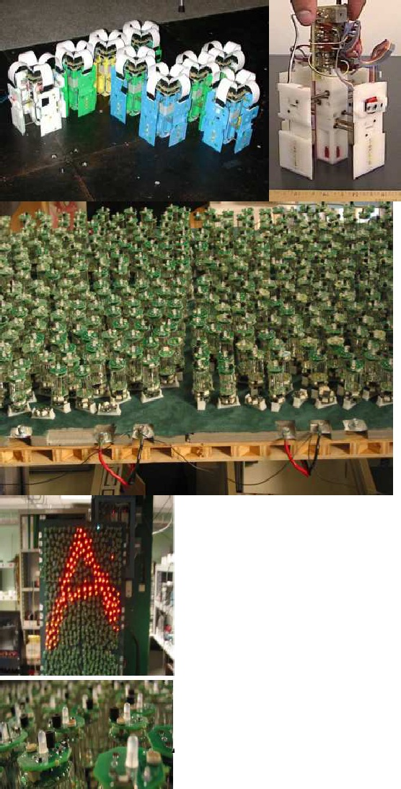

**Figure shows**: Vona and Rus’s Crystalline robot (top left) has unit-compressible modules (top right) that can change size by a factor of two and latch for reconﬁguration and amoeba-like mobility

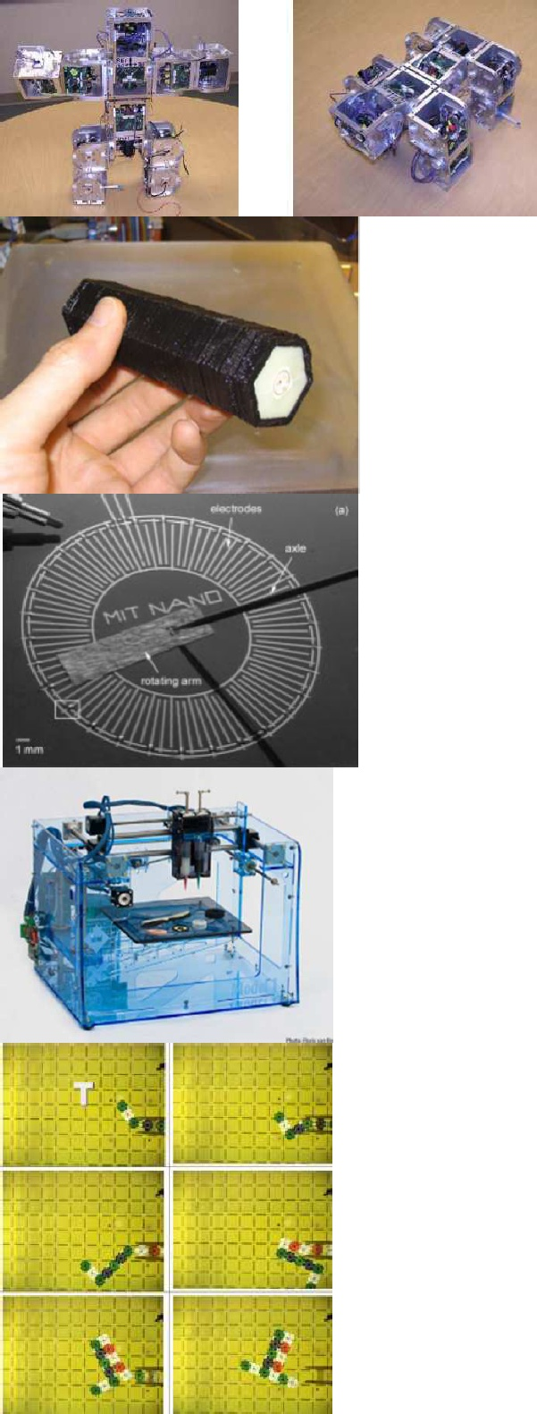

**Figure shows**: a) Shen’s Superbot configured as a biped walker and quadraped walker

b) Printed Flashlight

c) Ink-Jet printed electrostatic induction motor

d) FAB@HOME MODEL 1

**SUMMARY**

Programmable matter is a technology that allows us to control and manipulate 3- dimensional physical artifacts, in a similar way how we already control and manipulate two-dimensional images with computer graphics. In other words, programmable matter will allow us to take a big step beyond virtual reality, to synthetic reality, an environment in which all the objects in a user’s environment (including the ones inserted by the computer) are physically realized.

Claytronics is an instance of programmable matter, a system which can be used to realize

3D dynamic objects in the physical world. This technology not only realizes **pario** and **synthetic reality**, it also serves as the basis for a large scale modular robotic system.

The Claytronics system is essentially an embedded system, consisting of hardware and

Software parts, brought together for achieving a special purpose.

The hardware machine is known as Catoms. Each catom is a self-contained unit with a CPU, an energy store, a network device, a video output device, one or more sensors, a means of locomotion, and a mechanism for adhering to other catoms.

The software part, on the other hand, is taken care by Meld is a declarative language, which based on P2, a logic-programming language originally designed for programming overlay networks. It greatly simpliﬁes the thought process needed for programming large ensembles. Initial experience shows that this also leads to a considerable reduction in code size and complexity.

One of the novel applications of the Claytronics project is 3D printing and Fax machine- which exploits inter-module communication and computation without requiring self- reconﬁguration. As a result, this application may be feasible sooner than applications which depend upon modules being able to move themselves.

**CONCLUSION**

Claytronics is one instance of programmable matter, a system which can be used to realize 3D dynamic objects in the physical world. While our original motivation was to create the technology necessary to realize **pario** and **synthetic reality**, it should also serve as the basis for a large scale modular robotic system. At this point we have constructed a planer version of claytronics that obeys our design principles. We are using the planer prototype in combination with our simulator to begin the design of 3D claytronics which will allow us to experiment with hardware and software solutions hat realize full-scale programmable matter, e.g., a system of millions of catoms which appear to act as a single entity, in spite of being composed of millions of individually acting units.

The report told you about the advances made in the ﬁeld of programmable matter and the claytronics system. The scientists at Carneige Mellon University, in association with Intel is doing research on this ﬁeld of technology and striving to make Catoms of Micro and Nano scale, which follows the principles laid by the phenomena of programmable matter. The Massachusetts Institute Of Technology have also made contribution in the ﬁeld of designing of programmable matter.

With the advancement in technology, development of simpler and intuitive programming language along with consolidation and miniaturization of memory and other functional parts of Catoms, we can see a day in the future, when the images we see in the television will take physical forms and occupy the space, we live in. Not only can that, these completely realistic representations will interact with us in ways the real counterpart does.

**REFERENCES**

[1.] www.techalone.com

[2.] www.seminartopic.com

[3.] <http://www.scribd.com/doc/2211960/claytronics>

[4.] Claytronic, www.wikipedia.org <http://en.wikipedia.org/wiki/>

[5.] “A Modular Robotic System Using Magnetic Force Eﬀectors” in Proceedings of the 2007 IEEE/RSJ International Conference on Intelligent Robots and Systems San Diego, CA, USA,

Oct 29 ‐ Nov 2, 2007.

[6.] Extended abstract of “Claytronics: A Scalable Basis for Future Robots” by Seth Copen Goldstein and Todd Mowry