[C:\Documents and Settings\TRUPAL\Desktop\New Folder\Claytronics _ Rajat Sharma - Academia.edu_files\academia-logo.gif](http://www.academia.edu/)

* [Home](http://www.academia.edu/)
* [Log In](http://www.academia.edu/login)
* [Sign Up](http://www.academia.edu/signup)

Top of Form



Bottom of Form

[Claytronics](http://www.academia.edu/1979441/Claytronics)[more](file:///C:\Documents%20and%20Settings\TRUPAL\Desktop\New%20Folder\Claytronics%20_%20Rajat%20Sharma%20-%20Academia.edu.htm)

by [Rajat Sharma](http://jammuuniversity.academia.edu/RajatSharma)

[[C:\Documents and Settings\TRUPAL\Desktop\New Folder\Claytronics _ Rajat Sharma - Academia.edu_files\download.gif](http://www.academia.edu/attachments/28638427/download_file)Download (.pdf)](http://www.academia.edu/attachments/28638427/download_file)

**72**

Claytronics-modular robotics to a new extreme

Programmable Matter

Rajat Sharma

Department of Electronics and Communication EngineeringModel Institute of Engineering and TechnologyJammu, India.rajatkathua@gmail.com

 Abstract

 —

The present paper deals with the concept of newemerging technology called Claytronics. This paper explores thepublished articles that report on results from research conductedby the Intel and Carnegie Mellon University.

Claytronics is aform a programmable matter that takes the concept of modularrobots to a new extreme. The research is the brainchild of SethGoldstein, an Associate Professor in the Computer ScienceDepartment at Carnegie Mellon University and Todd Mowry,Director of Intel Research Pittsburgh.

They determined that, bytaking advantage of advances in Nano-scale assembly, they mightcreate human replicas from ensembles of tiny computing devicesthat could sense, move, and change colour and shape, enablingmore realistic videoconferencing.

The vision behind this researchis to provide users with tangible forms of electronic informationthat express the appearance and actions of original sources.

 Keywords- Research design: Dynamic Physical rendering;ensemble.

I.

I

NTRODUCTION

 Imagine a lump of clay in hands. Children will love tosqueeze it in between fingers, potters will fire it into bowls andartists will shape it into sculptures. This simple clay consists of hundreds and thousands of microscopic particles. Can amaterial be so intelligent that it changes its shape as we require.

The idea is simple: make basic computers housed in tinyspheres that can connect to each other and rearrangethemselves. Each particle, called a Claytronic atom or Catom,is less than a millimetre in diameter. With billions any objectcan be created.

Catoms, or Claytronics Atoms, are also referred to as'programmable matter'.

These are basically miniature pieces of matter so intricate that they can shape-shift into actual shapesof whatever desired based on a quick, programmable system.Catoms are described as being similar in nature to a Nano-machine, but with greater power and complexity. Whilemicroscopic individually, they bond and work together on alarger scale. Catoms can change their density, energy levels,state of being, and other characteristics. This vision of nanotechnology is light years away from today's world of carbon nanotubes.The

research called "Claytronics" at Carnegie-MellonUniversity, and "Dynamic Physical Rendering" at Intel isalready underway. According to the Claytronics project's SethGoldstein and Todd Mowry, programmable matter is:An ensemble of material that contains sufficient

•

Local computation

•

Actuation

•

Storage

•

Energy

•

Sensing & communicationwhich can be programmed to form interesting dynamicshapes and configurations.This novel idea has evolved into an ambitious collaborationinvolving almost 30 researchers. Jason Campbell, a seniorresearcher at Intel Research Pittsburgh, is the PrincipalInvestigator for the DPR project. Goldstein is leading theproject for Carnegie Mellon, and Mowry provides additionalleadership. The project is being funded by Intel, CarnegieMellon University, the National Science Foundation, and theDefence Advanced Research Projects Agency (DARPA).Creation of claytronics technology is the bold objective of collaborative research between Carnegie Mellon and Intel,which combines nano-robotics and large-scale computing tocreate synthetic reality, a revolutionary, 3-dimensional displayof information.Claytronic emulation of the function, behaviour andappearance of individuals, organisms and objects will fullymimic reality - and fulfil a well-known criterion for artificialintelligence formulated by the visionary mathematician andcomputer science pioneer Alan Turing.In 1950, in a ground-breaking article, Turing asked "CanMachines Think?" and offered a criterion to "refute anyonewho doubts that a computer can really think." His proposalwas that "if an observer cannot distinguish the responses of aprogrammed machine from those of a human being, themachine is said to have passed the Turing Test."Although the Turing Test remains a robust source of discussion among those who devote their lives to artificialintelligence, philosophy and cognitive science, claytronicsconceives of a technology that will surpass the Turing Test forthe appearance of thought in the behaviours of a machine.

The Carnegie Mellon Intel Claytronics Research Projectcombines two principal paths to create technology that willrepresent information in dynamic, life-like 3-D form--



Engineering design and testing of modular roboticcatom prototypes that will be suitable formanufacturing in mass quantities



Creation of programming languages and softwarealgorithms to control ensembles of millions of catomsII.

H

ARDWARE

 At the current stage of design, claytronics hardwareoperates from macro-scale designs with devices that are muchlarger than the tiny modular robots that set the goals of thisengineering research. Such devices are designed to testconcepts for sub-millimeter scale modules and to elucidatecrucial effects of the physical and electrical forces that affectnano-scale robots.

 A.

 Electrostatic latches

Electrostatic Latches model a new system of binding andreleasing the connection between modular robots, a connectionthat creates motion and transfers power and data whileemploying a small factor of a powerful force. A simple androbust inter-module latch is possibly the most importantcomponent of a modular robotic system. The electrostatic latchin Figure 1 was developed as part of the Carnegie Mellon-IntelClaytronics Research Project. It incorporates many innovativefeatures into a simple, robust device for attaching adjacentmodules to each other in a lattice-style robotic system. Thesefeatures include a parallel plate capacitor constructed fromflexible electrodes of aluminium foil and dielectric film tocreate an adhesion force from electrostatic pressure. Itsphysical alignment of electrodes also enables the latch toengage a mechanical shear force that strengthens its holdingforce.The electrodes that form the latch fit into "genderless" facesconstructed as star-shaped plastic frames carried by eachmodule. In the design of the circuits, each electrode functionsas one-half of a complete capacitor. A latch forms when thefaces of two adjacent modules come together and create anelectrostatic field between the flexible electrodes.

Figure 1.

Electrostatic Latches (Source-www.cs.cmu.edu/~claytronics)

 B.

Cubes

A lattice-style modular robot, the 22-cubic-centimeterCube, which has been developed in the Carnegie Mellon-IntelClaytronics Research Program, provides a base of actuation forthe electrostatic latch that has also been engineered as part of this program. The Cube shown in Figure 2 also models theprimary building block in a hypothetical system for roboticself-assembly that could be used for modular construction.Cubes employ electrostatic latches to demonstrate thefunctionality of a device that could be used in a system of lattice-style self-assembly at both the macro and nano-scale.The design of a cube, which resembles a box withstarbursts flowering from six sides, emphasizes severalperformance criteria: accurate and fast engagement, facilerelease and firm, strong adhesion while Cube latches clasps onemodule to another. Its geometry enables reliable coupling of modules, a strong binding electrostatic force and close spacingof modules within an ensemble to create structural stability.With extension and retraction of stem-drive arms that carrythe latches, the module achieves motion, exchanges power andcommunicates with other Cubes in a matrix that contains manyof these devices. Combining these forces of motion,attachment and data coupling, Cubes demonstrate a potential tocreate intricate forms from meta-modules or ensembles thatconsist of much greater numbers of Cubes; numbersdetermined by the scale of Cubes employed in an ensemble of self-construction.

C.

Planar Catoms

The self-actuating, cylinder-shaped planar catom testsconcepts of motion without moving parts, power distribution,data transfer and communication that will be eventuallyincorporated into ensembles of nano-scale robots. It provides atest bed for the architecture of micro-electro-mechanicalsystems for self-actuation in modular robotic devices.Employing magnetic force to generate motion, its operationsas a research instrument build a bridge to a scale of engineering that will make it possible to manufacture self-actuating nano-system devices.

Figure 2.

Cubes (Source-www.cs.cmu.edu/~claytronics)

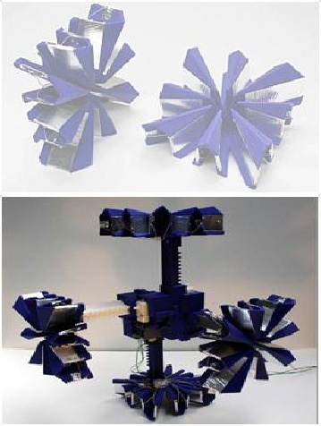

Figure 3.

Planar Catoms (Source-www.cs.cmu.edu/~claytronics)

The planar catom is approximately 45 times larger indiameter than the millimeter scale catom for which its work isa bigger-than-life prototype. It operates on a two-dimensionalplane in small groups of two to seven modules in order toallow researchers to understand how micro-electro-mechanicaldevices can move and communicate at a scale that humanscannot yet readily perceive or imagine.Among the six faces, the triangular flaps provide eachcatom with the means to form an electrostatic latch withanother cube from 24 positions - providing the cubes with acapacity to move at right angles in any direction. In additionto motion, the latches also equip the GHC with the means tocommunicate across the ensemble of catoms. In Figure 4, oneGiant Helium Catom pivots across the surface of another,revealing the positions and attachments of triangularelectrostatic flaps.III.

S

OFTWARE

 A.

 Distributed Computing in Claytronics

In a domain of research defined by many of the greatestchallenges facing computer scientists and robot-cists today,perhaps none is greater than the creation of algorithms andprogramming language to organize the actions of millions of sub-millimeter scale catoms in a claytronics ensemble.As a consequence, the research scientists and engineers of the Carnegie Mellon-Intel Claytronics Research Program haveformulated a very broad-based and in-depth research programto develop a complete structure of software resources for thecreation and operation of the densely distributed network of robotic nodes in a claytronic matrix.A notable characteristic of a claytronic matrix is its hugeconcentration of computational power within a small space.For example, an ensemble of catoms with a physical volume of one cubic meter could contain 1 billion catoms. Computing inparallel, these tiny robots would provide unprecedentedcomputing capacity within a space not much larger than astandard packing container. This arrangement of computing

Figure 4.

Matrix of 20,000 catoms (Source-www.cs.cmu.edu/~claytronics)

 capacity creates a challenging new programming environmentfor authors of software.A representation of a matrix of approximately 20,000catoms can be seen in the figure 5 shown. Because of its vastnumber of individual computing nodes, the matrix invitescomparison with the worldwide reservoir of computingresources connected through the Internet, a medium that notonly distributes data around the globe but also enables nodeson the network to share work from remote locations. Thephysical concentration of millions of computing nodes in thesmall space of a claytronic ensemble thus suggests for it themetaphor of an Internet that sits on a desk.

 B.

 An Internet in a box

Comparison with the Internet, however, does not representmuch of the novel complexity of a claytronic ensemble. Forexample, a matrix of catoms will not have wires and uniqueaddresses which in cyberspace provide fixed paths on whichdata travels between computers. Without wires to tether them,the atomized nodes of a claytronic matrix will operate in astate of constant flux. The consequences of computing in anetwork without wires and addresses for individual nodes aresignificant and largely unfamiliar to the current operations of network technology.Languages to program a matrix require a more abbreviatedsyntax and style of command than the lengthy instructions thatwidely used network languages such as C++ and Java employwhen translating data for computers linked to the Internet.Such widely used programming languages work in a network environment where paths between computing nodes can beclearly flagged for the transmission of instructions while thecomputers remain under the control of individual operatorsand function with a high degree of independence behind theirlinks to the network.In contrast to that tightly linked programming environmentof multi-functional machines, where C++, Java and similarlanguages evolved, a claytronic matrix presents a softwaredeveloper with a highly organized, single-purpose, denselyconcentrated and physically dynamic network of unwirednodes that create connections by rotating contacts with theclosest neighbors. Matrix software must also actuate the

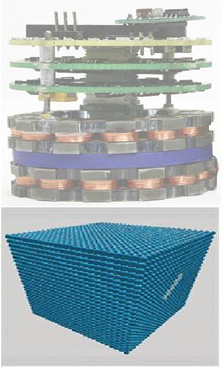

Figure 5.

Simulation of Meld (Source-www.cs.cmu.edu/~claytronics)

constant change in the physical locations of the anonymousnodes while they are transferring the data through the network.

C.

Programming Languages

Researchers in the Claytronics project have also createdMeld and LDP. These new languages for declarativeprogramming provide compact linguistic structures forcooperative management of the motion of millions of modulesin a matrix. Figure 7 shows a simulation of Meld in whichmodules in the matrix have been instructed with a very fewlines of highly condensed code to swarm toward a target.Meld is a programming language designed for robustlyprogramming massive ensembles. Meld was designed to givethe programmer an ensemble-centric viewpoint, where theywrite a program for an ensemble rather than the modules thatmake it up. A program is then compiled into individualprograms for the nodes that make up the ensemble. In this waythe programmer need not worry about the details of programming a distributed system and can focus on the logic of their program.Because Meld is a declarative programming language(specifically, a logic programming language), the programswritten in Meld are concise. Both the localization algorithmand the metamodule planning algorithms are implemented inMeld in only a few pages of code.While Meld approaches the management of the matrix fromthe perspective of logic programming, LDP employsdistributive pattern matching. As a further development of program languages for the matrix, LDP, which stands forLocally Distributed Predicates, provides a means of matchingdistributed patterns. This tool enables the programmer toaddress a larger set of variables with Boolean logic thatmatches paired conditions and enables the program to searchfor larger patterns of activity and behaviour among groups of modules in the matrix.

 D.

 Dynamic Simulation

As a first step in developing software to program aclaytronic ensemble, the team created DPR-Simulator, a tool

Figure 6.

Snapshot in DPRSim (Source-www.cs.cmu.edu/~claytronics)

test and visualize the behaviour of catoms. The simulatorcreates a world in which catoms take on the characteristicsthat researchers wish to observe.DPRSim operates as a Linux-based system on desktopcomputers. It is available as open source software. DPRSimhas become the primary tool of the Carnegie Mellon-IntelClaytronics Research Project for observing real-timeperformance when designing, testing and debugging modularrobots in claytronic ensembles.The simulated world of DPRSim manifests characteristicsthat are crucial to understanding the real-time performance of claytronic ensembles. Most important, the activities of catomsin the simulator are governed by laws of the physical universe.Thus simulated catoms reflect the natural effects of gravity,electrical and magnetic forces and other phenomena that willdetermine the behaviour of these devices in reality. DPRSimalso provides a visual display that allows researchers toobserve the behaviour of groups of catoms. In this context,DPRSim allows researchers to model conditions under whichthey wish to test actions of catoms. Figure 8 presents snapshotfrom simulations of programs generated through DPRSim.IV.

C

APABILITIES OF

C

ATOMS



Computation: Researchers believe that catoms couldtake advantage of existing microprocessor technology.Given that some modern microprocessor cores are nowunder a square millimeter, they believe that areasonable amount of computational capacity should fiton the several square millimeters of surface areapotentially available in a 2mm-diameter catom.



Motion: Although they will move, catoms will have nomoving parts. This will enable them to formconnections much more rapidly than traditional micro-robots, and it will make them easier to manufacture inhigh volume. Catoms will bind to one another andmove via electromagnetic or electrostatic forces,depending on the catom size.Imagine a catom that is close to spherical inshape, and whose perimeter is covered by smallelectromagnets. A catom will move itself around by

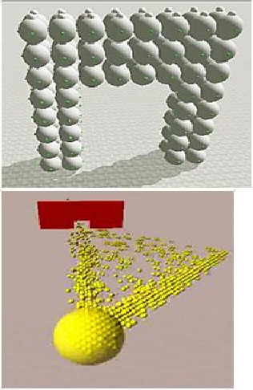

energizing a particular magnet and cooperating with aneighbouring catom to do the same, drawing the pairtogether. If both catoms are free, they will spin equallyabout their axes, but if one catom is held rigid by linksto its neighbours, the other will swing around the first,rolling across the fixed catom's surface and into a newposition. Electrostatic actuation will be required oncecatom sizes shrink to less than a millimeter or two. Theprocess will be essentially the same, but rather thanelectromagnets, the perimeter of the catom will becovered with conductive plates. By selectivelyapplying electric charges to the plates, each catom willbe able to move relative to its neighbours.



Power: Catoms must be able to draw power withouthaving to rely on a bulky battery or a wiredconnection. Under a novel resistor-network design theresearchers have developed, only a few catoms must beconnected in order for the entire ensemble to drawpower. When connected catoms are energized, thistriggers active routing algorithms which distributepower throughout the ensemble.



Communications: Communications is perhaps thebiggest challenge that researchers face in designingcatoms. An ensemble could contain millions or billionsof catoms, and because of the way in which they pack,there could be as many as six axes of interconnection.Another unique feature of catom networks is thatcatoms are homogeneous. Thus, unlike cell phones orother communications devices, the identity of anindividual catom is sometimes (but not always)unimportant. An application is more likely to careabout routing a message to the catoms comprising aspecific physical part of an ensemble (for instance, thecatoms comprising a "hand") rather than sending thesame message to specific catoms based on their serialnumbers. Furthermore, catoms may be in motionperiodically, as the shape of the ensemble changes.



Creating the replica: Researchers at Carnegie MellonUniversity also are exploring 3D image capture, in theVirtualized Reality project. They have developedtechnology that points a set of cameras at an event andenables the viewer to virtually fly around and watchthe event from a variety of positions. The DPRresearchers believe a similar approach could be used tocapture 3D scenes for use in creating physical, moving3D replicas.

Figure 7.

Replica Formation (Source: www.intel.com)

At a high level, there are two steps:

•Capturing a moving, three

-dimensional image and

•

Rendering it as a physical object.Replicas will be created from Catoms. Catomscan be framed into different shapes, and it can changecolor, through light-emitting diodes on its surface.Embedded photo cells will enable it to sense light, sothat a human replica can "see." Catoms might evensimulate the texture of the person or object beingreplicated. A replica will have computing capabilities,but these will be accessed through touch, voice, oranother natural interface rather than a keyboard ormouse. Catoms will be as close to spherical as possibleto support multiple packing densities.V.

A

PPLICATIONS

 The potential applications of dynamic physical renderingare limited only by the imagination. Following are a few of thepossibilities:



Medicine: A replica of your physician could appear inyour living room and perform an exam. The virtualdoctor would precisely mimic the shape, appearanceand movements of your "real" doctor, who isperforming the actual work from a remote office.



Disaster relief: Human replicas could serve as stand-ins for medical personnel, firefighters, or disaster relief workers. Objects made of programmable matter couldbe used to perform hazardous work and could morphinto different shapes to serve multiple purposes. A firehose could become a shovel, a ladder could betransformed into a stretcher.



Entertainment: A football game, ice skatingcompetition or other sporting event could be replicatedin miniature on your coffee table. A movie could berecreated in your living room, and you could insertyourself into the role of one of the actors.



3D physical modeling: Physical replicas could replace3D computer models, which can only be viewed in two

(Source: www.cs.cmu.edu/~claytronics)Figure 8.

3D model of Car formed by Catoms

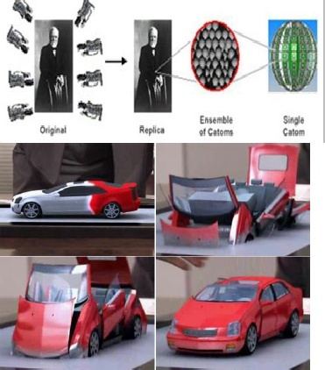

Top of Form



Bottom of Form

* [Job Board](http://www.academia.edu/Jobs)
* [About](http://www.academia.edu/about)
* [Press](http://www.academia.edu/press)
* [Blog](http://blog.academia.edu/)
* [We're hiring engineers!](http://www.academia.edu/hiring)
* [FAQ](http://www.academia.edu/FAQ)
* [Feedback](http://www.academia.edu/feedback)
* [Terms](http://www.academia.edu/terms)
* [Privacy](http://www.academia.edu/privacy)
* [Copyright](http://www.academia.edu/copyright)

Academia © 2013