ESC 113 | Engineering Coding Project
USGS Earthquake Data Analysis — September 2026 | Muhammed L. Janko

Introduction and methods
For this project, I analyzed real earthquake records from the USGS Comprehensive Earthquake Catalog (ComCat) to examine how magnitudes and depths vary and how Python can help engineers interpret scientific data. I focused on records from September 1–30, 2026 (UTC), with magnitudes of 4.0 or greater. Using pandas, I inspected and cleaned the data, computed summary statistics, and applied conditional functions to classify magnitudes, depths, and events for engineering reviews. I also used matplotlib to create four graphs.

Results briefly
Earthquakes | 1,226 | Average magnitude | 4.53
Magnitude range | 4.0–6.7 | Average depth | 75.34 km
Depth range | 5.0–665.057 km | Screened for review | 832 (67.9%)
Magnitude groups: 4.0–4.9: 1,059 (86.4%); 5.0–5.9: 161 (13.1%); 6.0–6.9: 6 (0.5%); 7.0+: 0. Depth groups: shallow: 886 (72.3%); intermediate: 262 (21.4%); deep: 78 (6.4%). Percentages are rounded.

Graph findings
Figure 1 — Magnitude distribution. Most recorded events were near the lower end of the selected range, particularly in the 4.0–4.9 range. The number of events decreased sharply at higher magnitudes.
Figure 2 — Magnitude versus depth. Earthquakes occurred at a wide range of depths, but the scatterplot did not show a clear, consistent relationship between magnitude and depth. A plot alone does not establish causation.
Figure 3 — Magnitude categories. The 4.0–4.9 group contained 1,059 of the 1,226 earthquakes; none reached magnitude 7.0. This chart makes comparisons between categories easy.
Figure 4 — Daily counts. Earthquake activity varied throughout the month. September 26 had the highest count, with seventy-nine recorded events. This describes the selected month, not a prediction of future earthquakes.

Engineering interpretation — seven questions
1. Most frequent magnitude category. Magnitude 4.0–4.9 was the most common, with 1,059 earthquakes (86.4%).
2. Most frequent depth category. Shallow earthquakes were most common: 886 (72.3%), compared with 262 intermediate and seventy-eight deep events.
3. Magnitude versus depth. I did not see a clear, consistent relationship in the scatterplot. Similar magnitudes occurred at different depths; further statistical analysis would be needed to quantify any association.
4. Event of engineering interest. The strongest event was a magnitude 6.7 earthquake on September 25, 2026, at 21:23 UTC, about 74 km ENE of Tadine, New Caledonia, at a depth of 10 km. Its magnitude and shallow depth make it worthy of further study, but actual risk depends on shaking, exposure, and construction.
5. Why magnitude and depth matter. Magnitude measures an earthquake's size, and depth indicates how deep the source is below ground. Engineers also need shaking intensity, distance, soil conditions, and structural details to assess potential damage.
6. Limitations. The study covers only one month and events with magnitude 4.0 or higher. The data does not directly report structural damage, and catalog values may be revised later.
7. How I would improve my studies. I would examine several years of records and incorporate ShakeMap ground motion, soil conditions, building vulnerability, and distance to communities.

Conclusion
This project helped me connect Python programming to a real-world engineering problem. I practiced reading a CSV file, validating data, writing classification functions, applying conditional logic, and creating graphs. The main finding was that magnitude 4.0–4.9 earthquakes were far more frequent than stronger ones in this dataset. I also learned that earthquake magnitude and depth are useful screening metrics, but they cannot predict damage on their own.
Source: USGS ComCat, September 1–30, 2026 (UTC), M ≥ 4.0. https://earthquake.usgs.gov/fdsnws/event/1/

Appendix | Four Python Graphs
Figure 1. Magnitude distribution
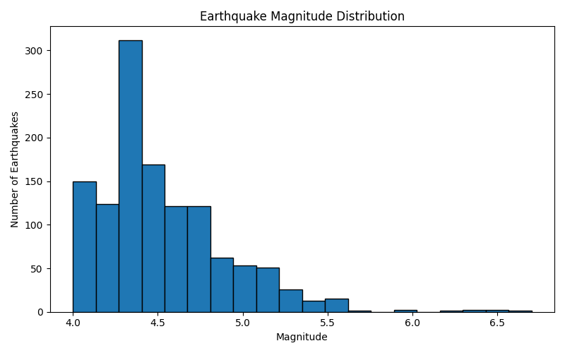

Figure 2. Magnitude versus depth
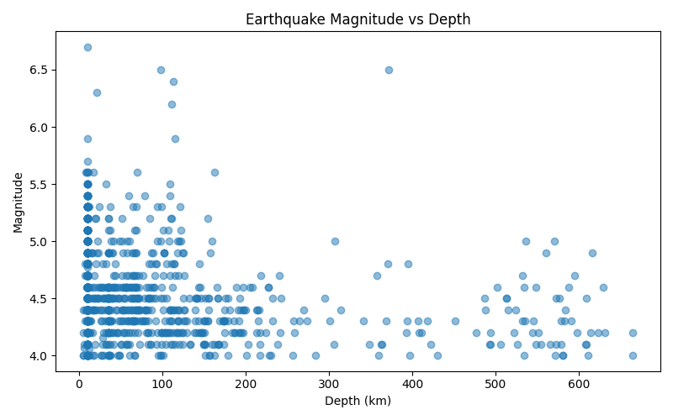

Figure 3. Magnitude categories
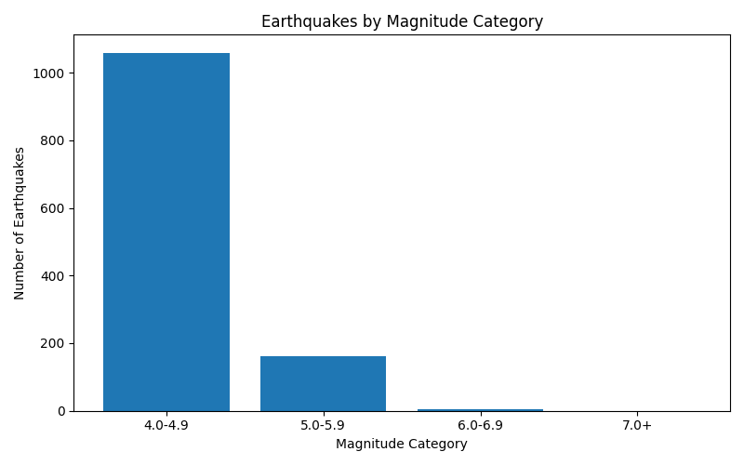

Figure 4. Daily earthquake activity
