**Upload Steps.**

1. Click the  icon to open all the available tabs.



1. Locate the “Order Upload” link from the list.

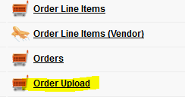

1. Click the “Order Upload” link to open the upload page.

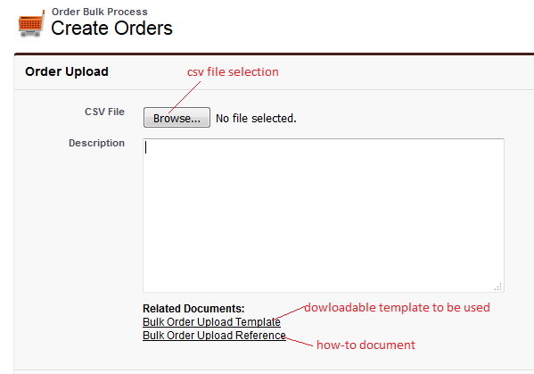

1. Click the “Browse” button to select the csv file to be processed.

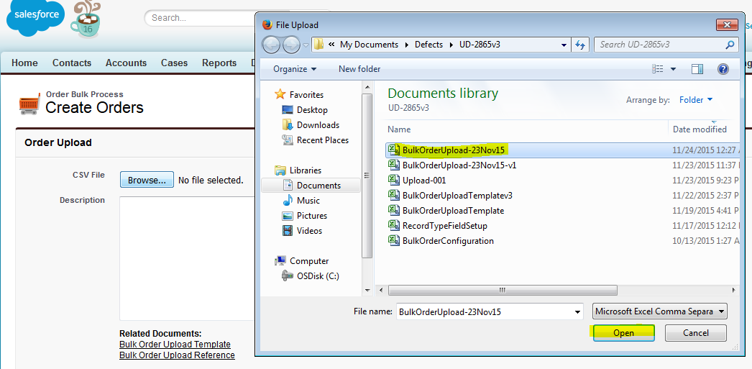

1. Once the file is selected, click the “Attach” button save the file in the server.

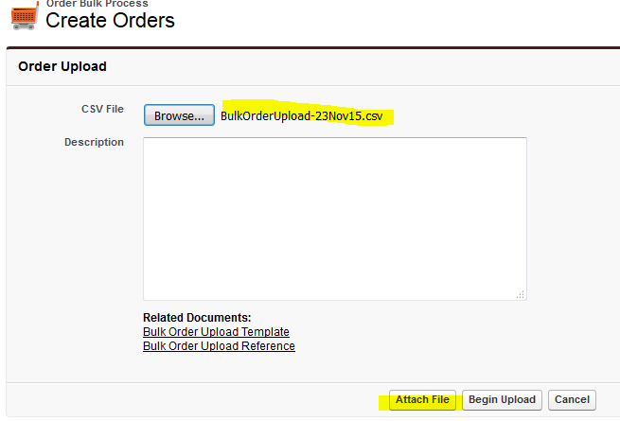

1. Once the file is successfully verified and save, confirmation message will be displayed.

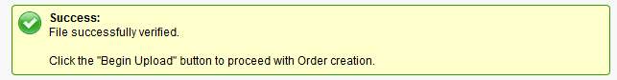

1. Click the “Begin Upload” button to proceed.



1. Message will be displayed once the upload process is completed.

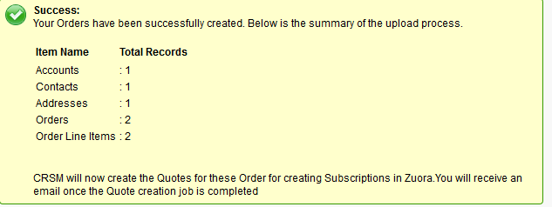

1. Confirmation will be sent to your email once the quote and subscription creation has been completed.

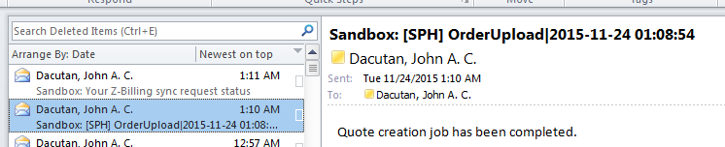

**Error Handling:**

1. Validation Error

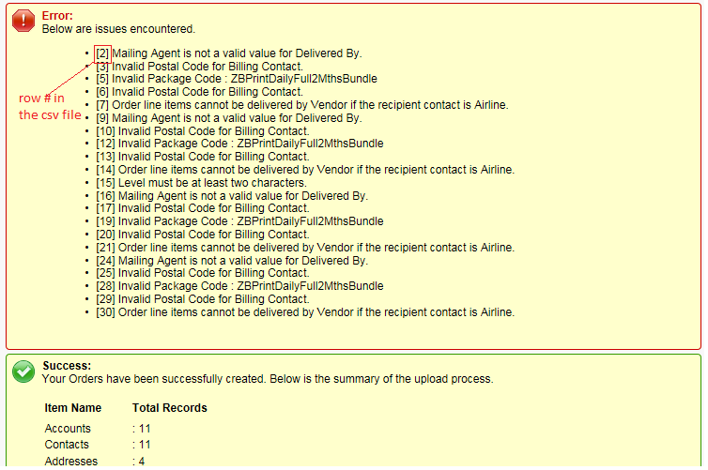

You may only re-upload the row(s) with validation issue to avoid duplicate entries for the rows that were successfully processed.

1. Exception Error

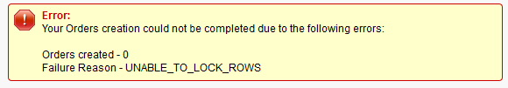

This is a system error that was encountered during the process. You may try to re-upload the csv file since all rows are not being processed if applicable. Otherwise, you have to contact your System Admistrator / Support Team.

**Using the template.**

Note: Please DO NOT change the format of the template, it may affect the data.

1. On the “Form” sheet of the template, populate the necessary fields for the order creation. Columns represent the records.

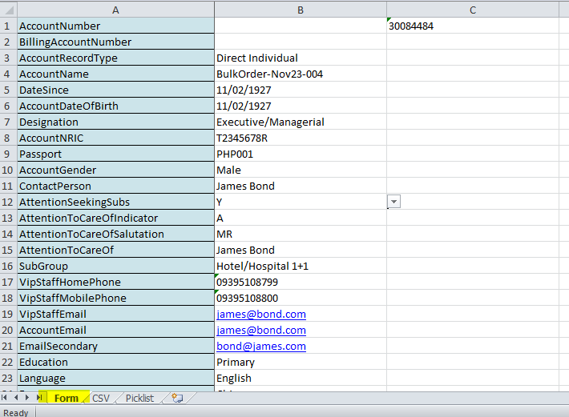

1. To save the template in csv format, go to “CSV” sheet then File🡪Save As. Select “CSV (Comma delimited)” as type. Enter the name of your csv file. Click “Save”. Several confirmation will prompt, just follow the steps provided in the screenshots below.

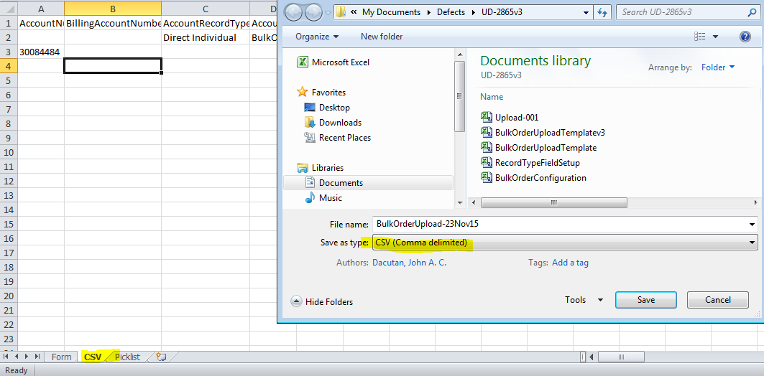

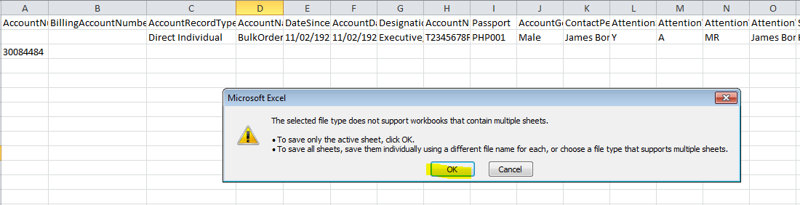

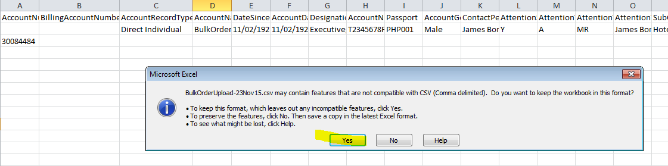

1. Once done verify your csv file.

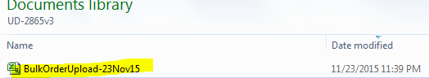

**Field Definition.**

|  |  |  |
| --- | --- | --- |
| **Column Header** | **Data type** | **Remarks** |
| AccountNumber | text | Account Number of the Account if want to use the existing account. If provided, all account related fields can be left as blank. |
| BillingAccountNumber | text | Account Number of the Billing Account if want to use the existing billing account |
| AccountRecordType | picklist | Record type of the account to be created |
| AccountName | text | Name of the account |
| DateSince | date | format is dd/mm/yyyy |
| AccountDateOfBirth | date | format is dd/mm/yyyy. Only applicable for Direct Individual account. |
| Designation | picklist | Only applicable for Direct Individual account. |
| AccountNRIC | text | Only applicable for Direct Individual account. |
| Passport | text | Only applicable for Direct Individual account. |
| AccountGender | picklist | Only applicable for Direct Individual account. |
| ContactPerson | text | Only applicable and required for Direct Corporate account |
| AttentionSeekingSubs | boolean |  |
| AttentionToCareOfIndicator | picklist |  |
| AttentionToCareOfSalutation | picklist |  |
| AttentionToCareOf | text |  |
| SubGroup | picklist |  |
| VipStaffHomePhone | text |  |
| VipStaffMobilePhone | text |  |
| VipStaffEmail | text |  |
| AccountEmail | text |  |
| EmailSecondary | text |  |
| Education | picklist | Only applicable for Direct Individual account. |
| Language | picklist |  |
| Race | picklist | Only applicable for Direct Individual account. |
| GstOutOfScope | boolean |  |
| GstInvoice | boolean |  |
| CreditAlert | boolean |  |
| AcknowledgementLetter | picklist |  |
| RenewalLetter | picklist |  |
| SmsRenewalNotification | boolean |  |
| VendorCommunicationPreference | picklist |  |
| EshopRefNo | text |  |
| AirlineIndicator | boolean |  |
| StaffId | text | Only applicable and required for SPH Inter-Division account |
| UniqueEntityNumber | text | Only applicable for Direct Corporate account |
| IncomeRange | picklist | Only applicable for Direct Individual account. |
| RCSalutation | picklist | Can be left as blank if existing contact will be used |
| RCFirstName | text | Required |
| RCLastName | text | Required |
| RCNRIC | text | Can be left as blank if existing contact will be used |
| RCPassport | text | Can be left as blank if existing contact will be used |
| RCAttnToName | text | Can be left as blank if existing contact will be used |
| RCAccountName2 | text | Can be left as blank if existing contact will be used |
| RCBusinessAddressIndicator | boolean | Can be left as blank if existing contact will be used |
| RCHomeNumber | text | Can be left as blank if existing contact will be used |
| RCFax | text | Can be left as blank if existing contact will be used |
| RCMobileNumber | text | Can be left as blank if existing contact will be used |
| RCMobileNumber2 | text | Can be left as blank if existing contact will be used |
| RCOfficeNumber | text | Can be left as blank if existing contact will be used |
| RCOfficeExtension | text | Can be left as blank if existing contact will be used |
| RCEmail | text | Can be left as blank if existing contact will be used |
| RCEmailSecondary | text | Can be left as blank if existing contact will be used |
| RCAddressRecordType | picklist | Required |
| RCPostalCode | text | For Local address |
| RCLevelNumber | text | For Local address |
| RCUnitNumber | text | For Local address |
| RCCountryCode | picklist | Only applicable for Overseas address |
| RCAddress1 | text | Only applicable for Overseas address |
| RCAddress2 | text | Only applicable for Overseas address |
| RCAddress3 | text | Only applicable for Overseas address |
| RCAddress4 | text | Only applicable for Overseas address |
| RCCompanyCode | picklist | Only applicable for Internal address |
| RCDepartmentCode | picklist | Only applicable for Internal address |
| RCDivisionCode | picklist | Only applicable for Internal address |
| RCLocationCode | picklist | Only applicable for Internal address |
| RCSectionCode | text | Only applicable for Internal address |
| RCPackingCode | picklist | Only applicable for Airline address |
| RCCityCode | picklist | Only applicable for Airline address |
| RCAdditionalInfo | text | Only applicable for Airline address |
| BCSalutation | picklist | Can be left as blank if Recipient Contact will be used as Billing Contact |
| BCFirstName | text | Can be left as blank if Recipient Contact will be used as Billing Contact |
| BCLastName | text | Can be left as blank if Recipient Contact will be used as Billing Contact |
| BCNRIC | text | Can be left as blank if Recipient Contact will be used as Billing Contact |
| BCPassport | text | Can be left as blank if Recipient Contact will be used as Billing Contact |
| BCAttnToName | text | Can be left as blank if Recipient Contact will be used as Billing Contact |
| BCAccountName2 | text | Can be left as blank if Recipient Contact will be used as Billing Contact |
| BCBusinessAddressIndicator | picklist | Can be left as blank if Recipient Contact will be used as Billing Contact |
| BCHomeNumber | text | Can be left as blank if Recipient Contact will be used as Billing Contact |
| BCFax | text | Can be left as blank if Recipient Contact will be used as Billing Contact |
| BCMobileNumber | text | Can be left as blank if Recipient Contact will be used as Billing Contact |
| BCMobileNumber2 | text | Can be left as blank if Recipient Contact will be used as Billing Contact |
| BCOfficeNumber | text | Can be left as blank if Recipient Contact will be used as Billing Contact |
| BCOfficeExtension | text | Can be left as blank if Recipient Contact will be used as Billing Contact |
| BCEmail | text | Can be left as blank if Recipient Contact will be used as Billing Contact |
| BCEmailSecondary | text | Can be left as blank if Recipient Contact will be used as Billing Contact |
| BCAddressRecordType | picklist | Can be left as blank if Recipient Contact will be used as Billing Contact |
| BCPostalCode | text | For Local address |
| BCLevelNumber | text | For Local address |
| BCUnitNumber | text | For Local address |
| BCCountryCode | picklist | Only applicable for Overseas address |
| BCAddress1 | text | Only applicable for Overseas address |
| BCAddress2 | text | Only applicable for Overseas address |
| BCAddress3 | text | Only applicable for Overseas address |
| BCAddress4 | text | Only applicable for Overseas address |
| BCCompanyCode | picklist | Only applicable for Internal address |
| BCDepartmentCode | picklist | Only applicable for Internal address |
| BCDivisionCode | picklist | Only applicable for Internal address |
| BCLocationCode | picklist | Only applicable for Internal address |
| BCSectionCode | text | Only applicable for Internal address |
| BCPackingCode | picklist | Only applicable for Airline address |
| BCCityCode | picklist | Only applicable for Airline address |
| BCAdditionalInfo | text | Only applicable for Airline address |
| Payment Mode | picklist |  |
| OtherPaymentMode | picklist |  |
| ArmsCustomerNumber | text |  |
| ArmsAccountNumber | text |  |
| ArmsBusinessProfile | picklist |  |
| ArmsDebtManagementTreatment | picklist |  |
| CashAmountPaid | decimal |  |
| CheckAmount | decimal |  |
| CheckDated | date | format is dd/mm/yyyy |
| CheckIssuingBank | text |  |
| CheckNumber | text |  |
| CheckRemarks | text |  |
| CostCentre | text |  |
| CreditCardAddress1 | text |  |
| CreditCardCity | text |  |
| CreditCardCountry | text |  |
| CreditCardCVV | integer |  |
| CreditCardExpirationMonth | integer |  |
| CreditCardExpirationYear | integer |  |
| CreditCardHolderName | text |  |
| CreditCardNumber | integer |  |
| CreditCardType | picklist |  |
| DeliveryAmount | decimal |  |
| DeliveryChargeType | picklist | If left blank, the respective default charge type associated to the address type will be used. |
| GlCode | text |  |
| Sponsor | boolean |  |
| VendorSmsRemark | text |  |
| SuppressAcknoweledgementLetter | boolean |  |
| SuppressRenewalAndReminderLetter | boolean |  |
| SuppressVendorNotification | boolean |  |
| GenerateInvoice | boolean |  |
| AutoRenew | boolean |  |
| PromotionCode | text |  |
| PackageCode | text |  |
| AddonPackageCode | text |  |
| GiftCodes | text | If multiple gift code, it must be delimited by semi-colon. Ex. GC1;GC2;GC3 |
| StartDate | date | format is dd/mm/yyyy. If left blank, the earliest start date will be used. |
| NewContractPeriod | integer |  |
| Quantity | integer |  |
| DeliveredBy | picklist |  |
| MailingAgentCode | text | Mailing Agent Code must be populated on this, This will be seen on Account with Mailing Agent Record Type, this must be active and a type of Airline |