

## *eCerto* Analyte Report

|  |  |  |  |
| --- | --- | --- | --- |
| **Study ID:** | CRM001 | **Date:** | 26 September, 2021 |
| **User:** | Jan Lisec | **Analyte:** | X |

### Data Import

These files have been provided to the tool by Jan Lisec:

ecerto_testdata_JL2_C01.xlsx,  
ecerto_testdata_JL2_C02.xlsx,  
ecerto_testdata_JL2_C03.xlsx,  
ecerto_testdata_JL2_C04.xlsx,  
ecerto_testdata_JL2_C05.xlsx

This is the imported data which was basis for all further calculations:

|  |  |  |  |  |  |  |
| --- | --- | --- | --- | --- | --- | --- |
| ID | Lab | analyte | replicate | value | unit | File |
| 1 | L1 | X | 1 | 0.0044 | mg/L | ecerto_testdata_JL2_C01.xlsx |
| 4 | L1 | X | 2 | 0.0060 | mg/L | ecerto_testdata_JL2_C01.xlsx |
| 7 | L1 | X | 3 | 0.0030 | mg/L | ecerto_testdata_JL2_C01.xlsx |
| 10 | L1 | X | 4 | 0.0065 | mg/L | ecerto_testdata_JL2_C01.xlsx |
| 13 | L1 | X | 5 | 0.0023 | mg/L | ecerto_testdata_JL2_C01.xlsx |
| 16 | L1 | X | 6 | 0.0050 | mg/L | ecerto_testdata_JL2_C01.xlsx |
| 19 | L2 | X | 1 | 0.0075 | mg/L | ecerto_testdata_JL2_C02.xlsx |
| 22 | L2 | X | 2 | 0.0053 | mg/L | ecerto_testdata_JL2_C02.xlsx |
| 25 | L2 | X | 3 | 0.0057 | mg/L | ecerto_testdata_JL2_C02.xlsx |
| 28 | L2 | X | 4 | 0.0025 | mg/L | ecerto_testdata_JL2_C02.xlsx |
| 31 | L2 | X | 5 | 0.0044 | mg/L | ecerto_testdata_JL2_C02.xlsx |
| 34 | L2 | X | 6 | 0.0022 | mg/L | ecerto_testdata_JL2_C02.xlsx |
| 37 | L3 | X | 1 | 0.0032 | mg/L | ecerto_testdata_JL2_C03.xlsx |
| 40 | L3 | X | 2 | 0.0062 | mg/L | ecerto_testdata_JL2_C03.xlsx |
| 43 | L3 | X | 3 | 0.0040 | mg/L | ecerto_testdata_JL2_C03.xlsx |
| 46 | L3 | X | 4 | 0.0065 | mg/L | ecerto_testdata_JL2_C03.xlsx |
| 49 | L3 | X | 5 | 0.0052 | mg/L | ecerto_testdata_JL2_C03.xlsx |
| 52 | L3 | X | 6 | 0.0043 | mg/L | ecerto_testdata_JL2_C03.xlsx |
| 55 | L4 | X | 1 | 0.0029 | mg/L | ecerto_testdata_JL2_C04.xlsx |
| 58 | L4 | X | 2 | 0.0050 | mg/L | ecerto_testdata_JL2_C04.xlsx |
| 61 | L4 | X | 3 | 0.0066 | mg/L | ecerto_testdata_JL2_C04.xlsx |
| 64 | L4 | X | 4 | 0.0048 | mg/L | ecerto_testdata_JL2_C04.xlsx |
| 67 | L4 | X | 5 | 0.0051 | mg/L | ecerto_testdata_JL2_C04.xlsx |
| 70 | L4 | X | 6 | 0.0061 | mg/L | ecerto_testdata_JL2_C04.xlsx |
| 73 | L5 | X | 1 | 0.0107 | mg/L | ecerto_testdata_JL2_C05.xlsx |
| 76 | L5 | X | 2 | 0.0098 | mg/L | ecerto_testdata_JL2_C05.xlsx |
| 79 | L5 | X | 3 | 0.0094 | mg/L | ecerto_testdata_JL2_C05.xlsx |
| 82 | L5 | X | 4 | 0.0110 | mg/L | ecerto_testdata_JL2_C05.xlsx |
| 85 | L5 | X | 5 | 0.0037 | mg/L | ecerto_testdata_JL2_C05.xlsx |
| 88 | L5 | X | 6 | 0.0037 | mg/L | ecerto_testdata_JL2_C05.xlsx |

### Statistics regarding lab means, lab variances and outlier detection

|  |
| --- |
| Tab1 |
| NA |

The following samples (IDs) have been removed by the user upon inspection of the oulier statistics:

85, 88

### Statistics regarding overall mean distribution and variance testing

|  |
| --- |
| Tab2 |
| NA |

The following Labs (IDs) have been removed by the user upon inspection of the oulier statistics:

L5

### Certified Values Plot

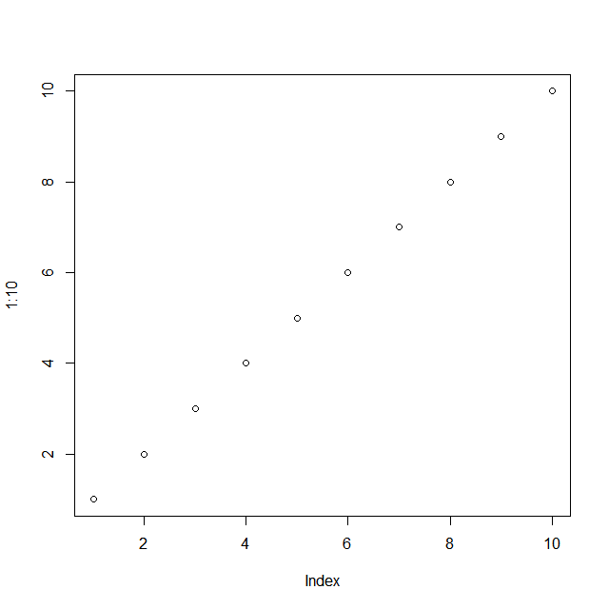

### Certified Value and uncertainty contributions

Here we could include the Tab.3 from the App including the certified values. However, this might be better done in the Material Report/Certificate.

***Note!*** This is a Report template for demonstration purpose. Specific layouts can be generated on demand.