Psychiatric Hospital

Probabilistic Simulation

Clinical service success
We use clinical service as an generic term for all kinds of treatment provided to patients in a psychiatric hospital. This includes in particular diagnosis and prescription, psychotherapy, and nursing care.
We simplify clinical service success to a binary outcome: either the patient recovers (SUCCESS) or not (FAIL).
In reality, the quantification of clinicialservice success is not as simple. In a hospital context, success could be quantified by the reason for discharge (e.g., full recovery, partial recovery, transfer to another facility, etc.). In a psychotherapy context, treatment success can be measured by clinical assessement scales for mental illness before and after treatment.
Not all mechanisms of functioning of psychotherapy and other treatment of patients is known, at least not deterministally known. Therefore, the effectiveness of clinical services is measured with randomized controlled trials. Through randomization, a causal relationship between treatment and treatment success can be established. However, this does neither establish a mechanistic explanation nor can it determine causal effectiveness of the clinical service for individual patients. Therefore, a probabilistic model of clinical service success is appropriate.
Again, we simplify the clinical service to three categories: effective, ineffective/harmful, and placebo/low-level.
In reality, there are many more gradations of effectiveness of clinical services. However, the three categories capture the essential differences in treatment effectiveness. The basic idea of this model is that effective clinical service have a high probability of success but also placebo services can lead to a success but with a lower probability. Finally, we assume that an ineffective service has an even lower probability of success than a placebo service.
So, our simplified model builds on the definition of these probabilities:
- $P\left(\text{success}∣\text{effective service}\right)=p^{\text{eT}}$ probability of success under effective service
- $P\left(\text{success}∣\text{placebo service}\right)=p^{\text{pT}}$ probability of success under placebo/low-level service
- $P\left(\text{success}∣\text{ineffective service}\right)=p^{\text{iT}}$ probability of success under ineffective/harmful service
and it holds that $1>p^{\text{eT}}>p^{\text{pT}}>p^{\text{iT}}>0$. The sharp inequalities with repsect to zero and one signify that even an effective service can fail and ineffective services can sometimes lead to success (e.g., through spontaneous remission of the illness).

Actions of the healthcare professionals
What determines effective, placebo, and ineffective service of health care professionals? In this model, we want to boil it down to two characteristics: self-efficacy expectation (self-efficacy for short in the following) and competence.
The total treatment of patients in a psychiatric hospital is provided by a team of professionals. Prototypically,
- a psychiatrist, mainly reposible for diagnosis and prescription,
- a psychotherapist, mainly repsonsible for applying psychotherapy, and
- a nurse mainly responsible for psychiatric care.

Simplified version with team as a whole
Each professional has his/her own self-efficacy and competence. However, as a first version of the probabilistic model we lump them together assuming a team self-efficacy and a team competence.
With this simplified assumption and our general setup it we assume:
- Self-efficacy is the probability of not applying a placebo/low-level service but aiming for an effecitive one, however it could turn out to be an ineffective/harmful one. $P\left(\text{effective}∪\text{ineffective}\right)=P\left(\text{non-placebo}\right)=p^{\text{SE}}$ and $P\left(\text{placebo}\right)=1−p^{\text{SE}}$.
- Competence applies only when the professional (or team) aims for a non-placebo service. Then it is the probability of applying an effective and not an ineffective/harmful for the patient, given that a non-placebo treatment is selected. $P\left(\text{effective}∣\text{effective}∪\text{ineffective}\right)=p^{\text{CO}}$ and $P\left(\text{ineffective}∣\text{effective}∪\text{ineffective}\right)=1−p^{\text{CO}}$.
$P\left(\text{effective}\right)$, $P\left(\text{ineffective}\right)$, and $P\left(\text{placebo}\right)$ can be derived from the two exogenously given probabilities $p^{\text{SE}}$ and $p^{\text{CO}}$:
$$\begin{matrix}P\left(\text{placebo}\right) & =1−p^{\text{SE}} \\ P\left(\text{ineffective}\right) & =p^{\text{SE}}\left(1−p^{\text{CO}}\right) \\ P\left(\text{effective}\right) & =p^{\text{SE}}p^{\text{CO}}\end{matrix}$$
We want to know $P\left(\text{success}∣\text{professional/team has }p^{\text{SE}}\text{ and }p^{\text{CO}}\right)$ which we may abbreviate as $P\left(\text{success}\right)$. Given the notions of the five exogenously given probabilities above it is:
$$\begin{matrix}P & \left(\text{success}∣\text{Professional has }p^{\text{SE}}\text{ and }p^{\text{CO}}\right) \\ = & P\left(\text{placebo}\right)p^{\text{pT}}+ \\ & P\left(\text{non-placebo}\right)P\left(\text{ineffective}∣\text{non-placebo}\right)p^{\text{iT}}+ \\ & P\left(\text{non-placebo}\right)P\left(\text{effective}∣\text{non-placebo}\right)p^{\text{aT}} \\ = & \underset{\text{(i)}}{\underset{⏟}{\left(1−p^{\text{SE}}\right)p^{\text{Pl}}}}+\underset{\text{(ii)}}{\underset{⏟}{p^{\text{SE}}\left(1−p^{\text{CO}}\right)p^{\text{iT}}}}+\underset{\text{(iii)}}{\underset{⏟}{p^{\text{SE}}p^{\text{CO}}p^{\text{aT}}}}\end{matrix}$$
It is the sum of the probabilities of three mutually exclusive events: (i) the professional does a placebo/low-level treatment and the patient recovers, (ii) the professional selects an ineffective non-placebo treatment but nevertheless the patient recovers, and (iii) the professional selects an efective non-placebo treatment and the patient recovers.
library(tidyverse)
library(numDeriv)
# Professional probabilities
p_SE <- 0.8 # Self-efficacy
p_CO <- 0.7 # Competence
# Treatment probabilities
p_aT <- 0.8 # Probability of success with appropriate treatment
p_iT <- 0.2 # Probability of success with inappropriate treatment
p_pT <- 0.5 # Probability of success with placebo
# Calculate overall probability of successful treatment
P_success <- function(p_SE, p_CO, p_aT = 0.8, p_iT = 0.2, p_pT = 0.5) {
(1 - p_SE) * p_pT + p_SE * (1 - p_CO) * p_iT + p_SE * p_CO * p_aT
}
Numerical example:
Professional Treatment probabilities:
$p^{\text{SE}}=0.8$, $p^{\text{CO}}=0.7$
Treatment Outcome probabilities:
$p^{\text{aT}}=0.8$ $p^{\text{iT}}=0.2$, $p^{\text{pT}}=0.5$
$$P\left(\text{success}\right)=\underset{\text{(i)}}{\underset{⏟}{0.1}}+\underset{\text{(ii)}}{\underset{⏟}{0.048}}+\underset{\text{(iii)}}{\underset{⏟}{0.448}}=0.596$$

Interventions on self-efficacy and competence
We can map the probability of successful treatment over a grid of self-efficacy and competence values and compute the gradients (black arrows) to see how changes in self-efficacy and competence affect the probability of successful treatment.
# Create a grid of self-efficacy and competence values
gradient_P_success <- function(params, p_aT, p_iT, p_pT) {
p_SE <- params[1]
p_CO <- params[2]
P_success(p_SE, p_CO, p_aT, p_iT, p_pT)
}
plot_heatmap_gradient <- function(p_aT, p_iT, p_pT) {
se_co_grid <- expand_grid(
p_SE = seq(0, 1, by = 0.1),
p_CO = seq(0, 1, by = 0.1)
) |> # Calculate the probability of success
mutate(P_success = P_success(p_SE, p_CO, p_aT, p_iT, p_pT)) |>
# Compute gradients
rowwise() |>
mutate(
grad = list(grad(
gradient_P_success,
c(p_SE, p_CO),
p_aT = p_aT,
p_iT = p_iT,
p_pT = p_pT
))
) |>
ungroup() |>
mutate(
dP_dSE = grad |> map_dbl(\(x) x[[1]] |> unlist()),
dP_dCO = grad |> map_dbl(\(x) x[[2]] |> unlist()),
) |>
mutate(
arrow_scale = 0.2,
dP_dSE_scaled = dP_dSE * arrow_scale,
dP_dCO_scaled = dP_dCO * arrow_scale
) |> # Plot the results
ggplot(aes(x = p_SE, y = p_CO, fill = P_success)) +
geom_tile() +
geom_segment(
aes(xend = p_SE + dP_dSE_scaled, yend = p_CO + dP_dCO_scaled),
arrow = arrow(length = unit(0.15, "inches")),
color = "black",
alpha = 0.7
) +
# diverging pallette
scale_fill_distiller(palette = "RdBu", direction = 1, limits = c(0, 1)) +
labs(
title = "Probability of Successful Treatment",
x = "Self-Efficacy (p_SE)",
y = "Competence (p_CO)",
fill = "P(Success)"
) +
theme_minimal()
}
g <- plot_heatmap_gradient(p_aT, p_iT, p_pT)
g
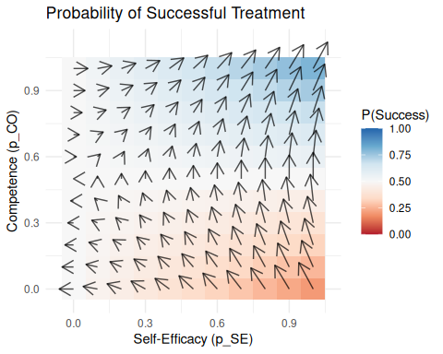

Line plots
plot_line <- function(p_aT, p_iT, p_pT) {
se_co_grid <- expand_grid(
p_SE = seq(0, 1, by = 0.1),
p_CO = seq(0, 1, by = 0.1)
) |> # Calculate the probability of success
mutate(P_success = P_success(p_SE, p_CO, p_aT, p_iT, p_pT)) |>
ggplot(aes(x = p_SE, y = P_success, color = factor(p_CO))) +
geom_line() +
labs(
title = "Probability of Successful Treatment",
x = "Self-Efficacy (p_SE)",
y = "P(Success)",
color = "Competence (p_CO)"
) +
theme_minimal()
}
g <- plot_line(p_aT, p_iT, p_pT)
g
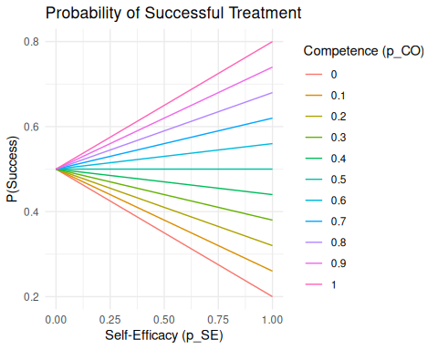
Probilities to select effective, placebo, and ineffective treatment as a function of self-efficacy for one level of competence with self-efficacy as x-axis and probabilities as y-axis:
plot_line_treatment <- function(p_aT, p_iT, p_pT) {
se_co_grid <- expand_grid(
p_SE = seq(0, 1, by = 0.1),
p_CO = seq(0, 1, by = 0.1)
) |> # Calculate the probabilities of effective, placebo, and ineffective treatment
mutate(
P_placebo = 1 - p_SE,
#P_ineffective = p_SE * (1 - p_CO),
P_effective = p_SE * p_CO
) |>
#filter(near(p_CO,0.7)) |> # Select one level of competence
pivot_longer(
# cols = c(P_placebo, P_ineffective, P_effective),
cols = c(P_placebo, P_effective),
names_to = "Treatment_Type",
values_to = "Probability"
)
se_co_grid |>
ggplot(aes(
x = p_SE,
y = Probability,
linetype = Treatment_Type,
color = factor(p_CO)
)) +
geom_line() +
labs(
title = "Probabilities of Treatment Types",
x = "Self-Efficacy (p_SE)",
y = "Probability",
color = "Competence (p_CO)",
linetype = "Treatment Type"
) +
theme_minimal()
}
g <- plot_line_treatment(p_aT, p_iT, p_pT)
g
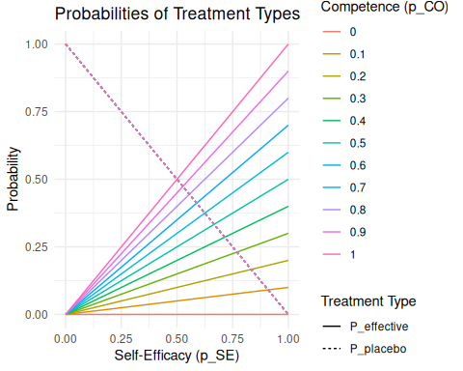

More plots
Different treatment outcome probabilities lead to different shapes of the heatmap and different gradients.
# Different treatment outcome probabilities
p_aT <- 0.95
p_iT <- 0.4
p_pT <- 0.5
g <- plot_heatmap_gradient(p_aT, p_iT, p_pT)
g
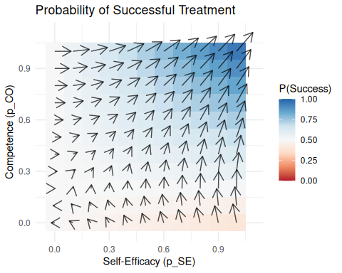
# Different treatment outcome probabilities
p_aT <- 0.7
p_iT <- 0.2
p_pT <- 0.3
g <- plot_heatmap_gradient(p_aT, p_iT, p_pT)
g
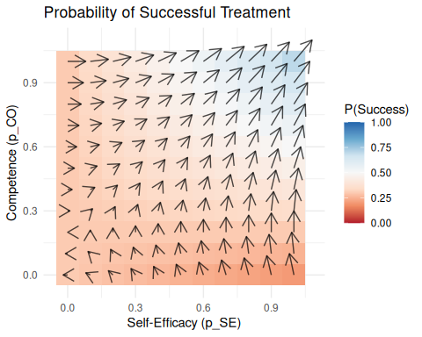

Psychiatrist, Psychotherapist, Nurse as separate professionals
In reality, the clinical service is provided by a team of professionals.
Roughly, the patients undergoes the clinical sevice in this way
- The psychiatrist makes a diagnosis and a prescription.
- Based on this the psychotherapist applies psychotherapy.
- The nurse provides psychiatric nursing care, supporting the patient in life in the clinic and supporting prescribed therapy.
We assume that effective, placebo, and ineffective service can happen similarly by all professionals. However, there is a natural order where the psychotherapist has to build on the diagnosis and prescription of the psychiatrist, and the nurse has to take care of patients undergoing the psychotherapy.
For the psychiatrist (1) we can assume the same as above:
$$\begin{matrix}P\left(\text{1_effective}\right) & =p_{1}^{\text{SE}}p_{1}^{\text{CO}} \\ P\left(\text{1_placebo}\right) & =1−p_{1}^{\text{SE}} \\ P\left(\text{1_ineffective}\right) & =p_{1}^{\text{SE}}\left(1−p_{1}^{\text{CO}}\right)\end{matrix}$$
However, the psychotherapist outcome service outcome depends on the input of the psychiatrist. So, we have to specify the conditional probabilities:
BELOW, NOT YET SPECIFIED:
$$
\begin{align}
P(\text{2\_effective} \mid \text{1\_effective}) &= p^\text{SE}_2 p^\text{CO}_2 & \\
P(\text{2\_placebo} \mid \text{1\_effective}) &= 1 - p^\text{SE}_2 & \\
P(\text{2\_ineffective} \mid \text{1\_effective}) &= p^\text{SE}_2(1 - p^\text{CO}_2) & \\
P(\text{2\_effective} \mid \text{1\_placebo}) &= p^\text{SE}_2 p^\text{CO}_2 & \\
P(\text{2\_placebo} \mid \text{1\_placebo}) &= 1 - p^\text{SE}_2 & \\
P(\text{2\_ineffective} \mid \text{1\_placebo}) &= p^\text{SE}_2(1 - p^\text{CO}_2) & \\
P(\text{2\_effective} \mid \text{1\_ineffective}) &= p^\text{SE}_2 p^\text{CO}_2 & \\
P(\text{2\_placebo} \mid \text{1\_ineffective}) &= 1 - p^\text{SE}_2 & \\
P(\text{2\_ineffective} \mid \text{1\_ineffective}) &= p^\text{SE}_2 & \text{SE is decisive\\
\end{align}
$$

