JoinPlay: Solving the Social Integration Crisis in Recreational Sports
The only community sports platform that instantly connects you with nearby pickup games and like-minded people, without the expensive memberships, long-term commitments, or intimidating skill requirements of traditional sports leagues and fitness apps. Spontaneous sports connections made easy!
Executive Summary
Recreational sports platforms have optimized for logistics (scheduling, payments, performance tracking, etc.) while completely abandoning users during the moment that determines retention: the transition from "I signed up" to "I belong here." Meanwhile, financial barriers have made sports participation increasingly exclusive, with players paying $200+ to play eight games in a weekly league, and youth programs charging $1,600+ per season. We're building the first platform that treats recreational sports as a social integration opportunity and activity discovery task, while making participation accessible and affordable.
The market opportunity is substantial: 242 million Americans participated in sports or fitness activities in 2023, representing nearly 80% of the population aged six and older. The adult social sports market alone is valued at $4.64 billion annually, with one in five Americans set to join a sports league. Yet comprehensive research reveals that social integration and psychological safety remain universally unserved across the entire competitive landscape.
JoinPlay addresses this through three core innovations: (1) Intelligent social-activity matching that helps users find both appropriate challenge levels and compatible group cultures; (2) Systematic social integration support from discovery through belonging confirmation; (3) Accessible entry points that eliminate expensive memberships and long-term commitments. We're not competing on logistics where established platforms excel, we're pioneering an entirely new category: social sports integration systems. People join up to find the perfect fit.
This document presents the problem validation, solution approach, competitive positioning, and path forward, supported by extensive market research and a disciplined product development framework.
The Problem: A Market Failure in Human Connection
Recreational sports participation fails at the moment that matters most: when someone new tries to find where they belong. Three compounding forces drive this failure: (1) social integration is left structurally unsupported, (2) performance norms have made the culture of most groups invisible and intimidating to outsiders, and (3) rising costs have turned participation into a luxury. Combined, they leave millions of people on the sidelines not for lack of interest, but for lack of support when it matters most.
- The Social Integration Crisis. Sports communities are built for members, not newcomers. The infrastructure assumes insider knowledge and existing relationships, and no platform has addressed that (see Appendix 1 for an example of current state).
This is the deeper barrier to sustained participation, and peer-reviewed science confirms it is central to whether recreational sports deliver wellbeing benefits at all. A 2023 review of 29 adult sports participation studies (Systematic Reviews) found that sports produces mental health benefits through two pathways: physical activity and social relationships, with ‘belonging’ explicitly identified as a key mechanism in the social pathway. One included study found no relationship between the amount of physical activity and mental health or life satisfaction outcomes, suggesting that social factors and not exercise volume are delivering this outcome. Platforms that optimize for access and scheduling while ignoring social integration may be optimizing the wrong pathway entirely.
Mapping the 16 jobs recreational sports participants need completed shows exactly where this breaks down. These jobs organize into three tiers with fundamentally different failure modes (see Appendix 2). The result is a market that solves the “How do I start?” problem while leaving the “Should I stay?” problem unaddressed.
    - Tier 1 – Access & Readiness (Jobs 1-5) covers finding activities, understanding costs, knowing what to bring, and joining with minimal friction. These jobs are adequately or partially served across the competitive landscape. When they fail, people don't start – but the failure is recoverable. The user can just try again.
    - Tier 2 – Social Integration (Jobs 6-11) covers showing up without disrupting group dynamics, navigating skill levels, feeling emotionally safe, being accepted regardless of ability, knowing others want you to return, and feeling genuinely welcomed. Across all 13 platforms analyzed, these jobs are almost entirely Unserved. When they fail, the participant hasn't hit a gap but instead experienced a social or identity threat: "I looked foolish," "I was out of place," "People noticed." This failure has two distinct pressure points: (1) Before joining, people have no way to assess social fit to determine whether a group will welcome them, match their intensity, or share their approach to the sport. (2) After joining, belonging is left to chance, with no feedback loop to tell someone whether they're valued. Ambiguity amplifies both and carries a social cost that changes future behavior. Ongoing participation (retention) stops not because the activity was bad, but because the risk is no longer worth taking.
    - Tier 3 – Identity & Belonging (Jobs 12-16) covers shared purpose, camaraderie, athletic identity, and sustained participation. These are the reward jobs that explain long-term retention, but only for participants who make it through Tier 2. People don't drop out because these jobs aren't completed but because they never even reach them.
The pattern exists at all age levels, and young players struggle with "Will I fit in with this team?" and "Am I good enough? Or too advanced?" In a study done by The Luka Dončić Foundation & Nonfiction Research, one parent described: "He enjoyed the practices more than the games because there was less pressure. If a game was coming, he'd be nervous all day." 20% of U.S. basketball parents reported their child experienced burnout, with 20% of players changing teams more than once per year in search of better social fit – not better basketball.
- The Performance Culture Shift. Social media has changed the social climate of recreational communities, not just the pressure individuals feel. 43% of U.S. parents report that youth basketball now prioritizes individual star power over team development. Nearly one in three young players share highlight reels regardless of actual ability, chasing perception over participation.
As a student of the game and someone who loves it, the whole brand and ME, ME, ME aspect is killing the poetry of the game, the team ball, the extra passes" one parent observed. “Everyone just wants the next highlight for their sports mixtape."
– Inside Youth Basketball 2025
Research identifies social climate as a primary variable in whether sports participation delivers mental health benefits. When a group's ambient culture shifts toward performance signaling, the cost of being visibly new, uncertain, or struggling goes up for everyone in that space. The question "Will I fit in?" gets harder to answer when fitting in requires projecting the right attitude, not just showing up. There is no signal (digital or otherwise) that tells a prospective participant whether a recreational group has held onto its casual character or drifted toward performance norms. That information gap sits directly on top of the social integration failure above and compounds it.
- The Cost Crisis. Recreational sports have become expensive enough to dissuade and exclude. The average U.S. family spent $1,016 on their child's primary sport in 2024, a 46% increase since 2019 and twice the rate of overall inflation. The gap widens by income: the wealthiest families ($100K+ income) spent $1,471 more per year than the lowest-income parents. Youth basketball alone averages $873 per child annually in program fees, ranging from $800 for basic recreation leagues to $1,351 for AAU, before travel, equipment, or tournaments. For families with multiple kids, the math becomes impossible.
“He's very close with a set of twins [...], but only one could afford to play. The twins decided themselves that neither of them will play because they both love it. For this particular AAU, it was close to $1600 — and then you have to multiply that by two for two kids."
That’s two talented young players, sitting at home, because basketball has become a game only some can afford to play.
– Inside Youth Basketball 2025
Basketball isn't the outlier. Between 2019 and 2024, average parent spending rose 105% for basketball, 69% for soccer, and 68% for baseball, with 2024 averages of $910 for soccer and $1,113 for baseball per child. Adult recreational leagues follow the same pattern. Major metropolitan organizers charge $700–$1,060 per season for co-ed volleyball or kickball, plus a separate deposit and facility membership.4 Participation has moved from community amenity to luxury good.
Table 1: Annual Family Youth Sports Spending. Average amount spent in the past year for child’s top sport.
Why the Market Hasn’t Fixed This. The three failures above compound each other. Rising costs narrow the participant pool toward those with higher performance orientation. Performance culture shifts remaining communities toward demonstration over belonging. And the social integration infrastructure that could bridge that gap doesn't exist, because every platform was built for a different problem.
Meetup and Facebook Groups aggregate existing communities; they don't onboard newcomers into them. Strava and Nike Run Club motivate individual improvement and, in doing so, produce the performance pressure that drives recreational participants away. ClassPass optimized the booking transaction and stopped there. TeamSnap and LeagueApps serve teams that already exist. Each platform is adequate at the problem it was designed to solve, but none were designed for social integration.
Local recreation centers are the exception that proves the rule, as social integration here is actively managed. They most often get the culture right with staff that are trained to support newcomers by being welcoming, skill-inclusive, and low-pressure. But they have almost no digital infrastructure and no way to make their culture visible to the people who most need to find it. Their success is not incidental; the culture is buildable, the infrastructure to scale it has just never been built.
Market Validation & Opportunity
Americans are returning to recreational sports at a pace not seen in a decade. Team sports participation grew 11% YoY in 2023, pushing total sports and fitness participation to 242 million people – nearly 80% of the population aged six and older. One in five Americans now plays in a recreational league or plans to join one (up to 31% among Millennials, and for Gen Z that number hits 47%), and participation intent has grown 118% since 2023. This isn’t a post-pandemic blip and demonstrates a sustained shift in how Americans spend their time and money; reflected in a market estimated to be worth $4.64 billion annually.5
The question is where to enter.
What Is the Beachhead? Major metros have leagues and pickup games everywhere because discovery is manageable, density is high, and the infrastructure exists (however imperfect). Mid-size cities are in a different situation. The 441 U.S. cities between 75,000 and 500,000 residents are home to 64 million Americans across 45 states. Expand to cities above 50,000 and the number reaches 130 million people – roughly one in three Americans. In these communities, finding the right league is harder, knowing whether you'll fit in is nearly impossible, and the digital infrastructure that makes discovery easy in big cities simply doesn't exist. The need for connection and discovery tools is more acute, not less. That gap also creates a strategic advantage during early development. When even the logistical infrastructure is inadequate, a platform that solves discovery communicates clear value before every social integration feature is built. Mid-size cities provide an extended MVP runway that major metro entry does not.
Who To Target Within That Beachhead? Not everyone in those 130 million has the same need. About 50% of adult league players participate primarily for social reasons, where sports is a vehicle for friendship, and the activity is secondary. The other 50% are activity-focused where they play because they love the sport, and social benefits are a bonus. Both groups exist in mid-size cities, and a third group sits between them. These three customer segments (based on social motivation) define the opportunity:
- Primarily Social players use sports to meet people. They have high lifetime value because social switching costs create loyalty. They generate word-of-mouth. No existing platform serves them well because every major competitor is built around the activity, not the relationship.
- Balanced Social-Activity players want both dimensions optimized: the right sport at the right level, with a group that fits. This is the largest addressable segment and the highest complexity problem. No current platform tries to serve both needs equally, and that's the opening.
- Activity-Focused players treat social benefits as secondary and existing fitness and sports apps serve them adequately. They're a secondary market that is reachable as their latent social needs surface, but not the primary target.
The data confirms the gap. Primarily Social and Balanced players consistently rate "welcoming environment," "social onboarding support," and "community belonging feedback" as highly important.8 Across the 13 platforms analyzed in our competitive review (see Appendix 2), none of these features exist in any meaningful form. The market is paying and the need is unserved, and mid-size cities are where both are most true at once.

The Solution: JoinPlay’s Approach
JoinPlay operates on three interconnected objects: users, groups, and activities. Users sign up and build a personal profile, rating themselves on skill level, schedule availability, and social preferences like competitive intensity and how much they value welcoming newcomers. Groups do the same: organizers create a group profile that describes who they are and what they offer along the same dimensions. Groups then post individual activities with limited spots, which surface in each user's personalized discovery view. Every activity card shows two scores derived from comparing the user's profile against the group's: Activity Fit and Social Fit. After attending, users can join the group itself (prompted through post-activity feedback and a history of past activities) giving them the option to engage and join a persistent community, not just a one-time game.
Three innovations, each targeting a distinct failure described in the problem section above, are what separate JoinPlay from existing platforms:
- Intelligent Social <-> Activity Matching. The cornerstone of the value being provided to the customer is “Find your perfect fit.” The social integration crisis exists because platforms match on logistics and stop there. JoinPlay will use a dual-criteria algorithm that scores and matches people to activities on two dimensions simultaneously: (A) Activity Fit, and (B) Social Fit. These equal-weight scores are visible to the user on every activity and produced by comparing two mirrored profiles, what the user needs (My Profile) and what the group provides (Group Profile). The gap between those profiles produces the fit scores that are presented to the user. Users who prioritize social fit see a ranked feed sorted by Social Fit while users who weight the activity fit more heavily see results ranked by their personal Activity Fit. The matching adapts to the individual; there is no single default sort.
  - Activity Fit scores on skill match, location, and schedule. At onboarding, users provide two required inputs per sport, a self-assessed skill tier as well as their availability (location and schedule preferences), with two additional optional dimensions available for users who want more accurate early matches: years of experience and frequency of play. The platform cross-validates and refines the skill profile over time. If post-activity feedback consistently indicates a mismatch, the inferred profile adjusts without asking the user to re-evaluate themselves. This removes the ego problem from self-reporting and corrects for the well-documented tendency to overestimate skill at sign-up. Group and Activity organizers set skill tier and intensity expectations at listing, and those inputs are validated against member feedback over time.
  - Social Fit scores on newcomer welcoming, competitive intensity, and social continuity, which map directly to the three points in the customer journey where social integration either takes hold or breaks down. No Social Fit score is shown for a new activity until a minimum feedback threshold is reached. Below that threshold, the activity card displays the organizer's self-reported culture profile with a clear label distinguishing it from a validated score. On launch, JoinPlay will leverage fixed research-defined weights based on the JTBD priority ranking, but once validated, the score is weighted by how strongly each dimension predicts whether newcomers return (retention-derived weight; If "I felt welcomed" turns out to correlate most strongly with return intent in the feedback data, that dimension will get the highest weight), calculated from aggregate platform data and updated as data accumulates.
Table 3: Example fit scoring. The example below illustrates the core product argument: a user can have near-perfect Activity Fit and mediocre Social Fit for the same activity. The competitive intensity mismatch pulls the Social Fit score to 66 despite reasonable welcoming and continuity scores.
Dimension | User Profile | Group Profile | Gap | Impact on Score | Fit Score
Competitive intensity | 2/10 (very casual) | 8/10 (plays hard) | 6 points | Large negative | Social Fit  66
Newcomer welcoming | 9/10 (critical) | 7/10 (decent) | 2 points | Small negative
Social continuity | 8/10 (primary motivation) | 6/10 (inconsistent) | 2 points | Moderate negative
Skill tier | 4/10 (beginner/intermediate) | 3-7/10 (wide range) | Within range | No penalty | Activity Fit  94
Location | Within 5 miles | 0.8 miles away | Under threshold | Strong positive
Schedule | Prefers Sunday mornings | Sunday 10AM | Exact match | Strong positive
- Systematic Social Integration Support. Performance culture has made the social climate of most recreational groups invisible from the outside and this creates an information gap: prospective participants have no way to know whether a group has stayed casual or drifted toward performance norms. JoinPlay closes that gap by making group culture visible, validated, and continuously updated.
At creation, group owners self-assess against the mirrored dimensions and set their profile. This self-report is the starting point, not the final score, and is clearly labeled as unvalidated until a minimum feedback threshold is reached. As members attend sessions and submit post-activity feedback, the group's scores update to reflect real experience. The owner's description either holds up or it doesn't. Over time, the validated score is what users see.
The feedback system is designed around one principle: users reflect on their own experience, not on each other. After each session, participants answer whether they felt welcomed, whether the group's actual vibe matched its stated intensity, and whether genuine social connection formed during or after the activity. These three dimensions, welcoming, vibe consistency, and social continuity, map directly onto the three points in the customer journey where social integration either takes hold or breaks down. Each response updates the group's validated scores and refines the accuracy of the user's own preference profile. The next match is more accurate than the last.
Organizers receive a structured signal after every session on how well they integrated newcomers. This creates accountability for welcoming culture that no current platform provides, and it gives organizers a concrete feedback loop for improving the experience they offer.
- Accessible Entry Points. The cost crisis prices people out before social integration ever becomes relevant. JoinPlay removes that barrier by separating the cost of participation from the cost of the platform entirely. Creating a group, joining an activity, and attending sessions costs nothing. The financial barrier that compounds social anxiety in every incumbent model does not exist here.
Any user can create a group or activity at no extra cost. Democratizing the supply side means the people most motivated to build communities are the people who experienced welcoming ones as newcomers. The culture they found as outsiders is the culture they replicate as organizers. Over time this creates a natural flywheel: newcomers experience belonging, become regulars, become organizers, build groups modeled on what worked for them, and welcome the next wave of newcomers. Culture building and transmission becomes organic rather than instructed.
New users get full access to the complete product from their first session: activity discovery, Your Fit scoring, personalized ranking, and the belonging feedback system. After three attended activities, continued access to the intelligence layer requires a subscription at $5-8 per month (pending WTP analysis). Three sessions are enough to experience the fit scoring working, generate meaningful feedback data, and establish whether the platform delivers on its promise. The paywall is thereby also tied to demonstrated value, instead of a calendar deadline that does not work for most people (especially newcomers).
This structure also reframes the subscription relative to the market. JoinPlay is not competing with a $700 seasonal league but the low-commitment, low-cost ramp for people who want to test social fit before making any larger commitment, financial or social. In a market growing at 118% participation intent since 2023, that entry point serves a large and expanding pool of people actively looking for a way in.
Revenue compounds as the user base grows. Subscription revenue funds the accessibility mission by keeping participation free, expanding to new markets, and deepening the social integration infrastructure. The institutional licensing lever (selling JoinPlay's infrastructure to recreation departments, YMCAs, and corporate wellness programs), remains available as a growth mechanism once the platform has sufficient community density to demonstrate value at scale.
The Product Concept Wireframes section (pages 6-9) contains concept wireframes for three critical user flows. These are illustrative and each screen is a direct response to the unserved gaps documented above.

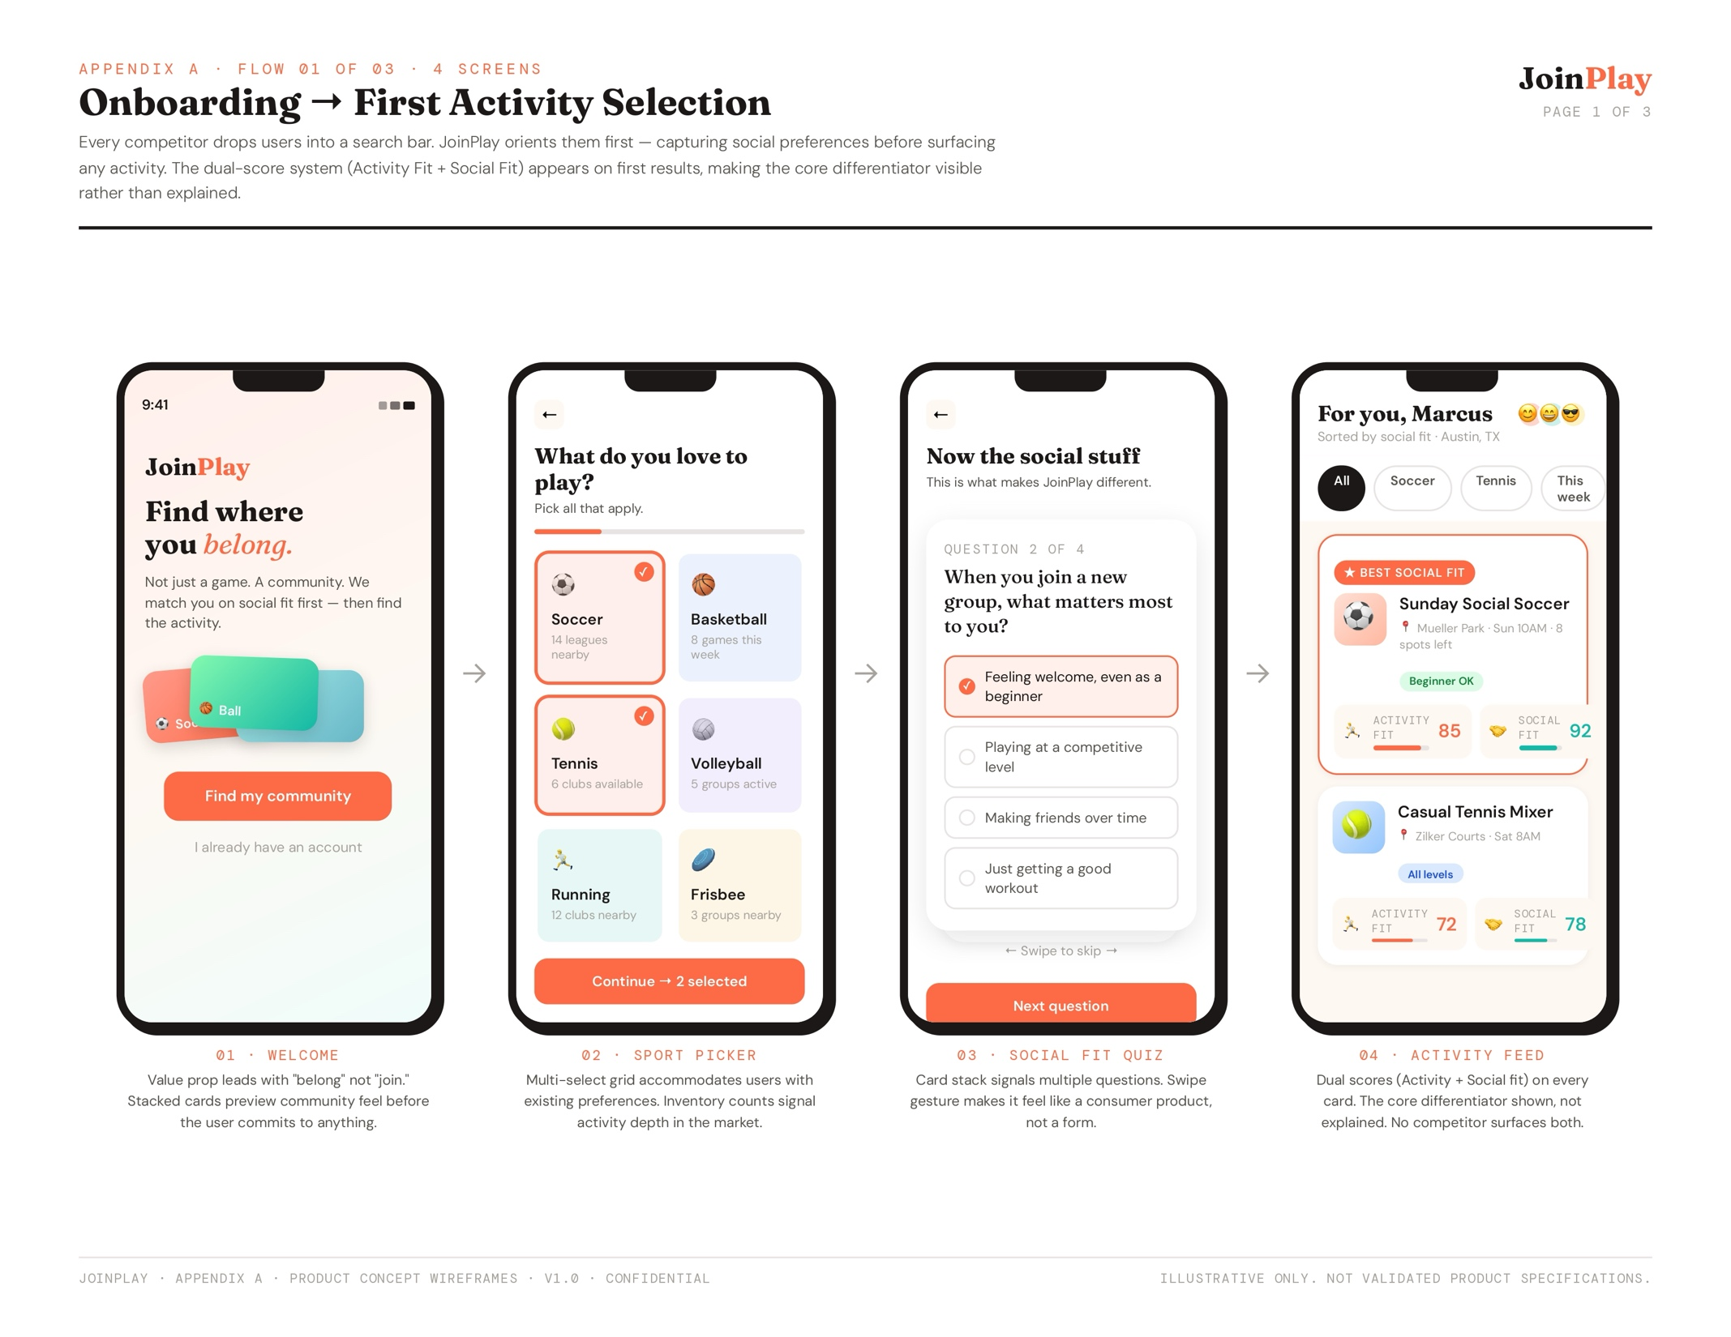
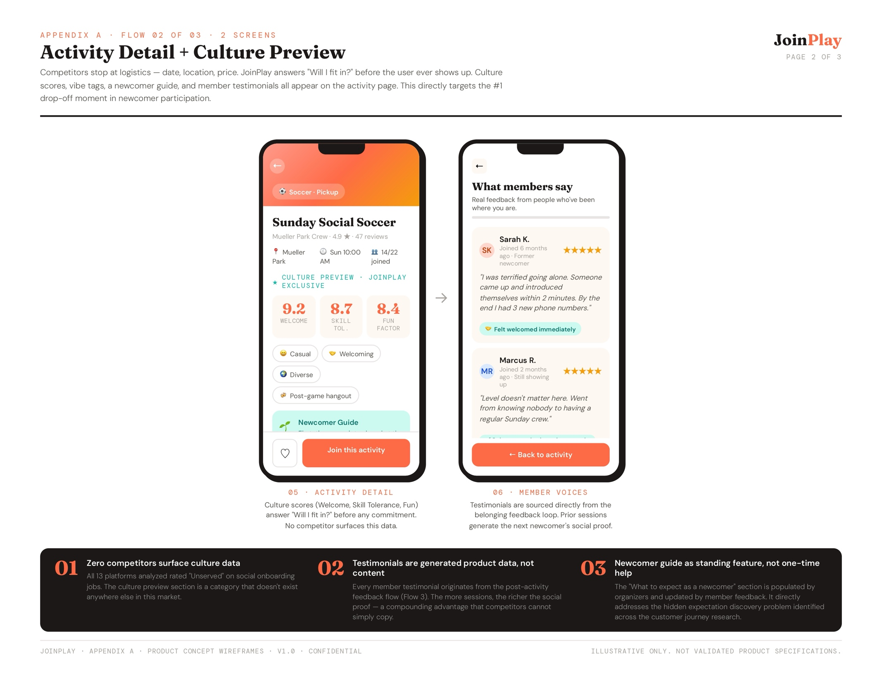
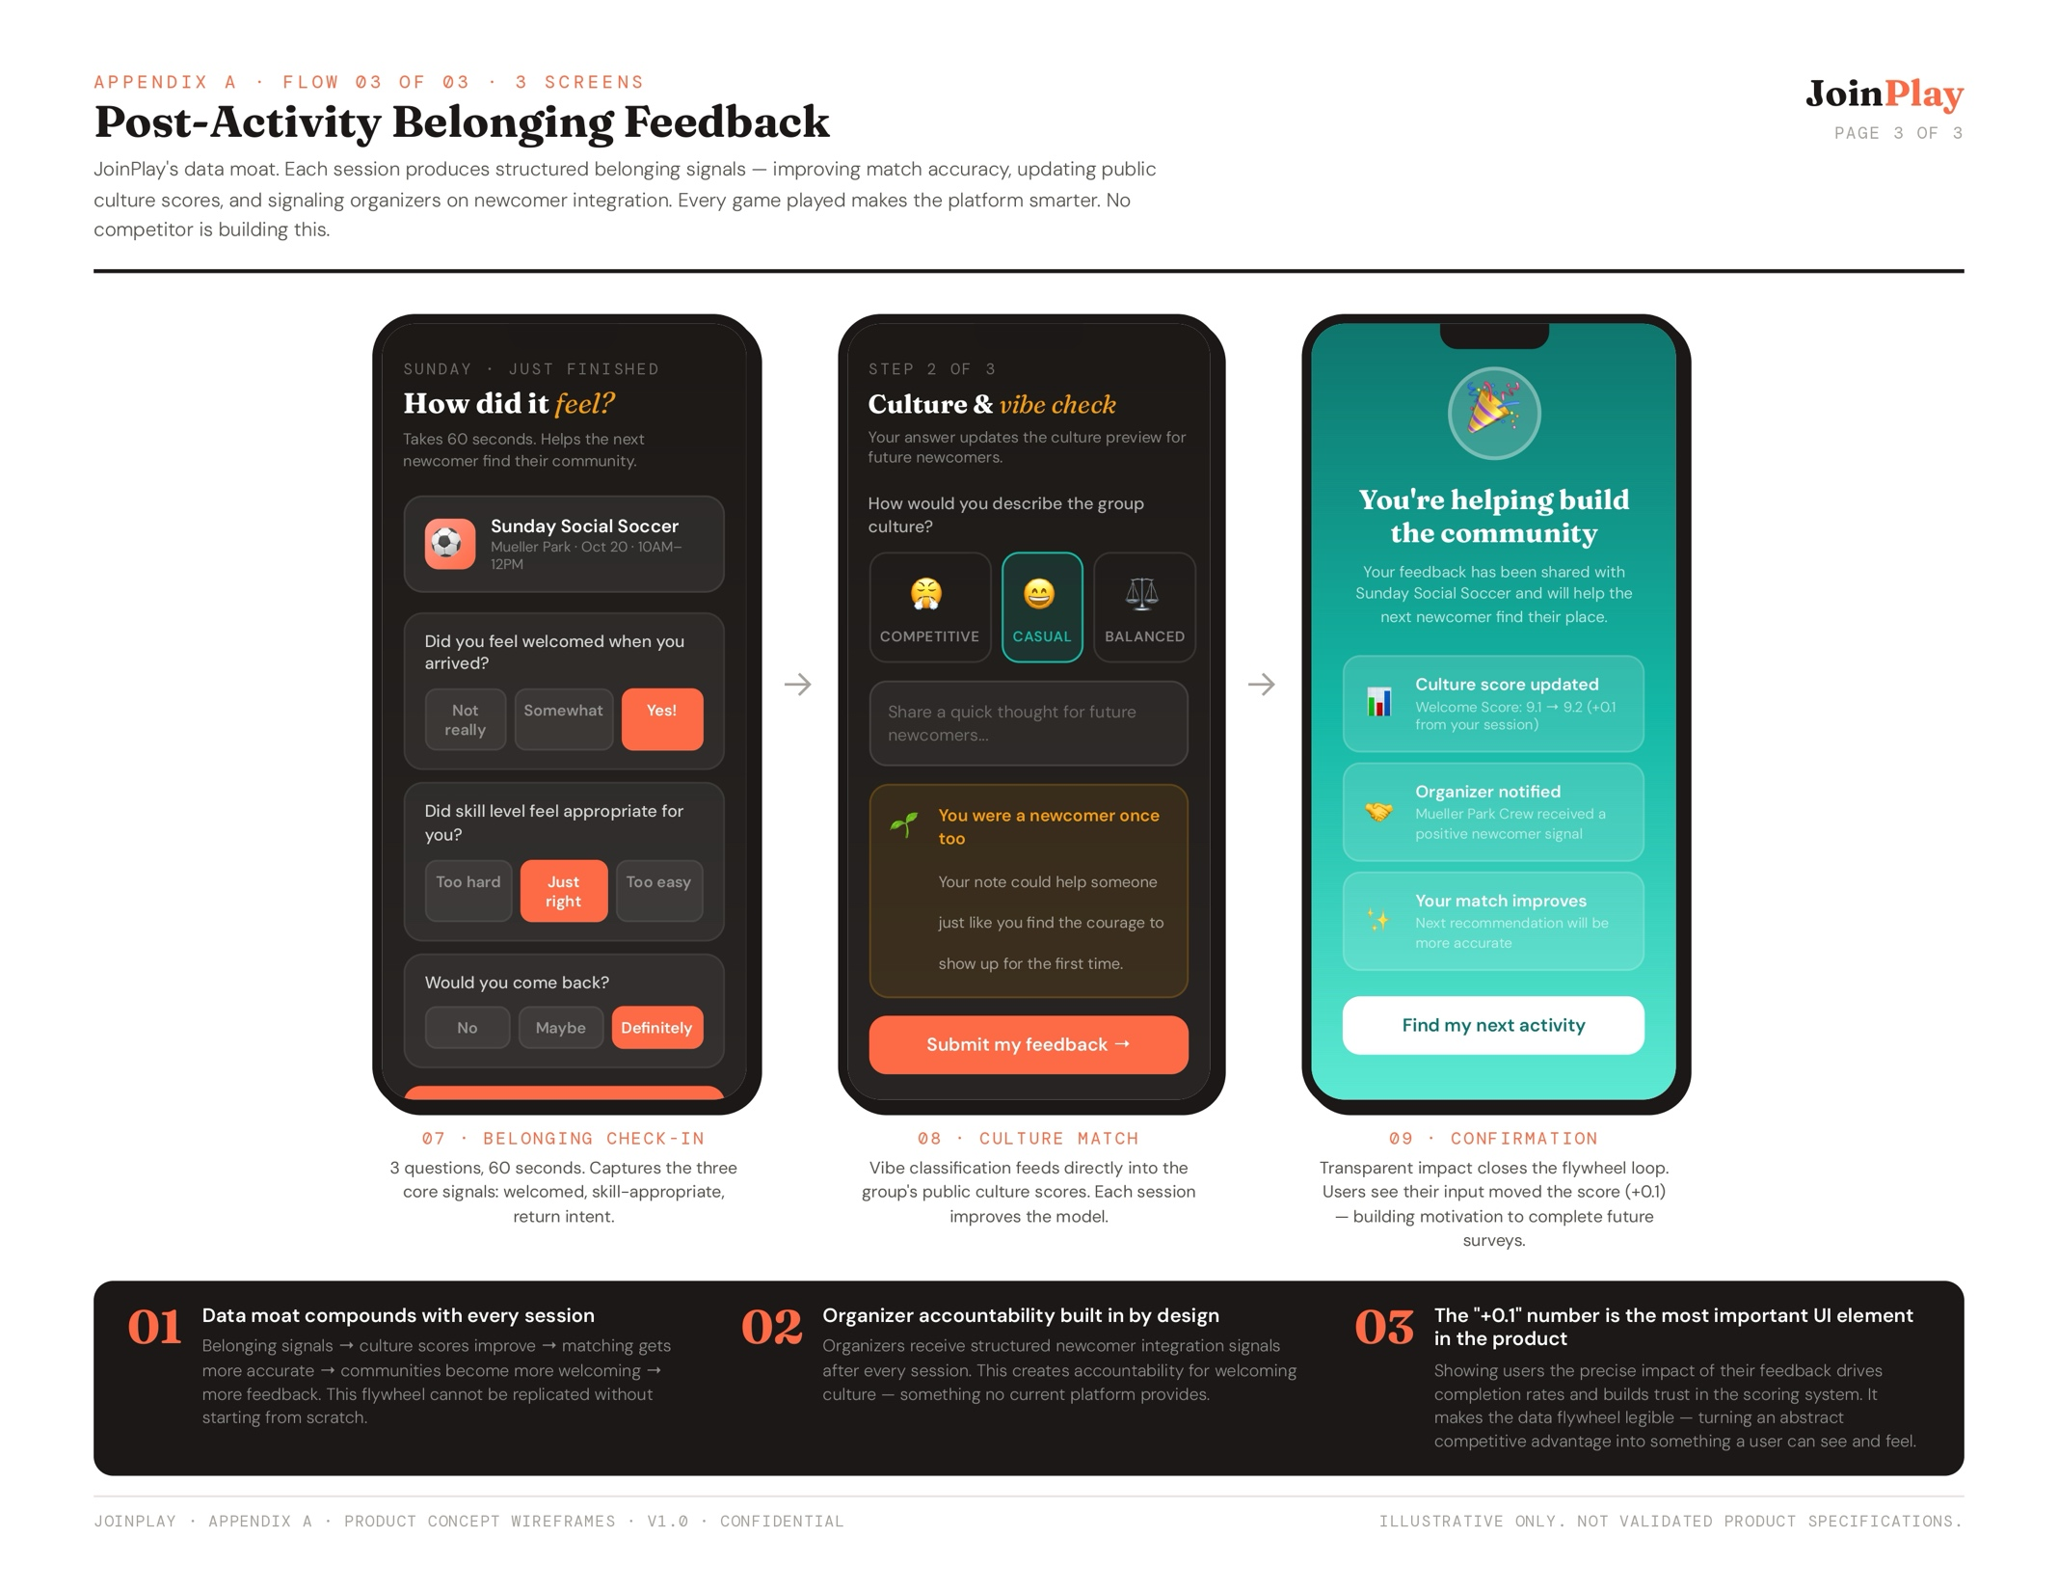
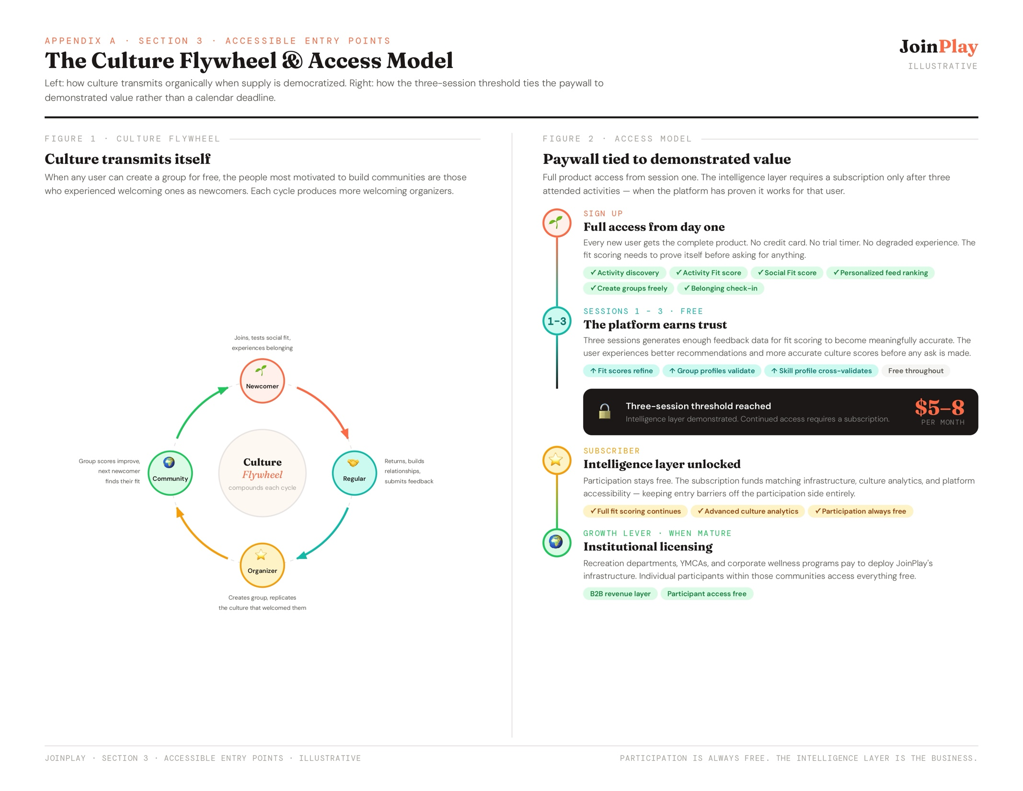
Product Launch Plan
The development plan for the MVP follows a framework that prioritizes solving social integration anxiety before adding complexity, maintaining focus on the core differentiation rather than competing on logistics where established platforms already excel.
- [Phase 1] Critical Path to Value. Core features that enable the fundamental value proposition and solve for the complete user journey at minimum viable functionality before adding complexity. Users can discover, evaluate, join, and provide feedback – the entire loop that validates the hypothesis.
- User registration and authentication
- Basic profile creation (sports interests, skill self-assessment, social preferences)
- Activity feed showing local opportunities
- Activity detail pages with logistics AND culture indicators
- Simple "I'm interested" / "I'm going" functionality
- Post-activity prompt: "How was your experience?" with belonging-specific questions
- [Phase 2] Social Integration Core. Now that basic functionality works, add the social integration features that create the competitive moat. These features are where the product diverges from logistics-focused competitors.
- Social fit scoring algorithm (attitude matching, competitive intensity alignment, skill compatibility)
- Culture preview system (participant testimonials, group philosophy, newcomer experience descriptions)
- Skill-social matching that balances "appropriate challenge" with "comfortable social environment"
- Enhanced belonging feedback (specific questions about welcome, culture match, return intent)
- Activity search and filtering by social attributes (not just logistics)
- [Phase 3] Belonging Feedback Loop. Create the feedback systems that ensure communities maintain welcoming cultures and users feel validated. This turns social integration from a one-time event into a systematic process. Advanced social features:
- Organizer dashboard showing newcomer integration success rates
- Reputation system for participants who welcome newcomers
- Community health metrics visible to organizers and participants
- Social validation messaging ("3 people like you had great experiences here")
- Belonging confirmation notifications ("The group loved having you—come back!")
- [Phase 4] Community Building. Once users successfully integrate, these features give them tools to deepen relationships and contribute to community health. This increases engagement and results in greater retention and lifetime value.
- Direct messaging between participants
- Activity organizer tools (create activities, manage RSVPs, view community health)
- Community moderation framework (reporting, organizer guidelines, conflict resolution)
- Social recognition (badges for welcoming behavior, consistent participation)
- Connection suggestions based on shared interests and proximity
- [Phase 5] Retention & Growth. Growth accelerators are only added after proving the core value proposition. This ensures healthy community growth rather than rapidly scaling a broken experience. Features that drive viral growth:
- Referral system rewarding successful social integrations
- Social sharing of positive experiences (with privacy controls)
- Community ambassador program for super-users
- Recreation center partnership tools
- Integration with existing sports platforms
Go-To-Market Strategy
The go-to-market approach prioritizes community-embedded growth over pure digital acquisition, focusing on quality over volume, and building deep community engagement in initial markets before expanding geographically. Success metrics focus on social integration speed (time from first activity to feeling welcomed), belonging confidence scores, and community health indicators rather than pure user acquisition numbers.
  - [Phase 1] Community Partnerships. (Months 1-3). Partner with local recreation centers, sports retailers, and community organizations for co-marketing and referral programs. These partnerships provide trusted local endorsements at the point of sports consideration, dramatically improving conversion rates despite higher partnership costs compared to digital channels.
  - [Phase 2] Search & Discovery Optimization (Months 2-4). Target problem-based searches ("pickup basketball near me," "find tennis partners") through Google Search marketing and SEO-optimized content. This captures users at the exact moment of need recognition with high intent and strong conversion potential.
  - [Phase 3] Word-of-Mouth Amplification (Months 3-6). Leverage social media content marketing (Instagram/TikTok lifestyle content, Facebook community groups) and community ambassador programs. Social-driven users show highest lifetime value and align with our community-building model.
  - [Phase 4] Embedded Growth (Months 6+). Deploy QR codes at sports facilities for contextual, immediate access at low ongoing cost. Implement referral systems that reward successful social integration rather than just new signups.
Success Metrics
Differentiation is at the crux of what can make JoinPlay successful and will be highly represented in what is measured:
- Social Integration Speed: Time from first activity to reported sense of belonging
- Belonging Confidence: Post-activity ratings of "feeling welcomed" and "would return"
- Culture Match Accuracy: Alignment between expected and actual group culture
- Community Health: Organizer welcoming behavior scores and newcomer integration success rates
- Retention Drivers: Social bonds formed vs. activity satisfaction as predictor of return
These metrics ensure the product is being optimized for its core value proposition (social integration and psychological safety) rather than getting distracted by logistics metrics where it isn’t differentiated.
Table 4: Metrics. Aside, from the primary success metrics, a weekly business review will look at the following metrics:
 | Metric | Category | Frequency | How Measured | Early Target
1 | Belonging Confidence Score | Social Integration | Weekly | Avg post-activity rating on "I felt welcomed by this group" (1–5 scale) | ≥4.0 / 5.0
2 | Social Integration Speed | Social Integration | Weekly | Median days from signup to user reporting a sense of belonging | <14 days
3 | Culture Match Accuracy | Social Integration | Weekly | % of users rating expected-vs-actual culture alignment ≥4 out of 5 | ≥70%
4 | Newcomer Absorption Rate | Social Integration | Weekly | % of newcomers who return to the same group at least twice | ≥50%
5 | Community Health Score | Social Integration | Weekly | Composite: organizer welcoming ratings + newcomer integration success rates | ≥80 / 100
6 | New User Signups | Acquisition | Daily | New accounts created per day | 50+ / week (Phase 1)
7 | Onboarding Completion Rate | Activation | Daily | % of new users who complete full social profile setup | ≥80%
8 | First Activity Completion | Activation | Weekly | % of new users attending ≥1 activity within 7 days of signup | ≥60%
9 | Weekly Active Users (WAU) | Engagement | Weekly | Users who browse or join ≥1 activity per week | 40%+ of registered
10 | Activity Join Rate | Engagement | Weekly | Avg activities joined per active user per week | ≥1.5
11 | Post-Activity Feedback Rate | Engagement | Weekly | % of attended activities where user submits belonging feedback | ≥70%
12 | Retention: Social Bond vs. None | Engagement | Weekly | 30-day return rate for users who formed connections vs. those who did not | 2× differential
13 | Trial-to-Paid Conversion | Monetization | Weekly | % of users converting to paid subscription after 3-session free trial | ≥15%
14 | Monthly Churn Rate | Monetization | Weekly | % of paid subscribers who cancel in a given month | <5%
15 | MRR Growth | Monetization | Weekly | Week-over-week growth in monthly recurring revenue | +10% / mo (Phase 2)
16 | Active Groups | Supply Health | Weekly | Groups posting ≥1 activity in the past 7 days | Baseline only (Phase 1)
17 | Organizer Retention Rate | Supply Health | Weekly | % of organizers who post at least one activity in their second month | ≥70%
18 | Group Capacity Utilization | Supply Health | Weekly | % of activity spots filled across all listed events | ≥65%

Callout: Several of the primary social metrics (Belonging Confidence Score, Culture Match Accuracy) can't be measured until the post-activity feedback loop is built, and survey response rates are historically low (from professional experience). To ensure ≥70% feedback completion before these become meaningful metrics, feedback completion will be a prerequisite (instead of hoping users volunteer the information) to unlock certain platform features in the early MVP.

Frequently Asked Questions (FAQs)
- These are our tenets (unless you know better ones):
  - Belonging Before Logistics. We solve "Will I fit in?" before optimizing scheduling or payments. Every feature decision prioritizes psychological safety over operational efficiency.
  - Operations Are Never Optional. Broken logistics destroys trust faster than bad social fit. A community that can’t reliably coordinate isn’t a community.
  - Community Depth Is the Leading Indicator. Integration quality predicts long-term growth because connected users stay, invite others, and build the density that makes social matching work. High retention with low integration is a warning sign, not a success.
  - Scale Enables Belonging. Social matching only works at volume. Without enough users, fit options are too narrow to be meaningful. Growth that outpaces integration quality is a risk, but growth that never comes is a bigger one.
  - No Financial Gatekeepers. We make participation accessible first. Pickup games, drop-in options, low or no-cost entry. Sports shouldn’t require money to belong.
  - Accessibility Requires Revenue. Free doesn’t scale, and premium features fund the accessibility mission. Staying free is a choice with a deadline.
  - Accurate Previews Over Appealing Ones. A user who shows up and doesn't belong never comes back. Accurate previews of group culture, skill levels, and social dynamics provide the core foundation of the product.
- Platform or Native App? JoinPlay will launch as a Progressive Web App (PWA) rather than native iOS/Android apps for several strategic reasons:
  - Faster iteration: Web-based development allows rapid testing and deployment of new features without app store approval delays. This is critical for early-stage hypothesis testing.
  - Lower Development Cost: PWA allows for a single codebase to serve all platforms. With AI assistance for technical implementation, this dramatically reduces development time and cost.
  - Easier A/B Testing: Can test different social integration approaches, messaging, and matching algorithms without version fragmentation.
  - Reduced discovery friction: Users can access via web browser without download barriers. Important for casual users testing if they'll engage. App stores are also bad for maximizing awareness and only adequate for evaluation – users don't browse app stores when first realizing they want local sports activities. Starting web-first aligns with how users discover solutions.
  - Future Mobile Path: Once product-market fit is proven, we can build native apps that leverage the proven web experience. The PWA serves as a working prototype for native development.
- What is your Safety & Moderation approach? As a platform facilitating in-person meetings, safety is paramount. The following features will be incrementally prioritized and added to the platform.
- Pre-Participation Verification:
- Email/phone verification for all accounts
- Optional social profile linking for additional trust signals
- Activity organizer verification process
- Clear community guidelines visible during onboarding
- In-Activity Safety:
- Activities occur in public spaces (parks, recreation centers, sports facilities)
- Group activities rather than one-on-one meetings
- Encourage bringing friends/partners, especially for first activities
- Location sharing features for user safety
- Post-Activity Accountability:
- Rating system for both participants and organizers
- Specific safety and behavior feedback mechanisms
- Clear reporting tools for inappropriate behavior
- Organizer accountability for community culture
- Platform Moderation:
- Community guidelines emphasizing respect, inclusion, and safety
- Tiered response system (warnings, temporary bans, permanent removal)
- Human review of reported incidents
- Partnership with local recreation programs for additional oversight
- Privacy Protection:
- Users control what personal information is visible
- No social media-style public profiles unless user opts in
- Data minimization – collect only what's needed for matching and safety
- What other revenue model considerations were made? While the final business model requires further validation, research explored several viable options:
  - Freemium Model. The free tier allows basic activity discovery with limited matches and a standard joining experience, while the premium tier provides unlimited matching, advanced social fit insights, priority placement, and enhanced profile features.
    - Pros: Broad accessibility at entry. Users experience the product before committing financially, which lowers the barrier to adoption and widens the top of the funnel
    - Cons: The freemium line is hard to draw without degrading the core experience. If fit scoring is paywalled, free users get a logistics-only product that is identical to every competitor. If fit scoring is free, the subscription value proposition collapses. Most consumer apps get this balance wrong on the first attempt.
  - Community Subscriptions. Participants pay a monthly or annual subscription with an emphasis on ongoing community membership instead of per-activity fees, which aligns incentives with long-term engagement and belonging.
    - Pros: Aligns revenue with the belonging thesis. A membership frame signals ongoing community participation rather than transactional activity access, which is consistent with the product's core value proposition.
    - Cons: Asks users to pay before social fit is established which enables the same structural problem as a seasonal league fee, just cheaper. A user committing to a monthly subscription before their first session is still taking a financial risk before knowing whether the platform works for them.
  - Organizer Tools. Free for basic activity posting, with paid tiers providing activity promotion, advanced analytics, and community management tools. Monetizes the supply side while keeping the demand side accessible.
    - Pros: Keeps costs entirely off participants. Organizers are the direct beneficiaries of analytics and tools, so charging them rather than users is structurally aligned with the accessibility tenet.
    - Cons: Creates a two-class system between paid organizers who own the supply and free users who consume it. This is a subtle recreation of the insider/outsider dynamic the product is designed to eliminate. It also disincentivizes organic group creation, which is the mechanism that drives the culture flywheel. If creating a group requires payment, the people most motivated to build welcoming communities (former newcomers who want to replicate what worked for them) face a financial barrier at exactly the wrong moment.
  - Partnership Revenue. Partnerships with recreation centers (white-label solutions, referral fees), sports retailers (contextual equipment recommendations), and corporate wellness programs (team licenses) replace consumer monetization with B2B revenue supplements.
    - Pros: Removes cost entirely from the participant side. Institutions with community-building mandates (parks departments, YMCAs, employer wellness programs) have existing budgets and a clear reason to pay for an outcome they are already trying to achieve with less effective tools.
    - Cons: Dependent on platform maturity to be credible in B2B sales conversations. Institutional buyers need evidence of community density and demonstrated outcomes before committing. This model is not viable as a primary revenue source at launch, and building toward it requires capital before it generates any return.
  - Hybrid Approach (Selected Model). Free basic access for all participants (accessibility tenet); premium features for power users seeking enhanced experiences; tools and analytics for activity organizers; partnership revenue from community organizations and brands.
    - Pros: Threads the needle between accessibility and revenue. The three-session threshold where full product access is free until three attended activities, and subscription is required after, ties the paywall to demonstrated value rather than a calendar deadline. By the third session, the fit scoring is meaningfully accurate, the user has experienced the product working, and the ask is credible. Democratizing group creation (free for all users) protects the culture flywheel: the people most motivated to build welcoming communities are former newcomers, and removing financial friction at the point of group creation keeps that mechanism intact. Institutional licensing is preserved as a growth lever for when the platform has the community density to support B2B sales conversations.
    - Cons: Subscription revenue compounds slowly and requires meaningful user volume before the business is viable. In mid-size cities with smaller addressable populations, hitting subscription scale takes longer than in major metros. The mid-size city strategy buys time by delivering genuine value on the logistics layer (which is underserved in those markets) while the social integration layer matures. That runway is real, but it requires a hard internal commitment to a timeline for when the social integration layer must stand on its own, and intentional early community seeding to ensure feedback data reflects the target user rather than whoever shows up first because discovery was broken.
Appendix
- Seattle-area Facebook Group for recreational soccer. With 22.1K members, this proves the demand exists; but even in this active group with posts made by a diverse user group every hour or so, newcomers to the group or the sport, (1) need inside knowledge of division labels, league acronyms, facility names, or position terminology, as well as (2) have no way to assess fit before committing, requiring “cold-call” DMs to strangers with no culture signal or group vibe.
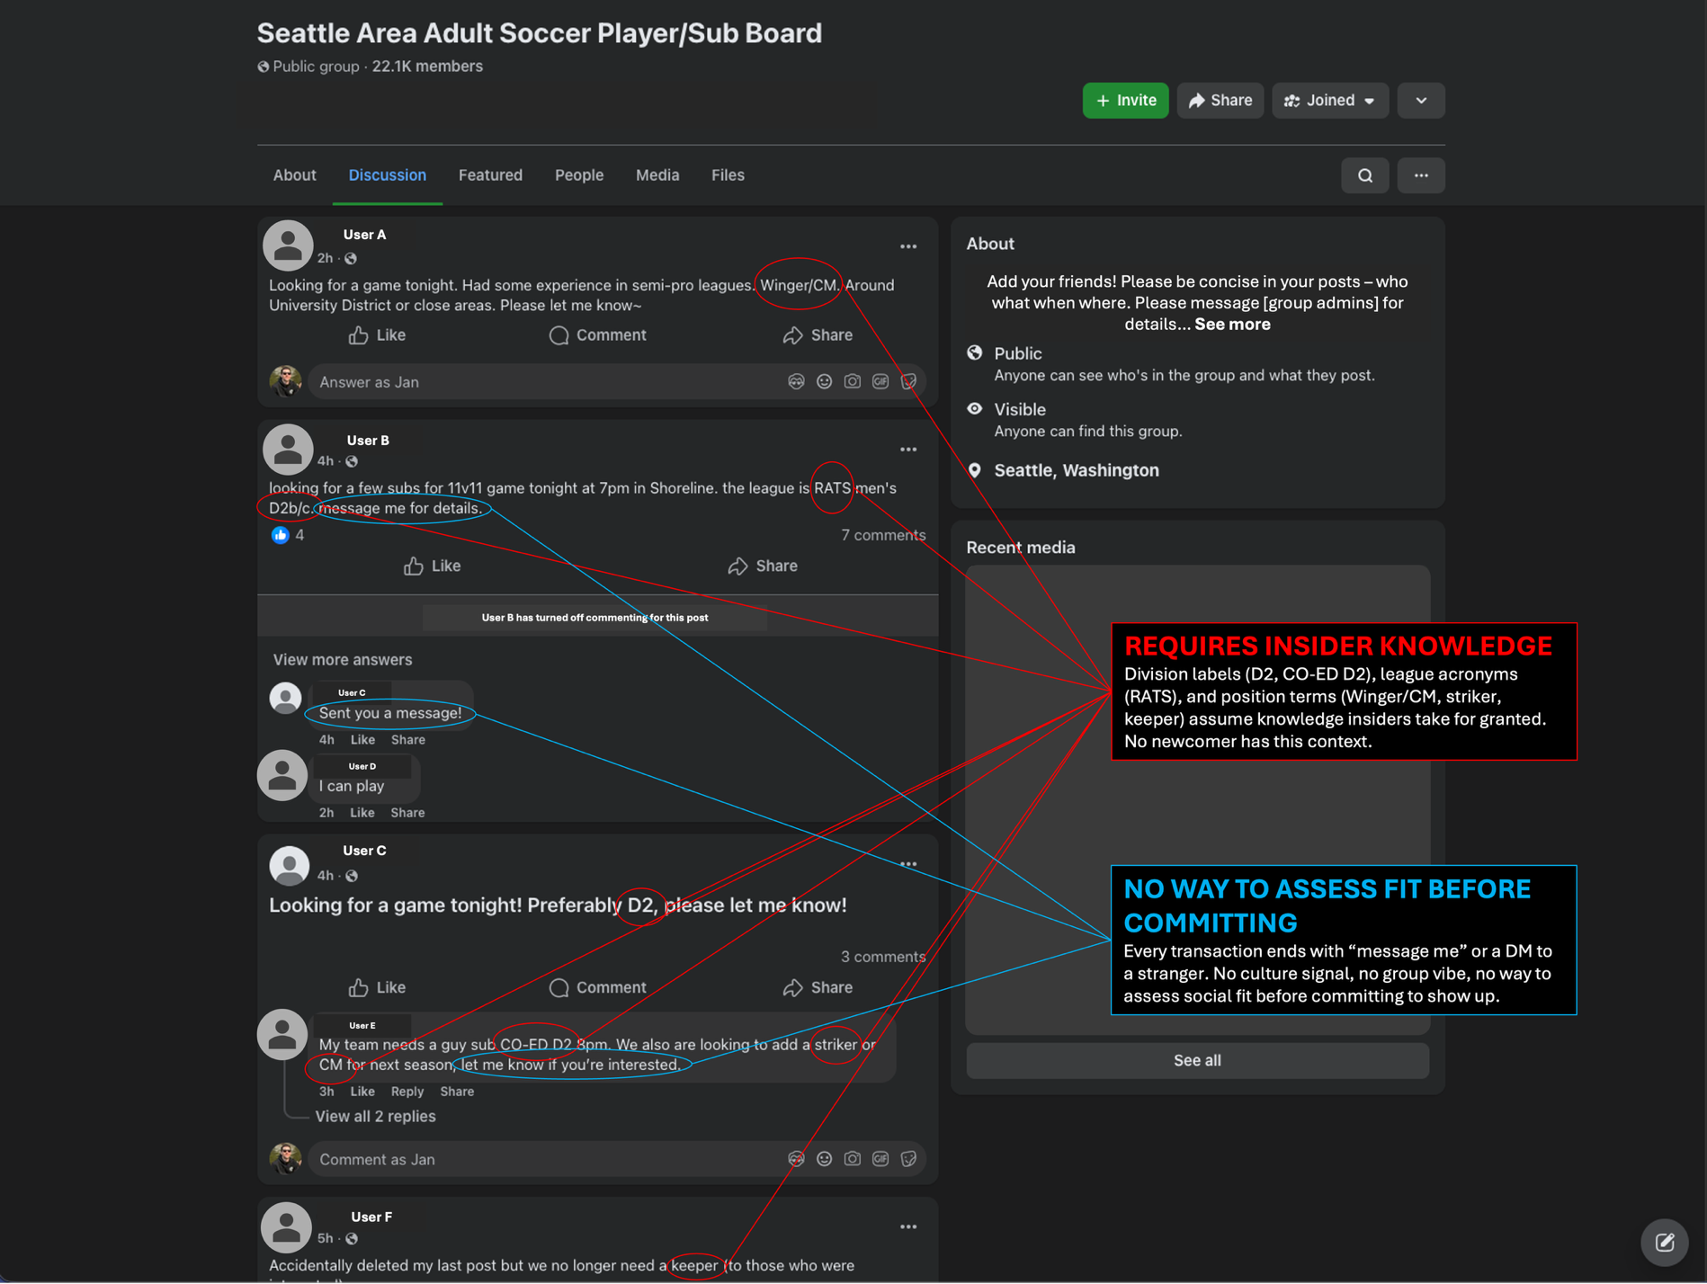
- JTBD Competitive Analysis – Methodology & Framework. This analysis evaluates 13 competitor platforms across 16 Jobs-to-Be-Done organized into three tiers: Access & Readiness (1–5), Social Integration (6–11), and Identity & Belonging (12–16). Each platform was rated Adequate (job substantially served), Underserved (partial coverage with meaningful gaps), or Unserved (job not addressed in platform design). Ratings reflect platform-level design intent, not individual organizer or community variation.
The “Jobs-To-Be-Done” were identified from the perspective of a skill-diverse active teen or adult who has a moderate athletic identity, is socially motivated, and has some sports experience with a balanced non-intense attitude towards sports participation. The core job to be done that informs all these jobs is ‘To connect with and join local sports activities.’
(blank page)

Eather N, et al. Systematic Reviews. 2023; 12:102.
JTBD (Jobs-To-Be-Done): a framework that focuses on understanding the fundamental "job" a customer is trying to accomplish, rather than just their demographics or the product's features, and views customers as "hiring" a product to get that job done in specific life situations.
Inside Youth Basketball 2025. The Luka Dončić Foundation & Nonfiction Research.
2025 Youth Sports Parent Survey, Aspen Institute Project Play initiative, Utah State University Families in Sport Lab, Louisiana Tech University Minds in Motion Lab. 2022 and 2019 figures are from previous Aspen Institute surveys with Utah State and Louisiana Tech.
Sports Destinations. (2024). "Record Number of Americans Participated in Sports." https://www.sportsdestinations.com/sports/all-sports/record-number-americans-participated-sports-33929
CivicScience. (2023-2025). Recreational sports league research: - (June 2023). "Americans Embrace Recreational Sports Leagues to Improve Health and Social Connections Post-Pandemic." https://civicscience.com/americans-embrace-recreational-sports-leagues-to-improve-health-and-social-connections-post-pandemic/ - (April 2025). "Rec Sports on the Rise: 1 in 4 Adults Eye Summer League Play, Seeking to Relieve Stress." https://civicscience.com/rec-sports-on-the-rise-1-in-4-adults-eye-summer-league-play-seeking-to-relieve-stress/
Mid-sized American cities demographic analysis: - Metroideas. (2016). "Get to Know America's Midsize Cities." https://metroideas.org/blog/get-to-know-americas-midsize-cities/ - Big Towns. (2026) "What is a Big Town? A Look at Mid-Sized America." https://bigtowns.org/news/what-is-a-big-town-a-look-at-mid-sized-america/
Profluence. (2024). "Adult Social Sports Market Research." https://profluence.com/adult-social-sports/
WTP (Willingness To Pay) is the maximum price a customer is willing to spend for a product or service. Expressed as a $ figure or range, this amount is determined through methodological surveying, in which a target customer is presented multiple similar products with varying features removed or added at different price points and asked to choose which ones they would buy.

