Beginning Spring MVC

Spring MVC is—as its name suggests—an implementation of the model-view-controller design pattern. The MVC pattern is fundamental to lose coupling between the data, its visual representation and manipulation. In MVC terms, the data is the model, the visual representation of the data is the view and the data manipulator is the controller.

The MVC pattern is not restricted to just the web; you may find the MVC pattern in Java Swing applications and, outside Java for example in Objective-C Cocoa and Carbon applications.

The clear separation between the M, the V and the C in the pattern means that it is easy to make changes to each of the components with as little impact on the other components. This is the principle of loose coupling and, therefore, it should not be a great surprise that the MVC pattern gets extensive support in the Spring Framework. Even though the MVC pattern does not impose any environment, Spring MVC deals only with web applications.

In this chapter, we will explore how the Spring Framework implements the MVC design pattern. To fully understand this chapter, you will need to understand dependency injection, you need to be fluent in Java annotations and you should be able to understand HTML.

Java EE web application revisited

We begin by looking at Java EE web applications. Unlike the command-line applications we have been implementing so far, web applications do not have any public static void main(String[]) method. This method is in the servlet container (Tomcat, for example). The servlet container expects the web application to follow a predefined structure; it looks for descriptor files and, using the information in the descriptor files, the servlet container can run the web application.

In practice, the Java EE web application’s structure must follow the one shown in Figure 1.

Figure 1. Java EE web application structure

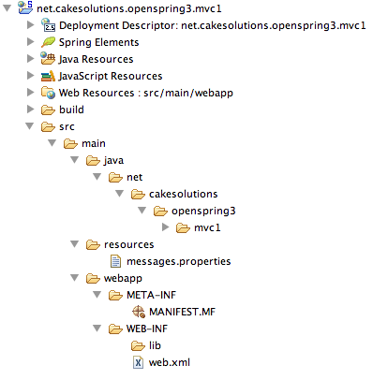

Now, the servlet container will read the contents of the web.xml file and construct any servlets it defines. In our case, the servlet is Spring’s DispatcherServlet. The DispatcherServlet will construct the Spring application context by reading a file whose name follows the servletname-context.xml convention. This Spring application context file defines all controllers, view resolvers, annotation handlers, validators and many other components we will cover in this chapter. In real applications, these web components usually need the rest of the application components to operate: the services, which in turn use the repositories, and so on. These components must be ready before the DispatcherServlet attempts to construct the web components. Spring web applications use the ContextLoaderListener to construct the bowels of the application, even before the DispatcherServlet sees the first request. Listing 1 shows the most important elements of our web.xml file.

Listing 1. Web.xml file

<?xml version="1.0" encoding="utf-8"?>

<web-app xmlns="http://java.sun.com/xml/ns/javaee"

xmlns:xsi="http://www.w3.org/2001/XMLSchema-instance"

xsi:schemaLocation="http://java.sun.com/xml/ns/javaee

http://java.sun.com/xml/ns/javaee/web-app_2_5.xsd"

version="2.5">

<listener>

<listener-class>

org.springframework.web.context.ContextLoaderListener

</listener-class>

</listener>

<context-param>

<param-name>contextClass</param-name>

<param-value>

com.springsource.server.web.dm.ServerOsgiBundleXmlWebApplicationContext

</param-value>

</context-param>

<servlet>

<servlet-name>mvc1</servlet-name>

<servlet-class>

org.springframework.web.servlet.DispatcherServlet

</servlet-class>

<load-on-startup>1</load-on-startup>

</servlet>

<servlet-mapping>

<servlet-name>mvc1</servlet-name>

<url-pattern>/</url-pattern>

</servlet-mapping>

</web-app>

The two most important elements in Listing 1 are the ContextLoaderListener (with its context-param set to ServerOsgiBundleXmlWebApplicationContext) and, the DispatcherServlet. It is time to explore how the DispatcherServlet handles the requests.

The story of the film so far

If we were in Monty Python and the Holy Grail, we could say:

Doug and Bob are metropolitan policemen with a difference. Doug likes nothing more than slipping into little cocktail frocks, while Bob bouffants his hair for a night on duty. Still, as the art immace, no one gives their last names.

The real story of the film so far:

Pucky Reginald Vas Deferens is a nuclear scientist in love with mafia boss Enrico Marx, who is himself married to Conchito Macbeth, a lively belly-dancer at the Belgian disco whose manager…

Unfortunately, we are just Java EE programmers. And so, we have to explore what happens in our servlet container (see Figure 2).

Figure 2. Java EE web application start up

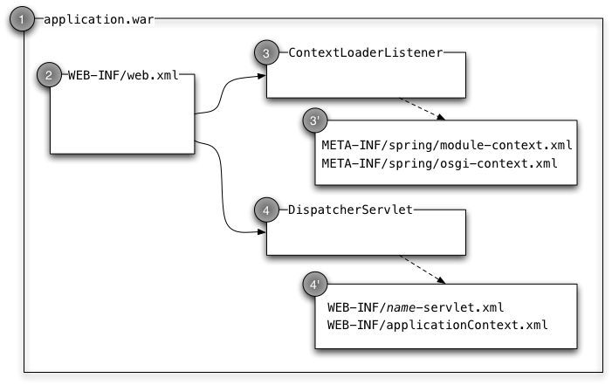

We see that the servlet container deploys our application (1) and, during this process, it reads the WEB-INF/web.xml file. The web.xml file defines the ContextLoaderListener and the DispatcherServlet. The ContextLoaderListener builds the bowels of our Spring-powered application. It does this typically by looking for all module-context.xml and osgi-context.xml files in the META-INF/spring directory. So much for Spring-powered applications. However, even in traditional (read old-school) servlet applications, there are usually multiple servlets, each servlet implemented in its own class and each servlet handling requests to a specific URL. In Spring web applications, there is usually just the DispatcherServlet, which handles all requests.

From high above, the DispatcherServlet needs to route the requests to the appropriate controllers; the controllers react to the requests, prepare models and indicate which view should render the model. The dispatcher servlet takes the model and the view and finds the required view that will ultimately render the model. The DispatcherServlet will return whatever the view’s rendering method returns. In this sense, the DispatcherServlet is the controller, the components we call controllers in Spring are more like controller workers. In Spring-speak, they are sometimes called handlers.

Read on to find out how the DispatcherServlet does this.

The DispatcherServlet

As you have already seen, the DispatcherServlet is the central point of a Spring Framework web application. The servlet handles all requests (passed on to it by the servlet container). To handle the request, it must find one of our controllers, look up the appropriate handler method; then it must examine the handler method’s signature and prepare the argument values. It must then invoke the method and examine the returned value. Depending on the returned value, the DispatcherServlet may have to find the appropriate view. Finally, it will take the model the handler method prepared (the model may remain empty if the handler method does not add any attributes to the model); it will give the prepared model to the view and pass on whatever the view returned back to the servlet container as the response to the request. The servlet container will in turn pass on this response to the client. Figure 3 shows what is happening.

Figure 3. DispatcherServlet processing requests

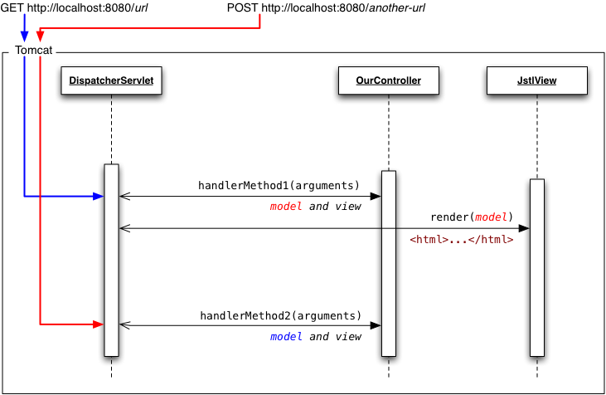

What can the DispatcherServlet use to route the request—and here by request we mean the HttpServletRequest? It can use its URL, HTTP method, query parameters, header parameters, and the values of the cookies. In fact, the DispatcherServlet can use any combination of these attributes of the HttpServletRequest to find the appropriate handler (and appropriate method in the handler) that maps to the request. Once the handler method completes, the DispatcherServlet will examine the returned value and locate the appropriate view and pass the model the handler method prepared to the view’s rendering method.

However, it would be bad design to include all code to handle all the request routing logic in the DispatcherServlet itself. Furthermore, there is infinite number[1] of combinations for the arguments of the handler methods. Additionally, the handler methods should be able to signal how the rest of the framework should continue processing the request. The DispatcherServlet therefore needs these components:

HandlerMapping  
Finds handler chain that could handle the request (typically the “controller” beans); it maps the requests to a chain of handlers that could contain handler methods that may ultimately handle the request.

HandlerAdapter  
Presents a unified interface to allow the DispatcherServlet to invoke the handler method; it adapts the varying handler method signatures, thus allowing the DispatcherServlet to execute any handler method.

ViewResolver  
Allows the DispatcherServlet to locale an appropriate View interface implementation if the handler method does not return the ModelAndView object with its view property is not null; if all that the DispatcherServlet has is a view name (we will explore how it may obtain it later on), it will use the ViewResolver to resolve the name into a View).

Request routing

Let’s now examine in detail how the DispatcherServlet uses the HandlerMappings, HandlerAdapters and ViewResolvers to process the request. We begin by looking at how the Spring Framework locates the handler and the handler method to process the request. We will use the contemporary implementations: the DefaultAnnotationHandlerMapping and the AnnotationMethodHandlerAdapter. As the handler adapter’s and handler mapping’s class names suggest, they look at the annotations in the handler beans—we will explore the details later on in this chapter—for now, let’s assume that all handlers carry the @Controller stereotype annotation.

Suppose now that the servlet container receives some request; also suppose that the DispatcherServlet defined in the web.xml file is mapped to the request URL (see <servlet-mapping> in Listing 1). The servlet container will invoke the DispatcherServlet’s service method; the implementation of the DispatcherServlet will ultimately invoke the doDispatch method. The doDispatch method will then delegate to the configured HandlerMapping and HandlerAdapter to find the handler that will ultimately process the request. The HandlerMapping will construct the HandlerExecutionChain. The DispatcherSerlvet will then iterate over each entry in the HandlerExecutionChain and check that the configured HandlerAdapter can perform the required action given the handler and the request. If so, then the DispatcherServlet will call the HandlerAdapter’s handle method. The handle method returns ModelAndView, which, as its name suggests, contains the model and the view.

Unfortunately, the ModelAndView class name is misleading: it always contains the model; in some cases, it carries only the view name while in other cases it carries the complete View instance.

Once the HandlerAdapter’s hanle method completes, the DispatcherServlet will examine the returned ModelAndView, then:

if view is not null, the DispatcherServlet will invoke view.render(model);

if view is null, but viewName is not null, the DispatcherServlet iterate over all configured ViewResolvers and, for each ViewResolver, it will call the resolveView method to attempt to turn the String viewName into a View. The DispatcherServlet will use the first non-null View;

finally, if both view and viewName are null, the DispatcherServlet will attempt to find the view name using the configured RequestToViewNameTranslator. If the view and viewName remain null even after the translation, the DispatcherServlet will not perform any further processing (in this case, the handler method has typically written some output directly to the response)

This is the essence of request dispatching in Spring MVC. As you can see, it is not conceptually difficult; the DispatcherServlet carefully delegates the work to the HandlerAdapters, HandlerMappings and ViewResolvers.

Routing example

Let’s see how the routing strategy we discussed works in practice. We will use the code in Listing 2 to explain how the handler mapping and handler adapters work.

Listing 2. Simple controller

@Controller

**public class** IndexController {

@RequestMapping(value = "/a")

**public void** a(){

}

@RequestMapping(value = "/b")

**public** Stringb() {

**return** "x";

}

@RequestMapping(value = "/c")

**public** ModelAndViewc(){

}

}

Suppose now that the servlet container receives a HTTP request for /a URL (and that this URL is mapped to our DispatcherServlet and that we are using the DefaultAnnotationHandlerMapping and the AnnotationMethodHandlerAdapter): the HandlerMapping will return the HandlerExecutionChanin that contains only one handler, the IndexController. The DispatcherServlet will call the handler adapter’s handle method on the first and only entry in the HandlerExecutionChain. Now, the AnnotationMethodHandlerAdapter will discover that there is a method in the IndexController that can handle the /a URL (by examining the @RequestMapping annotation). It will then invoke the IndexController.a method. Because the method returns void, the model will remain empty (pay attention, empty not null!); and the view and the viewName will also remain null. Because the view and the viewName are null, there is no more work for the DispatcherServlet and the request processing completes.

Now, in another example, let’s issue a request for the /b URL. The handler mapping will return the same HandlerExecutionChain; the handler adapter will now find the b method in the IndexController. Because the b method returns String, the Spring Framework will use the returned String as the viewName. Therefore, in this example, the model will still remain empty, but the viewName is set. The DispatcherServlet will therefore iterate over all ViewResolvers and, for every ViewResolver, it will call its resolveView method. If that method returns a non-null View, the DispatcherServlet will take that view and call its render method, thus completing the request processing.

Finally, in the last example, the request is for the /c URL. The handler method returns ModelAndView, making the HandlerAdapter’s job easier: the adapter will take whatever model and view (or viewName) the handler method returns. The DispatcherServlet will continue processing just like in the previous two examples. Typically, in this situation, the returned ModelAndView will include some custom View instance.

The handlers

As we said in the previous section, we are going to consider the contemporary implementations of the HandlerMapping and HandlerAdapter interfaces: the DefaultAnnotationHandlerMapping and the AnnotationMethodHandlerAdapter. These implementations of the HandlerMapping and HandlerAdapter use the annotations on the handlers (the @Controller stereotype classes) and annotations on their methods.

We will begin with an overview of our goal: we would like to implement handler methods that handle requests in Table 1.

Table 1. URLs and handler methods

|  |  |
| --- | --- |
| URL | Handler method |
| GET /home | void home() |
| GET /posts?start=5&count=20 | void posts(int start, int count) |
| GET /post/my-post-name/edit | String edit(String title) |
| POST *post form* to /post/add | String add(Post post) |

Fear not, we will tackle requests that are more complicated later. For now, let’s construct the appropriate annotations and handler methods for our four example URLs. Typically, we’d create the “home” controller and “posts” controller, but in this example, we will use just one controller. Listing 3 shows its code.

Listing 3. Example controller code

@Controller

public class ExampleController {

@RequestMapping(value = "/home", method = RequestMethod.GET)

public void home() { }

@RequestMapping(value = "/posts", method = RequestMethod.GET)

public void posts(@RequestParam int start, @RequestParam int count) { }

@RequestMapping(value = "/post/{title}/edit", method = RequestMethod.GET)

public String edit(@PathVariable String title) {

return "viewName";

}

@RequestMapping(value = "/post/add", method = RequestMethod.POST)

public String add(@ModelAttribute Post post) {

return "redirect:/posts.html";

}

}

This fully implements the handler (and the handler methods) that handle the four URLs from Table 1. Let’s examine the methods and their annotations in detail, starting with

@RequestMapping(value = "/home", method = RequestMethod.GET)

public void home() { }

When the DispatcherServlet receives a request to the /home URL, it[2] will find this handler and the home handler method. It will use reflection to find the method’s arguments (none) and its return type (void). This means that the HandlerAdapter has very little work to do—there’s no need to prepare arguments or examine the return type. It will simply create empty ModelAndView object, invoke the handler method and return to the DispatcherServlet. The DispatcherServlet will see that the view and viewName in the ModelAndView are null, and will attempt to translate the request URI to view name. The DefaultRequestToViewNameTranslator will examine the request URI (/home) and return "/home" as view name. The DispatcherServlet will continue the request processing, invoking, in sequence, each configured ViewResolver’s resolveViewName method until the method returns non-null View or until there are no more ViewResolvers. If the DispatcherServlet obtains a View, it will call its render method, passing in the model.

Onwards! The next URL is /posts?start=5&count=20; its handler method is

@RequestMapping(value = "/posts", method = RequestMethod.GET)

public void posts(@RequestParam int start, @RequestParam int count) { }

When the servlet receives a GET request to the /posts URL, it will find the posts handler method in the ExampleController. The handler method adapter now has a bit more work to do. The handler method needs two arguments of type int and the arguments carry the @RequestParam annotation. The adapter understands that it will need to get the parameter values from the request. By default, the adapter will use the argument name as request parameter name. In essence, the adapter is executing this code:

int p1 = *convert*(request.getParameter("start"));

int p2 = *convert*(request.getParameter("count"));

ModelAndView mav = new ModelAndView();

handler.posts(start, count);

return mav;

The rest of the processing sequence remains exactly the same: the DispatcherServlet will attempt to translate the request to view name and then find the View using the configured ViewResolvers; if it succeeds, it will use the view’s render method to produce the response.

What would happen if we didn’t use the @RequestParam annotations in the handler method? The adapter would fail, because it would be unable to calculate the value of the parameter to pass to the handler method. After all, there are 232-1 possible values of int. Without giving the adapter information about the purpose of the parameter, it cannot proceed.

The next example uses path variables. As the name suggests, the handler method adapter computes the value of a path variable’s using an element of a path (in our case, the request URL). So, when the servlet receives a GET request to /post/my-special-post/edit, it will find the void edit(String) method in the ExampleController. The handler method adapter will process its parameters, and see the @PathVariable annotation. It will then assign the pattern represented by {title} in the @RequestMapping to the value of the parameter. The rest of the request processing remains, unsurprisingly, the same.

1. Really, there are infinitely many combinations of the handler methods’ arguments. For every n possible combinations you give me, I can always give you n + 1 combination. ■
2. Not the DispatcherServlet itself, naturally; but the HandlerMapping

   and HandlerAdapter