Hedger 1972: survey of buffalo in Chobe NP, Botswana. Pop size = 3000, 62 sampled.

If I use the suggested cut-off for seropositivity of “+ if >=32”, and designate as follows:

S = antibodies <32 AND no virus detected in probang;

I = viremia detected

R = antibodies >=32 AND no virus detected in probang

C = virus detected in probang (almost always this also means antibodies >32, but see \*\*)

-- then I get the following distribution:

age < 1yr (all <6m), N=6, all M (except \*)

age 1-2yrs, N=8, SAT1: 1S, 1I, 4R, 2C; SAT2: 1S, 5R, 2C; SAT3: 1S, \*\*5R, 2C

age 2-3yrs, N=9, SAT1: 2S, 6R, 1C; SAT2: 1S, 2R, 6C; SAT3: 1S, 3R, 5C

age 3-4yrs, N=8, SAT1: 3R, 5C; SAT2: 2S, 5R, 1C; SAT3: 6R, 2C

age 4-6yrs, N=11, SAT1: 1S, 8R, 2C; SAT2: 1S, 7R, 3C: SAT3: 1S, 9R, 1C

age 7+, N=19, SAT1: 2S, 14R, 3C; SAT2: 1S, 16R, 2C; SAT3: 16R, 3C

\* one newborn calf was seronegative for SAT2 (-?)

\*\* one animal was seronegaive for SAT3, but virus was isolated from probang: recent recovered animal (no viremia, but ab response not yet mounted).

Interesting patterns (to be regarded with skepticism, due to small sample sizes):

* dip in the fraction of recovered animals between age 2-3 for all SATs.
* Corresponding (ish) rise in carrier animals and maybe susceptibles.
* Recovered slump / carrier peak happens later in SAT1 than SAT2,3
* MAYBE immunity from initial infection wanes after a year or two, and animals become susceptible again. When re-exposed, some again become carriers, others recover directly-?
* After age 2-3, fraction of carriers declines, but not to 0 in this sample of animals
* After age 2-3, fraction recovered hovers between 60-80%, maybe equilibrating there?
* There are susceptible animals present in all age classes for SAT1,2, though perhaps not for SAT3.

Here is interpretation by the authors:

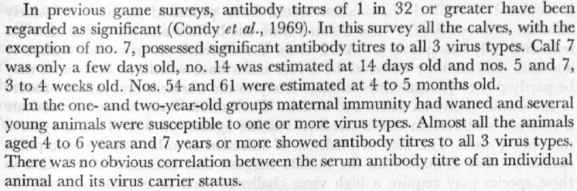

I did not find other surveys with usable data (no age designation, or serology and probang not done on the same / all individuals).