**Smartphone (Bluetooth) Controlled Car Using Arduino**

**Abstract -**This Work is based on Arduino, motor driver and Bluetooth module. Arduino is an opensource prototyping platform Based on easy-to-use hardware and software. Arduino uses an ATmega328 microcontroller. Since robotics has become a major part in our daily life and also in the engineering field and it plays a vital role in the development of new technology. This is a very simple and easy type form of remote control car, where the ordinary micro-controller has been replaced by Arduino and IR sensors has been replaced by a Bluetooth module. The remote can be any android or IOS cell phones. This project can be made in a bigger scale for real time vehicles.

**Block Diagram**

Basic schematic of the project:-

|  |
| --- |
|  |
|  |

**OUR WORK**

This project of ours is controlling car not by using a sensors or transmitter but using Bluetooth which is a very simple communication medium in the present day. The remote in this project is an android device which has an inbuilt Bluetooth module. The Bluetooth is a serial communication medium through which we can connect two devices. Here we have inserted a Bluetooth module which gets connected to the phone‘s Bluetooth, that allows us to communicate and allows to take command over it. The Bluetooth module does not work on its own in controlling the car. The main part in controlling the car is played by the Arduino UNO which houses the micro-controller ATMEGA32. Arduino has played a major role in the robotic section and has made it easier to convert digital and analog signal to physical movements. The project is Bluetooth based because it gives us wider range of control and more efficiency. It also gives us the advantage of changing the remote anytime, meaning that we can use any android devices including phones, tablets, computers. Physical barriers like walls, doors, etc. do not effect in controlling the car.

**Actual view of rover**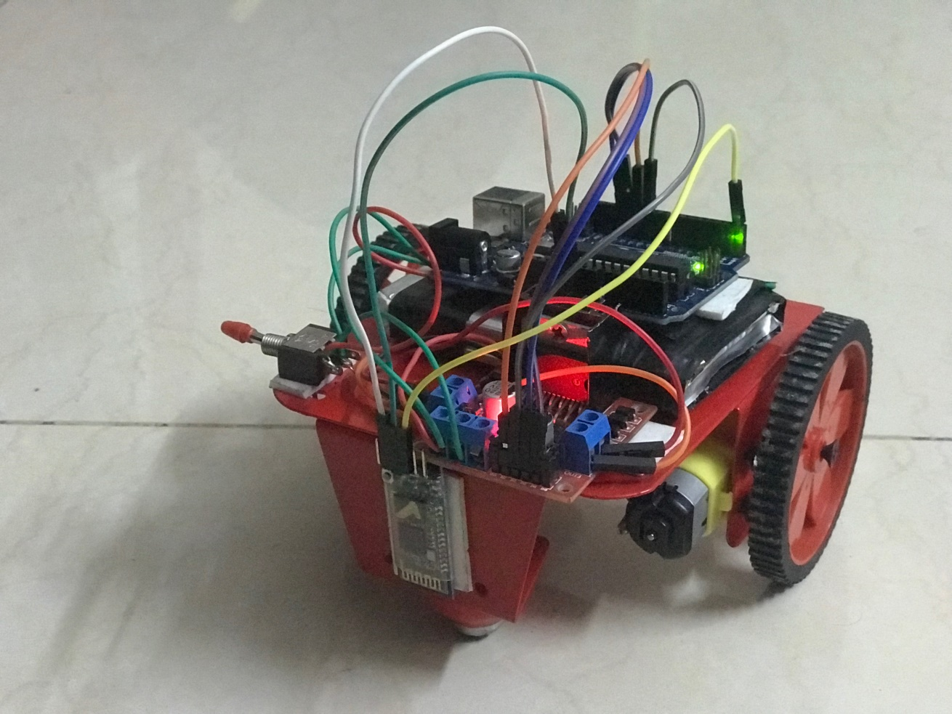

**Arduino uno**

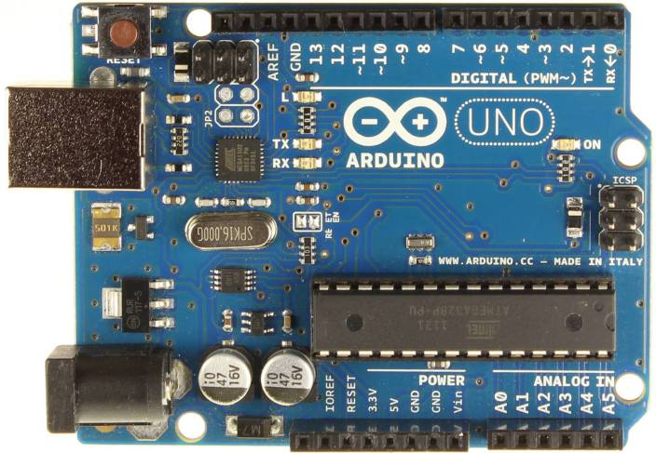

**CIRCUIT DESCRIPTION**

As show in the diagram, two rechargeable batteries as supply is used which is connected to motor driver and arduino respectively. When the circuit is energized, we will have to first pair the android phone with the Bluetooth module through the phones Bluetooth setting the default password of the Bluetooth module will be ‗1234‘. Once the phone gets paired open the application ‗CAR BLUETOOTH RC‘ which we can download from ‗Google play store‘. on opening the application there will be sets of control displayed on the screen. If the device has not been connected the control will be locked meaning the control buttons cannot be pressed. When the car is at its initial position the the application automatically sends the command ‗S‘ meaning stop. The stop command is put in a loop that keeps on repeating throughout the execution of the program. As the user presses any control buttons the stop command will be interrupted by the move forward, backward, right, left, depending on the user and the car moves like wise. The program is designed in such a manner that we can also give two commands at the same time i.e. move front and turn International Journal of Engineering Trends and Technology (IJETT) – Volume 33 Number 8- March 2016 ISSN: 2231-5381 http://www.ijettjournal.org Page 383 right or left and same with the backward motion. The Arduino also stores the program in its memory so it does not require re-uploading of Program. The IN1, IN2, IN3 and IN4 are the inputs for the motor driver that receives command from the Arduino for the two motors respectively. The motor driver should be grounded with the Arduino ground pin (GND). The motor driver requires minimum of 6v and above to run, any voltage below 6v the motor remains off.The RXD pin of the Bluetooth module is for receiving commands from the Android devices and sends to Arduino through this pin and the TXD is for transmitting or sending dates or information‘s. It is supplied with a 5v dc source from the arduino 5v pin. The main part of the above circuit diagram is arduino UNO. The power supply section is very Important. It should provide constant voltage to the devices for successful working of the project.

**Components Required**

These are the list of components which are required for the making of the project, all this can be found out easily or can be purchased online.

* **Arduino UNO**
* **Motor Driver L293D**
* **Bluetooth Module HC-05**
* **Jumper Wires**
* **Two Wheel Drive Robot Car Chassis with DC Motor**
* **Bread Board**
* **9V Battery**

**Circuit diagram**

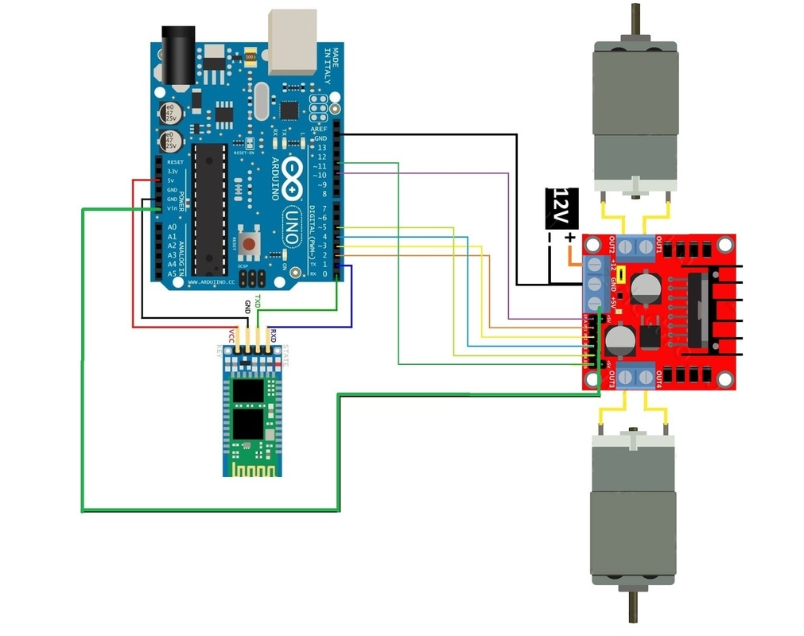

**The Project is having Mainly 5 Blocks.**

1. Bluetooth Module  
2. Arduino UNO  
3. DC Motor Driver  
4. DC Motor 1  
5. DC Motor 2  
  
**Bluetooth Module**: This block is mainly responsible for establishing the connection between Andriod mobile phone and the Circuit  
  
**Arduino UNO:**Arduino is the brain of this project. This will control and co-ordinate all the other components connected with this project.  
  
**DC Motor Driver:**We use this module as Arduino will not be able to provide the required Voltage and Current to Rotate the DC motor by alone. Digital Pins of Arduino will be connected to the input section of DC Motor Driver. This section will rotate the DC motors according the Volages received on the Arduino digital pins.  
  
**DC Motor 1 & DC Motor 2:**These two DC motors will decide the direction of the Car. This car can move to the following directions.

1.Forward Direction

2.Reverse Direction

3.Forward Right

4.Forward Left

5.Reverse Right

6.Reverse Left

**Operation block diagram of the rover**

|  |
| --- |
|  |
|  |  |  |  |  |  |  |
|  | | | | | | |
|  | | | | | | |  |  |

Now let me try to explain the working of this project. The Circuit will get ready to receive commands once the Android Application is successfully paired with the Bluetooth Module HC-05.  
When a button is pressed(Suppose Forward Button) a value will be sent(Value "F") and it will be received by the Bluetooth Module. This Value again will be sent to Arduino UNO by the Bluetooth Module.  
Once Arduino receives the Value it will check what action need to be taken according to the value received. In this case Arduino will set digital pins 10 to 13 in such a way that the DC Motor will rotate in  forward direction. The digital pins 10-13 of Arduino UNO is connected to the  input pins of DC Motor Driver M1.a,M1.b,M2.a and M2.b respectively. Output pins of DC Motor driver will be connected to the DC Motors. This way Arduino will start to control the DC Motors using their Digital pins 10-13  
The Table shown below explains the Value and action that are used for this project.

|  |  |
| --- | --- |
| **Value** | **Action** |
| F | Forward |
| B | Backward |
| S | Stop |
| R | Right |
| L | Left |
| I | Forward Right |
| J | Backward Right |
| G | Forward Left |
| H | Backward Left |

**WHY ARDUINO?**

•We have used Arduino because it is an open source

device which can be programmed through any

operating system like Windows, Mac, Linux, etc.

•The language used is understandable and easy.

•Arduino can be used by beginner in robotics to professionals

•Changing of program is easy. •Shield (external circuits) are available for various purpose like, if we want to connect the arduino to a network then a wi-fi shield is available. For controlling the motor a motor shield is available, and for this project a Bluetooth shield is used.

**REFERENCE**

[ 1] UjjwalKumar, Deepak Rasaily, PriyankaRana. ―Cell phoneBased Device Control with Voice Acknowledgemen

International Journal of Engineering Trends and Technology

(IJETT), ISSN: 2231-5381, Volume-32, Issue-5, February

[ 2] Technology Intelligent Home: SMS Based Home Security

System with Immediate Feedback International Journal Of

Advance Research In Science And Engineering

http://www.ijarse.com IJARSE, Vol. No.2, Issue No.5, May,

2013 ISSN-2319-8354(E).

[ 3] HACKSTER.IO

[4] google and wikihow.