**Test Plan for SUIT Flat Field**

*Prepared by Janmejoy Sarkar and Sreejith Padinhatteeri*

There are two motivations for flat calibration-

1. Flatness of the response from the camera +science filter+ lens.
2. Variation in the field flatness over the life time.

Ground based flat images will be taken with the full payload with a uniformly illuminated light source such as a flat box or a uniformly illuminated diffuser screen. This will be called as ‘Ground Flat.’

SUIT payload has an LED assembly for on board flat calibration. There are two types of LEDs with wavelengths **258nm or 355nm**. Four LEDs of a particular wavelength are placed 90 degrees apart, which can be switched ON individually as well as all the four combined. Apart from the main four LEDs, there are four redundant LEDs as well for each wavelength.

The light from the LEDs passes through the science filters and field corrector lens and reach the camera. Therefore, any non-uniformity in transmission from any one of these components will be apparent in the onboard LED flats. Since the LEDs are radially away from the optical axis, each LED expose only a part of the sensor. All four combined cover the whole sensor, but due to overlapping of individual LEDs some features will be seen, as shown in the Figure 1. Hence a master flat has to be created from the combination of the four LEDs.

Two broad methods are designed and tested for generating master flat. They are as follows-

1. **Method 1 – For small spatial scale (pixel to pixel) variation.**
   1. SUIT Flat field images using LEDs (both individual as well as combined) to be taken during onboard calibration cycle.
   2. Median Image: After dark subtraction, pixel wise median over multiple images to be taken to avoid spurious signals.
   3. Large scale features: A boxcar average of the image to remove small scale features and to bring out only the large-scale features (due to overlap of individual LED light). The spatial scale will be decided based on the size of boxcar.
   4. Master Flat = (Median Image - Large scale features)Normalised
   5. Example of this method can be seen in Figure -2
2. **Method – For large spatial scale variation (over time)**
   1. SUIT ground flat is recorded and kept as master flat.
   2. Median Image: After dark subtraction, pixel wise median over multiple images to be taken to avoid spurious signals.
   3. Variation in LED images over time to be captured by comparison with previous median image (by dividing).
   4. The resultant image is to be multiplied to the master flat to update the SUIT master flat image which is to be used for subsequent flat calibration of science images.
3. **Troubleshooting-**
   1. Images on glowing each of the LEDs are to be recorded for all possible science filter combinations. This is so that any flat can be generated by adding the illumination for each of the LEDs.
   2. Individual LED degradation will be quantified during stellar calibration (Sirius to be placed at four locations on the camera corresponding to four individual LEDs).

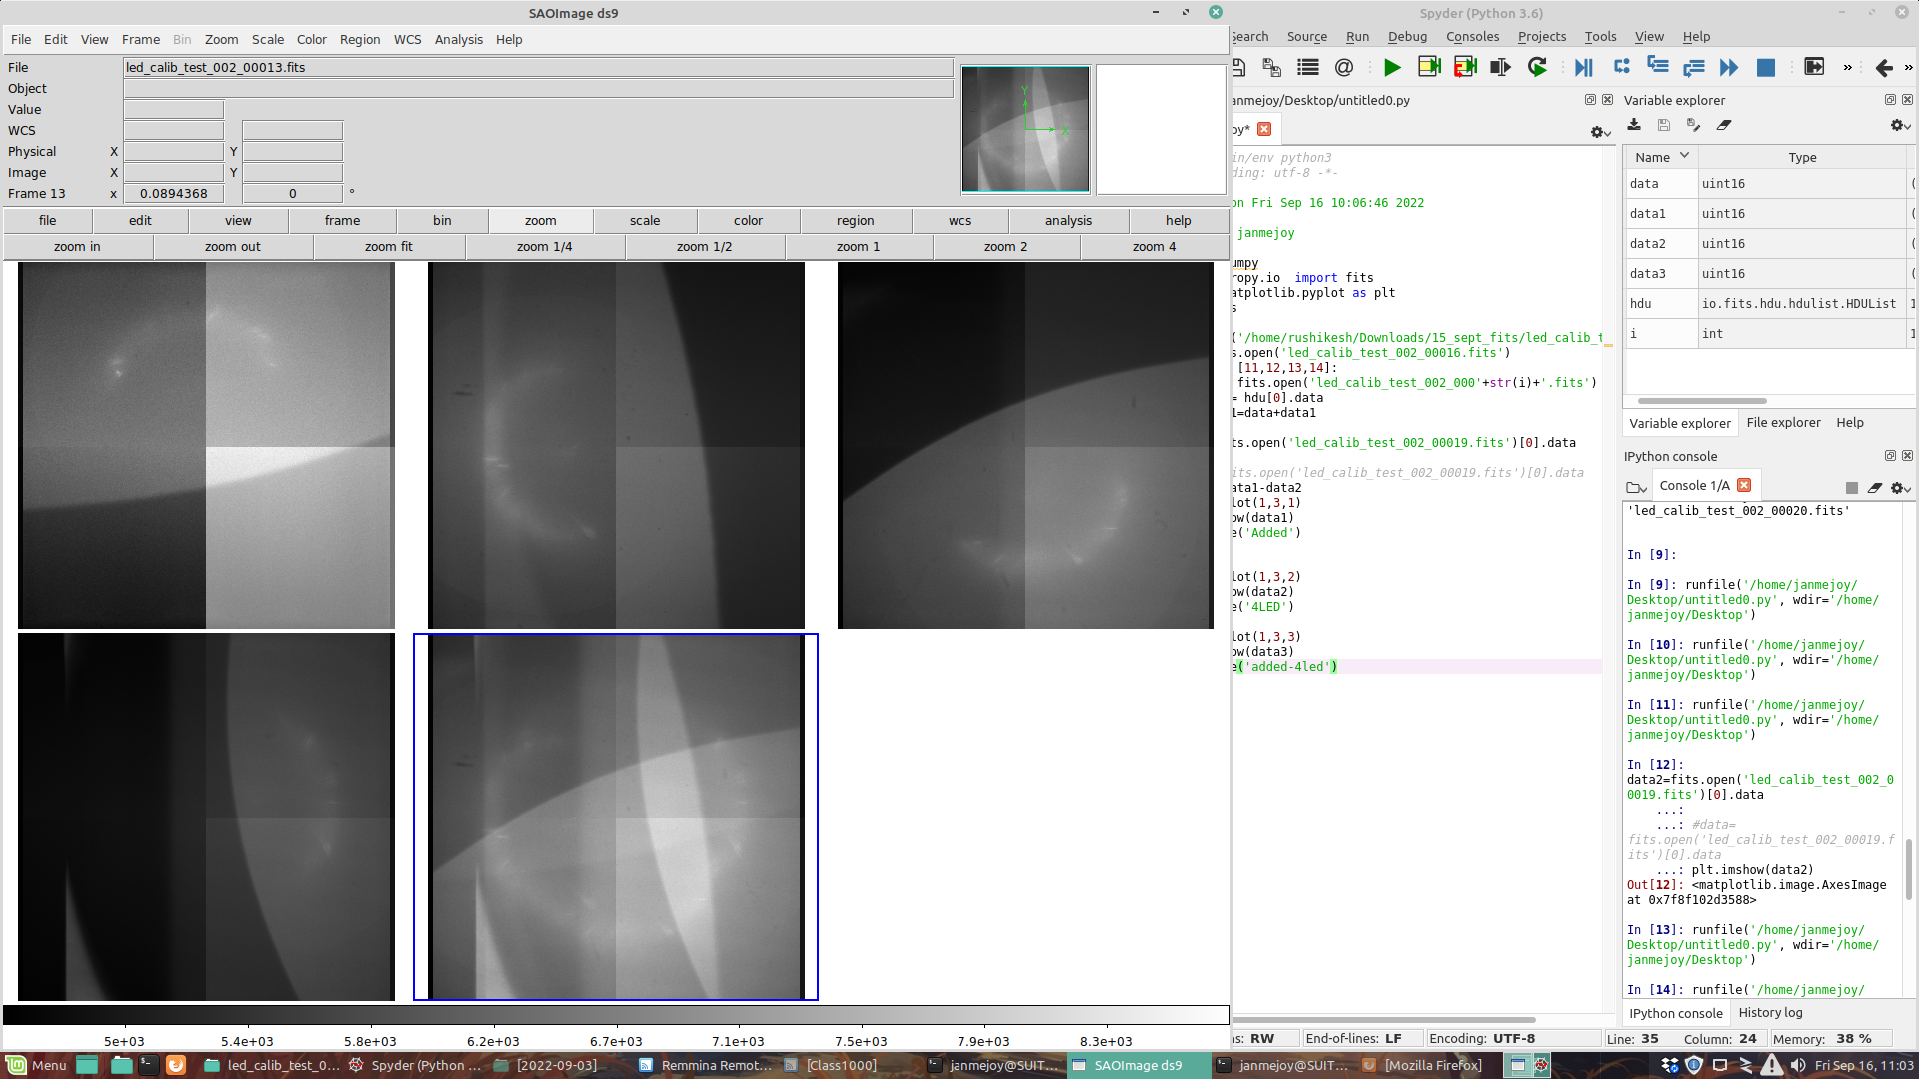

Figure-1: (Top left to Bottom right) Four LEDs illumating individually and 4 LEDs illuminating CCD together.

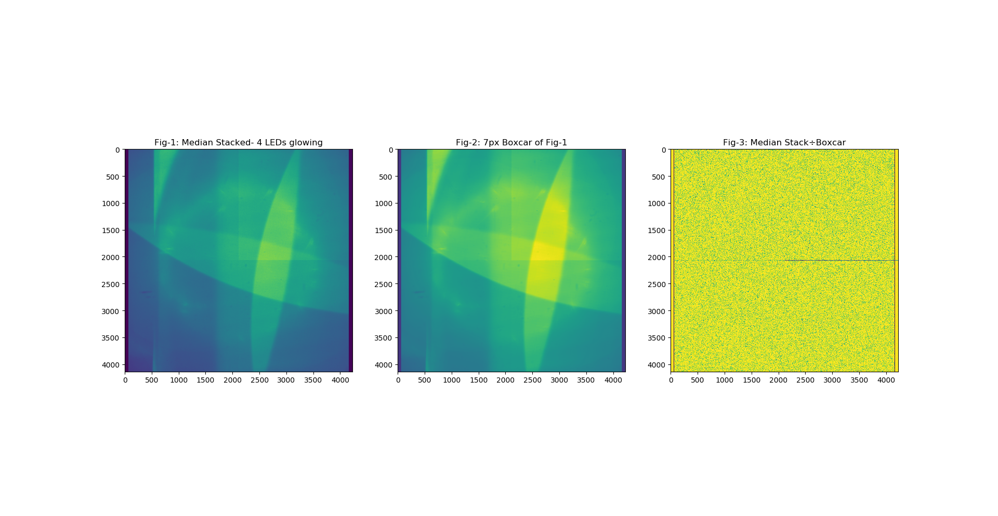

Figure-2: Median stack, 7px Boxcar of Median stack and Division of Median stack and Boxcar.