**To generate LED based flat-field for correction of pixel to pixel response variation of SUIT CCD.**

Janmejoy Sarkar | June 11, 2023

**Methodology:**

* 20 LED images are added to improve signal to noise ratio. This gives the Parent image.
* The added image is blurred by Boxcar convolution method. The kernel size is chosen so as to preserve the large scale pattern while removing the small scale pattern as much as possible.
* The convolved image is divided from the parent image. This gives an image with exclusively small scale structures which is the flat field image, representing the pixel-to-pixel response variation.
* The kernel size is maximized till the large scale pattern starts appearing in the flat field image. Finally, the Flat Field is generated with the optimized kernel size.
* The Flat Field image is divided from any recorded data to correct for pixel to pixel variations.

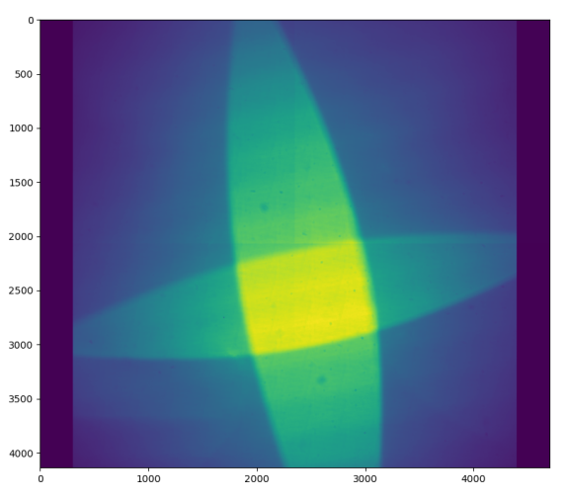**Results:**

Figure : Parent Image (Sum of 20 LED images)

* 20 LED images upon summing gives the Parent image. The images used were obtained using 355 nm LED with SUIT BP3-BB3 science filter combination.
* The kernel size is optimized and Boxcar convolution is applied to the parent image. This is to remove the small scale variations while preserving the large scale variations in the image.
* The Parent image is then divided by the boxcar convolved image to get the Flat Field. The convolution kernel size is maximized while ensuring there is no residual from the large scale patterns in the generated Flat Field images. In our case, an 11 x 11 pixel kernel appeared as the optimized choice. Large scale structures started appearing in the Flat Field upon increasing the kernel size any further.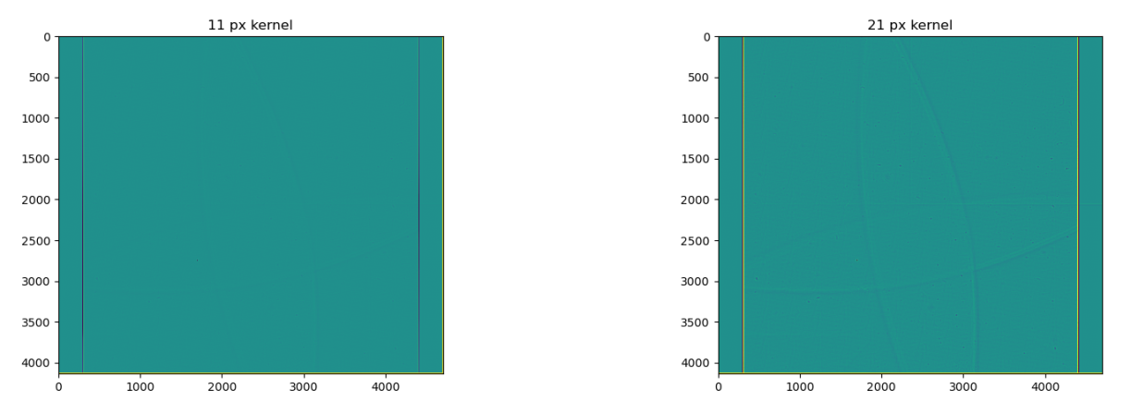

Figure : Comparison of Kernel sizes. These images were generated after dividing the parent image with Boxcar convolved image. The kernel size was increased till residual of large scale structures were apparent in the generated Flat Field images. Note the prominent residual pattern with 21 px kernel, while it is almost nil with 11 px kernel.

* The Boxcar convolved image with a kernel size of 11 pixels is compared to the Parent Image. A line cut is taken from the Parent Image as well as the convolved image and the counts are scaled between 0 and 1. It is seen in the Boxcar Convolved Image that small scale brightness variations (pixel scale) are not present while the large scale brightness variation is preserved.

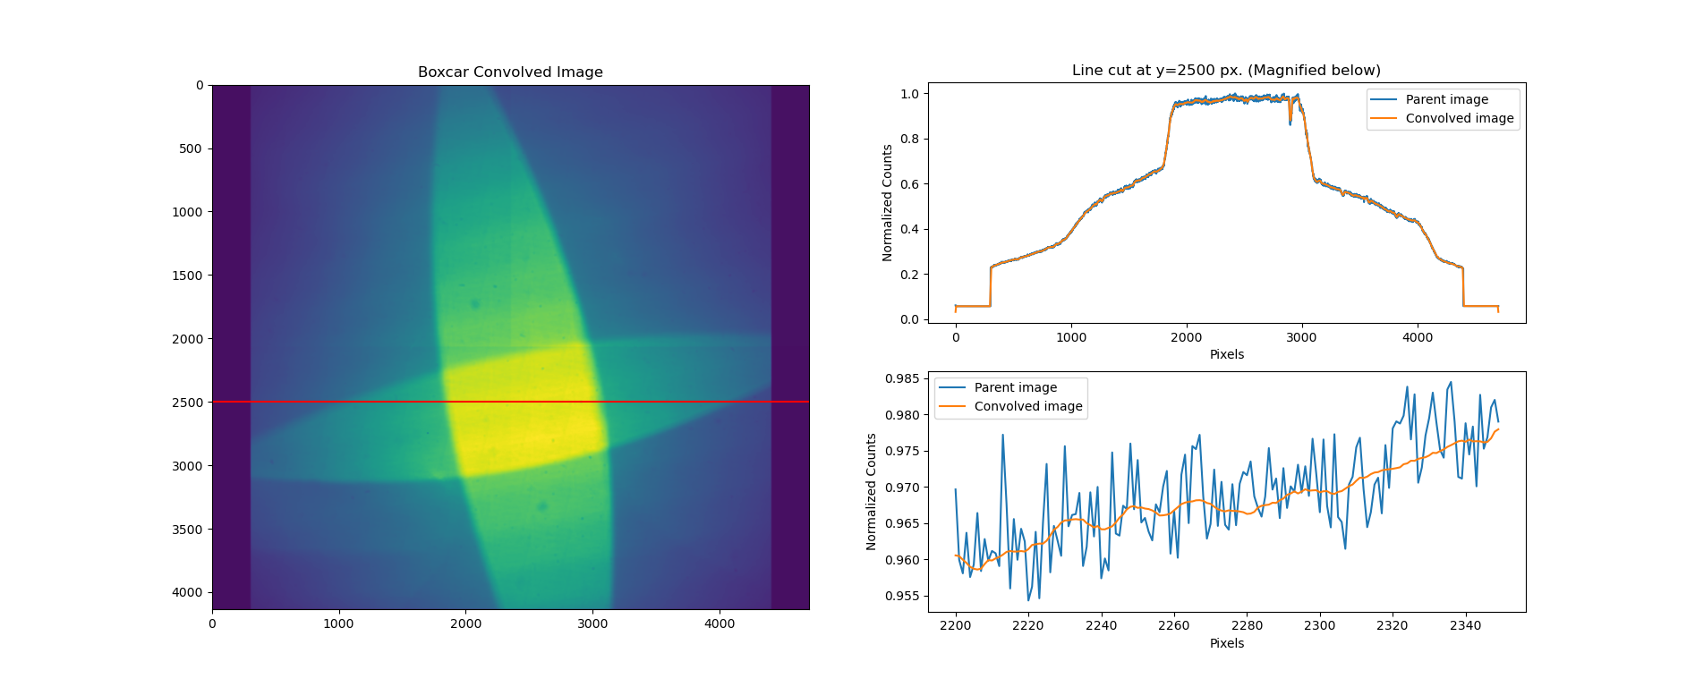

Figure : Line cut from Parent Image and Boxcar Convolved Image.

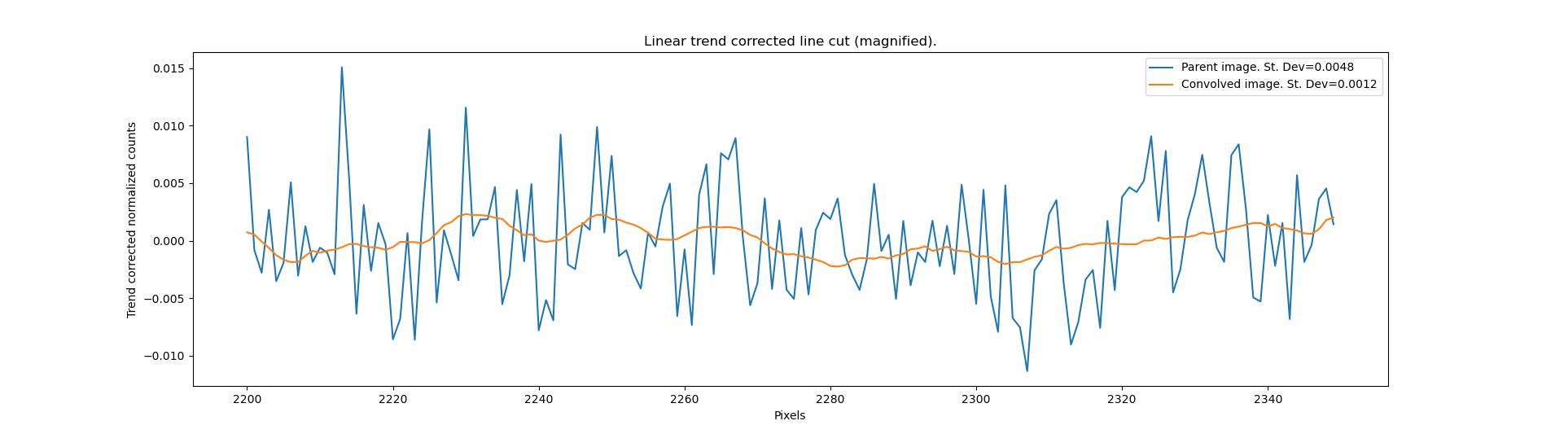

Figure : Linear trend is removed form the line cut to compute standard deviation.

* A more or less linearly varying portion of 150 pixels was chosen from the line cut. The linear trend was removed to study only the fluctuations in the data. The standard deviation was computed for the Parent Image and the Boxcar Convolved Image. The Parent image is seen to have a standard deviation of 0.0048 while the Convolved image has a standard deviation of 0.0012, i.e. 25% that of the parent image. This quantitatively shows the extent of small scale variation removal as a result of Boxcar convolution.
* Finally, the Flat Field Image (generated by dividing the Parent image by Boxcar Convolved Image) is divided from one LED Image (Test Image) to get a Corrected Image.

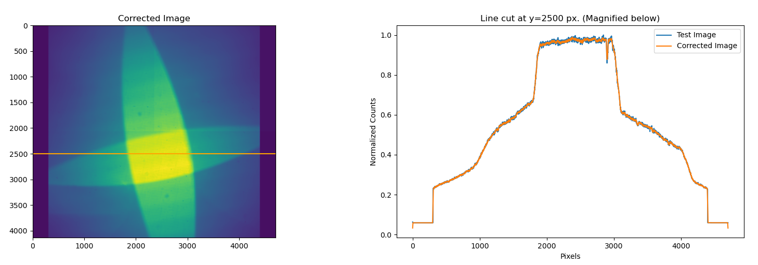

Figure : Corrected image created after the Flat Field was divided from the Test Image. The line cut shows that the large scale structures are well preserved after flat field correction.

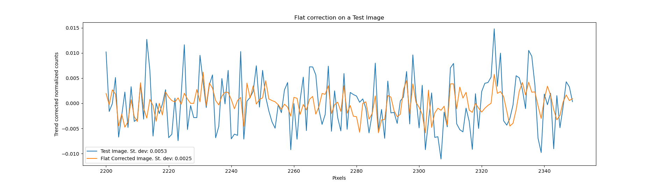

Figure : Magnified, trend removed line cut from a Test Image before and after flat field correction. The standard deviation of the flat corrected image is lesser, representing effective correction in pixel-to-pixel scale.

* The same line cut is chosen from the Test Image as well as the from the Corrected Image. The linear trend is removed from the data and the standard deviation is computed. It is seen that the standard deviation for the single raw image is 0.0053, while that of the Corrected Image is 0.0025. This suggests the small scale, pixel-to-pixel variation of the image has been corrected to a large extent while preserving the large scale structures.

**Scope for development**

* Better optimization of convolution kernel shape/ size for improved preservation of large scale structures.
* Wavelets Transformation methods may be explored for extracting pixel-to-pixel variation information.

-x-