**Check for on-board LEDs functionality**

**Test Purpose:**

The SUIT on-board LEDs are used to measure the Pixel Response Non-Uniformity (PRNU) of the SUIT CCD. Although the SUIT CCD operates at a particular gain which gives an equivalent number of AD counts with respect to the set gain parameter, the response from one pixel to another may vary minutely. Non uniformity of the order ~1% at pixel scales need to be corrected for performing photometry with a SNR better than 100:1. Therefore, it is necessary to check if all LEDs are glowing post launch, to facilitate this calibration.

It should be noted that the LEDs are meant to be used for CCD PRNU correction and to check CCD response only. It cannot be used to correct for spatial transmission non uniformity of the FCLA or science filters. This is because the illumination pattern of the LEDs on these optics is very different from that of the light entering through the telescope.

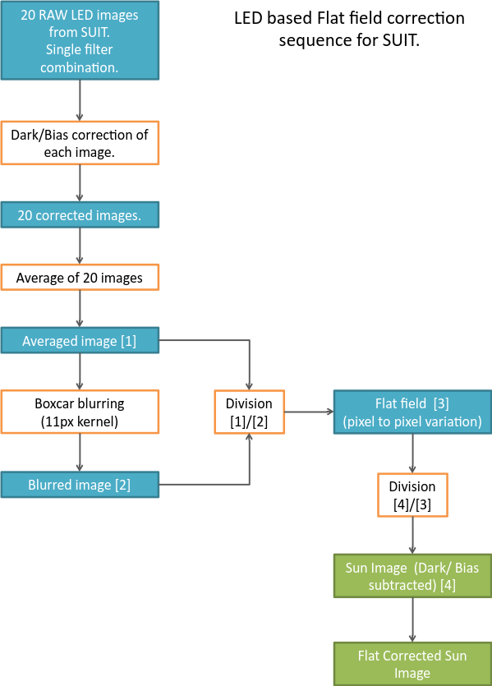

**Methodology/ Data Analysis:**

SUIT payload has a collection of 16 on board LEDs, 8 each of 255 nm and 355 nm. These LEDs are mounted in a circular pattern beyond the shutter assembly and 4 LEDs of a particular wavelength, placed radially 90 degrees apart, are glowed simultaneously to expose the CCD. 4 other LEDs of the same wavelength operate as redundancies. Light from the LEDs pass through the science filters and FCLA before getting imaged on the CCD.

The methodology for PRNU correction finds the normalized variation of intensity at single pixel scales. The sequence of steps for this activity is concisely illustrated in the flow chart. Please refer to the appendix for a detailed explanation.

**Acceptance Criteria:**

Requisite LEDs should illuminate on issuing the specific command which should be apparent in the simultaneously recorded images. Single LED and 4 LED combined illumination data counts should be similar to ground test results for a particular LED and science filter combination.

**Action, in case criteria is not met:**

Criteria may not be met under the following circumstances-

*One LED not glowing; One or more LED(s) degraded; One LED not glowing, other(s) degraded; two LEDs opposite to each other not glowing; two LEDs opposite to each other not glowing, other two degraded:* 4 LED glowing command is to be issued and multiple images are to be taken and added such that the PRNU is the dominant contributor to image noise over shot noise, in even the most dim locations of the image. The number of exposures to be taken depends on the position and degree of the malfunction.

*Two LEDs at 90 degrees not glowing; more than two LEDs in a set of 4 not glowing:* Use redundant set of 4 LEDs for illumination.

*No LEDs of a particular wavelength are glowing:* Use LEDs and corresponding filter combination of the other wavelength.

**Reference Documents:**

Test results, methodology development and statistical study of PRNU correction results are explained in detail in the attached reference document.

-x-